GLOBAL SALES AND FINANCIAL PERFORMANCE
INTERACTIVE SALES DASHBOARD
Project Report

Submitted By
Name: Chandni
Tool Used: Microsoft Power BI Desktop

1. Introduction
For this project, I built a global sales and financial performance dashboard in Power BI. The report combines product, employee, category and regional analysis with financial KPIs.
The dashboard is designed to provide both a summary view and detailed product-level validation.

2. Objectives
- Analyse total sales, cost and profit.
- Analyse average sales and order count.
- Validate product-level sales, profit and quantity.
- Compare sales by category and region.
- Compare profit by employee.
- Track sales by month.
- Create an interactive dashboard with Year, Category and Region filters.
- Provide a compact sales tooltip.

3. Dataset Description
- ProductName
- Total Sales
- Total Profit
- Total Quantity
- MonthName
- EmployeeName
- Category
- Region
- Year

4. Data Preparation
The data was prepared so that product, financial, time, employee, category and region fields could be used in measures and visuals.
- Prepared product-level sales, profit and quantity fields.
- Prepared month information.
- Prepared employee, category and region dimensions.
- Prepared Year for dashboard filtering.
- Created KPI measures.

5. DAX Validation
The DAX VALIDATION page contains a product-level table with ProductName, Total Sales, Total Profit and Total Quantity. The visible total row shows Total Sales of 7,06,35,711.87, Total Profit of 2,51,16,018.03 and Total Quantity of 300006.
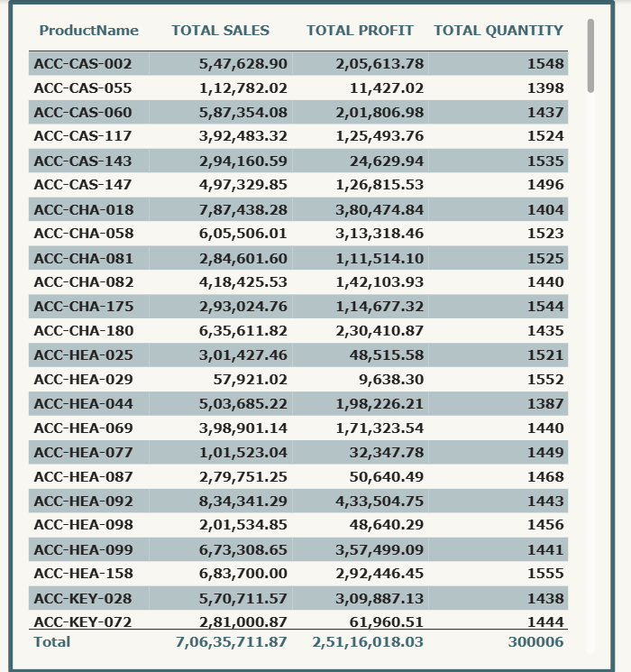
Figure 1: DAX VALIDATION

6. KPI Cards
The KPI CARDS page displays five financial and operational measures:
- Total Profit – 25.12M
- Average Sales – 706.36
- Total Cost – 45.52M
- Total Sales – 70.64M
- Order Count – 100K
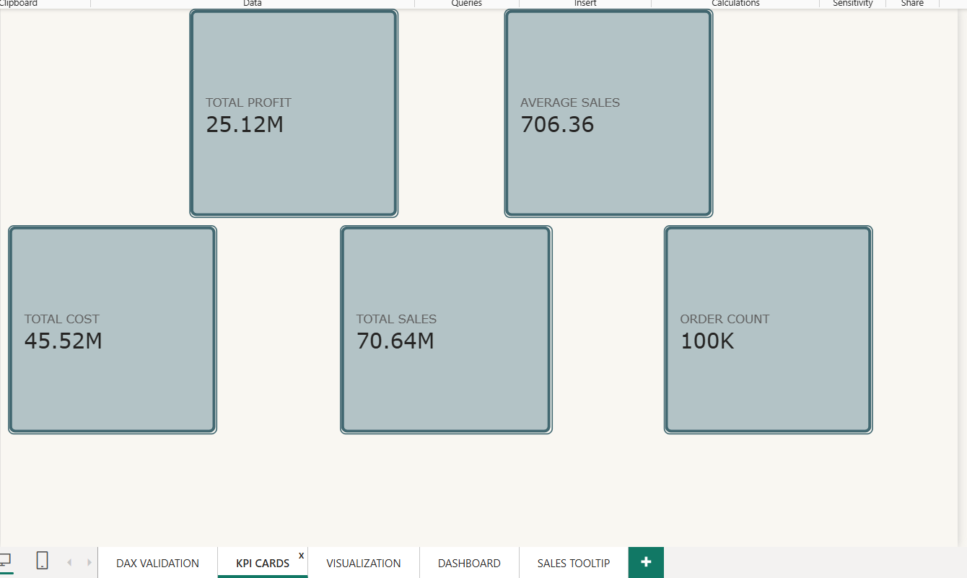
Figure 2: KPI CARDS

7. Total Sales by Month
The monthly line chart compares total sales across the displayed months. The visible values range approximately from 5.6M to 6.2M.
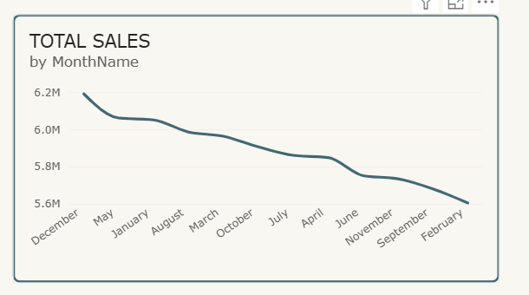
Figure 3: TOTAL SALES by MonthName

Total Profit by Employee
The employee chart compares total profit. Visible employee names include Khaled Hassan, Omar El-Sayed, Hassan El-Sayed, Ahmed Ibrahim, John Smith, Nora Garcia and Fatima Johnson.

8. Total Sales by Category
The category chart contains Clothing, Accessories, Kitchen, Electronics, Outdoors and Furniture. The displayed category sales values are approximately between 9M and 15M.
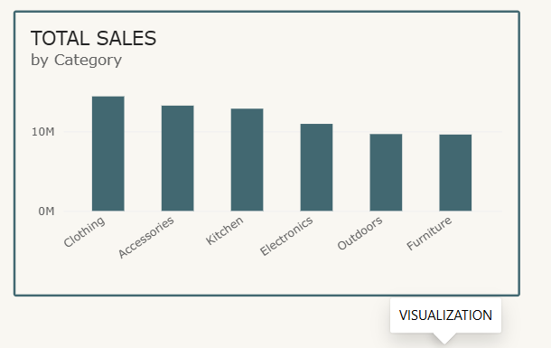
Figure 4: TOTAL SALES by Category

Total Sales by Region
The regional doughnut chart contains Central, South, West, North and East. The centre displays 70.64M total sales.
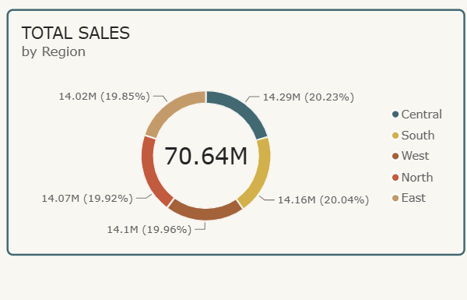
Figure 5: TOTAL SALES by Region

9. Interactive Dashboard
The DASHBOARD page combines Total Sales, Total Cost, Total Profit, Order Count, category sales, monthly sales, regional sales, employee profit and a product-level table.
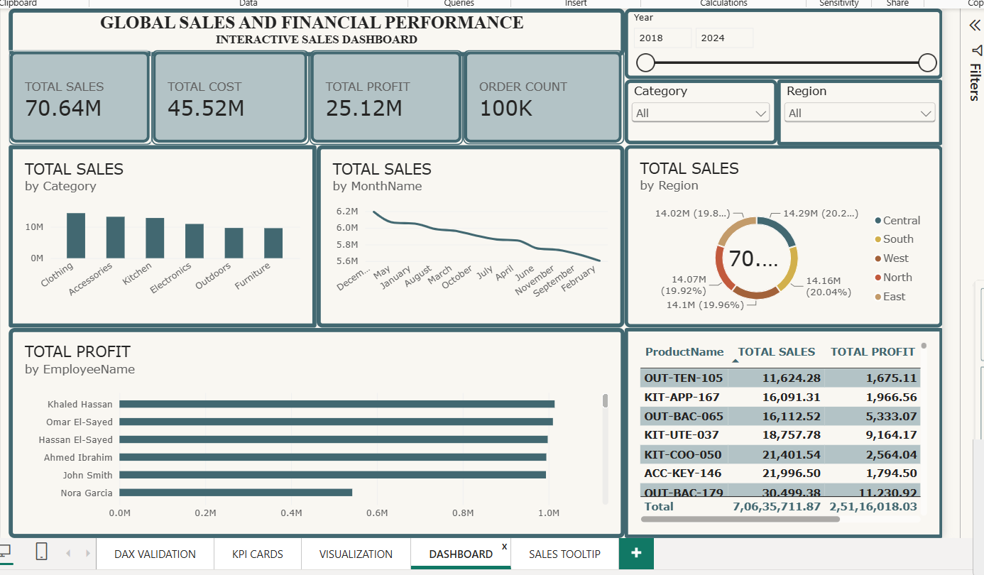
Figure 6: GLOBAL SALES AND FINANCIAL PERFORMANCE

Dashboard Filters
- Year – displayed as a range from 2018 to 2024.
- Category – filters the report by category.
- Region – filters the report by region.

10. Sales Tooltip
The SALES TOOLTIP page contains three compact KPI cards:
- Total Sales – 70.64M
- Total Profit – 25.12M
- Order Count – 100K
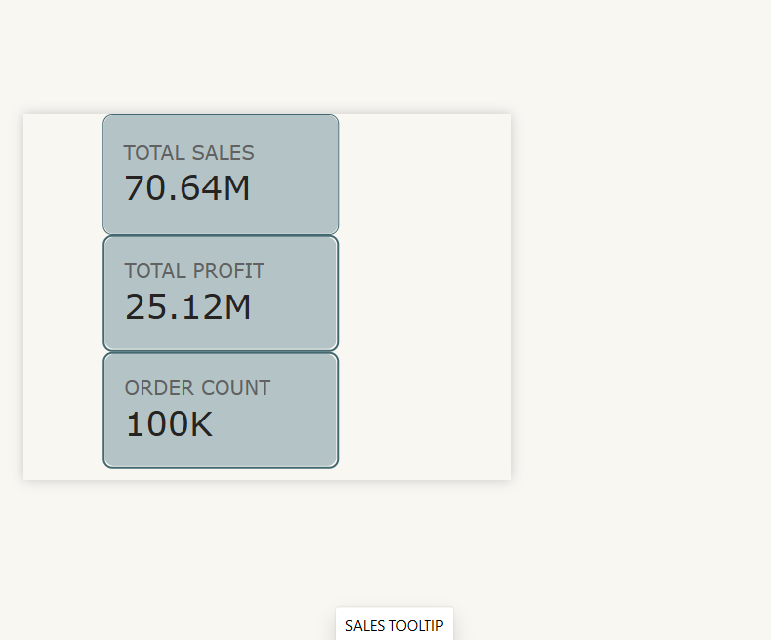
Figure 7: SALES TOOLTIP

Key Findings
- Total Sales is displayed as 70.64M.
- Total Profit is displayed as 25.12M.
- Total Cost is displayed as 45.52M.
- Average Sales is displayed as 706.36.
- Order Count is displayed as 100K.
- The DAX validation total quantity is 300006.
- The DAX validation table shows Total Sales of 7,06,35,711.87 and Total Profit of 2,51,16,018.03.
- The report provides category, regional, employee and monthly analysis.
- Year, Category and Region filters are available.

Conclusion
The Global Sales and Financial Performance dashboard demonstrates how Power BI can combine financial KPIs, product validation, time analysis, employee profit, category sales, regional sales and interactive filtering in one report.

References
- Microsoft Power BI Desktop
- Sales and Financial Performance Dataset
- Microsoft Power BI Documentation

