

Bachelor of Computer Applications (BCA) Programme

Minor Project Report

BCA Sem V

AY 2023-24

*Project Title: Health Insights*

*by*

|  |  |  |
| --- | --- | --- |
| Exam No. | Roll No. | Name of Student |
| 6360 | 637 | Singh Chandni Jaiprakash |

**Project Guide by :**

Prof. Nehal Patel

**Acknowledgement**

The success and final outcome of this project required a lot of guidance and assistance from many people and we are extremely fortunate to have got this all along the completion of our minor project work. Whatever we have done is only due to such guidance and assistance.

I could not forget to thank I/C Principal Dr. Aditi Bhatt, IQAC coordinator and trust representative Dr. Vaibhav Desai, Head of BCA Department Dr. Vimal Vaiwala and Minor Project guide Prof. Nehal Patel and all other Assistant professors of SDJ International College, who took keen interest on our project work and guided us all along, till the completion of our project work by providing all the necessary information for developing a good system.

I am extremely grateful to his for providing such a nice support and guidance though he had busy schedule managing the college dealings.

I am thankful and fortunate enough to get support and guidance from all Teaching staffs of Bachelor of Computer Application Department which helped us in successfully completing our project work. Also, I would like to extend our sincere regards to all the non-teaching staff of Bachelor of Computer Application Department for their timely support.

**Chandni Singh (6360)**

I N D E X

|  |  |  |
| --- | --- | --- |
| **Sr. No** | **Description** | **Page No.** |
| 1 | Introduction | 02 |
|  | 1.1 Project description |  |
|  | 1.2 Project Profile |  |
| 2 | Environment Description | 03 |
|  | 2.1 Hardware and Software Requirements |  |
|  | 2.2 Technologies Used |  |
| 3 | System Analysis and Planning | 08 |
|  | 3.1 Existing System and its Drawbacks |  |
|  | 3.2 Feasibility Study |  |
|  | 3.3 Requirement Gathering and Analysis |  |
| 4 | Proposed System |  |
|  | 4.1 Scope |  |
|  | 4.2 Project modules |  |
|  | 4.3 Module vise objectives/functionalities Constraints |  |
| 5 | Detail Planning | 17 |
|  | 5.1 Data Flow Diagram / UML |  |
|  | 5.2 Process Specification / Activity Flow Diagram |  |
|  | 5.3 Data Dictionary |  |
|  | 5.4 Entity-Relationship Diagram / Class Diagram |  |
| 6 | System Design | 25 |
|  | 6.1 Database Design |  |
|  | 6.2 Directory Structure |  |
|  | 6.3 Input Design |  |
|  | 6.4 Output Design |  |
| 7 | Software Testing | 27 |
| 8 | Limitations and Future Scope of Enhancements | 29 |
| 9 | References | 31 |

**Introduction**

**1.1 Project Summary**

Health Watch Insights is more than just data collection; it's about empowerment and proactive health management. With our advanced algorithms, we turn your data into actionable insights, helping you make informed decisions about your well-being.

Our platform is designed to notify you of potential health concerns before they escalate. It's about taking charge of your health, preventing issues before they become problems, and ultimately, leading a happier and healthier life.

Every user is unique, and we believe in tailoring the experience to your individual needs. That's why we provide you with a personal health portal, where you can set goals, track your progress, and access valuable resources to support your wellness journey.

**1.2 Project Profile**

|  |  |
| --- | --- |
| Project Title: | Health Insights |
| Definition: | We provide you with a personal health portal, where you can set goals, track your progress, and access valuable resources to support your wellness journey. |
| Developed For : | SDJ International College, Vesu, Surat |
| Project Guide(s): | Prof. Nehal Patel |
| Front End: | CSS, BOOTSTRAP, JAVASCRIPT |
| Scripting language : | PYTHON |
| Back End : | PYTHON DJANGO |
| Operating System: | Ubuntu 22.04.3 LTS |
| Tools used for ERD & DFD | Visual Studio, Chrome |
| Submitted By | Singh Chandni Jaiprakash (5634) |

**Environment Description**

**2.1 Hardware and Software Requirements**

Online flight booking system requires following technical specifications to run

properly and efficiently.

SERVER SIDE:

* **Hardware Requirements**

➢ Intel® Core™ i5-7300HQ CPU @ 2.50GHz × 4

➢ 8.0 GiB RAM

* **Software Requirements**

Ubuntu 22.04.3 LTS

MySQL

Django

Bootstrap, CSS, Javascript.

CLIENT SIDE:

* **Hardware Requirements**

➢ Intel® Core™ i5-7300HQ CPU @ 2.50GHz × 4

➢ 8.0 GiB RAM

* **Software Requirements**

Ubuntu 22.04.3 LTS

Browsers : Mozila firefox, Google Chrome

**2.2 Technologies Used**

Front End: **HTML** (HyperText Markup Language):

* HTML is used for structuring the content and layout of your web pages. It defines the structure of your webpage by specifying headings, paragraphs, links, forms, images, and other elements.
* **Bootstrap**:



* Bootstrap is a free and open-source front-end web framework for
* designing websites and web applications. It contains HTML- and
* CSS-based design templates for typography, forms, buttons,
* navigation and other interface components, as well as optional
* JavaScript extensions.
* It aims to ease the development of dynamic website and web
* application.
* Bootstrap is a front end web framework, that is, an interface for the user, unlike the
* server-side code which resides on the "back end" or server.
* Bootstrap provides a set of stylesheets that provide basic style definitions for all key
* HTML components. These provide a uniform, modern appearance for formatting text,
* tables and form elements.
* **CSS:**



* Cascading Style Sheets (CSS) is a style sheet language used for describing the
* presentation of a document written in a markup language. Although
* most often used to set the visual style of web pages and user
* interfaces written in HTML and XHTML, the language can be
* applied to any XML document, including plain XML, SVG and
* XUL, and is applicable to rendering in speech, or on other media.
* Along with HTML and JavaScript, CSS is a cornerstone
* technology used by most websites to create visually engaging
* webpages, user interfaces for web applications, and user
* interfaces for many mobile applications. Before CSS, nearly all
* presentational attributes of HTML documents were contained
* within the HTML markup. All font colors, background styles,
* element alignments, borders and sizes had to be explicitly described,
* often repeatedly, within the HTML. CSS lets authors move much of
* that information to another file, the style sheet, resulting in considerably
* simpler HTML.
* **JavaScript**:



* JavaScript is a high-level, dynamic, untyped, and interpreted programming language.
* It has been standardized in the ECMAScript language
* specification. Alongside HTML and CSS, JavaScript is one of
* the three core technologies of World Wide Web content
* production; the majority of websites employ it, and all modern
* Web browsers support it without the need for plug-ins.
* JavaScript is prototype-based with first-class functions,
* making it a multi-paradigm language, supporting object-
* oriented, imperative, and functional programming styles. It has
* an API for working with text, arrays, dates and regular
* expressions, but does not include any I/0, such as networking,
* storage, or graphics facilities, relying for these upon the host
* environment in which it is embedded.

**Back End: Django**



Django is a high-level, open-source web framework for building web applications using the Python programming language. It's designed

to simplify and speed up the process of web development by providing a robust set of tools and conventions for common tasks. Here's a brief overview of Django:

* MVC Architecture: Django follows the Model-View-Controller (MVC) architectural pattern, although in Django's terminology, it's referred to as Model-View-Template (MVT). This pattern helps separate the application into three main components:
  + Model: Defines the data structure and how to interact with the database.
  + View: Handles the presentation logic and what the user sees.
  + Template: Defines the HTML structure for rendering data from the views.
* Database Abstraction: Django provides a high-level Object-Relational Mapping (ORM) system, allowing you to define your data models in Python code. It abstracts the underlying database system (e.g., MySQL, PostgreSQL, SQLite) so that you can work with databases using Python classes and methods.
* Admin Panel: Django includes an automatic admin interface. Once you define your data models, Django generates a fully functional admin panel, making it easy to manage and manipulate data without writing custom administrative code.
* URL Routing: Django uses a URL dispatcher to route incoming HTTP requests to the appropriate view function. You can define URL patterns that map to specific views and pass data between them.
* Middleware: Middleware components can be added to the request/response processing pipeline to perform various tasks such as authentication, logging, and security checks.
* Authentication and Authorization: Django provides a robust authentication system out of the box, including user management, login, and password reset. You can also implement fine-grained authorization by defining user roles and permissions.
* Security: Django is known for its strong focus on security. It includes built-in protections against common web vulnerabilities like Cross-Site Scripting (XSS), Cross-Site Request Forgery (CSRF), and SQL injection.
* Template System: Django's template system allows you to define reusable HTML templates with dynamic content placeholders. It supports template inheritance and helps keep the presentation layer clean and maintainable.
* Reusable Apps: Django encourages modular development by allowing you to create reusable apps. You can use existing third-party apps or build your own and easily integrate them into your project.
* Community and Ecosystem: Django has a large and active community, which means you can find extensive documentation, tutorials, and third-party packages to extend its functionality.

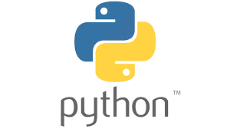Python:

Python is a high-level, general-purpose programming language. Its design philosophy emphasizes code readability

with the use of significant indentation. Python is dynamically typed and garbage-collected. It supports multiple programming

paradigms, including structured, object-oriented and functional

MySQL

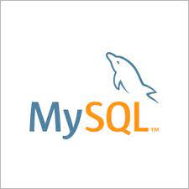

MySQL runs on virtually all platforms, in cluding Linux, UNIX, and Windows. Although it can be used in a wide range of applications, MySQL is most often associated with web-based applications and

online publishing and is an important component of an open

source enterprise stack called LAMP. LAMP is a Web development platform that uses Linux as the operating

system, Apache as the Web server, MySQL as the relational

database management system and PHP as the object-

oriented scripting language.MySQL is an essential part of

almost every open source PHP application. Good example

for PHP/MySQL-based script are PHPBB.

**System Analysis and Planning**

**3.1 Existing System and its Drawbacks**

In the current health monitoring landscape, users are often burdened with manual data entry and lengthy processes. These limitations highlight the necessity of Health Watch Insights:

* Manual Data Entry: In the existing system, users must manually input their health data, resulting in time-consuming processes and a higher likelihood of data entry errors.
* Limited Data Accessibility: Users have no means to upload or download the latest updates related to their health. This hinders the ability to stay up-to-date with their well-being.
* Lack of Web Services and Remoting: The absence of web services and remote data access restricts users from securely accessing their health insights from anywhere and at any time.
* Risk of Mismanagement: Relying on manual data entry during project development increases the risk of data mismanagement and inaccuracies, potentially compromising user health information.
* Security Concerns: The current system offers limited security measures, putting user health data at risk of unauthorized access or breaches.
* Limited Data Management: The manual nature of data entry makes it challenging to update, delete, or view information. This limitation obstructs the efficient management of health data.
* Time-Consuming Processes: Users and healthcare providers are inconvenienced due to the lengthy processes involved in data entry and analysis, resulting in delays in proactive health management.
* Lack of Coordination: The existing system lacks proper coordination between different applications and users, making it difficult to ensure seamless data sharing and communication.
* Scalability Challenges: As the number of users and health data entries grows, it becomes increasingly difficult to maintain and retrieve detailed health insights efficiently.
* User-Friendliness: The current system is not user-friendly, causing frustration for both users and staff involved in health monitoring.

These drawbacks underscore the critical need for Health Insights. Our project aims to address these issues by providing an automated, secure, and user-friendly platform for health data collection, analysis, and proactive health management.

**3.2 Feasibility Study**

In this section, we will conduct a feasibility study to assess the viability and potential success of HealthWatch Insights. This study will encompass various aspects, including technical, operational, economic, and scheduling feasibility.

Technical Feasibility:

* Data Integration: HealthWatch Insights relies on integrating data from various smartwatches and wearable devices. The technical feasibility of seamless data integration will be examined, ensuring compatibility with a wide range of devices.
* Scalability: We will assess the platform's capability to scale efficiently with the growing number of users and data, ensuring that it can handle increased data loads without compromising performance.
* Security: Ensuring the security of user health data is paramount. We will evaluate the technical measures in place to protect against unauthorized access, data breaches, and other potential security threats.

Operational Feasibility:

* User Acceptance: User feedback and usability testing will be conducted to determine whether the platform is user-friendly and meets the needs and expectations of our target audience.
* Resource Availability: We will assess the availability of the necessary resources, including hardware, software, and human resources, required for the successful operation of HealthWatch Insights.
* Data Management: The feasibility of efficiently managing and storing large volumes of health data will be evaluated to ensure the platform's operational stability.

Economic Feasibility:

* Cost-Benefit Analysis: A comprehensive cost-benefit analysis will be performed to determine the economic feasibility of HealthWatch Insights. This analysis will consider development costs, operational expenses, and potential revenue streams.
* Return on Investment (ROI): We will assess the projected ROI of the project to determine whether it is financially viable in the long run.

Scheduling Feasibility:

* Project Timeline: We will establish a realistic project timeline, taking into account development, testing, and deployment phases. This will help ensure that the project can be completed within the allotted time frame.
* Resource Allocation: Proper allocation of resources, including manpower and equipment, will be considered to meet project milestones and deadlines.

**3.3 Requirement Gathering and Analysis**

In this section, we will delve into the process of gathering and analyzing the requirements for the successful development and deployment of Health Insights, a health monitoring and proactive management platform.

Hardware Requirements:

Minimum Hardware Requirements:

* Processor: Intel® Core™ i5-7300HQ CPU @ 2.50GHz × 4
* Hard Drive: 740.2 GB
* RAM: 8.0 GiB

Preferred Hardware Requirements:

* Processor: Intel® Core™ i5-7300HQ CPU @ 2.50GHz × 4
* Hard Disk Drive: 740.2GB
* RAM: 8.0 GiB

Software Requirements:

* Operating System: Ubuntu 22.04.3 LTS
* Networking: LAN connectivity is essential, and an internet connection is required for data synchronization and updates.

Other Requirements:

* Security: Robust security measures will be implemented to protect user health data from unauthorized access, ensuring confidentiality and compliance with privacy regulations.
* Portability: The software will be designed to be platform-agnostic, allowing for seamless deployment on various operating systems and devices.
* Correctness: The system will accurately capture and analyze health data, minimizing errors and inaccuracies.
* Efficiency: Efficient data processing and response times will be a priority to ensure a smooth user experience, even with large datasets.
* Flexibility: The platform will offer flexibility in terms of data input methods, data visualization, and user customization.
* Reusability: Components of the system will be designed for reusability to streamline future enhancements and maintenance.

Performance Requirements:

* User Satisfaction: Health Insights will aim to meet and exceed user expectations by providing valuable health insights and a user-friendly experience.
* Response Time: All system operations will be optimized for swift response times, ensuring that users can access their health data quickly.
* Error Handling: Robust error handling mechanisms will be in place to gracefully manage user errors and unexpected situations without disrupting the system's operation.
* Safety and Robustness: The platform will be designed to mitigate potential risks and ensure robust operation, minimizing the likelihood of critical failures.
* Portability: Health Insights will be developed to be architecture-agnostic, allowing for easy deployment on various platforms if the need arises.
* User Friendliness: The system will prioritize user-friendliness, ensuring that even non-technical users can navigate and utilize its features effectively, promoting widespread adoption.

The requirements gathered and analyzed in this section will serve as the foundation for the design and development phases of Health Insights, ensuring that the final product aligns with user needs and expectations while meeting technical and operational standards.

**Processed System**

**4.1 Scope**

The scope of Health Insights encompasses the development and deployment of a comprehensive health monitoring and proactive management platform. The project aims to provide users with a user-friendly and secure environment to collect, analyze, and manage their health data efficiently. Key aspects of the project scope include:

* Data Collection: Users will be able to connect their smartwatches and wearable devices to the platform to seamlessly collect health data, including vital signs, activity levels, and more.
* Data Analysis: Advanced algorithms will transform raw health data into meaningful insights, helping users better understand their health trends and potential risks.
* Proactive Alerts: Health Insights will provide timely notifications to users, alerting them to potential health issues before they escalate, allowing for early intervention.
* User Portals: Each user will have a personalized portal for managing their health data, setting goals, and accessing resources for improving their well-being.
* Security: Robust security measures will be implemented to protect user health data, ensuring confidentiality and compliance with privacy regulations.

**4.2 Project Modules**

Health Insights will be organized into the following modules, each serving a specific function:

* User Registration and Authentication Module:
  + Objective: Allow users to create accounts and ensure secure authentication.
  + Functionality: User registration, login, password recovery, and profile management.
  + Constraints: Security and privacy of user data must be maintained.
* Data Integration and Collection Module:
  + Objective: Collect health data from connected smartwatches and wearable devices.
  + Functionality: Data synchronization, data validation, and device management.
  + Constraints: Compatibility with various device types and data formats.
* Data Analysis and Insights Module:
  + Objective: Transform raw health data into meaningful insights.
  + Functionality: Data processing, trend analysis, anomaly detection, and predictive modeling.
  + Constraints: Accuracy and efficiency in data analysis.
* Proactive Alerts and Notifications Module:
  + Objective: Provide timely alerts to users about potential health issues.
  + Functionality: Alert generation, notification delivery, and user preferences management.
  + Constraints: Real-time responsiveness and reliability in alert delivery.
* User Health Portal Module:
  + Objective: Offer users a personalized portal for health data management.
  + Functionality: Profile customization, goal setting, and data visualization.
  + Constraints: User-friendly interface and data accessibility.

**4.3 Module-wise Objectives/Functionalities and Constraints**

For each module, specific objectives, functionalities, and constraints will be defined as follows:

Note: This is a simplified example. In a real project, you would provide more detailed objectives, functionalities, and constraints for each module.

User Registration and Authentication Module:

* Objective: To allow users to securely create and manage their accounts.
* Functionality: User registration, login, two-factor authentication (2FA), profile management.
* Constraints: User data privacy, protection against unauthorized access.

Data Integration and Collection Module:

* Objective: To collect and synchronize health data from various wearable devices.
* Functionality: Data validation, device compatibility, real-time data updates.
* Constraints: Support for a wide range of devices and data formats.

Data Analysis and Insights Module:

* Objective: To process health data and provide users with meaningful insights.
* Functionality: Data processing, trend analysis, anomaly detection, predictive modeling.
* Constraints: Accuracy, efficiency, and scalability of data analysis.

Proactive Alerts and Notifications Module:

* Objective: To send timely alerts to users regarding potential health issues.
* Functionality: Alert generation, notification delivery, user preferences management.
* Constraints: Real-time responsiveness, reliability in alert delivery.

User Health Portal Module:

* Objective: To offer users a user-friendly portal for managing their health data.
* Functionality: Profile customization, goal setting, data visualization.
* Constraints: Intuitive user interface, data accessibility, and personalization options.

These module-wise objectives, functionalities, and constraints will guide the development and implementation of each component of HealthWatch Insights, ensuring that the project stays on track and delivers a comprehensive health monitoring solution.

**Detail Planning**

**6.1 Database Design**

**Table name: Contact**

**Description: This table gives detail about user contact information**

|  |  |  |  |
| --- | --- | --- | --- |
| **Field Name** | **Field Type** | **Constraint** | **Description** |
| **Name** | varchar(200) | Not null | name |
| **Email** | varchar(200) | Not null | email |
| **Message** | varchar(200) | Not null | message |

**Table name: Signup Users**

**Description: This table gives detail about user signup information**

|  |  |  |  |
| --- | --- | --- | --- |
| **Field Name** | **Field Type** | **Constraint** | **Description** |
| **Username** | varchar(200) | Not null | username |
| **Name** | varchar(200) | Not null | name |
| **Password** | int | Not null | password |
| **Image** | ImageField | Not null | Image |

**Table name: User health data ( auto genarated)**

**Description: This table gives detail about user health information**

|  |  |  |  |
| --- | --- | --- | --- |
| **Field Name** | **Field Type** | **Constraint** | **Description** |
| ID | int(20) | Primary key | Id |
| Username | varchar(200) | Not null | Username |
| CurrentTime | varchar(200) | Not null | CurrentTime |
| Temperature | float | Not null | Temperature |
| Heartbeat | float | Not null | Heartbeat |
| SpO2 | float | Not null | SpO2 |
| RBC | float | Not null | RBC |
| WBC | float | Not null | WBC |
| Platelets | float | Not null | Platelets |
| BloodGlucose | float | Not null | BloodGlucose |
| HbConcentration | float | Not null | HbConcentration |
| RespirationRate | float | Not null | RespirationRate |
| SleepMonitoring | varchar(200) | Not null | SleepMonitoring |

**5.1 Data Flow Diagram / UML**

**Context-level:**

**1st Level (admin) Diagram:**

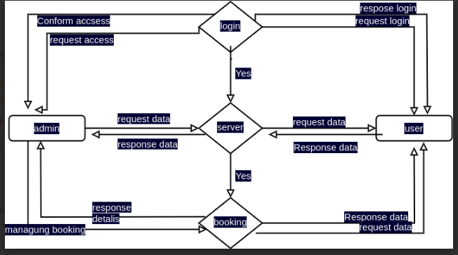

**2nd level Diagram:**

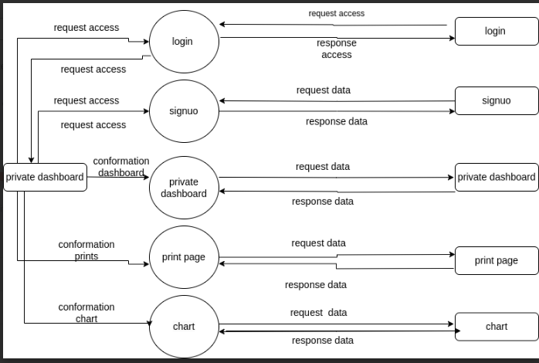

**5.4 Entity-Relationship Diagram / Class Diagram**

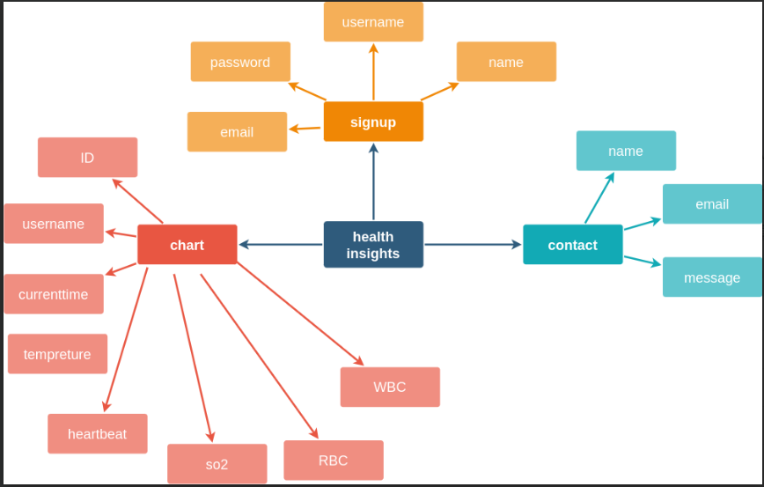

**6.1 Database Design**

**Table: admin**

**Description: This table gives detail about admin information**

**6.2 database structure**

**➢ Admin:**

**• home.html**

**• contact.html**

**➢ User**

**• signup**

**• signin**

**• private dashboard**

**• chart**

**6.3 Input Design**

Home page:

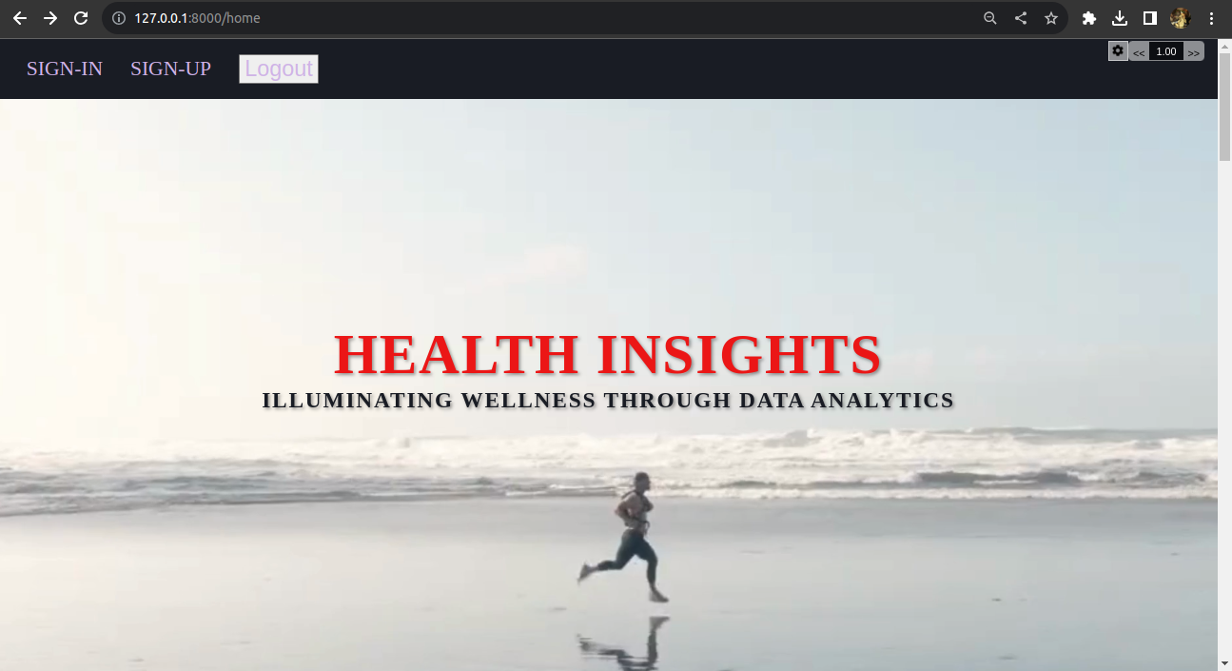

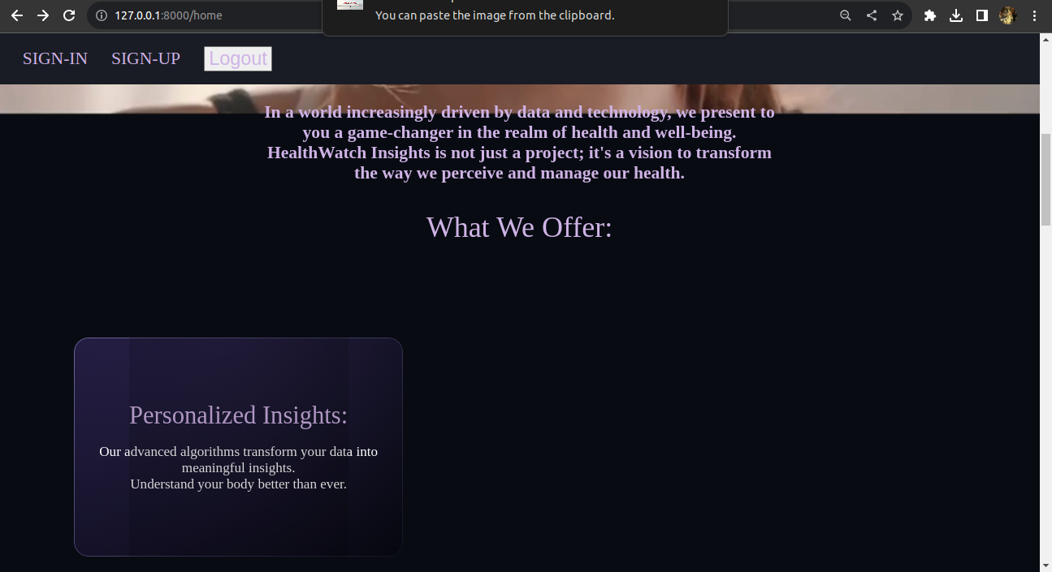

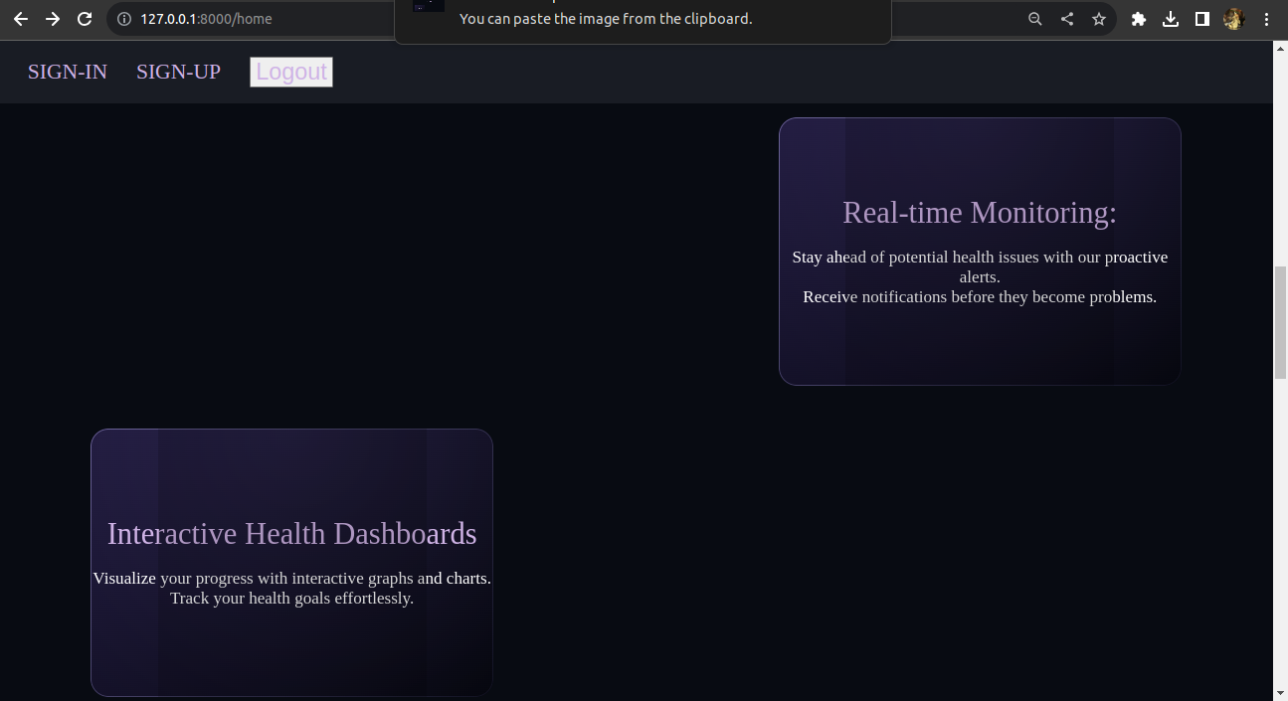

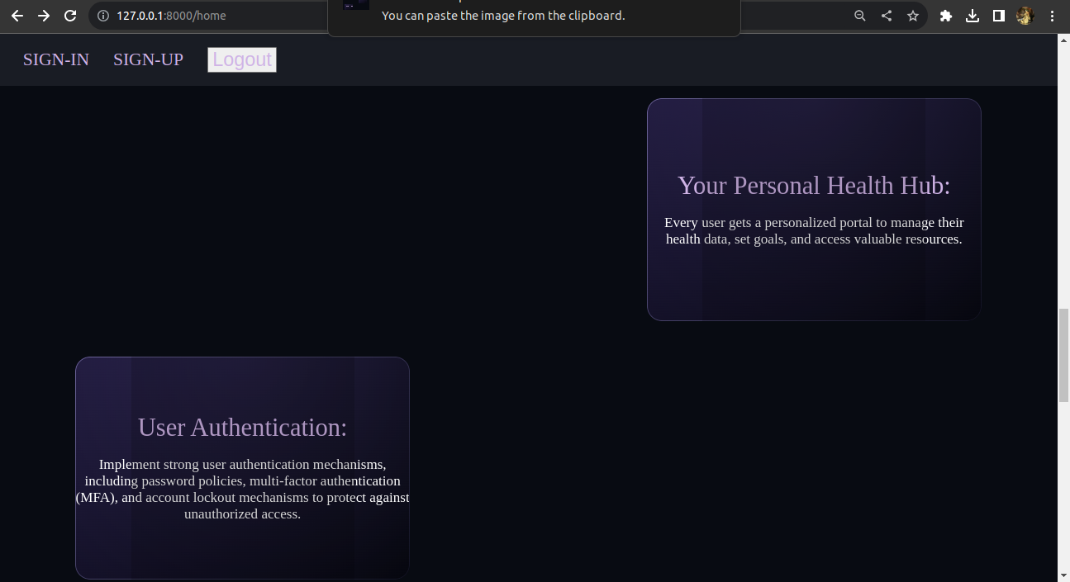

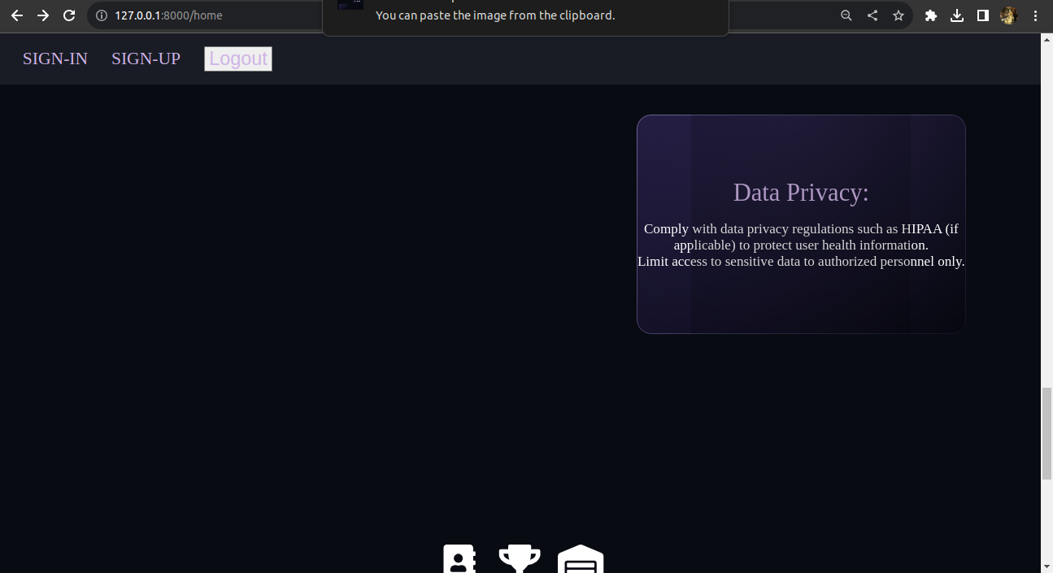

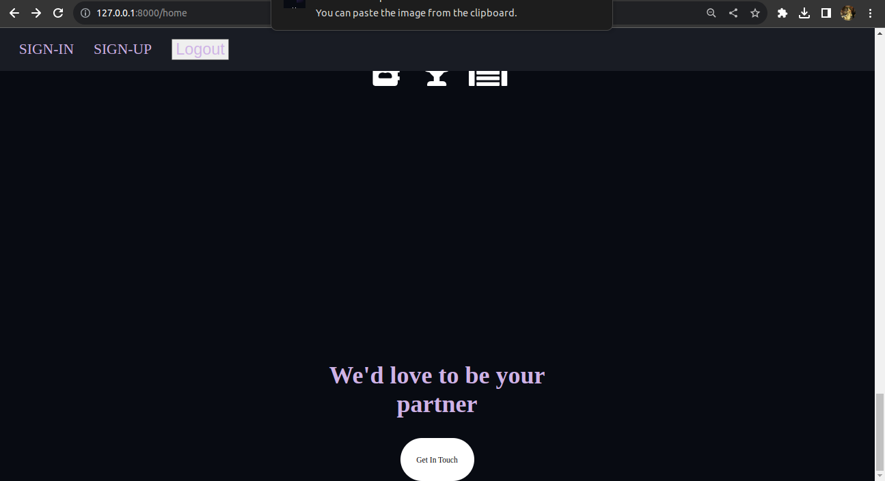

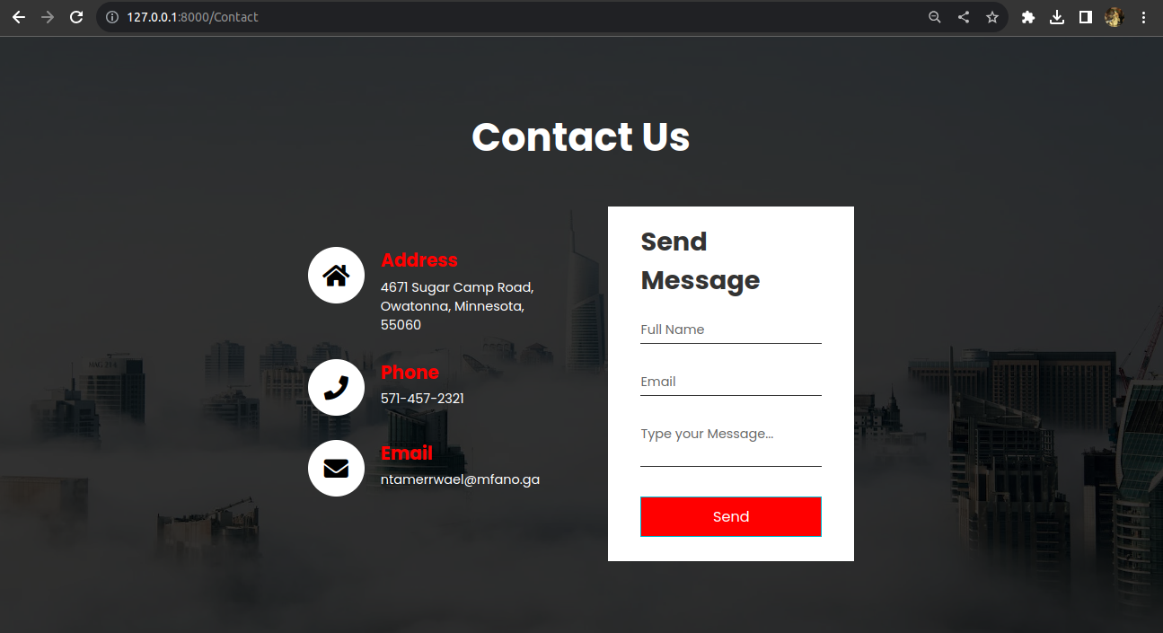

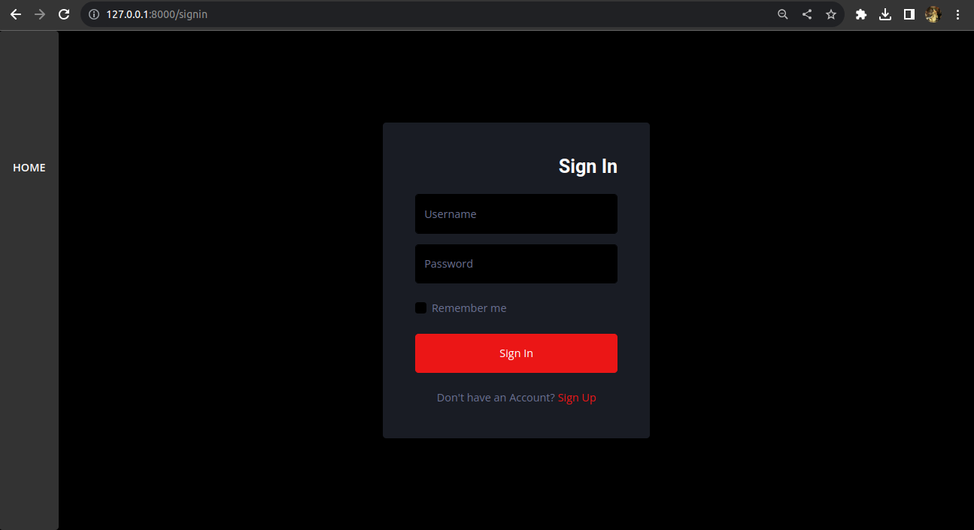

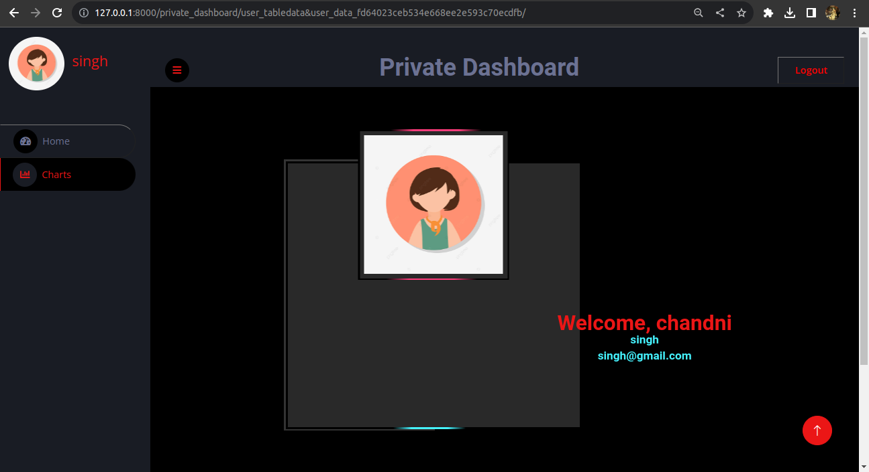

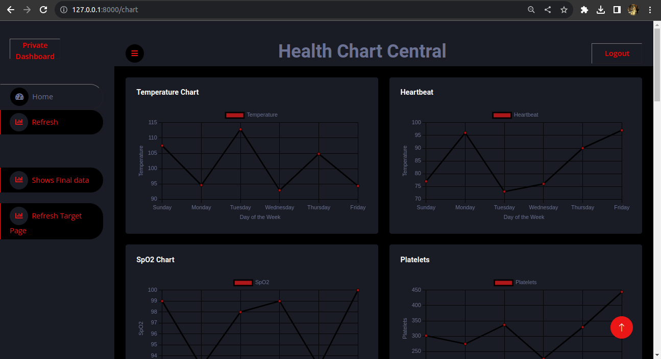

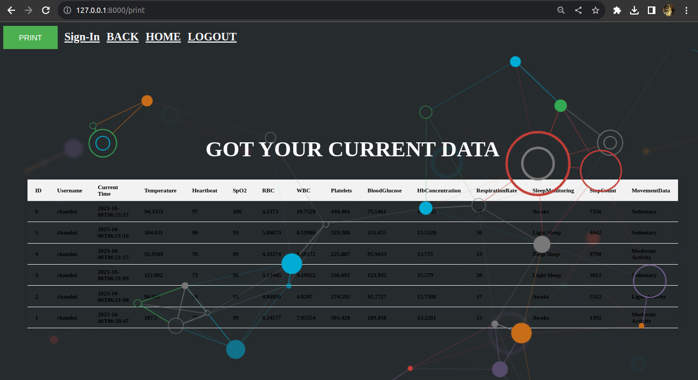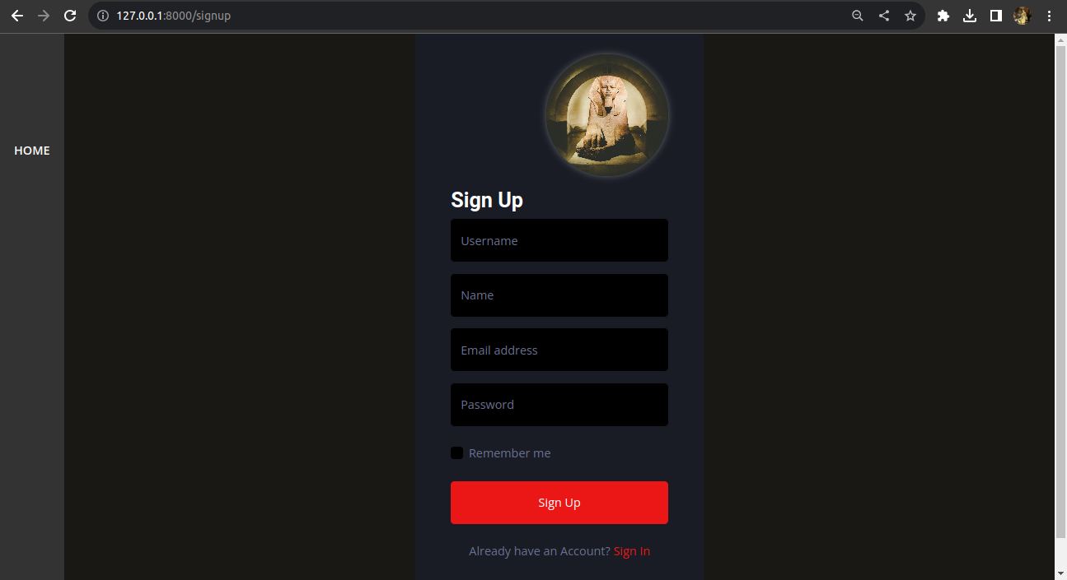

**7. Software Testing**

The testing phase is a crucial step in the development of Health Insights, where we focus on verifying the software's functionality, usability, and compatibility with different environments. Our testing process ensures that the system performs as intended and meets the highest quality standards.

Functional Testing:

Functional testing aims to validate that every aspect of Health Insights functions correctly and delivers the intended features and capabilities. Key areas of focus include:

* Web Page Functionality: Ensuring that all web pages within Health Insights are fully functional, responsive, and free from errors.
* Navigation Testing: Verifying that users can navigate the platform smoothly, accessing various features and modules without encountering issues.
* Database Integration: Validating the seamless integration of MySQL database operations, including data storage, retrieval, and management.
* UI/UX Design: Confirming that all pages are designed to perfection, providing an intuitive and visually appealing user interface.

Environment Testing:

Environment testing assesses the compatibility of Health Insights with different hardware and software configurations, ensuring a seamless user experience in various setups. The following environments will be considered:

* Web Browsers: Extensive testing will be conducted on Internet Explorer and Chrome to ensure compatibility and operability on these widely used web browsers.
* Web Server: The software will be tested for compatibility with web servers such as IIS (Internet Information Services) and Apache.
* Database Compatibility: Compatibility with MYSQL Server Management Studio will be thoroughly tested, ensuring smooth database operations.
* Operating System: HealthWatch Insights will be tested on Ubuntu to verify its operability and performance on this platform.
* Browser Compatibility: Extensive browser compatibility testing will be performed to ensure that the software functions consistently and optimally across various browsers, with a focus on Internet Explorer and Chrome.

Testing Methodology:

The testing process for Health Insights will follow industry best practices, including but not limited to:

* Unit Testing: Testing individual software components.
* Integration Testing: Verifying the integration of different modules.
* System Testing: Evaluating the system as a whole.
* User Acceptance Testing (UAT): Involving users to validate the system against real-world scenarios.

Test Scenarios and Test Cases:

A comprehensive set of test scenarios and test cases will be developed to cover all aspects of Health Insights, ensuring thorough testing of its features and functionality.

By conducting rigorous testing in both functional and environmental contexts, we aim to deliver a reliable and user-friendly health monitoring platform that meets the highest standards of quality and performance.

**8.Limitations and Future Scope of Enhancements**

In the development of Health Insights, we acknowledge certain limitations and anticipate exciting opportunities for future enhancements.

**Limitations:**

* Data Compatibility: Health Insights currently supports a wide range of smartwatches and wearable devices. However, due to evolving technology, some devices may not be fully compatible.
* User Data Privacy: While we prioritize data security and privacy, there is always a potential risk associated with handling sensitive health data. We have implemented robust security measures, but data breaches can never be entirely eliminated.
* Internet Connectivity: The requirement for an internet connection may limit usage in areas with limited connectivity.
* Hardware Constraints: The software's performance may be constrained by the hardware capabilities of the user's device, particularly for resource-intensive data analysis.
* Browser Compatibility: Although we strive for broad compatibility, some older or less common web browsers may not provide an optimal user experience.

**Future Scope of Enhancements:**

* Machine Learning Integration: Future enhancements may include the integration of machine learning algorithms to provide more accurate health predictions and personalized recommendations based on historical user data.
* Mobile App Development: Expanding the platform to include mobile applications for Android and iOS devices will enhance accessibility for users on the go.
* Data Visualization: Enhancements in data visualization tools will allow users to gain deeper insights into their health trends and patterns.
* Healthcare Provider Integration: Collaborations with healthcare providers to enable direct data sharing, facilitating remote patient monitoring and telemedicine.
* IoT Integration: Expanding compatibility with a broader range of IoT (Internet of Things) devices to capture additional health-related data, such as smart scales and blood pressure monitors.
* Multi-Language Support: Adding support for multiple languages to make Health Insights accessible to a global audience.
* Continuous Security Enhancements: Ongoing improvements in security measures to address emerging threats and further protect user data.
* Research and Development: Investing in research and development to stay at the forefront of health monitoring technology and ensure that Health Insights remains cutting-edge.
* User Feedback Integration: Actively gathering and incorporating user feedback to fine-tune existing features and prioritize new developments.
* Offline Mode: Developing an offline mode to allow users to access and record their health data even without an internet connection.

As we move forward, Health Insights will continue to evolve and improve, addressing limitations and embracing new opportunities to provide users with a comprehensive and innovative health monitoring solution. Your feedback and support will play a crucial role in shaping the future of our platform.

**9. References**

[**https://stackoverflow.com/questions/19595067/git-add-commit-and-push-commands-in-one**](https://stackoverflow.com/questions/19595067/git-add-commit-and-push-commands-in-one)

[**https://stackoverflow.com/questions/17702953/getelementbyid-in-separate-js-file-doesnt-find-asp-net-control**](https://stackoverflow.com/questions/17702953/getelementbyid-in-separate-js-file-doesnt-find-asp-net-control)

[**https://stackoverflow.com/questions/10378693/how-does-mysql-store-data**](https://stackoverflow.com/questions/10378693/how-does-mysql-store-data)

[**https://stackoverflow.com/questions/35571256/found-another-file-with-the-destination-path-where-is-that-other-file**](https://stackoverflow.com/questions/35571256/found-another-file-with-the-destination-path-where-is-that-other-file)