EXECUTIVE SUMMARY
Predictive Modeling and Risk Scoring for Bank Customer Churn
Prepared for government and regulatory stakeholders
Customers Analyzed  10,000 | Churn Rate Observed  20.4% | Prediction Accuracy  87.1% | Model Reliability (AUC)  0.87

Why This Matters
Customer churn — the loss of banking customers to competitors or account closure — directly affects financial stability, consumer trust, and market competitiveness. This project developed a data-driven early-warning system that identifies which customers are at risk of leaving, before they leave, so that banks can act proactively rather than reactively. This supports consumer protection objectives by encouraging banks to address service and pricing issues that drive customers away, rather than relying solely on reactive customer service.

What Was Built
- A predictive model that scores every customer's likelihood of churning, with 87% accuracy on unseen data.
- An explainability layer identifying the specific factors driving churn risk for each customer — required for transparent, accountable use of predictive analytics in financial services.
- An interactive dashboard enabling non-technical staff to check risk scores and simulate the effect of policy or product changes.

Headline Findings
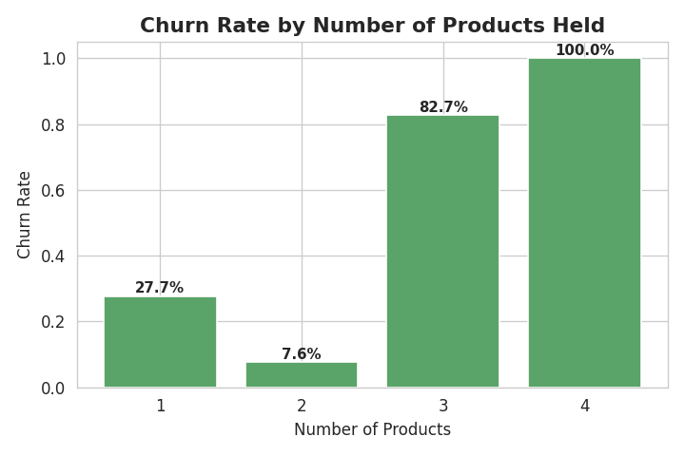
Customers holding 3–4 products churn at 83–100%, versus 8% for customers holding 2 — a strong signal of product-fit or fee dissatisfaction rather than loyalty.
- Germany shows a churn rate of 32.4%, roughly double France and Spain — suggesting market-specific service or pricing gaps worth regulatory attention.
- Customers aged 45–65 and disengaged (inactive) customers are disproportionately likely to churn, pointing to life-stage transitions and lapsed engagement as key risk windows.

Recommendation
We recommend banks adopt risk-based, proactive retention practices informed by transparent, explainable models such as this one — prioritizing outreach to customers flagged as high-risk, auditing product bundles associated with high churn, and monitoring geographic disparities in customer outcomes as part of ongoing consumer-protection oversight.

