# **Topic:** Northwest University Police Department (UPD)

**Section:** 44664-01

**Team name**: Bearcats

**Team members**:

1. Harika Naidu
2. Mouni Krishna Atluri
3. Rahul Reddy Dayam
4. Srujana Gattu
5. Vipul Chandoor

**Team logo**:



# Requirements Analysis:

**Ascertain user needs:**

* In This Website, the user can able to purchase the parking lots in the Northwest Missouri State University.
* The user can know the offers provided by the Northwest University Police Department and the users can contact the department police peoples without getting registered to the website
* The customer is allowed to edit his profile on the website
* They can also check and pay parking and traffic violation tickets.
* The user need to register and need to login before accessing the website for purchasing parking lots and to check/pay tickets.

**Ensure Reliability:**

* All the users personal details, credit/debit card details to pay the bills and are kept confidential
* User is allowed to use the website any number of times.
* All the users are authorized by the admin so that un-authorized users cannot access the websites.

**Promote Standardization, Integrity, Portability and Consistency:**

* The Total website follows consistency in fonts, colors and can navigation form one page to another page.
* The website is portable and can accessible through different browsers anytime.

**Budget and Time:**

* The final date for the project completion is April 26, 2019 before 5 PM.
* Cost of the project is approximately 100 dollars.

# Functional Requirements:

**Users:**

* Users should be able to register in the website.
* Users should be able to login into the website if she/he already registered.
* Users should be able to view the list purchase parking lots available and offers provided by the University Police Department.
* Users should be able to purchase/ block available parking lots.
* The user must be able to make the payment using different payment options for blocked parking lots and parking/traffic violation tickets.
* User should be able to view payment history with all the details about the parking lots and parking/traffic violation tickets.
* Users should be able to report complaints.

**Administrator:**

* Admin should be able to login to the website.
* Admin should be able to approve and assign parking requests from users.
* Admin can view details of a user by entering the user ID.
* Admin can view/add/remove/edit the details of the parking slots.
* Admin should be able to view complaints.

# ER Diagram:

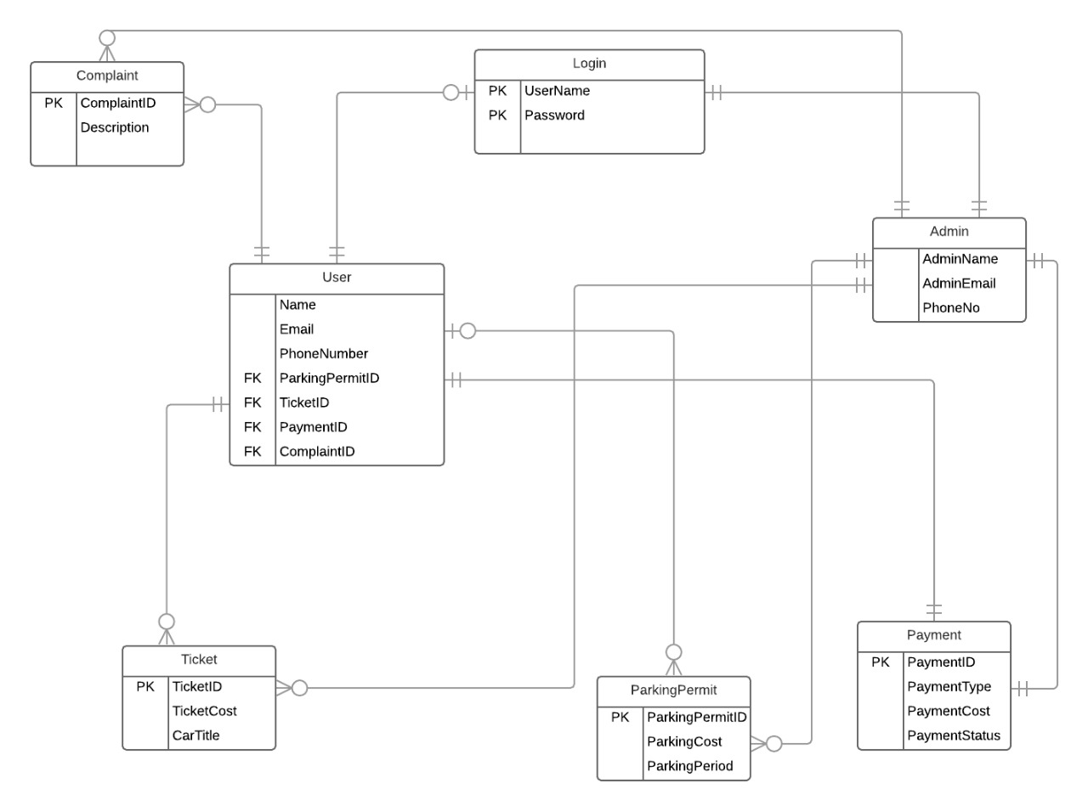

# Prototype:

Please Click on below link for moqups.

<https://app.moqups.com/TxEAwTzWh7/view/page/ab0555010>

# Task descriptions/ Usability Testing:

1. Customers can reserve Parking slots - Customers should be able to reserve parking slots on particular date for different timings.
2. User offers: Users can book parking lots and can check and pay parking/traffic violation tickets.
3. Contact Page: We also have a contact page for user if he have any queries.
4. User Login Page: Users can login to their account by signing up and logging into their account. Check user has successfully logged in successfully or not.
5. User Logout Page: Whenever the user want to leave the website or want to login from another account. Click on logout to successfully log out. Check user has successfully logged out successfully or not.
6. User Registration Page: Users fill the form by entering details like a name, email_id, and password. If details like username, email_id exists, then the user enters new one, otherwise is will shows a pop of entered field are already exit. Check user has successfully registered successfully or not.
7. Admin Home Page: Admin can see all users and their details in that page.
8. Admin adding users: Admin can add new users.
9. Admin can add new Parking slots: Admin can be able to see or add new parking slots for users so that they can view and book the slots.
10. User Booking Parking lots: User can be able to see the available parking slots and book them for some particular date and time. Check whether user can successfully select the parking lot or not.
11. Confirming Booking Parking lots: After redirecting to next page when click on book it will redirect to next page asking you plan or time, then it shows amount for booking that slot.
12. Parking/traffic violation tickets: In this page the user can able to see the fine that he/ she need to pay because of the violation tickets with a payment button.
13. Redirecting to payment: It asks you how you are paying with and redirect to next step.
14. Users Payment History: Booking slots for certain users are shown in payments button at Users home.

|  |  |  |
| --- | --- | --- |
| **Usability measures** | **How we plan to quantify** | **Formula** |
| Learnability | How to make it easy for users to accomplish basic functionalities when they encounter the design for first time. |  |
| Efficiency | Once the user has signed up and used the website for certain amount of time. Should note how quickly they are performing their tasks. For example: user can be able to book parking slot easily. | Task Time = End Time – Start Time |
| Rate of errors by users | This is determined when attempting to complete a task. In this website, user is notified if they didn’t enter correct credentials. | (Number of errors / Time taken to complete the task) |
| Retention over time | This determines about the proficiency of website. When users return to the design after a period of not using it is it do they need to reestablish it. For example in they can be able to see their registration details any time by just refreshing the page. |  |
| Subjective Satisfaction | Users should be satisfied by interface. It is measured through standardized satisfaction questionnaires after each task or each session. Feedbacks and contact pages are used for this in the website. | Use a Likert scale |

# Usability Measures:

# Informed Consent:

**To whomever it may concern**

1. I have freely volunteered to participate in this usability testing.
2. I have been informed in advance about what my task(s) will be and what procedures that I must follow.
3. I have been given the opportunity to ask questions before or during the test.
4. I have been told that I have the right to withdraw consent and to abort participation at any time, without prejudice to my future treatment.
5. My signature below can be taken as affirmation of all the above statements; it was given prior to my participation.

Harika Naidu 04/07/2019

Mouni Krishna Atluri 04/07/2019

Rahul Reddy Dayam 04/07/2019

Srujana Gattu 04/07/2019

Vipul Chandoor 04/07/2019

(SIGNATURE) (DATE)