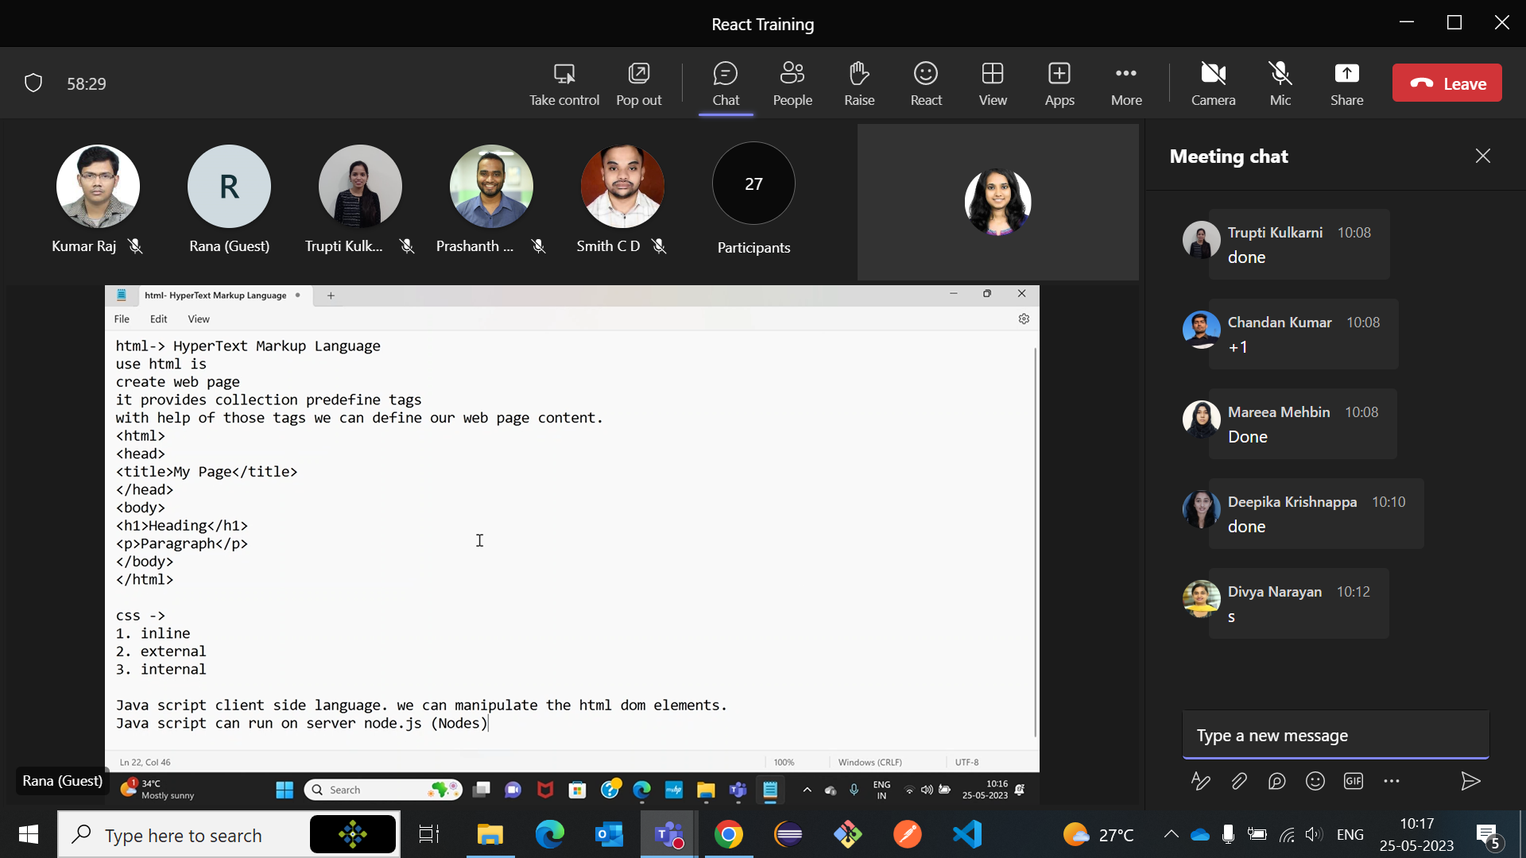

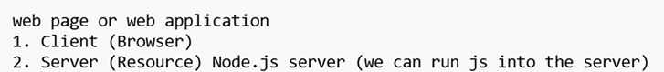

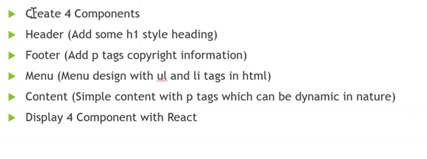

React

JavaScript framework