The crmflx code estimates an ion flux value at a satellite position of a given magnetic activity KP index based on the preset ion flax maps. The code was originally written in a FORTRAN in early 2000s. Since no one was maintaining it, the MTA group decided to rewrite it in PYTHON (v.3.6) so that it is easier to maintain in the future.

CRM Flux Computation Steps
The steps to compute Chandra specific ion fluxes are described below. Note that the original code was designed to accommodate various cases, but we shortened the code to speed up the computation.

1. Read a KP value and GSM coordinates of the satellite.
2. Convert the GSM coordinates to the Geotail aligned coordinates.
3. Find which regions (Solar Wind, Magnetosheath, Magnetosphere) the satellite is located.
4. If the satellite is in the Solar Wind region, the estimated flux is zero.
* We do not use the flux data in the solar wind region (the outside of the bowshock), and the
flux values are set to zero in this script.
5. If the satellite is in the Magonetosheath, go to the Page 2.
6. If the satellite is in the Magnetosphere, go to page 3.

Figure 1a: CRM Flux Computation Step: Beginning
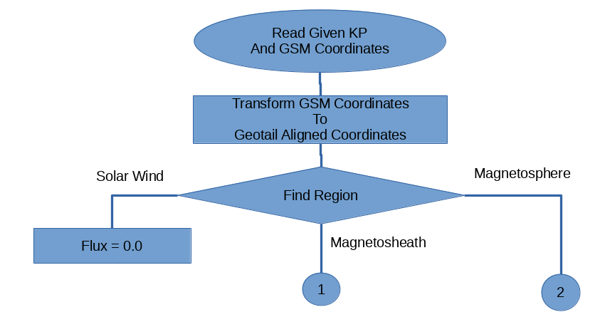
Ion Flux Model Data File contains:
* cell positions in x, y, z between -30 and 30 with an increment of one Earth radius at the center of the Earth as (0, 0, 0).
* nine average flux values of different KP values between 1 and 9.
* numbers of non-zero flux values used to compute the average flux values in each cell of different KP values between 1 and 9.
Notes:
* It seems that the model data tables were created with Tsyganenko's geopack.f, but we cannot confirm that. If it is true, since the geopack.f and its parameter files were updated recently, our data files are probably out of date.
Magnetosheath
If the satellite is in the magnetosheath:
1. Compute a scaling factor.
* divide the region into four sectors
* compute a scaling factor of each sector based on the KP value given
* find the distance to each sector from the satellite position
* order them from the nearest to the farthest
* compute a distance weighted scaling factor based on the scaling factors from all sectors

2. Determine how far the flux cell data should be included in the z-direction based on x value in the geotail aligned coordinates.

3. Compute an average flux.
* from magnetosheath model ion flux database, collect the flux cell data around the satellite
* collect all cells inside of the predetermined distance from the satellite position
* collect flux values and take an average of the fluxes

4. Compute the scaled flux
* multiply the scaling factor from step 1 to the averaged flux value from step 3 to estimate the final flux.

Figure1b: CRM Flux Computation Step: Magnetosheath
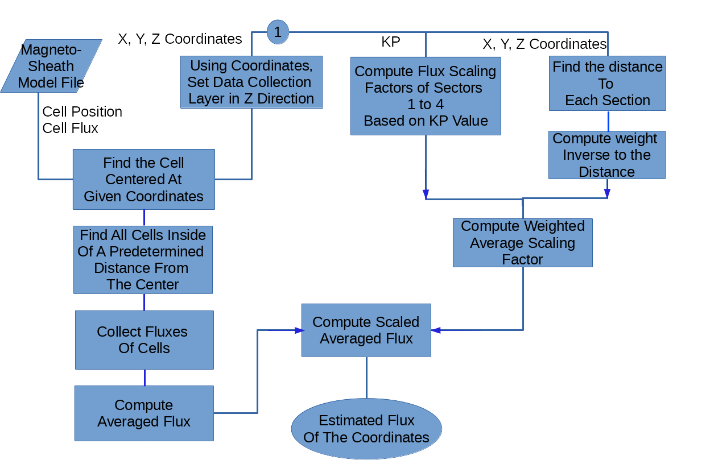

Magnetosphere
If the satellite is in the magnetosphere:
1. Compute a scaling factor.
* divide the region into ten sectors
* compute a scaling factor of each sector based on the KP value given
* find the distance to each sector from the satellite position
* order them from the nearest to the farthest
* compute a distance weighted scaling factor based on the scaling factors from all sectors

2. Read data and set a cell region.
* from magnetosphere database, collect the flux cell data around the satellite

3. If x coordinate in the geotail is in the head side or less than 8 Earth radii in the tail side:
* use all available fluxes.
* find all cells closer than the predetermined distances
* collect fluxes from the cells and compute the averaged flux

Figure1c: CRM Flux Computation Step: Magnetosphere
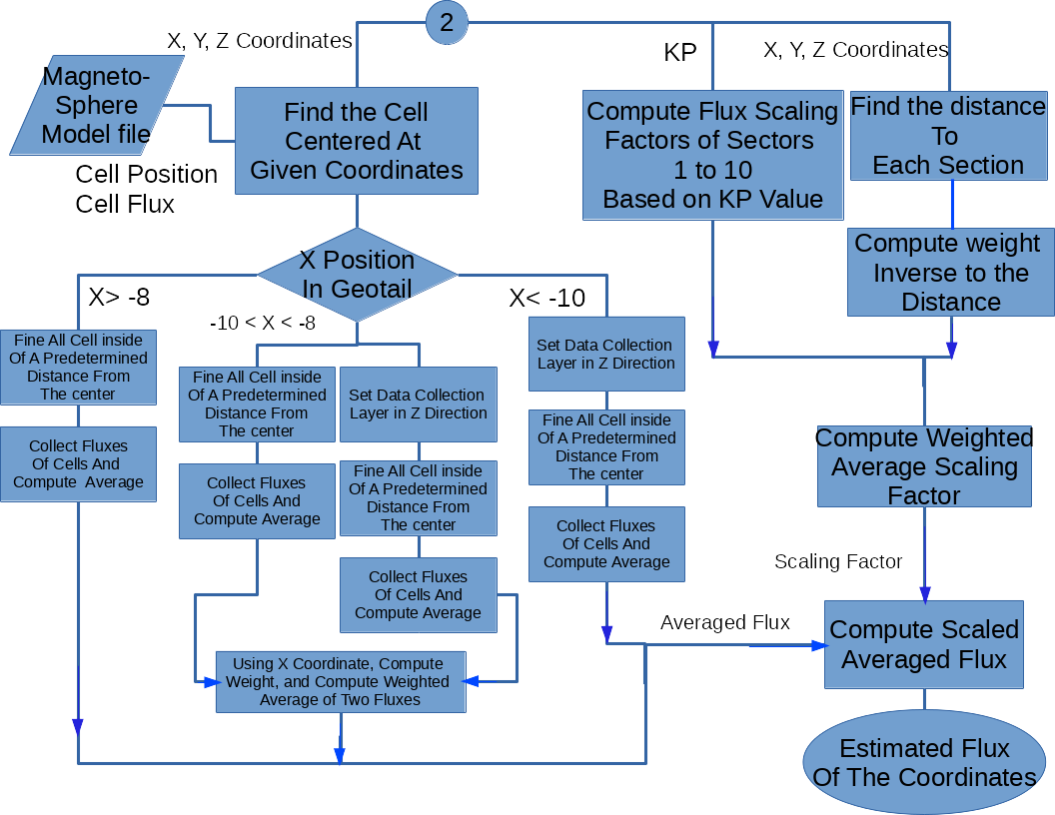

4. If the satellite is located beyond 10 radii in the tail side:
* determine a layer in the z direction where we collect data cell
* find all cells closer than the predetermined distances in that layer
* collect fluxes from the cells and compute the averaged flux

5. If the the satellite is between 8 and 10 radii in the tail side:
* compute fluxes with the both step 3 and step 4 so we have two flux values.
* compute weights for the fluxes depending of the satellite x position in the geotail
* compute the weighted average of two flux values.

6. Using the averaged flux from either step 3, 4, or 5, and the averaged scaling factor from step 1, compute the final estimated ion flux.

How to Speed Up the PYTHON Script

The PYTHON script, which was directly translated from the FORTRAN code, took nearly sixty minutes to compute the entire CRM data set (FORTRAN code takes less than one minute.) To shorten the computation time, the following changes are made.

* When possible/useful, NumPy arrays are used which assign the memory space and speed up the computation.

* The original FORTRAN code is designed to take many options. We streamlined the code and left only essential for our needs. This reduced many condition statements and loops which could slow down the computation.

* The model data in the data table files were mostly null data. We removed them from the data file, and let the script read only valid data. This reduced the computation time slightly.

The above modifications did not speed up the code much; however, the following two steps significantly improved the computation time.

* The code is compiled with Cython. The computation time is reduced to fifteen minutes.

Reference: https://cython.readthedocs.io/en/latest/src/tutorial/cython_tutorial.html

* Use of "typed memoryview." The script spends the majority of time in two functions. By assigning typed memoryviews to the variables in these two functions, the computation time is reduced to three minutes.

Reference:: https://cython.readthedocs.io/en/latest/src/userguide/memoryviews.html

* We tried typed memoryviews in the other functions in the code, but it did not reduce the computation time any farther, or it actually increased the computation time in some other instances.

The Flux Discrepancy in the Magnetosphere between the FORTRAN Code and the PYTHON Code

When computing the fluxes in the magnetosphere, there are some discrepancies between values calculated by the FORTRAN code and those by the PYTHON code (Figure 3). It is because the FORTRAN code often misses collecting the flux values in the outer area.

The algorithm of the FORTRAN code to compute the flux is the following.

1. In the flux map of n by n by n 3D binned space, locate the satellite position.
2. Start accumulating the flux from the nearest bin to the satellite position.
3. Increment step 1 in one of the three directions and find the distance to the cell.
4. If the distance is smaller than the predetermined distance, add the flux.
5. If the distance is larger than the predetermined distance, stop.

The problem is step 5. Please see the Figure 2 below. In this 2D surface, the satellite is located at the bin (0, 0) and supposed to accumulate all flux values in the bins covered by the gray circle (predetermined distance from the center).

The algorithm checks (0, 1), (0, -1), (1, 0), (-1, 0), then moves to check (0, 2), (0,-2) etc. However, once it reaches the -2/2 region, the problem happens. The code checks (0, -2), (-1, -2), (1, -2), but when it reaches (-2, -2), which is outside of the predetermined distance, it stops accumulating the fluxes. However, there are still some other bins (e.g.,(0, 2), (-1, 2)) which are inside of the predetermined distances.

The PYTHON version fixes this deficiency and covers all bins under the predetermined distance by checking region much farther than the predetermined distance, but only collecting fluxes from the cells inside of the predetermined distance.

Figure 2: Binning Example
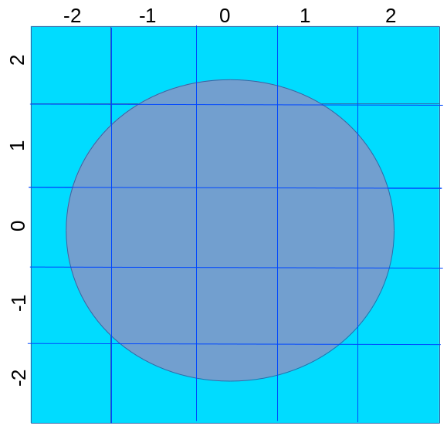

Let's see the computation in the actual codes.

Table 1 shows the functions compute magnetosphere ion fluxes. The left side shows the FORTRAN code, and the right side shows the PYTHON code.

The first difference between the two codes is introduced in lines 8-11 in both codes. The values ioffset/joffsee/koffset are the bins in the previous example, and sorted in order of the distance from the center (0, 0, 0). However, since the sorting algorithms are different between two codes, the order of the offsets are different.

Please see the first several lines of Table 2, which shows the outputs from these two codes. The left side is the output from the FORTRAN code, and the right side is from the PYTHON code. X, Y, Z are the values of ioffset, joffset, and koffset.

As you can see, X, Y, Z values appear in different orders, and the order of flux values collected are different between the two codes.

The second difference comes in while collecting the ion flux values from the cells. The two codes use the same criteria (rngabs <4.0) to collect the flux values (lines 23-25 in FORTRAN / lines 29-31 in PYTHON). Steps are:

1. Compute the distance from the center to the cell (dist).
2. Compute the difference between the distance and the minimum distance (rngabs). The minimum distance is the first entry of the table.
3. If rngabs is smaller than then criteria (4.0), include the flux of the cell in the computation.

However, in the codes, these steps are implemented differently . Please see red highlighted lines.

At line 33 of the FORTRAN code, if the rngabs value is found to be larger than the criteria (4.0), the code stops collecting fluxes.

In PYTHON, even if the rngabs exceeds the criteria, it keeps looking for more cells (lines 52-54) to ensure that all cells with rngabs value smaller than the criteria are included.

Please see Table 2 again.

In FORTRAN code, the code stops collecting the flux at N=287 as rngabs value (4.09) exceeds 4.0 (red highlighted entries.) If we do the same in PYTHON code, it stops at N=269. Notice that flux values of N=266, 269 in FORTRAN output are not included in the PYTHON output, if the PYTHON code stops collecting fluxes at the first time when the rngabs exceeds the criteria (see blue highlighted entries).

(N value is the index of the flattened 3D space, but it is not essential for this discussion and think it as an ID of the flux cell. Note, FORTRAN starts at 1, but PYTHON begins at 0).

To make sure to include all fluxes inside of the criteria, PYTHON code searches farther and finds several more flux cells that meet the criteria (green highlighted entries). The FORTRAN code misses these fluxes.

Figure 3 shows fluxes computed by FORTRAN (blue) and those by PYTHON (red) in the magnetosphere region. The top figure is the case when the PYTHON stops collecting flux values at the first time when the rngabs value exceeds the criteria. The second figure shows that the PYTHON code keeps looking for the flux values until the father distance criteria is met.

Note that, since the different algorithm is used, this type of discrepancy does not happen in the computation of fluxes in the magnetosheath region (see Figure 4).

Table 1: Magnetosphere Computation in FORTRAN and PYTHON

FORTRAN FLXDAT_MAP_Z  01: indx = int((xgsm - xmin)/xinc) + 1  02: indy = int((ygsm - ymin)/yinc) + 1  03: indz = int((zgsm - zmin)/zinc) + 1  04:c  05: rngcell = 1.e+25  06: numcell = 0  07:c  08: do i = 1,nsphvol  09: ii = indx + ioffset(i)  10: jj = indy + joffset(i)  11: kk = indz + koffset(i)  12: if ((ii.ge.1).and.(jj.ge.1).and.(kk.ge.1).and.(ii.le.maxnum)  13: $ .and.(jj.le.maxnum).and.(kk.le.maxnum)) then  14: indexnow = imapindx(ikp,ii,jj,kk)  15: if(indexnow.gt.0) then  16: fve = fluxbin(ikp,indexnow)  17:c  18: if(fve .gt.0.) then  19: zve = zflux(ikp,indexnow)  20: if((zve.ge.zcklo).and.(zve.le.zckhi)) then  21: xve = xflux(ikp,indexnow)  22: yve = yflux(ikp,indexnow)  23: rng = sqrt((xve-xgsm)**2 + (yve-ygsm)**2 + (zve-zgsm)**2)  24: rngdiff = rng - rngcell  25: rngabs = abs(rngdiff)  26: if(numcell.eq.0) then  27:c there is a new nearest neighbor data cell.  28: numcell = 1  29: rngcell = rng  30: flxsto(1) = fve  31: numsto(1) = numbin(ikp,indexnow)  32: else  33: if(rngabs.le.rngchk) then  34:c there is a new data cell within the range  35:c tolerance to the nearest neighbor. this cell's flux  36:c should be included in the average for this location.  37: numcell = numcell + 1  38: flxsto(numcell) = fve  39: numsto(numcell) = numbin(ikp,indexnow)  40: if(numcell.eq.maxcell) go to 1000  41: else  42: go to 1000  43: end if  44: end if  45: end if  46: end if  47: end if  48: end if  49: end do  50:c  51:1000 continue  52:c  53:c use the average of the flux from all bins at the same distance.  54:c  55: flux = 0.  56: avgnum = 0.  57: if(numcell.eq.1) then  58: flux = flxsto(1)  59: avgnum = float(numsto(1))  60: else if(numcell.gt.1) then  61: numavg = 0  62: do i = 1,numcell  63: flux = flux + flxsto(i)  64: numavg = numavg + numsto(i)  65: end do  66: flux = flux/float(numcell)  67: avgnum = float(numavg)/float(numcell)  68: end if  69:c  70: return  71: end | PYTHON FLXDAT_MAP(_Z)  01: rngcell = 1.0e25  02: numcell = 0  03:#  04:#-- give extra margin on rngchk so that most of the neighbors are included  05:#  06: rngchk2 = 1.20 * rngchk  07:  08: for n in range(0, nsphvol):  09: i = indx + ioffset[n]  10: j = indy + joffset[n]  11: k = indz + koffset[n]  12: if (i >= 0) and (j >= 0) and (k >= 0)\  13: and (i < maxnum) and (j < maxnum) and (k < maxnum):  14: indexnow = imapindx[i][j][k]  15:  16: if indexnow >= 0:  17: zve = zflux[indexnow]  18:#  19:#--- for the map_z, extra check is required  20:#  21: if zchk > 0:  22: if (zve < zcklo) or (zve > zckhi):  23: continue  24:  25: fve = fluxbin[indexnow]  26: xve = xflux[indexnow]  27: yve = yflux[indexnow]  28:  29: rng = compute_rng(xve, yve, zve, xgsm, ygsm, zgsm)  30: rngdiff = rng - rngcell  31: rngabs = abs(rngdiff)  32:#  33:#--- there is a new nearest neighbor data cell  34:#  35: if numcell == 0:  36: flxsto[numcell] = fve  37: numsto[numcell] = numbin[indexnow]  38: numcell = 1  39: rngcell = rng  40:#  41:#--- there is a new data cell within the range tolerance to the nearest neighbor.  42:#--- this cell's flux should be included in the average for this location.  43:#  44: else:  45: if rngabs <= rngchk:  46: flxsto[numcell] = fve  47: numsto[numcell] = numbin[indexnow]  48: numcell += 1  49:  50: if numcell > maxcell-1:  51: break  52: else:  53: if rngabs > rngchk2:  54: break  55:#  56:#--- use the average of the flux from all bins at the same distance  57:#  58: if numcell == 0:  59: flux = 0.0  60: avgnum = 0.0  61: rngcell = 0.0  62:  63: elif numcell == 1:  64: flux = flxsto[0]  65: avgnum = float(numsto[0])  66:  67: elif numcell > 1:  68: flux = numpy.mean(flxsto[:numcell])  69: avgnum = numpy.mean(numsto[:numcell])  70:  71: return flux, avgnum, rngcell, numcell

Table 2: Output from FORTRAN and PYTHON Codes

FORTRAN Output  N x y z flux dist rngabs  1 0 0 0 70.0400009 0.47384930 0.0  3 1 0 0 497.799988 1.33221877 0.85836947  4 0 1 0 1160.00000 1.41181505 0.93796575  6 0 -1 0 27.3500004 0.67516255 0.20131328  7 -1 0 0 59.8600006 0.82113289 0.34728363  9 -1 -1 0 25.5799999 0.95161473 0.47776547  12 -1 1 0 67.3799973 1.56299329 1.08914399  17 1 1 0 127.500000 1.88241756 1.40856826  19 1 -1 0 95.4100037 1.41637504 0.94252574  28 -2 0 0 68.8399963 1.76747990 1.29363060  29 0 -2 0 36.5499992 1.63925457 1.16540527  31 0 2 0 1514.00000 2.40039778 1.92654848  41 -1 -2 0 9.99199963 1.77112448 1.29727519  42 1 -2 0 102.900002 2.05850172 1.58465242  44 -2 -1 0 29.7800007 1.83174682 1.35789752  45 -2 1 0 45.4300003 2.21193886 1.73808956  53 -1 2 0 1441.00000 2.49231529 2.01846600  55 1 2 0 82.8099976 2.70410490 2.23025560  82 2 2 0 79.0800018 3.29582429 2.82197499  88 -2 -2 0 31.4799995 2.36360073 1.88975143  90 -2 2 0 681.500000 2.94301915 2.46916986  100 0 -3 0 26.8600006 2.63029790 2.15644860  105 0 3 0 67.9899979 3.39567375 2.92182446  107 -3 0 0 17.7500000 2.75203776 2.27818847  130 -1 3 0 51.7700005 3.46126080 2.98741150  133 1 -3 0 20.1299992 2.91011000 2.43626070  137 -3 -1 0 30.6399994 2.79374695 2.31989765  140 1 3 0 59.7099991 3.61674905 3.14289975  142 -3 1 0 49.9799995 3.05653381 2.58268452  147 -1 -3 0 35.6300011 2.71444154 2.24059224  184 -3 2 0 563.799988 3.62092352 3.14707422  187 2 3 0 70.0599976 4.07813025 3.60428095  193 -2 3 0 32.3100014 3.79869080 3.32484150  253 0 4 0 72.4899979 4.39309502 3.91924572  257 -4 0 0 53.5299988 3.74478793 3.27093863  263 -1 -4 0 31.9200001 3.68775058 3.21390128  266 -1 4 0 14.0500002 4.44398594 3.97013664  269 -4 -1 0 15.8400002 3.77554631 3.30169702  284 -4 1 0 41.6899986 3.97393084 3.50008154  287 1 4 0 70.4400024 4.56613159 4.09228230  flux: 192.575165 | PYTHON Output  N x y z flux dist rngabs  0 0 0 0 70.04000 0.47385 0.0  1 1 0 0 497.8000 1.33222 0.85837  2 -1 0 0 59.86000 0.82113 0.34728  3 0 1 0 1160.000 1.41182 0.93797  6 0 -1 0 27.35000 0.67516 0.20131  9 1 -1 0 95.41000 1.41638 0.94253  14 -1 1 0 67.38000 1.56299 1.08914  17 -1 -1 0 25.58000 0.95161 0.47776  18 1 1 0 127.5000 1.88242 1.40857  29 0 -2 0 36.55000 1.63925 1.16540  30 0 2 0 1514.000 2.40040 1.92655  31 -2 0 0 68.84000 1.76748 1.29363  35 -1 2 0 1441.000 2.49232 2.01847  42 1 2 0 82.81000 2.70411 2.23026  45 -2 1 0 45.43000 2.21194 1.73809  46 -2 -1 0 29.78000 1.83175 1.35790  47 -1 -2 0 9.992000 1.77112 1.29727  55 1 -2 0 102.9000 2.05850 1.58465  82 -2 2 0 681.5000 2.94302 2.46917  86 2 2 0 79.08000 3.29583 2.82198  87 -2 -2 0 31.48000 2.36360 1.88975  93 0 -3 0 26.86000 2.63030 2.15645  104 0 3 0 67.99000 3.39567 2.92182  112 -3 0 0 17.75000 2.75204 2.27819  124 1 -3 0 20.13000 2.91011 2.43626  132 -1 3 0 51.77000 3.46126 2.98741  133 -3 -1 0 30.64000 2.79375 2.31990  135 -1 -3 0 35.63000 2.71444 2.24059  136 -3 1 0 49.98000 3.05653 2.58268  138 1 3 0 59.71000 3.61675 3.14290  191 2 3 0 70.06000 4.07813 3.60428  192 -3 2 0 563.8000 3.62092 3.14707  201 -2 3 0 32.31000 3.79869 3.32484  253 -4 0 0 53.53000 3.74479 3.27094  254 0 4 0 72.49000 4.39310 3.91925  265 -1 -4 0 31.92000 3.68775 3.21390  268 -4 1 0 41.69000 3.97393 3.50008  269 1 4 0 70.44000 4.56613 4.09228  270 -1 4 0 14.05000 4.44399 3.97014  272 -4 -1 0 15.84000 3.77555 3.30170  294 1 -4 0 164.3000 3.83406 3.36022  320 -3 -3 0 19.27000 3.77725 3.30340  325 -3 3 0 19.95000 4.34509 3.87124  366 2 4 0 2862.000 4.93962 4.46577  368 -4 -2 0 17.25000 4.06030 3.58645  369 -4 2 0 1247.000 4.42276 3.94891  387 -2 4 0 29.42000 4.71155 4.23770  485 0 -5 0 31.83000 4.62397 4.15012  486 -4 3 0 694.3000 5.03284 4.55899  487 0 5 0 4057.000 5.39147 4.91762  flux: 204.0500

Figure 3: Flux Comparison between FORTRAN and PYTHON: Before and After PYTHON Code modification
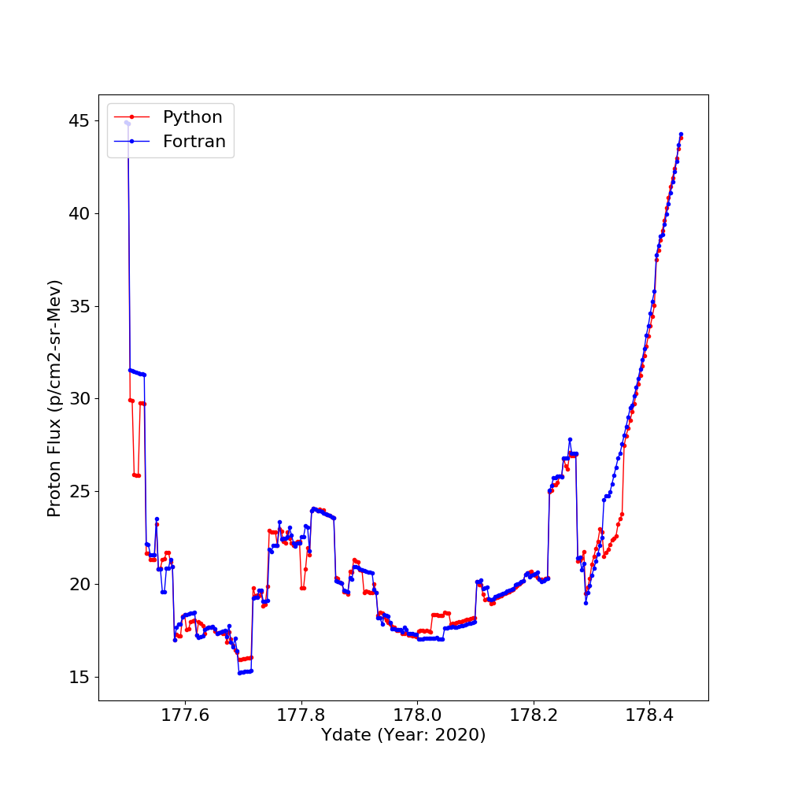

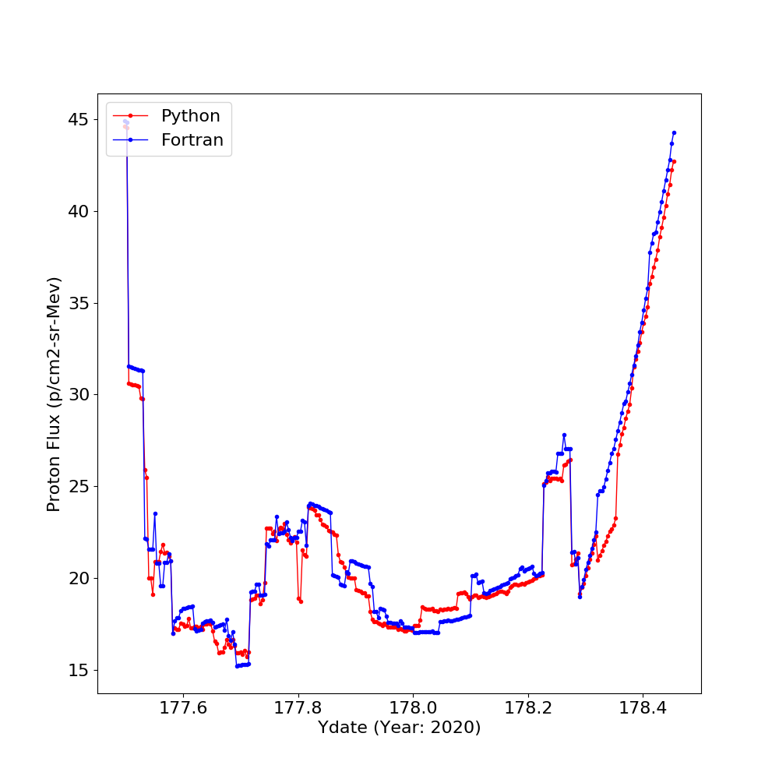

Figure 4: Flux Comparison of FORTRAN and PYTHON: Magnetosheath
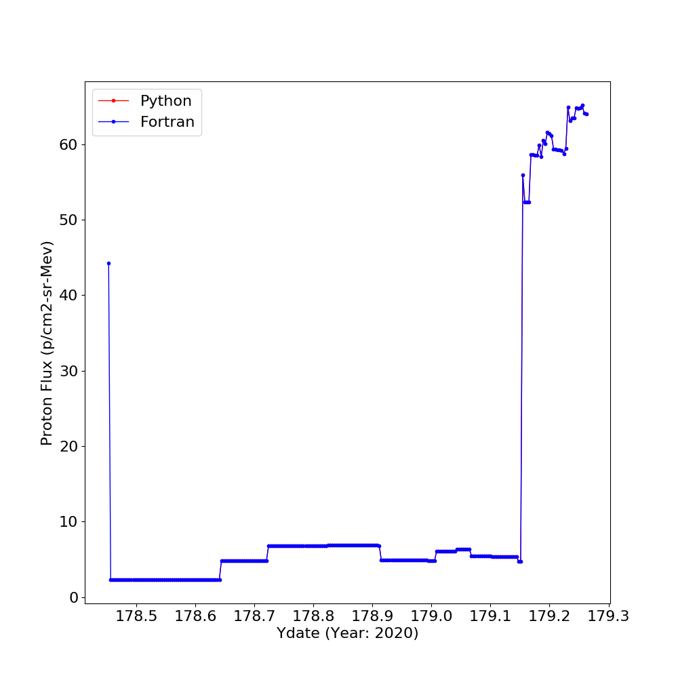

The Script Details

runcrmf.py:
==========
This is a control PYTHON code. It reads the model data files, EPHEM data in GSM coordinates, and sets up KP values.
It calls swinit, mshinit, and mspinit (from crmflx.py), and run the main function crmflx (from crmflx.py)

crmflx.pyx
==========

crmflx:
-------
the primary function to calculates the ion flux as a function of the magnetic activity kp index.
main inputs: (X, Y, Z) GSM coordinates of the satellite
KP index
Magnetsheath data table
Magnetosphere data table
Data table binning map

output: ion flux at the GSM coordinates

function used: locreg --- identify which region the satellite is in
scalkp2 --- collect data from sections in the magnetosheath
nbrflux --- compute the ion flux in the magnetosheath
scalkp3 --- collect data from sections in the magnetosphere
nbrflux_map_z --- compute the ion flux in the magnetosphere

mspinit:
--------
read magnetosphere database
mshinit:
--------
read magnetosheath database
swinit:
-------
read solar wind database

output: cell positions in x, y, z between -30 and 30 with an increment of one Earth radius at the center of the Earth as (0, 0, 0).
average flux value of each cell of different KP values between 1 and 9.
numbers of non-zero flux values used to compute the average flux in each cell of different KP values between 1 and 9.

function used: read_init_data_file --- read the data

mapsphere:
----------
finds the (i,j,k) index offset values used to define the search volume for the near-neighbor flux

input: step and step sizes
output: sets of offset in x, y, z coordinates

logreg:
------
determines which phenomenological region the spacecraft is in

input: KP value
GSM coordinates of the satellite

output: id to indicate in which region the satellite is in
x, y, z coordinates in the geotail system.

function used: solwnd --- set solar wind parameters
rog8ang --- rotate coordinates
locate --- defines the position of a point at the model magnetopause
bowshk2 --- give the bow shock radius, at a given x

solwind:
-------
set solar wind parameters

input: KP value
output: a set of solar wind parameters for the given KP value

bowshk2:
-------
give the bow shock radius, at a given x

input: a set of solar wind parameters given by "solwind" function
output: cylindrical radius of the bow shock

function used: fast --- local fast magnetosonic speed

fast:
----
local fast magnetosonic speed

input: a set of solar wind parameters
output: local fast magnetosonic speed

locate:
-------
defines the position of a point at the model magnetopause

input: gsm coordinates
solar wind proton density/ram pressure/velocity

output: coordinates of a point at the magnetopause

function used: compute_rng --- compute a distance between two points

nbrflux:
--------
provides the region's ion flux as a function of k

input: sector information
geotail coordinates
data tables
output: estimated flux

function used: neighbr --- the nearest neighbors to the point
wtscal --- compute weighted scaling factors
zbinner --- find which z layer we should collect data
flxdat1 --- finds the flux corresponding to the satellite's position

flxdat1
-------
finds the flux corresponding to the satellite's position (magnetosheath)

input: satellite coordinates
data table
range in the z-direction of data collection
output: flux

function used: comput_rng --- compute a distance between two points

nbrflux_map_z:
--------------
provides the region's ion flux as a function of k
this function is used magnetosphere computation and requires distinguishing where in the geotail the satellite is located. See the algorithm page for more details.

input: sector information
geotail coordinates
data tables
output: estimated flux

function used: neighbr --- the nearest neighbors to the point
wtscal --- compute weighted scaling factors
zbinner --- find which z layer we should collect data
flxdat1_map --- finds the flux corresponding to the satellite's position

flxdat1_map:
------------
finds the flux corresponding to the satellite's position (magnetosphere)

input: satellite coordinates
data table
range in the z-direction of data collection
output: flux

function used: comput_rng --- compute a distance between two points

compute_rng:
compute a distance between two points

input: two coordinates
output: the distance between two coordinate

neighbr:
--------
finds the nearest neighbors from the given location to the sector location

input: satellite x, y coordinates
arrays of sector locations

output: sorted ranking of distance to each sector

rot8ang:
--------
rotates the 2-d vector about its hinge point in the XY-plane

input: angle, x, y, and x value of aberration hinge point

output: computed x, y values

scalkp1:
--------
compute scaling parameters in the solar wind region
scalkp2:
---------
compute scaling parameters in the magnetosheath region
scalkp3:
--------
compute scaling parameters in the magnetosphere region

input: KP value
output: scaling factors

function used: get_scalkp --- compute the scaling factor

get_scalkp:
-----------
compute the scaling factor

input: KP value
a list of section functions (see sectr** below)

output: scaling factors

sectr11 --- sectr13:
--------------------
provide the proton flux against kp scaling for the solar wind region
input: KP value
output: scaling factor

function used: sect_comp --- compute scaling factor for the given sector

sectr21 --- sectr24:
--------------------
provide the proton flux against kp scaling for the magnetosheath region
input: KP value
output: scaling factor

function used: sect_comp --- compute scaling factor for the given sector

sectr31 --- sectr310:
--------------------
provide the proton flux against kp scaling for the magnetosphere region
input: KP value
output: scaling factor

function used: sect_comp --- compute scaling factor for the given sector

sect_comp:
---------
compute scaling factor for given parameters

input: KP values
a parameter list
output: scaling factors

wtscal:
-------
calculates the distance weighted sum of the Kp scaling factors

input: sector information including flux scale factor
distances to each sector

output: distance weighted scaling factor

function used: create_weighted_sum --- calculate a weighted sum

create_weighted_sum:
--------------------
calculate a weighted sum

y_interpolate:
--------------
interpolate the coordinates between two points
input: coordinates of two points
x coordinates of the third point
output: estimated y coordinate

zbinner:
--------
determine the z-layer of the magnetosphere

input: x and z gsm coordinates
output: bottom and top z coordinates

