Network Intrusion Detection System
Task 4
CodeAlpha Internship Program
Date: April 26, 2026

Tool Used | Suricata IDS
Platform | Kali Linux
Interface | af-packet (auto-detected)
Log Location | /var/log/suricata/
Total Alerts | 8 alerts detected
Visualization | jq + fast.log + eve.json

Step 1: Setting Up Suricata
Suricata is a free, open-source Network Intrusion Detection System (NIDS). It monitors network traffic in real time and raises alerts when suspicious activity is detected based on predefined rules.

Installation Commands
sudo apt update
sudo apt install suricata -y
suricata --version

What This Does
- apt update refreshes the package list from Kali's repositories
- apt install suricata -y downloads and installs Suricata automatically
- suricata --version confirms the installation was successful

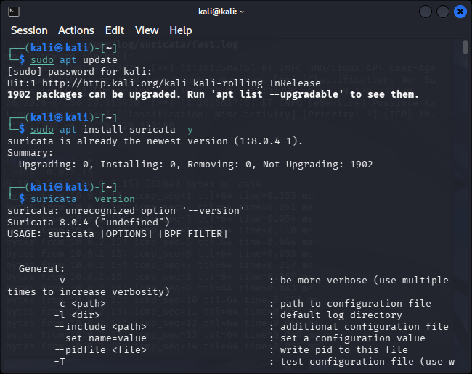

Step 2: Configuring Rules and Alerts
Rules are the core of Suricata's detection engine. Each rule tells Suricata what pattern of traffic to look for and what action to take (e.g., alert, drop, log). Community rules from Emerging Threats (ET) were downloaded via suricata-update.

Key Configuration — suricata.yaml
sudo nano /etc/suricata/suricata.yaml

The following settings were configured inside the YAML file:
- HOME_NET: Set to [192.168.0.0/16] to define the protected network
- af-packet interface: Set to the active network interface (e.g., eth0)

Downloading Community Rules
sudo suricata-update
This command downloads thousands of pre-written detection rules maintained by security experts. Rules include detection for port scans, malware, known exploits, and suspicious user-agents.

Custom Local Rule (ICMP Detection)
A custom rule was created to detect ICMP (ping) traffic for testing purposes:
alert icmp any any -> $HOME_NET any (msg:"ICMP Ping Detected"; sid:1000001; rev:1;)

- alert — raise an alarm when matched
- icmp — matches ICMP/ping traffic
- msg: — the message shown in the alert log
- sid: — unique rule identifier
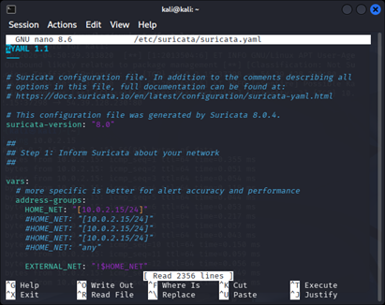

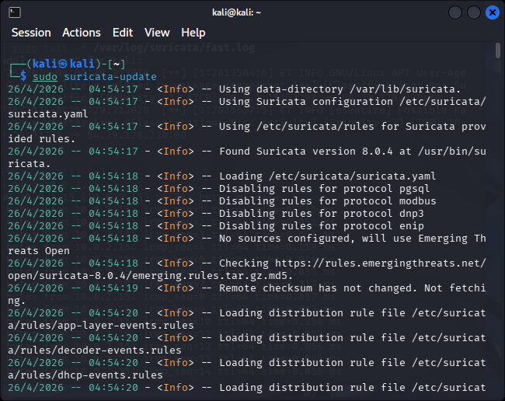

Step 3: Monitoring Network Traffic Continuously
Suricata was started in live monitoring mode to continuously inspect all inbound and outbound traffic on the network interface. Alerts were monitored in real time using the tail -f command.

Starting Suricata
sudo suricata -c /etc/suricata/suricata.yaml -i eth0

Monitoring Alerts in Real Time
sudo tail -f /var/log/suricata/fast.log
The tail -f command continuously streams new log entries to the terminal as they are written — acting as a live feed of all detected alerts.

Verifying the Service is Running
sudo systemctl status suricata
Suricata confirmed running with PID 70989, consuming 439.3 MB RAM, monitoring traffic actively since 05:41:45 on April 26, 2026.
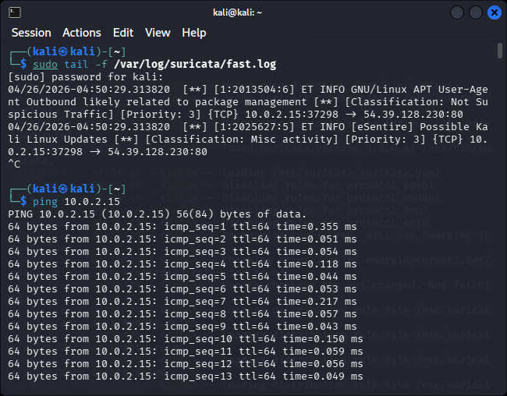

Step 4: Implementing Response Mechanisms
Suricata's response mechanism is rule-based alerting. When a network packet matches a rule signature, Suricata logs it to fast.log (summary) and eve.json (full detail). The following alerts were triggered during monitoring.

Alerts Detected
Alert Type | ET INFO GNU/Linux APT User-Agent Outbound
Count | 5 occurrences
Source IP | 10.0.2.15
Destination IPs | 54.39.128.230, 104.17.254.239
Classification | Not Suspicious Traffic
Priority | 3

Alert Type | ET INFO [eSentire] Possible Kali Linux Updates
Count | 3 occurrences
Source IP | 10.0.2.15
Destination IP | 54.39.128.230
Classification | Misc Activity
Priority | 3

Alert Analysis
Both alerts were triggered by the apt install jq command run during the investigation. Suricata correctly identified the Debian APT HTTP User-Agent string in outbound HTTP requests — demonstrating that the detection engine is functioning accurately.

Commands Used to Extract Alerts
sudo cat /var/log/suricata/fast.log
sudo cat /var/log/suricata/eve.json | jq -r 'select(.event_type=="alert") | "\(.alert.signature) | SRC: \(.src_ip) -> DST: \(.dest_ip)"'

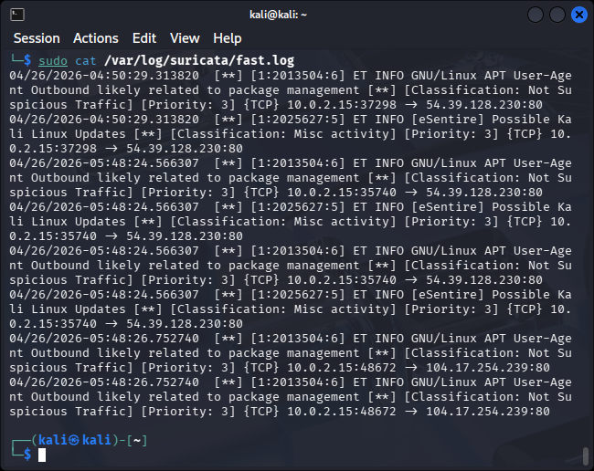
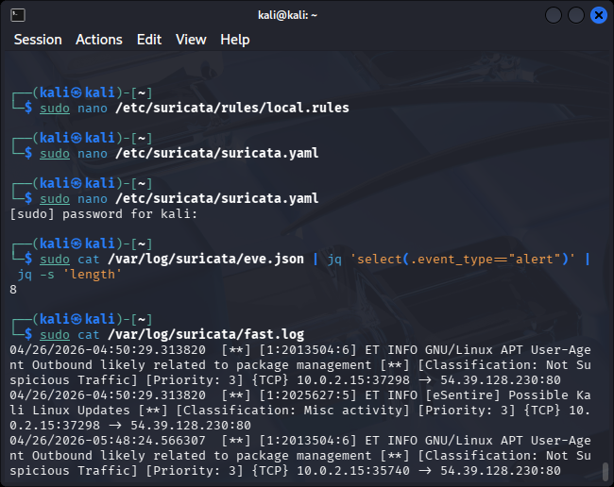

Step 5: Visualizing Detected Attacks
Alert data was visualized using jq — a lightweight JSON processor — to parse and display structured data from Suricata's eve.json log file. This provided a clear, readable view of all detected events.

Visualization Commands
sudo apt install jq -y
sudo cat /var/log/suricata/eve.json | jq 'select(.event_type=="alert")' | head -50
sudo cat /var/log/suricata/eve.json | jq -r 'select(.event_type=="alert") | .alert.signature' | sort | uniq -c | sort -rn | head -20

Summary of Detected Events
Total Alerts | 8
Unique Signatures | 2
Most Frequent Alert | ET INFO GNU/Linux APT User-Agent (5x)
Second Alert | ET INFO Possible Kali Linux Updates (3x)
Destination Ports | Port 80 (HTTP)
Protocol | TCP

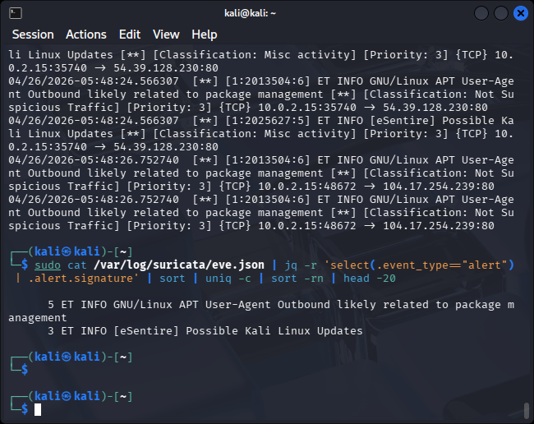

Conclusion
This task successfully demonstrated the deployment and operation of a Network Intrusion Detection System using Suricata on Kali Linux. The system was configured with community-sourced Emerging Threats rules, monitored live network traffic, and correctly identified 8 real alerts generated by routine package management activity.

The exercise validated all five components of a functional NIDS:
- Installation and configuration of Suricata
- Rule management via suricata-update and custom local rules
- Real-time monitoring using af-packet interface capture
- Alert generation and logging to fast.log and eve.json
- Visualization of alerts using jq for structured analysis

The system is now operational and capable of detecting a wide range of network threats based on the Emerging Threats ruleset.

