Dark Site

**Proposed setup**

* One web server with minimum requirements.
* One App server
* Public domain need to setup .

**Current setup:**

Those new servers will be installed at current jobserver at staging.

Current Jobserver in staging capacity details

Storage Details as of 10th Aug 2022 - Need to upgrade

Only 23GB is available as storage.

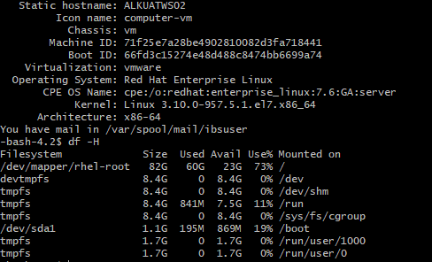

Memory Details as of 10th Aug 2022 - Need to upgrade

Only 8 GB is RAM is left over

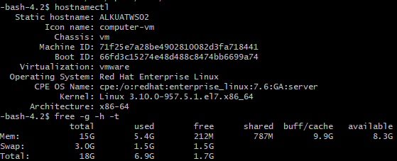

**Current production server capabilities**

|  |  |  |  |  |  |
| --- | --- | --- | --- | --- | --- |
| t3.xlarge | 4 | 96 | 16 | 75GB | Up to 5 |

**App server and Web server:**

16GB Ram

75 GB storage

**Performance for EFS**

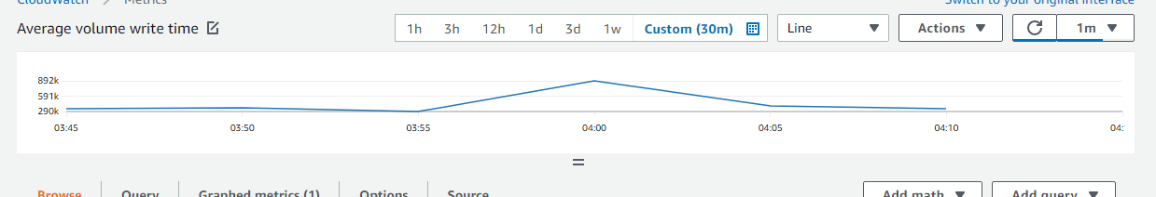

As per analysis in current AWS production environment.

Current EFS (Elastic File System), 83800 bytes or .6704 MB are write per minute in each EFS for both app server and web server.

Steps to setup

* Public domain will not be accessible from this server. Need to check.
* Need to upgrade RAM and Storage
* Test it extensively

On 16th August discussion,

* When AWS site/service is down, from front-end redirecting to EveryMundo Page like
* whenever getting 500 error from browser then redirecting to everymundo by doing code change in front-end.
* While doing redirection, we need to pass a status variable like AWS_UNAVAILABLE to EveryMundo.
* Now the EveryMundo’s flight search page will appear for customer. He/She searches flight and select ‘Search” button.
* Now, Based on status variable, the EveryMundo call new API (Temp_API) (later we can change name) in spring boot application.
* EveryMundo need to do code change by calling new api call (Temp_API) which is dedicated to AWS services is/are down scenario along with all regular parameters.
* Then this call goes to spring boot application.
* The spring boot application which resides in app server create a API called Temp_API with regular parameters.
* Create an application loader HTML page in spring boot application before calling flight search API.
* Now call application will call flight search API with regular parameters.