**Q.1. Write a program to show type conversion in C.**

**Ans.** #include <stdio.h>

int main()

{

int x = 10;

char y = 'a';

x = x + y;

float z = x + 1.0;

printf("x = %d, z = %f", x, z);

return 0;

}

**OUTPUT:**

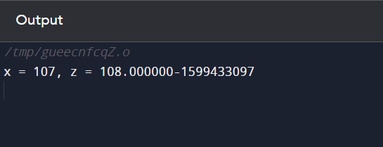

**Q.2. Write a program which show all Mathematics operations in C.**

Ans. #include <stdio.h>

int main()

{

int P, Q;

int sum, sub, mult, mod;

float div;

printf("Enter any two numbers: ");

scanf("%d%d", &P, &Q);

sum = P + Q;

sub = P - Q;

mult = P * Q;

div = (float)P / Q;

mod = P % Q;

printf("SUM = %d\n", sum);

printf("DIFFERENCE = %d\n", sub);

printf("PRODUCT = %d\n", mult);

printf("QUOTIENT = %f\n", div);

printf("MODULUS = %d", mod);

return 0;

}

OUTPUT:

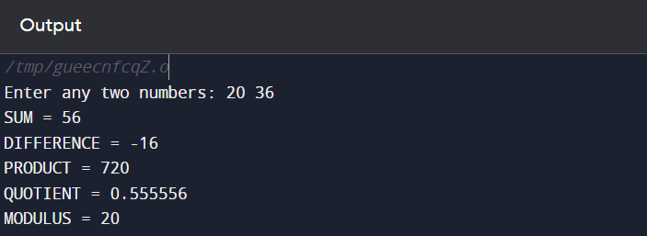

**Q.3. Write a program to multiply two floating point numbers.**

Ans: #include <stdio.h>

int main()

{

float x,y,z;

printf("Enter the first value=");

scanf("%f",&x);

printf("Enter the second value=");

scanf("%f",&y);

z=x*y;

printf("The Multiplication is=%f",z);

return 0;

}

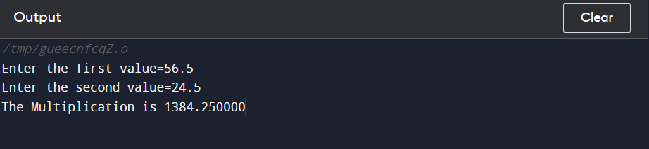

**Q.4. Find the ASCII value of a character in C.**

Ans: #include <stdio.h>

int main()

{

char A;

printf("Enter a charcter=");

scanf("%c",&A);

printf("ASCII value of = %d",A);

return 0;

}

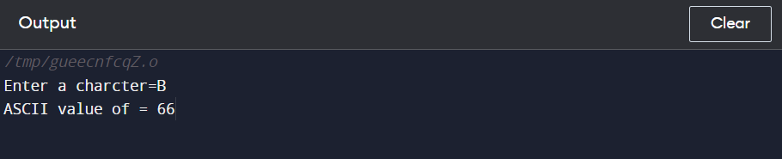

**Q.5. Swapping two no program in C.**

Ans: #include <stdio.h>

int main()

{

int a,b;

printf("Enter the first num=");

scanf("%d",&a);

printf("Enter the second num=");

scanf("%d",&b);

a=b;

printf("The value of a=%d",a);

return 0;

}

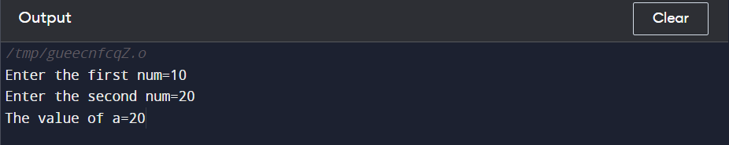

**Q.6. Calculate Simple interest program in C.**

Ans: #include <stdio.h>

int main()

{

float p,r,t,Si;

printf("Enter the principal=");

scanf("%f",&p);

printf("Enter the rate=");

scanf("%f",&r);

printf("Enter the time=");

scanf("%f",&t);

Si=(p*r*t)/100;

printf("Simple Interest is= %f",Si);

return 0;

}

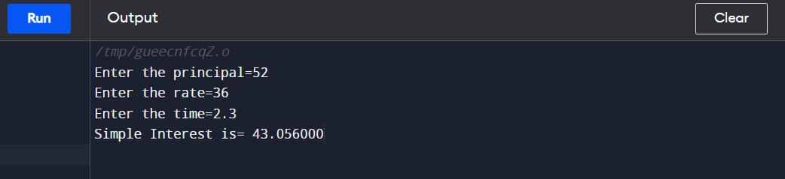

**Q.7. Find parameter and area of a triangle in C.**

Ans: #include <stdio.h>

int main()

{

int b,h,Area;

printf("Enter the base=");

scanf("%d",&b);

printf("Enter the height=");

scanf("%d",&h);

Area=(b*h)/2;

printf("Area of traingle is= %d",Area);

return 0;

}

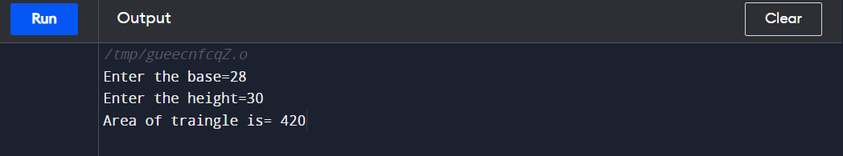

**Q.8. Write a program to check whether a no entered by users in positive, negative or zero.**

Ans: #include <stdio.h>

int main() {

int Num=0;

printf("Enter the number=");

scanf("%d",&Num);

if (Num>0)

{

printf("Number is Positive");

}

else if (Num < 0)

{

printf("Number is Negative");

}

else

{

printf("Number is Zero");

}

return 0;

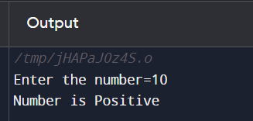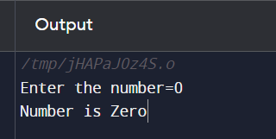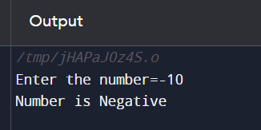}

Q.9. Write a program to print even/odd numbers between 1-100.

Ans. #include <stdio.h>

int main() {

for(int i=1;i<=100;i++){

if(i%2==0){

printf("even=%d\n",i);

}else{

printf("odd=%d\n",i);

}

}

}

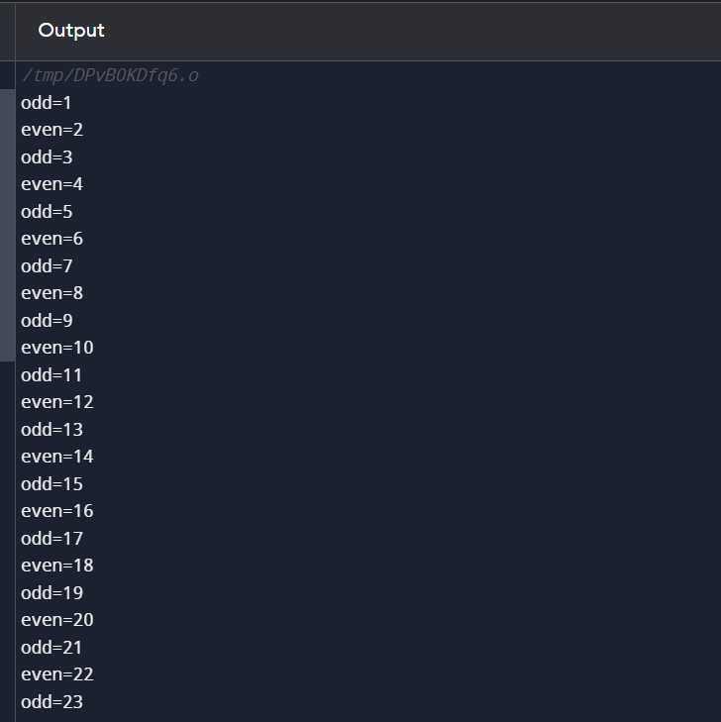

Q.10. Write a program to print given no is Armstrong no or not.

Ans: #include <stdio.h>

int main() {

int n,r,arm=0,c;

printf("Enter the number=");

scanf("%d",&n);

c=n;

while (n>0){

r=n%10;

arm=(r*r*r)+arm;

n=n/10;

}

if (c==arm)

printf("Armstrong Number");

else

printf("Not");

return 0;

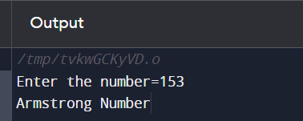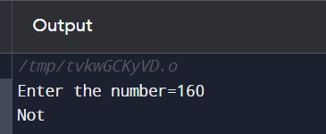}

Q.11. Write a program to print Fibonacci series.

Ans: #include <stdio.h>

int main() {

int i,c,a=0,b=1,n;

printf("Enter the number of term=");

scanf("%d",&n);

for(i=1;i<=n;i++)

{

printf("%d ",a);

c=a+b;

a=b;

b=c;

}

return 0;

}

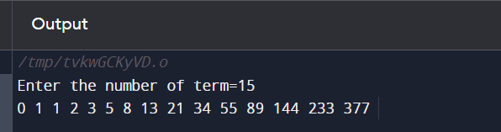

Q.12. Write a program to find LCM of two number.

Ans:

Q.13. Write a program to check given no is palindrome or not.

Ans: #include <stdio.h>

int main() {

int n,c,r,s=0;

printf("Enter the number of term=");

scanf("%d",&n);

c=n;

while(n>0)

{

r=n%10;

s=r+(s*10);

n=n/10;

}

if (c==s)

printf("Palindrome number");

else

printf("Not");

return 0;

}

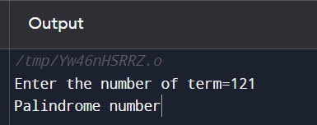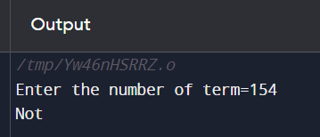

Q.14. Write a program to factor of positive number.

Ans: #include <stdio.h>

int main() {

int num,i;

printf("Enter a positive number is=");

scanf("%d",&num);

printf("Factor of %d are=",num);

for (i=1;i<=num;i++){

if (num%i==0){

printf("%d",i);

}

}

return 0;

}

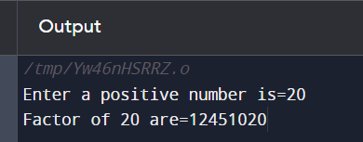

Q.15. Write a program find factorial of a no entered by users.

Ans:

Q.16. Write a program to swap two numbers using function call by value

Ans- #include <stdio.h>

void swap(int, int);

int main()

{

int x,y;

printf("enter the value of x and y\n");

scanf("%d%d",&x,&y);

printf("main value\nx= %d\n y=%d\n", x,y);

swap (x,y);

printf("swaping value\nx=%d\n y=%d\n", x,y);

return 0;

}

void swap (int a, int b)

{

int c;

c=a;

a=b;

b=c;

printf("value of a %d\n" ,a);

printf("value of b %d\n" ,b);

}

1. Write a program c language to swap two numbers with using the third variable (by using call by function)
2. Write a program