1. **pwd**

**Command explanation:**

**“pwd”** command prints the current working directory where a user is currently in. Suppose a user wants to print the absolute path of the directory in which he is in, he can use the “**pwd**” command.

**Example:**

Typing **“pwd”** on the acadgild terminal as soon as a user logs in gives the directory path as “**/home/acadgild**”. This is shown below.



1. **vi**

**Command explanation:**

The “**vi**” command is a text editor which is used to create a new file or open an existing file for editing purpose. A number of options are available to the command and can be checked by typing “**man vi**” on the command prompt.

Content can be added to the file by going to insert mode (pressing “**i**”) and the changes can be saved by typing “**:wq**”.

**Example:**

1. **Creating a new file**

Running the command “**vi testNewFileCreation**” creates the new file “**testNewFileCreation**” as shown below.

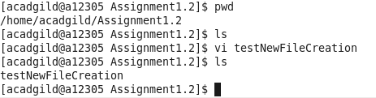

1. **Opening the above file and editing it.**

Running the command “**vi testNewFileCreation**” again opens the previously created file “**testNewFileCreation**” as shown below. The snapshot shows a new content “*Creating a new test file*” updated to the file.

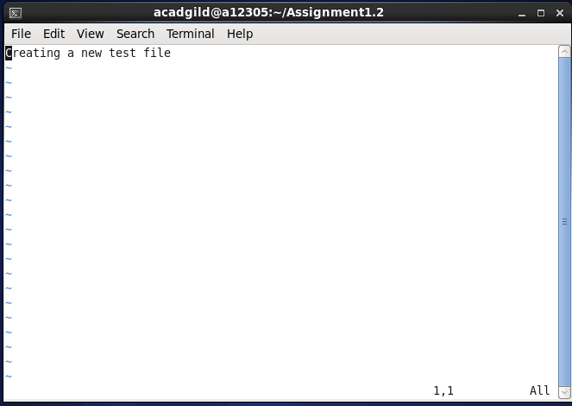

1. **touch**

**Command explanation:**

**“touch”** is a command used to update the access date and/or modification date of a file or directory. By default, the command will create or open a file and save it without any change to the file contents.

**Example:**

1. **Creating a new file.**

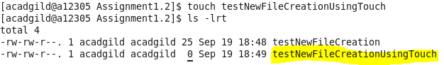

1. **Updating the access time of a file.**

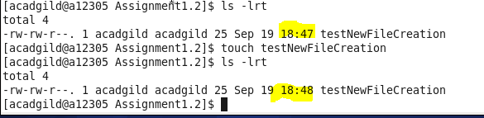

1. **mkdir**

**Command explanation:**

The “**mkdir**” command is used to create a new directory.

**Example:**

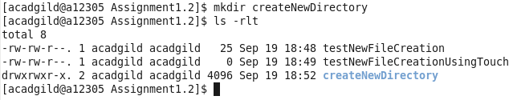

1. **rm**

**Command explanation:**

The “**rm**” command is used to delete file(s) or directory(ies).

**Example:**

The example below illustrates the removal of a file “*testNewFileCreationUsingTouch*” using “**rm**” command.

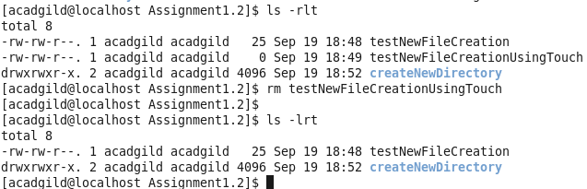

1. **ls**

**Command explanation:**

The “**ls**” command is used to list all the files and directories present inside a file system. We can also pass the directory or its path where we want to list all the files and directories under that path.

**Example:**

The below snapshot shows the usage of “ls” command to list all the files under “Assignment1.2” directory.

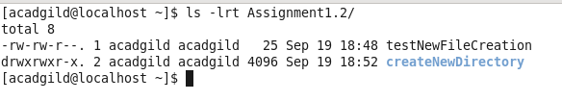

1. **echo**

**Command explanation:**

The “**echo**” command is used to display the text passed in the command or output the variable value on the screen.

**Example:**

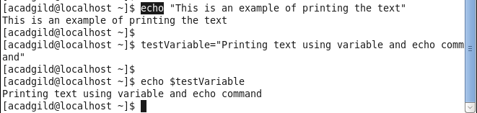

1. **cat**

**Command explanation:**

The “**cat**” command is used to display the contents of a file on the standard output.

**Example:**



1. **who**

**Command explanation:**

The “**who**” command is used to display the list of logged in users.

**Example:**

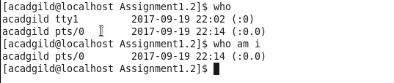

1. **cd**

**Command explanation:**

The “**cd**” command is used to change the directory from the current directory to another directory. The path of the other directory can be passed as argument to the cd command.

If no argument is passed, the “**cd**” command will change the directory to the user’s home directory.

**Example:**

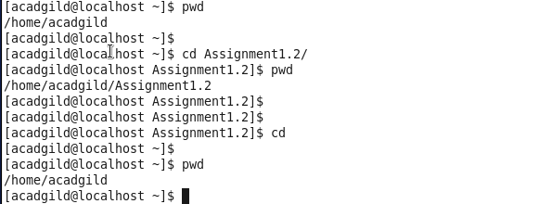

1. **date**

**Command explanation:**

The “**date**” command is used to get / display the current date and time.

**Example:**



1. **cal**

**Command explanation:**

The “**cal**” command is used for displaying a calendar in the terminal. Just running the “cal” command without any arguments will display the days in the current month. An example is shown below.

**Example:**

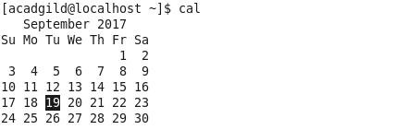

**13. mv**

**Command explanation:**

The “**mv**” command is used for moving files and directory from one location to another location. It can also be used to rename a file or directory.

**Example:**

1. **Moving files from directory “source” to “destination”**

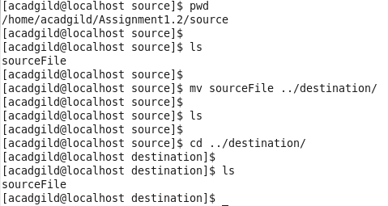

1. **Renaming a file from “sourceFile” to “destinationFile”**

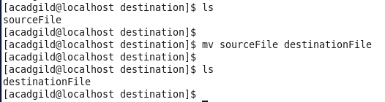

**14. cp**

**Command explanation:**

The “**cp**” command is used to create a copy of file(s). It can also be used to copy a directory and all the files inside that directory.

**Example:**

This example shows copying a file “*testNewFileCreation*” from the current directory to another directory “*destination*” using the “**cp**” command.

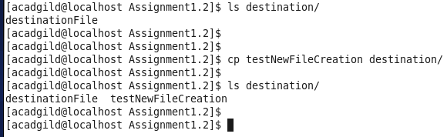

**15. which**

**Command explanation:**

The “**which**” command is used to find the location of a an executable program

**Example:**

