npm install xml2js --save-dev

Assignment 1: Read a xml file, change some values and write the xml in to new file
The “samplexml.xml” file contains the sample data, we are trying to read the file and modify the element and creating “modified-samplexml.xml”
Before running the program,
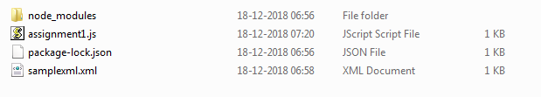
Only samplexml.xml is available .
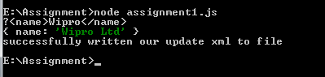
After running the program, new file created with modified content.
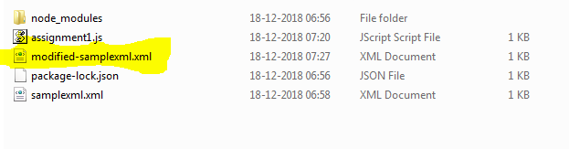

Assignment 2 : Read a JSON file, change some values and write the json in to new file
The “samplejson.json” file contains the sample data, we are trying to read the file and modify the element and creating “modified-samplejson.json”
Before running the program,
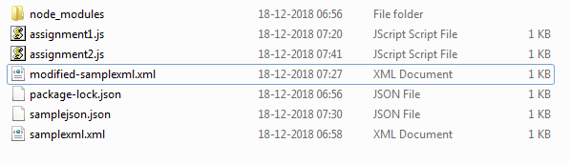
Only samplejson.json is available.
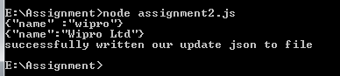

After running the program, new file created with modified content.
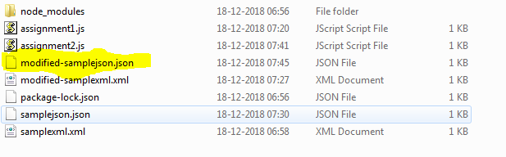

Assignment 3: Make a SOAP call. Assert response status code and assert any one node value in response
npm install mocha chai request –save
The below URL is used to get the Stock details.
http://ws.cdyne.com/delayedstockquote/delayedstockquote.asmx?op=GetQuote
The GetStock Service request is present in “soap-testdata.xml”

In Assignment2.js , once the response is received we are trying to assert the status code and StockSymbol value.
Expected value:
Status code : 200
StockSymbol : NSE:WIPRO
Success Scenario
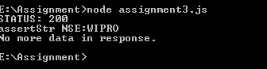
Failure Scenario
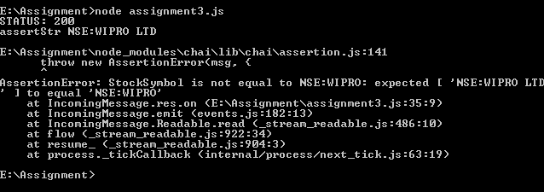

Assignment 4 : Make a GET call. Assert the response status code and userId
The assignment4.js will invoke the service - https://jsonplaceholder.typicode.com/posts/1
And assert with response code and user id.

Expected value :
Status code : 200
UserId : 1

Success Scenario :
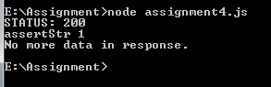

Failure Scenario :

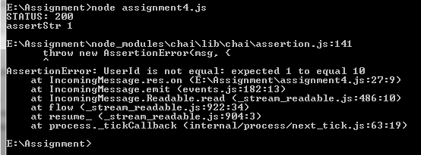

Assignment 5 : Make a POST call. Assert the response status code and id

The assignment5.js will invoke the POST service https://jsonplaceholder.typicode.com/posts
And assert with response code and userid.

Expected value:
Response code : 201
UserID : 1120

Succes Scenario:

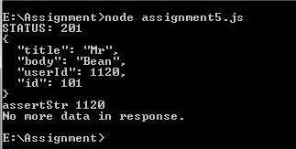

Failure Scenario:
