STUDENT CASE STUDY EXECUTION REPORT
Department | FED
Subject | DSA-2
Academic Year | I-III Semester (2025-26)
Faculty Name | _DR. SREERAM MURTY_________________
Student Name | SAI KRISHNA THIRUNAGARI__________________
Roll Number | _2520090156_________________
Branch | __CSIT________________

Case Study Topic
Student Attendance Analysis using Longest Common Subsequence (LCS)

Introduction
This case study explains a Student Attendance Analysis System using the Longest Common Subsequence (LCS) algorithm. The system compares attendance records of two semesters
LCS Algorithm
The Longest Common Subsequence (LCS) finds the longest sequence that appears in the same order in both attendance records.
Attendance Records
Semester 1:
P A P P A P
Semester 2:
P P A P A P
Where:
- P = Present
- A = Absent

Working of LCS
- Compare attendance records of both semesters.
- Identify matching attendance patterns.
- Store results using Dynamic Programming.
- Find the longest common subsequence.

Result of LCS
P P A P
Length of LCS = 4

Complexity Analysis
Operation | Complexity
LCS Algorithm | O(m × n)
Where:
- m = Length of First Record
- n = Length of Second Record

Result / Output
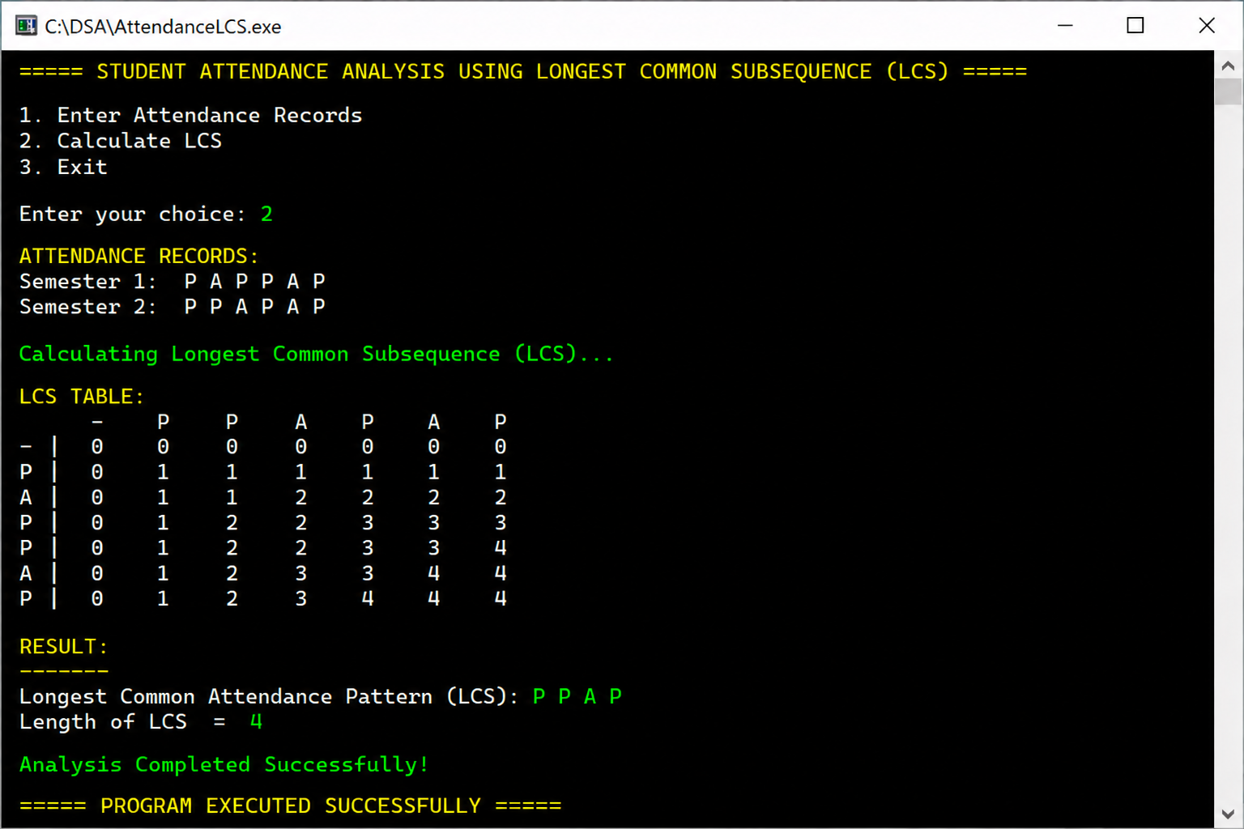

Conclusion
This case study helped in understanding the Longest Common Subsequence (LCS) algorithm and its application in attendance analysis systems. LCS efficiently identifies common patterns between two datasets using Dynamic Programming.
GITHUB LINK: https://github.com/chandra8340046-ai/DSA-CASESTUDIES

Student Signature | Faculty Signature
__________________ | __________________

