STUDENT CASE STUDY EXECUTION REPORT
Department | FED
Subject | DSA-2
Academic Year | I-III Semester (2025-26)
Faculty Name | DR. SREERAM MURTY_________________
Student Name | SAI KRISHNA THIRUNAGARI
Roll Number | _2520090156_________________
Branch | _CSIT_________________

Case Study Topic
Emergency Ambulance Allocation System using Heap Data Structure (Priority Queue)

Introduction
This case study explains an Emergency Ambulance Allocation System using a Heap (Priority Queue). In hospitals, patients are treated based on the severity of their condition. A Heap helps in automatically selecting the patient with the highest priority (most critical condition) for ambulance service.
This system ensures fast response for emergency cases and improves life-saving efficiency.
. They help in fast indexing and efficient data retrieval for large student databases.
Non-Linear Data Structure Used
Heap (Max Heap / Priority Queue)
A Heap is a complete binary tree where:
- In a Max Heap → highest priority element is at the root
- Parent node has higher priority than child nodes

Patient Priority Structure
Each patient contains:
- Patient Name
- Emergency Level (1–10 scale)
- Arrival Time

Operations Performed
Insert Patient
- Add patient into heap based on emergency level
Allocate Ambulance
- Remove patient with highest emergency level
Update Priority
- Increase emergency level if condition worsens
Display Queue
- Show all patients in priority order

Heap Representation Example
Max Heap (Emergency Level):
- 10 (Critical Patient A) ← Root
  - 8 (Patient B)
  - 7 (Patient C)
    - 5 (Patient D)
    - 6 (Patient E)

Complexity Analysis
Operation | Complexity
Insert | O(log n)
Delete Max | O(log n)
Peek Max | O(1)
Build Heap | O(n)

Result / Output
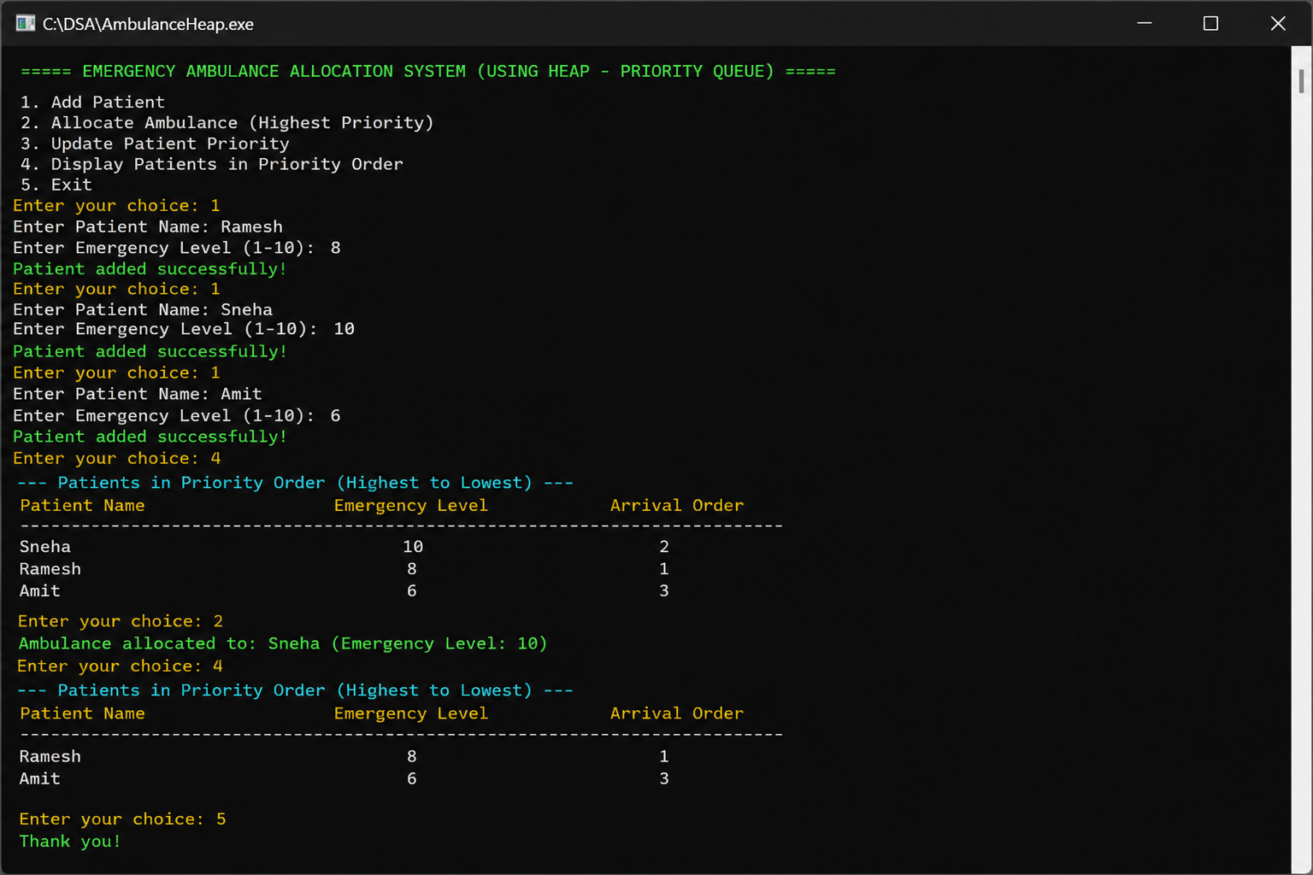

Conclusion
This case study helped in understanding Heap as a Non-Linear Data Structure. Priority Queue ensures efficient handling of urgent tasks, making it highly useful in real-world emergency and scheduling systems.
GITHUB LINK: https://github.com/chandra8340046-ai/DSA-CASESTUDIES

Student Signature | Faculty Signature
__________________ | __________________

