STUDENT CASE STUDY EXECUTION REPORT
Department | FED
Subject | DSA-2
Academic Year | I-III Semester (2025-26)
Faculty Name | __________________
Student Name | _SAI KRISHNA THIRUNAGARI_______________
Roll Number | _2520090156_____________
Branch | _CSIT________________

Case Study Topic
Mobile Contacts Management System using BST and AVL Tree

Introduction
This case study explains a simple Mobile Contacts Management System using Binary Search Tree (BST), AVL Tree, B-Tree, and B+ Tree concepts. These trees help in storing, searching, deleting, and managing contact numbers efficiently.

BST Concepts and Operations
BST was used to store contact numbers. Operations such as insertion, deletion, and searching were performed successfully.
Example Data: 50, 30, 70, 20, 40, 60, 80

Tree Traversals
In-order Traversal: 20, 30, 40, 50, 60, 70, 80
Pre-order Traversal: 50, 30, 20, 40, 70, 60, 80
Post-order Traversal: 20, 40, 30, 60, 80, 70, 50

Complexity Analysis
BST Search: O(log n)
BST Insert: O(log n)
BST Delete: O(log n)
Worst case complexity may become O(n) when the tree becomes skewed.

AVL Trees and Rotations
AVL Trees maintain balance using rotations such as LL Rotation, RR Rotation, LR Rotation, and RL Rotation. These rotations reduce tree height and improve searching speed.

AVL Insertion and Deletion
Student records were inserted and deleted in AVL Tree. After every insertion or deletion, rotations balanced the tree automatically.

BST vs AVL Comparison
BST is simple but may become unbalanced. AVL Tree remains balanced and provides faster searching, insertion, and deletion operations.

B-Tree and B+ Tree Concepts
B-Tree and B+ Tree are used in databases and file systems. They help in fast indexing and efficient data retrieval for large student databases.

Result / Output
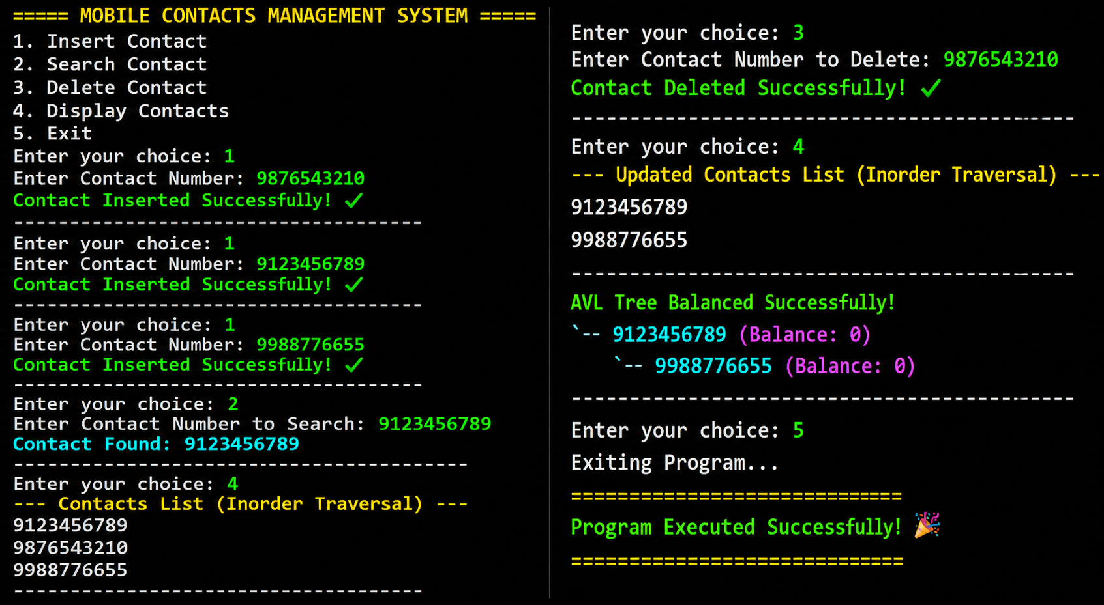

Conclusion
This case study helped in understanding BST, AVL Trees, B-Tree, and B+ Tree operations. AVL Trees provided better performance due to balancing techniques. Overall, the study explained efficient data management using tree data structures.
GITHUB LINK: https://github.com/chandra8340046-ai/DSA-CASESTUDIES

Student Signature | Faculty Signature
__________________ | __________________

