STUDENT CASE STUDY EXECUTION REPORT
Department | FED
Subject | DSA-2
Academic Year | I-III Semester (2025-26)
Faculty Name | DR. SREERAM MURTY__________________
Student Name | SAI KRISHNA THIRUNAGARI__________________
Roll Number | __2520090156______________
Branch | __CSIT_______________

Case Study Topic
Internet Network Connectivity using DFS Algorithm.

Introduction
This case study explains a simple Internet Network Connectivity System using the Depth First Search (DFS) algorithm. DFS helps check whether all computers in a network are connected and reachable from a starting computer.
DFS Algorithm
DFS is a graph traversal algorithm that explores a node completely before moving to the next node.
Example Network
Computers: A, B, C, D, E
Connections:
A → B
A → C
B → D
C → E
DFS Traversal
Starting Node: A
Traversal Order:
A → B → D → C → E

Working of DFS
- Start from Computer A.
- Visit an unvisited neighboring computer.
- Continue until no unvisited neighbor exists.
- Backtrack and continue traversal.
Complexity Analysis
DFS Traversal: O(V + E)
Where:
- V = Number of Computers
- E = Number of Connections

Result / Output
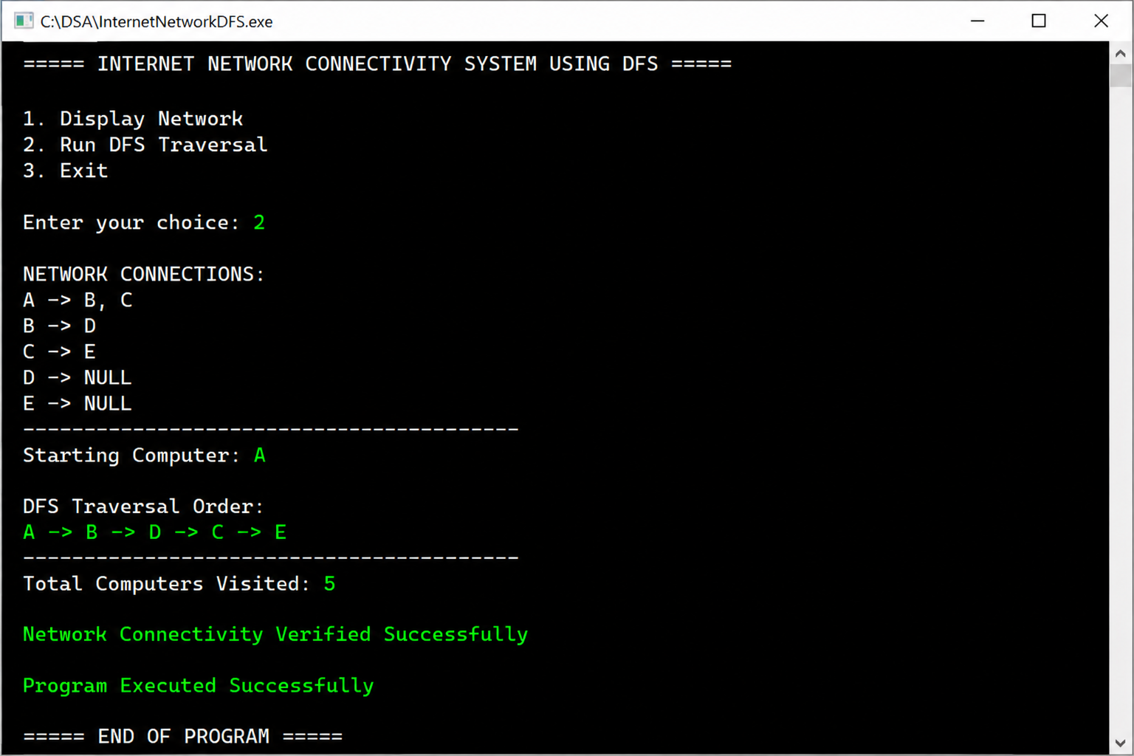

Conclusion
This case study helped in understanding the DFS graph traversal algorithm and its real-world application in network connectivity systems. DFS efficiently explores all connected nodes and verifies network connectivity.
GITHUB LINK: https://github.com/chandra8340046-ai/DSA-CASESTUDIES

Student Signature | Faculty Signature
__________________ | __________________

