STUDENT CASE STUDY EXECUTION REPORT
Department | FED
Subject | DSA-2
Academic Year | I-III Semester (2025-26)
Faculty Name | _DR. SREERAM MURTY_________________
Student Name | SAI KRISHNA THIRUNAGARI__________________
Roll Number | __2520090156________________
Branch | _CSIT_________________

Case Study Topic
Ambulance Route Planning System using Dijkstra's Algorithm

Introduction
This case study explains an Ambulance Route Planning System using Dijkstra's Algorithm. In emergency situations, ambulances must reach patients through the shortest route to save time and provide quick medical assistance.
Dijkstra's Algorithm
Dijkstra's Algorithm finds the shortest path between a source location and a destination in a weighted road network.
Example Locations
- H = Hospital
- A = Junction A
- B = Junction B
- P = Patient Location
Road Distances:
- H → A = 4 km
- H → B = 6 km
- A → P = 3 km
- B → P = 5 km

Working of Dijkstra's Algorithm
- Start from Hospital (H).
- Assign distance 0 to Hospital.
- Find the nearest unvisited location.
- Update distances of neighboring locations.
- Continue until Patient Location is reached.

Shortest Route
Hospital(H) → Junction A → Patient(P)
Total Distance:
4 + 3 = 7 km
Shortest Distance = 7 km

Complexity Analysis
Operation | Complexity
Dijkstra's Algorithm | O((V + E) log V)
Where:
- V = Number of Locations
- E = Number of Roads

Result / Output
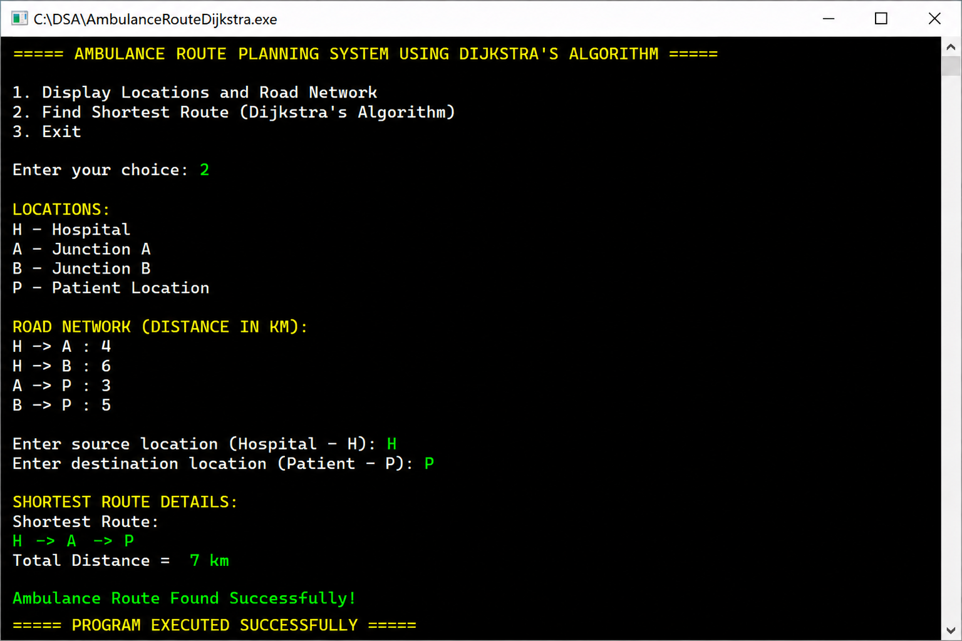

Conclusion
This case study helped in understanding Dijkstra's Algorithm and its real-world application in ambulance route planning systems. The algorithm efficiently finds the shortest route, helping emergency services reach patients quickly.
GITHUB LINK: https://github.com/chandra8340046-ai/DSA-CASESTUDIES

Student Signature | Faculty Signature
__________________ | __________________

