STUDENT CASE STUDY EXECUTION REPORT
Department | FED
Subject | DSA-2
Academic Year | I-III Semester (2025-26)
Faculty Name | _DR. SREERAM MURTY_________________
Student Name | SAI KRISHNA THIRUNAGARI_________________
Roll Number | _2520090156_________________
Branch | _CSIT_________________

Case Study Topic
Travel Ticket Cost Optimization using Dynamic Programming

Introduction
This case study explains a Travel Ticket Cost Optimization System using Dynamic Programming. A traveler wants to reach a destination with minimum travel cost by choosing the best combination of available routes.
Dynamic Programming Concept
Dynamic Programming stores previously calculated results to avoid repeated calculations and find the minimum cost efficiently.
Example Route Costs
Route | Cost (₹)
A → B | 100
A → C | 150
B → D | 200
C → D | 100

Working
- Start from Source City A.
- Calculate travel costs to intermediate cities.
- Store minimum costs.
- Determine the cheapest path to Destination D.
Minimum Cost Path
A → C → D
Total Cost:
150 + 100 = 250

Complexity Analysis
Operation | Complexity
Dynamic Programming Solution | O(n)

Result / Output
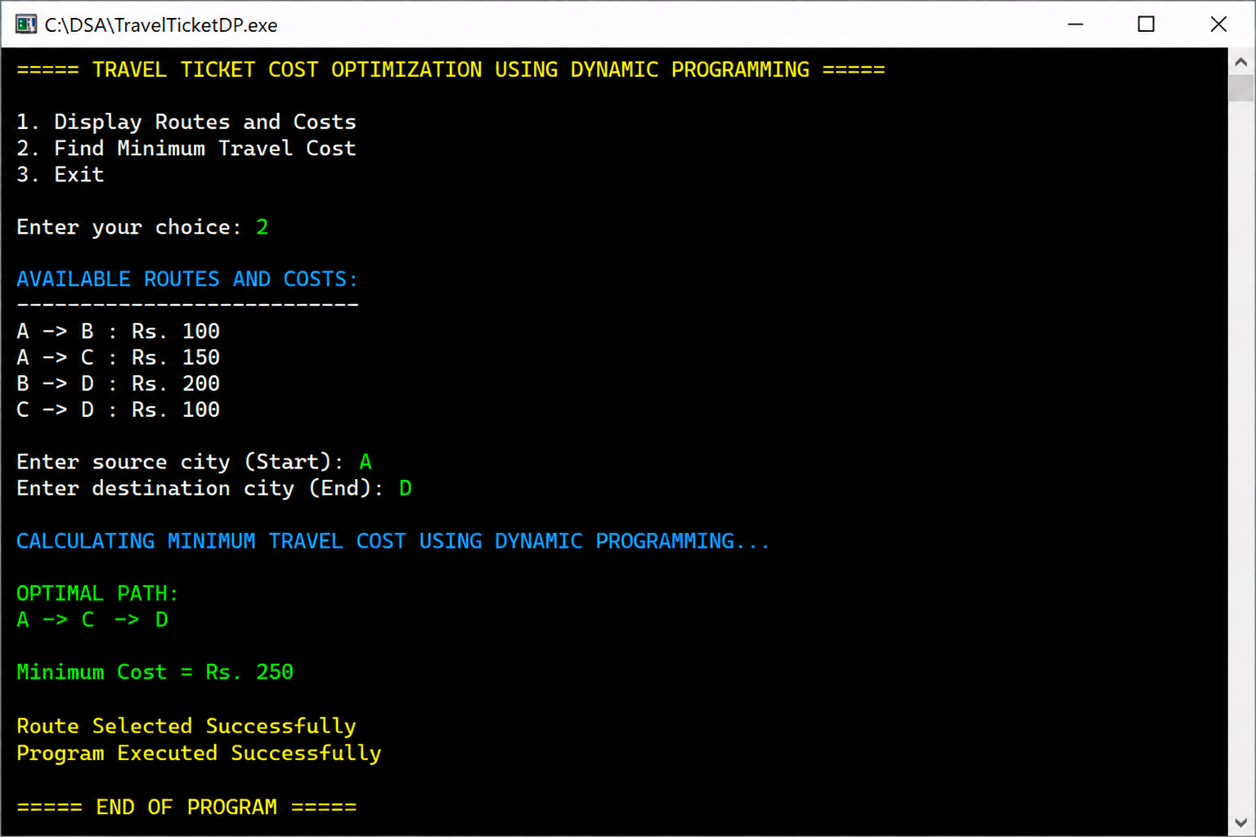

Conclusion
This case study helped in understanding Dynamic Programming and its application in travel cost optimization. The algorithm efficiently finds the minimum-cost route while avoiding unnecessary calculations.
GITHUB LINK: https://github.com/chandra8340046-ai/DSA-CASESTUDIES

Student Signature | Faculty Signature
__________________ | __________________

