pwd - Returns the full pathname of the current working directory

vi – Unix editor

cat - Concatenate files and print on the standard output

touch - Create or open a file and save it without any change to the file contents.

ls - List information about the files

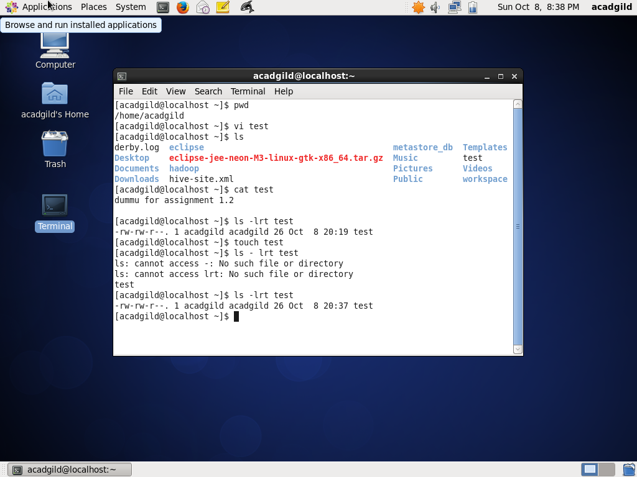

mkdir – make directory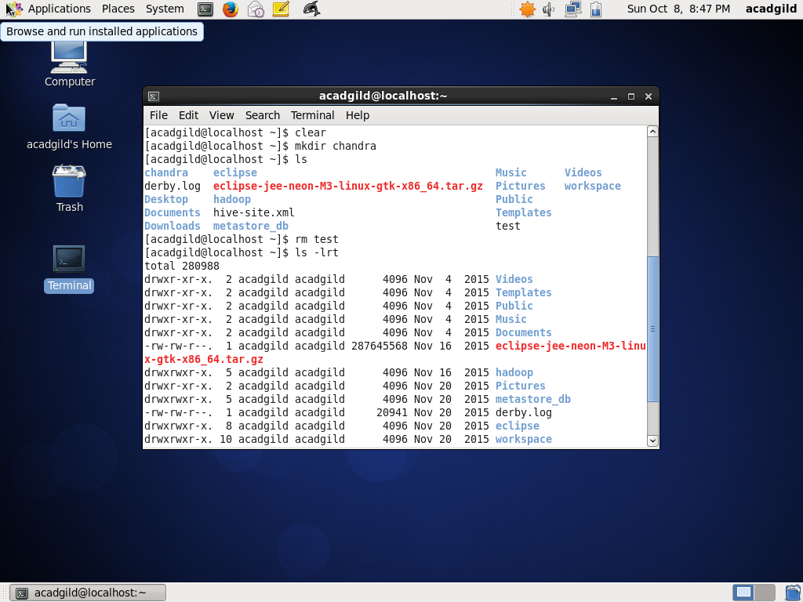

rm – remove files or directory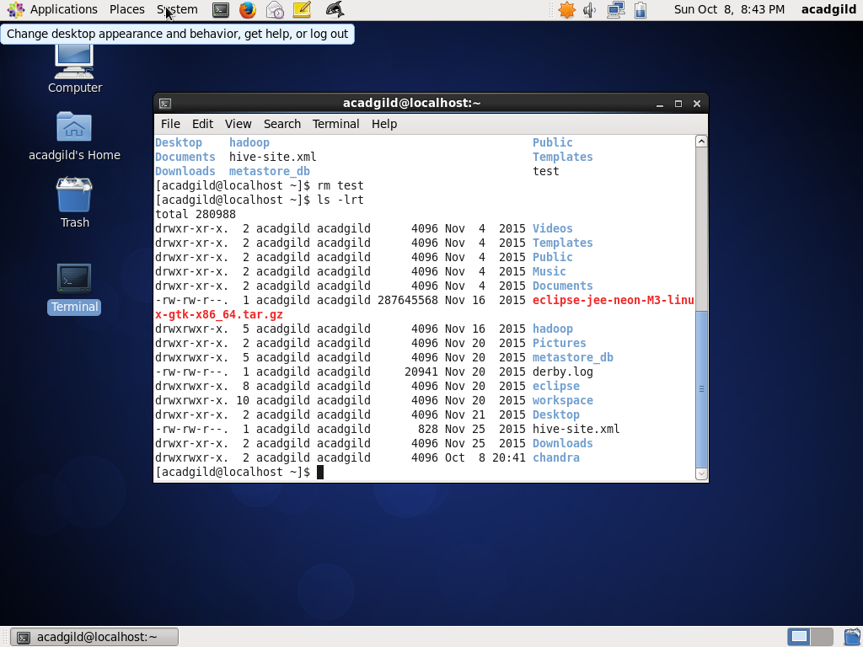

echo - Write arguments to the standard output

who - The standard Unix command who displays a list of users who are currently logged into the computer.

cd – change directory

date – format both date/time

cal - Display a simple calendar

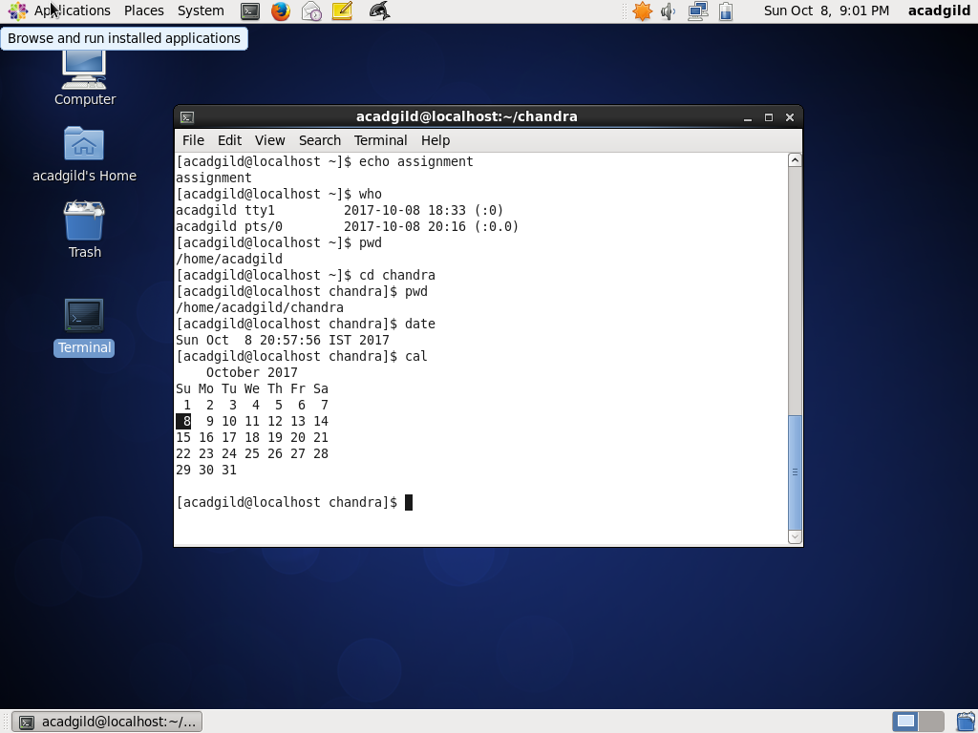

cp – copy files and directories

mv - moves one or more files or directories from one place to another.

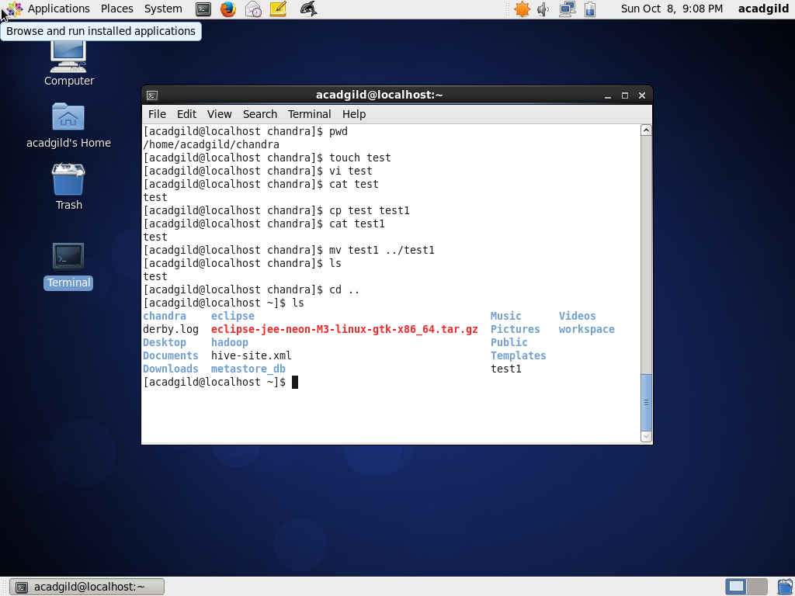

which - Command used to identify the location of executables in the path

