# Create Twitter App and update keys in flume.conf

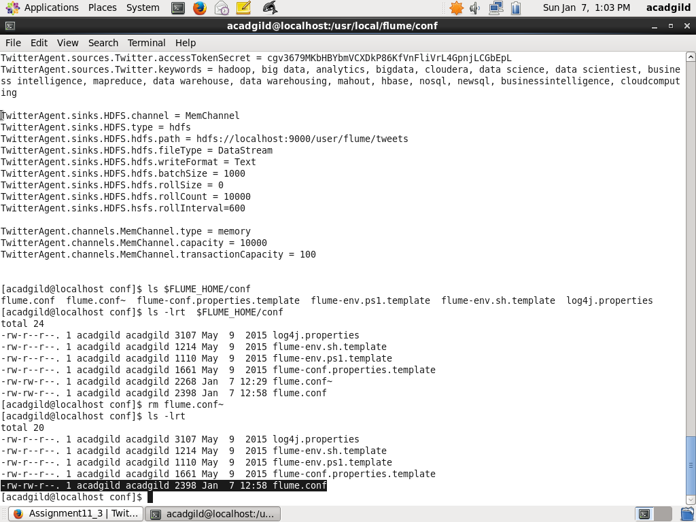

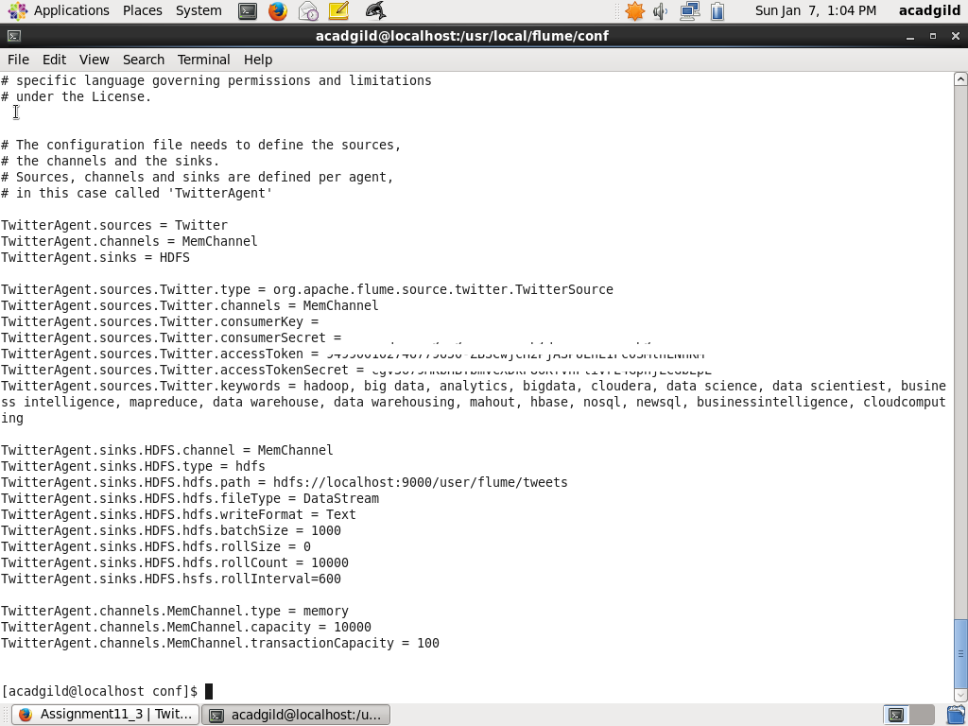

# Start Flume Agent to source Twitter Data

flume-ng agent -n TwitterAgent -f $FLUME_HOME/conf/flume.conf

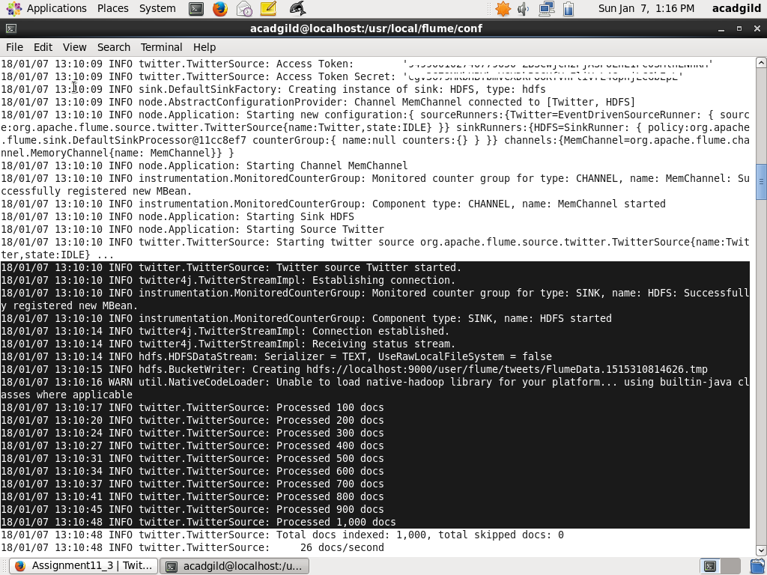

# Data Stored in HDFS

