* Create a list of tuples, where the 1st element of the tuple is an int and the second element is a string.
* for the above list, print the numbers where the corresponding string length is 4

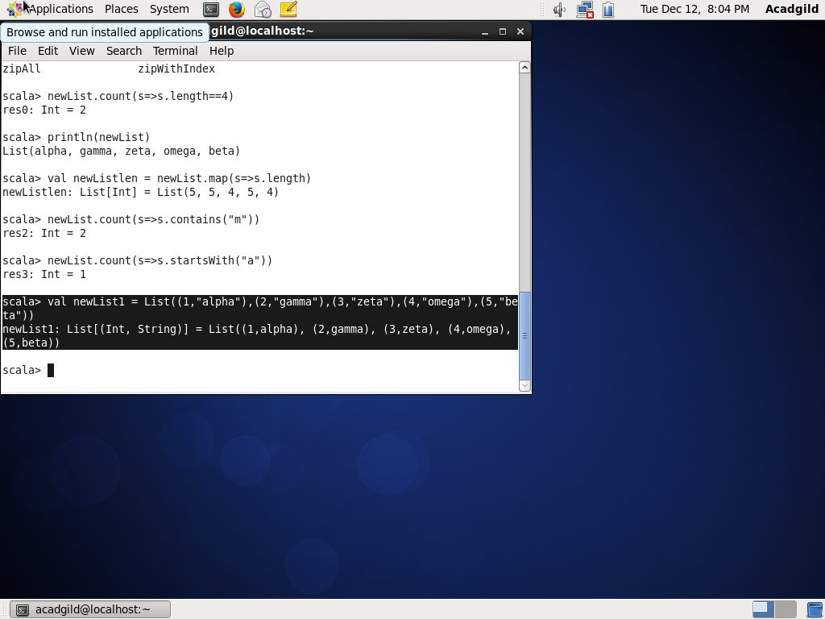

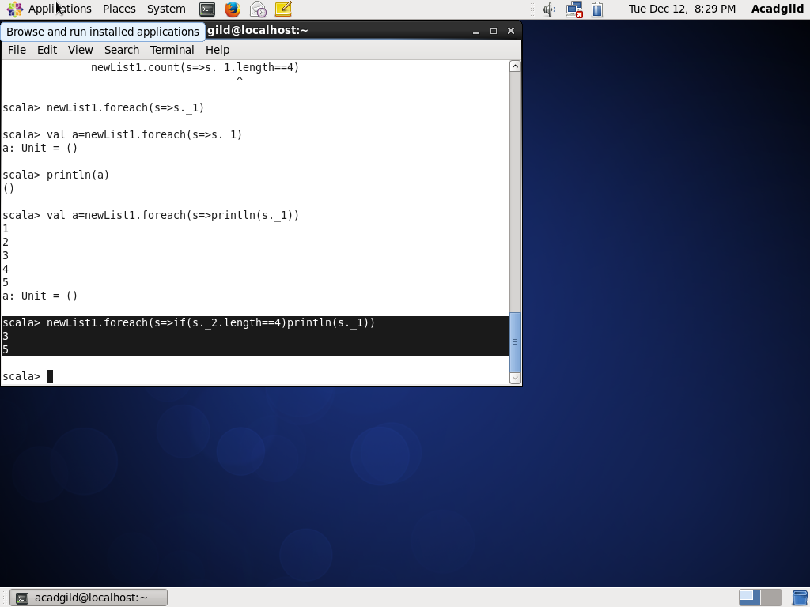

find the average of all numbers, where the corresponding string contains alphabet ‘m’

or alphabet ‘z’

