## Write a partial function to add three numbers in which one number is constant and two numbers can be passed as inputs and define another method which can take the partial function as input and squares the result.

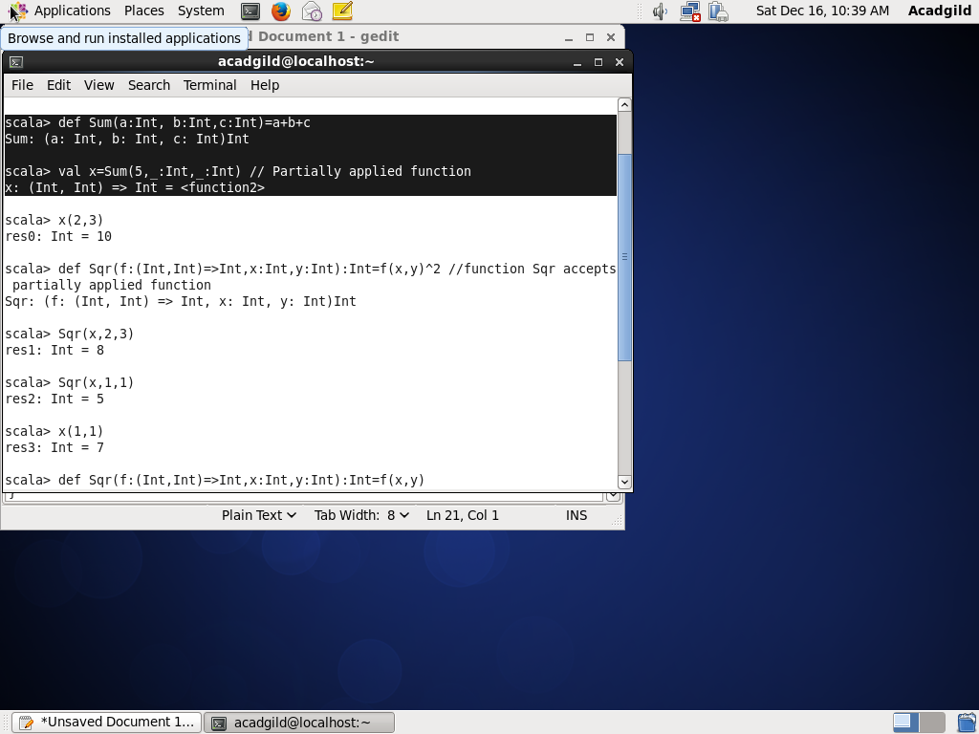

Partial applied function passed as parameter to function Sqr

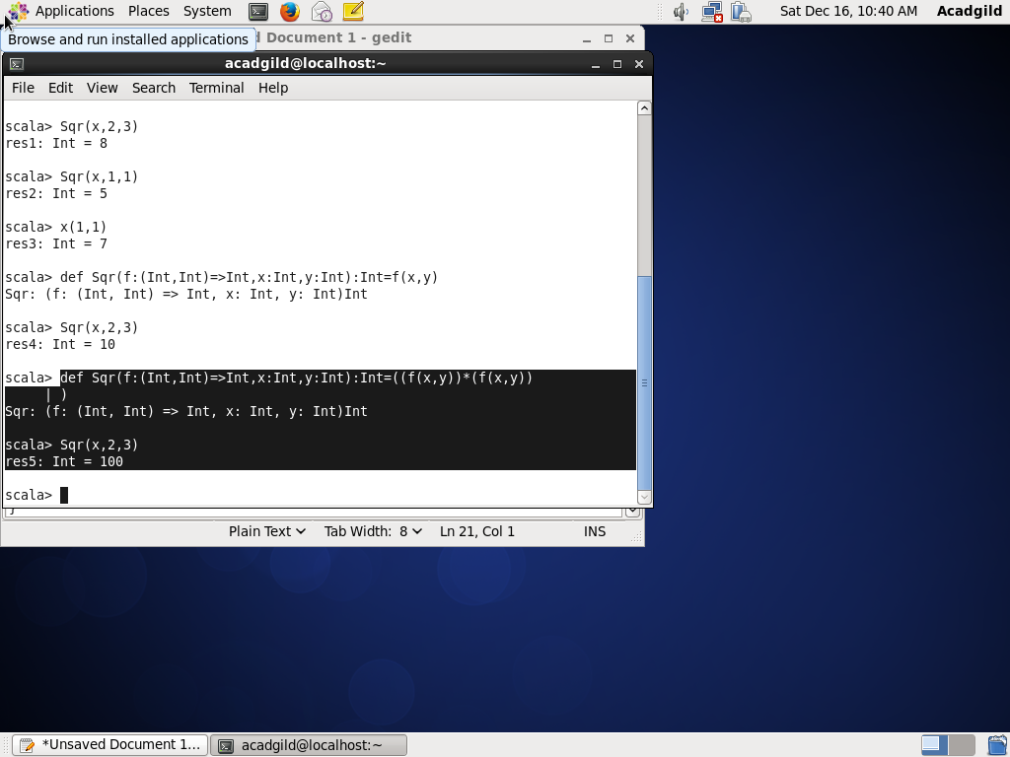

## Write a program to print the prices of 4 courses of Acadgild: Android-12999,Big Data

## Development-17999,Big Data Development-17999,Spark-19999 using match and add a default condition if the user enters any other course.

Using match-case

