## find the sum of all numbers in a list

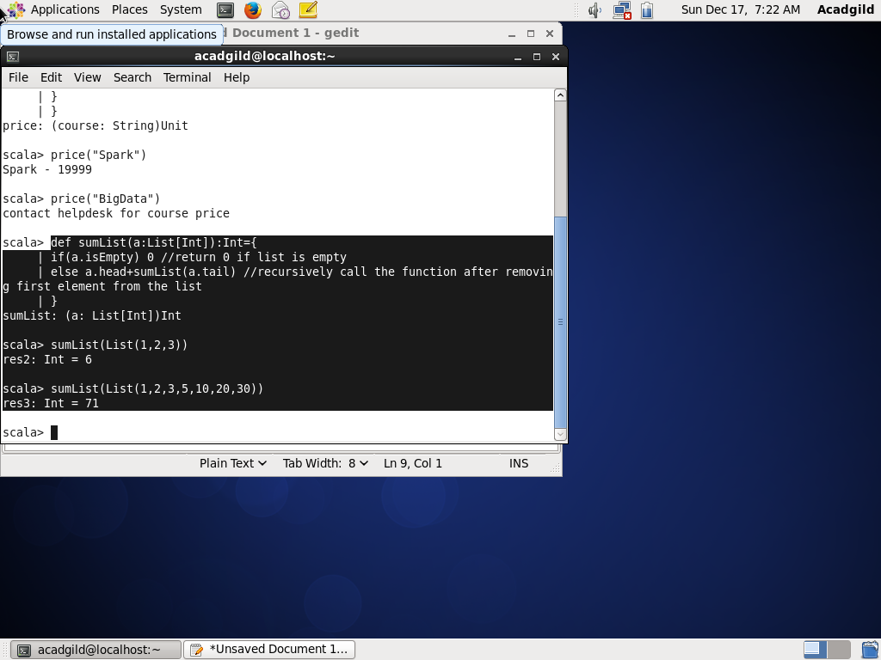

## find the total elements in the list

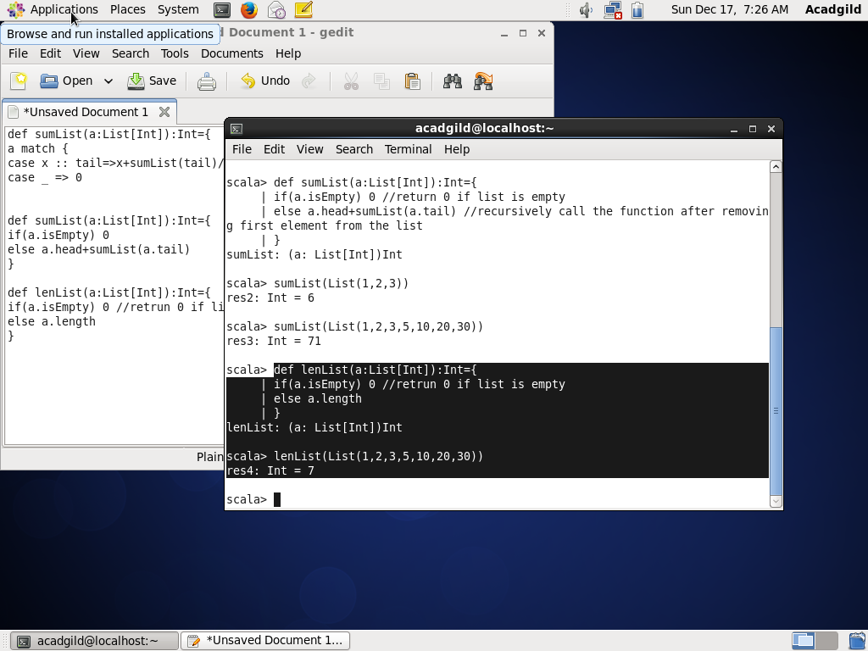

## calculate the average of the numbers in the list

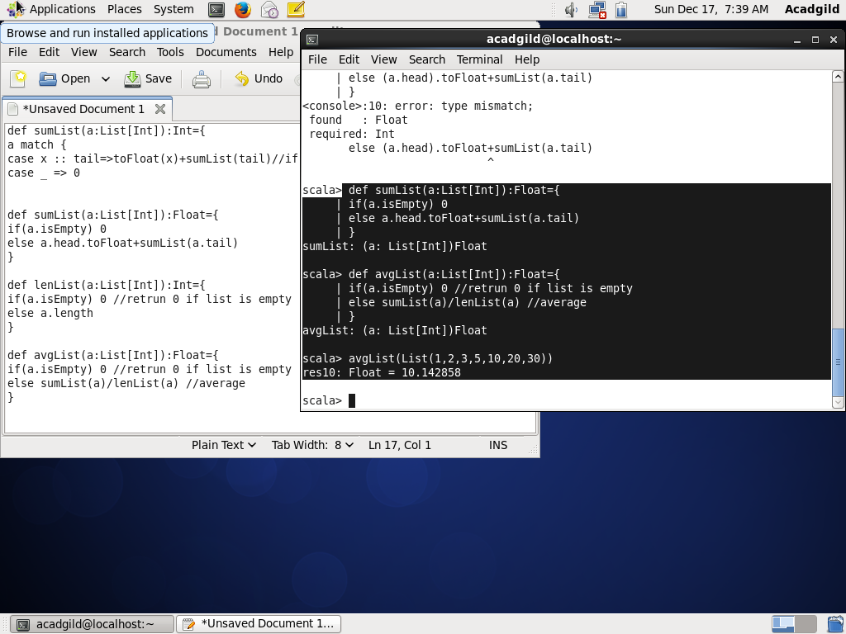

## find the sum of all the even numbers in the list

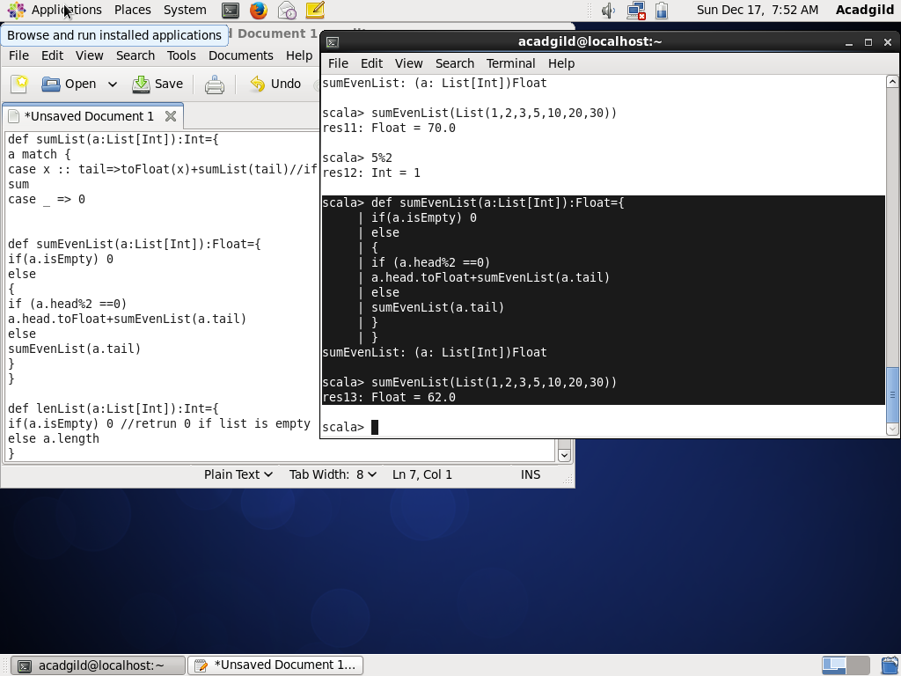

## find the total number of elements in the list divisible by both 5 and 3

