### Check derby.log exists in home directory

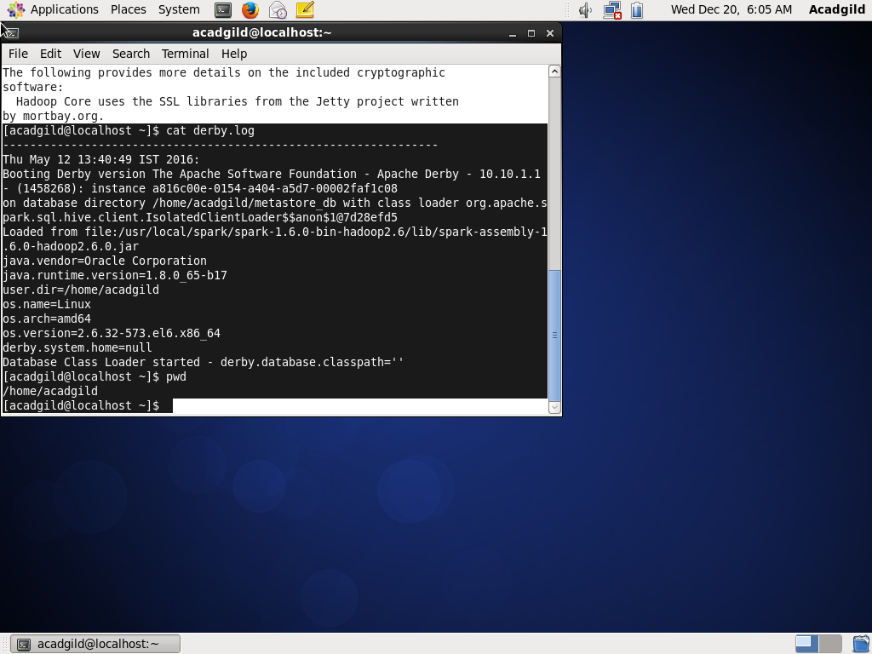

### Write a program to read a text file and print the number of rows of data in the document.

Create a RDD using SparkContext and get **row count** using count()

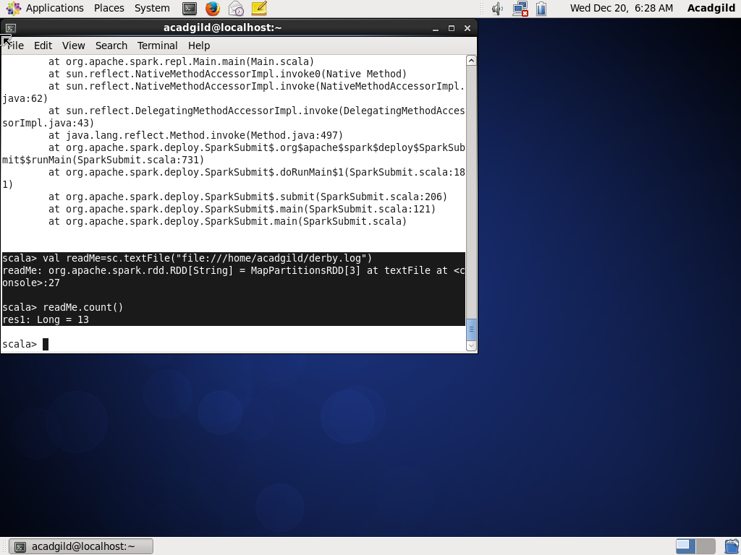

### Write a program to read a text file and print the number of words in the document.

Convert RDD readMe which is a list of statements to a RDD containing list of words using split() and then count the words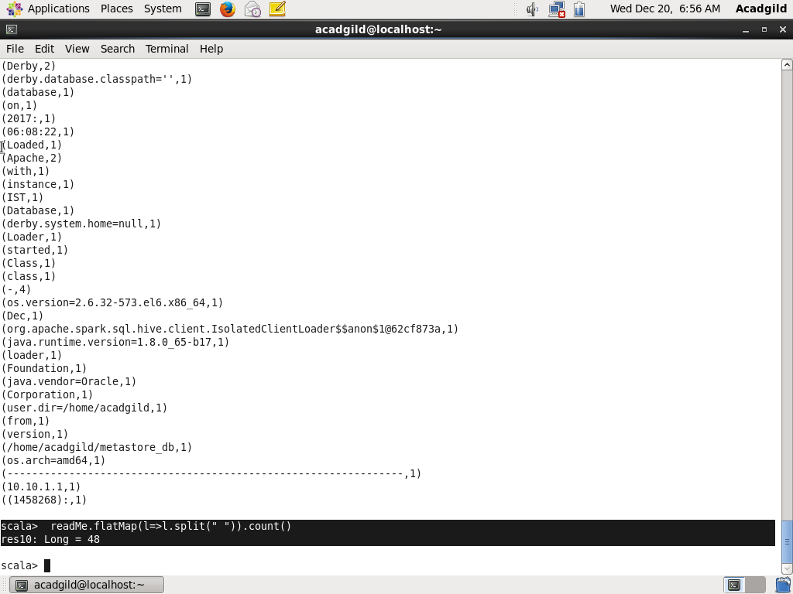

### We have a document where the word separator is -, instead of space. Write a spark code, to obtain the count of the total number of words present in the document.

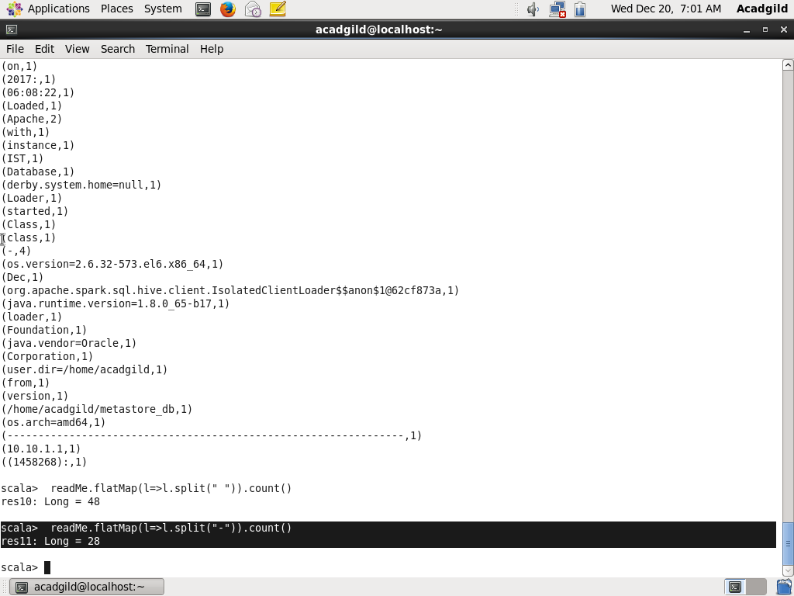

### Count of individual word (wordcount) separated by “-“

