Assignment 7.2

Loading Olympics data into Hive table Olympic_tbl

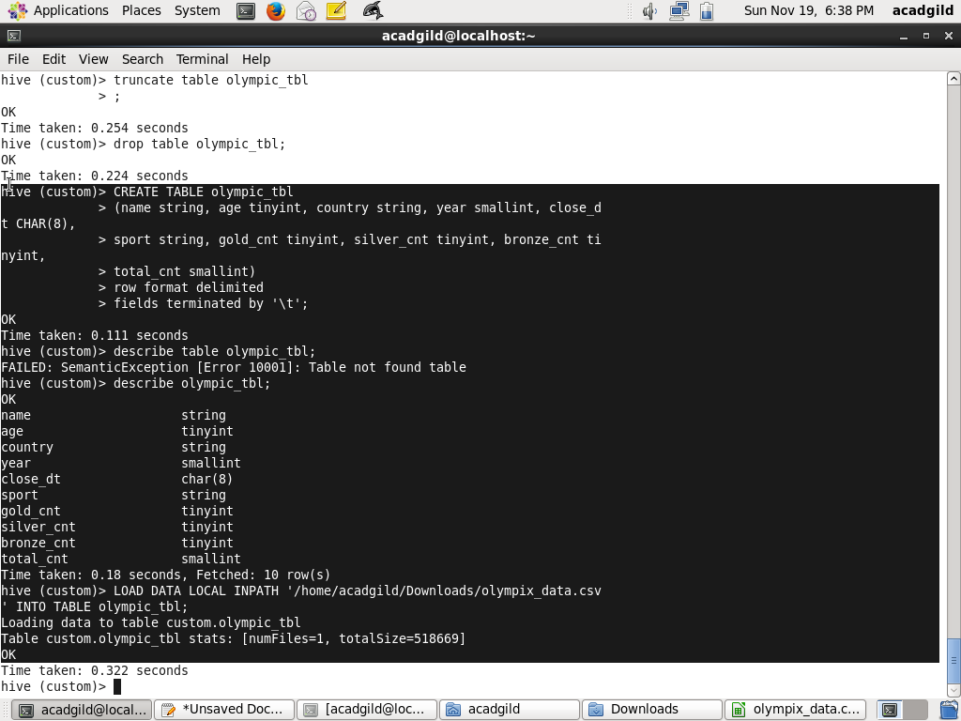

Problem Statement 1

Write a Hive program to find the number of medals won by each country in swimming.

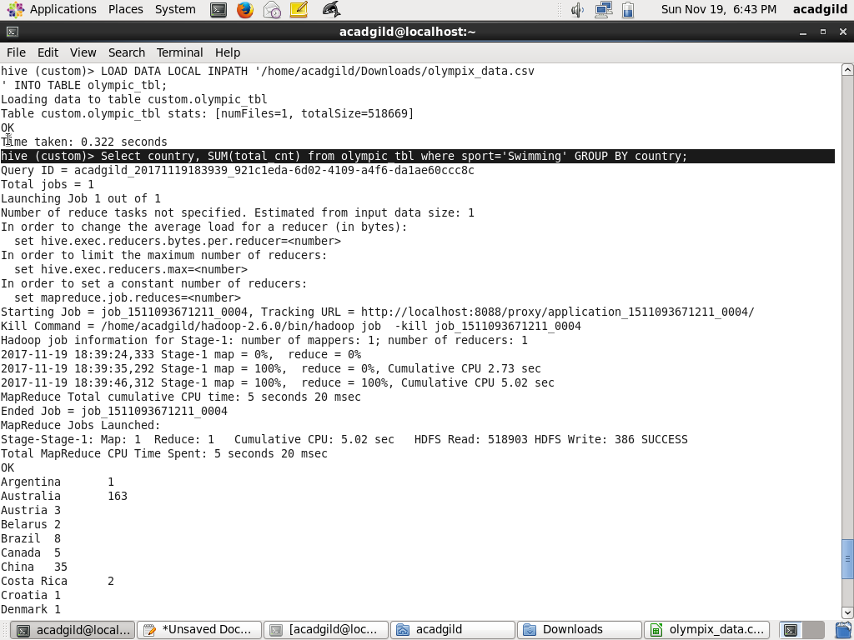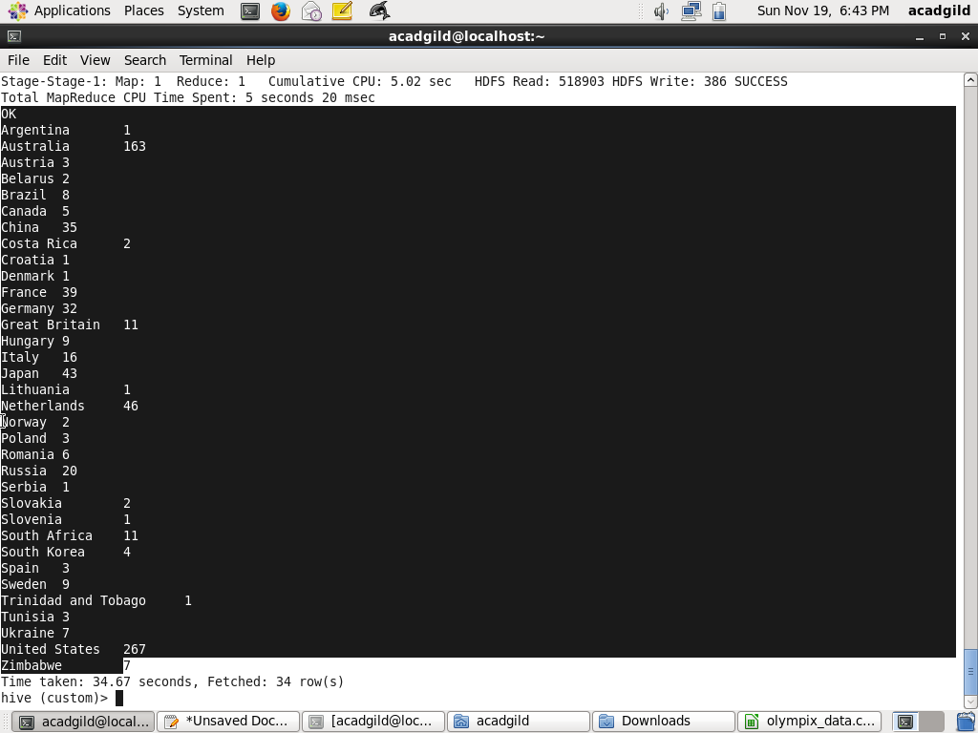

# Problem Statement 2

Write a Hive program to find the number of medals that India won year wise.

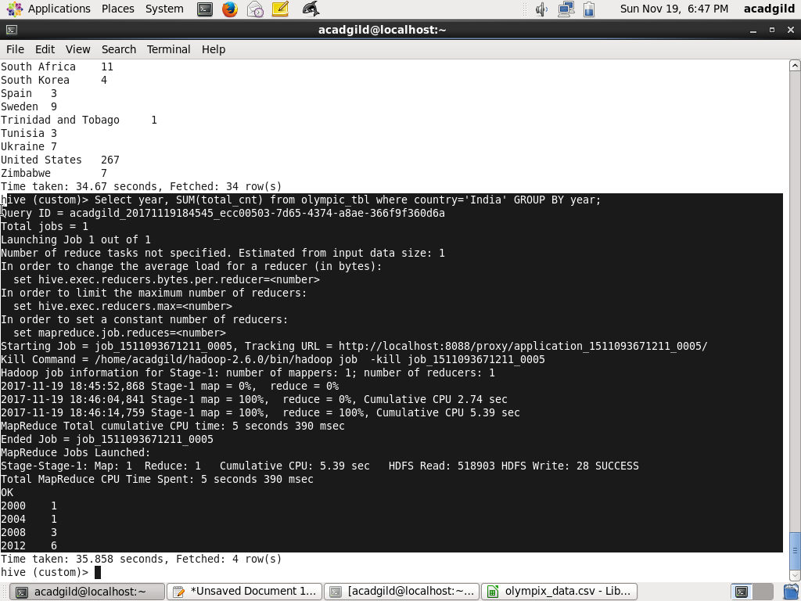

# Problem Statement 3

Write a Hive Program to find the total number of medals each country won.

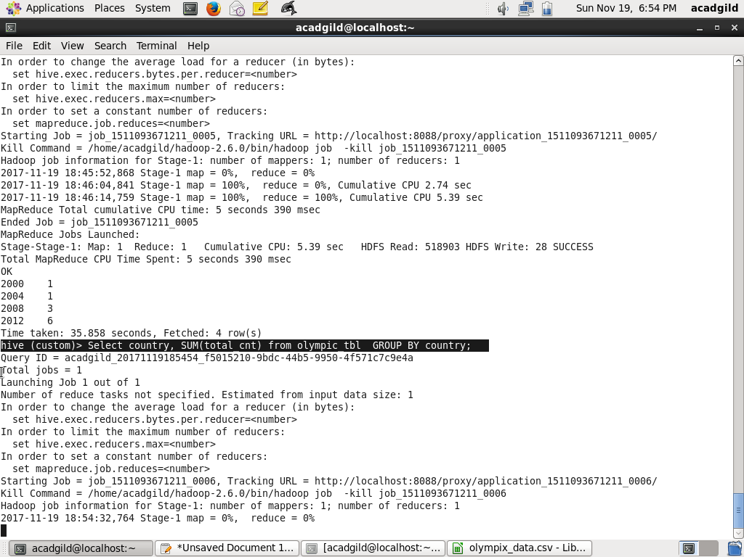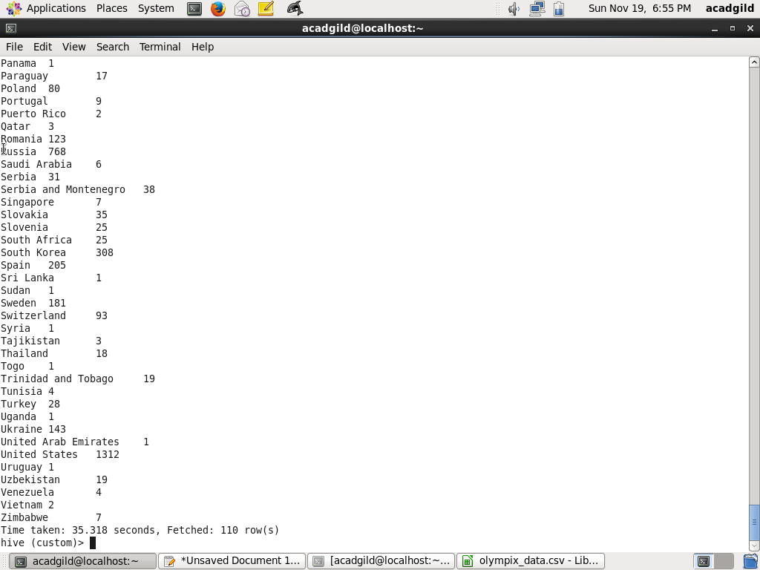

# Problem Statement 4

Write a Hive program to find the number of gold medals each country won.

