**SYNOPSIS**

**1. Abstract:**

The project mainly focuses on detecting if any person becomes drowsy, mainly while driving and can alert the user using a beep or alarm sound.

**2. Introduction of the Project:**

With this Python project, we will be making a drowsiness detection system.

Drowsiness detection is a safety technology that can prevent accidents that are caused by drivers who fell asleep while driving.

A countless number of people drive on the highway day and night. Taxi drivers, bus drivers, truck drivers and people traveling long-distance suffer from lack of sleep. Due to which it becomes very dangerous to drive when feeling sleepy.

Therefore we have chosen this topic, to help lower the rate of road accidents, and it can help to save lives.

**3. Objective (100 words):**

* Driver drowsiness detection is a car safety technology which helps to save the life of the driver by preventing accidents when the driver is getting drowsy.
* To capture the face of the driver and create a region of interest.
* To design a system to detect driver’s drowsiness by continuously monitoring the retina of the eye.
* To alert the driver on the detection of drowsiness by using a buzzer or alarm.

**4. Scope (100 words):**

The scope of our project is very vast. Our project may be applicable on every vehicle whether it is two wheeler or four wheeler. Today one of the major causes of road accidents is due to the drowsiness of the driver, and here our project can play a major role, and hence can be implemented on a large scale.

Not only while driving, we can also implement our project in every other place where the user needs to be alerted when he/she gets drowsy. Ex.- studying, security guards,classrooms,online exam etc.

**5. Study of Existing System (200 words):**

| * **Steering pattern monitoring** | * **Vehicle position in lane monitoring** | * **Driver face monitoring** | * **Physiological measurement** | * **Drowsiness Detection using face and eyes** |
| --- | --- | --- | --- | --- |
| Primarily uses steering input from electric power steering system. | Uses lane monitoring camera for Monitoring a driver. | Uses computer vision to observe the driver's face. | Requires body sensors to measure parameters like brain activity, heart rate activity. | Scans face and eyes and other factors. |
| Monitoring a driver this way only works as long as a driver actually steers a vehicle actively instead of using an automatic lane-keeping  system. | only works as long as a driver actually steers  a vehicle actively instead of using an automatic lane-keeping system. | Monitors face only which is not perfect system. | Monitoring body does not guarantee good safety. | Monitors face movement and evey closing and opening and activities. |
| Can be unstable in high and low traffic area. | System may misbehave while overtaking. | Sometimes face may not show drowsiness due to which system can fail. | If a person goes unconscious then body sensor may not distinguish whether the person is conscious or not | If a person is sleepy or unconscious or even if he/she is not looking forward it will raise an alarm. |

**6. Project Description (200 words):**

In this Python project, we will be using OpenCV for gathering the images from webcam and feed them into a [*Deep Learning*](https://data-flair.training/blogs/deep-learning-tutorial/) model which will classify whether the person’s eyes are ‘Open’ or ‘Closed’. The approach we will be using for this Python project is as follows :

Step 1 – Take image as input from a camera.

Step 2 – Detect the face in the image and create a Region of Interest (ROI).

Step 3 – Detect the eyes from ROI and feed it to the classifier.

Step 4 – Classifier will categorize whether eyes are open or closed.

Step *5 – Calculate score to check whether the person is drowsy.

* 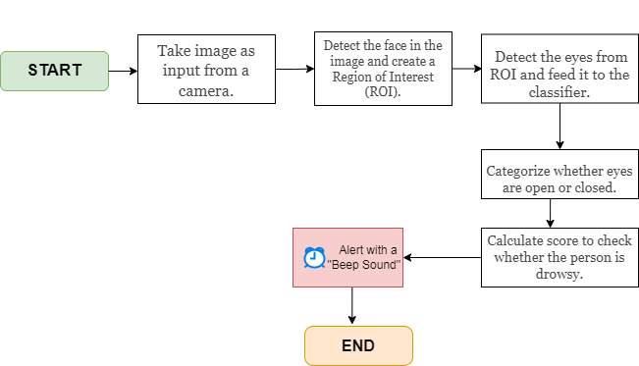

**7. Resources and Limitations (150 words):**

The requirement for this Python project is a webcam through which we will capture images. We need to have Python installed on your system.

* **OpenCV –** pip install OpenCv-python (face and eye detection).
* **dlib-** To detect and localize facial landmarks.
* **Playsound–** pip install play sound (to play alarm sound).
* **Rasberry Pi-** Small CPU with a nightlight camera to be installed in front of driver.

**8. Conclusion (100-150 words):**

* This system can be used to reduce the amount of road accidents that happens to great extent.
* This can save lot of lives, which is a main motive of this system.
* This system does not need any complex system to work effectively.
* Taking the facts into consideration driver drowsiness detection system is the future of road safety.

**9. Bibliography:**

* <https://www.pyimagesearch.com/2017/05/08/drowsiness-detection-opencv/>
* https://www.leadingindia.ai/internshipproject
* <https://en.wikipedia.org/wiki/Car_safety>
* <https://data-flair.training/blogs/deep-learning-tutorial/>