AR523: Robot Manipulators
Assignment 3: Vision-based control of a robotic arm

Overview:
- This assignment focuses on implementing and analyzing vision-based control strategies for robotic manipulators.

- The simulation environment is PyBullet (Fig. 1), which provides kinematic and dynamic utilities for a robotic manipulator with real-time camera images. You may refer the following for learning PyBullet: PyBullet Official Documentation

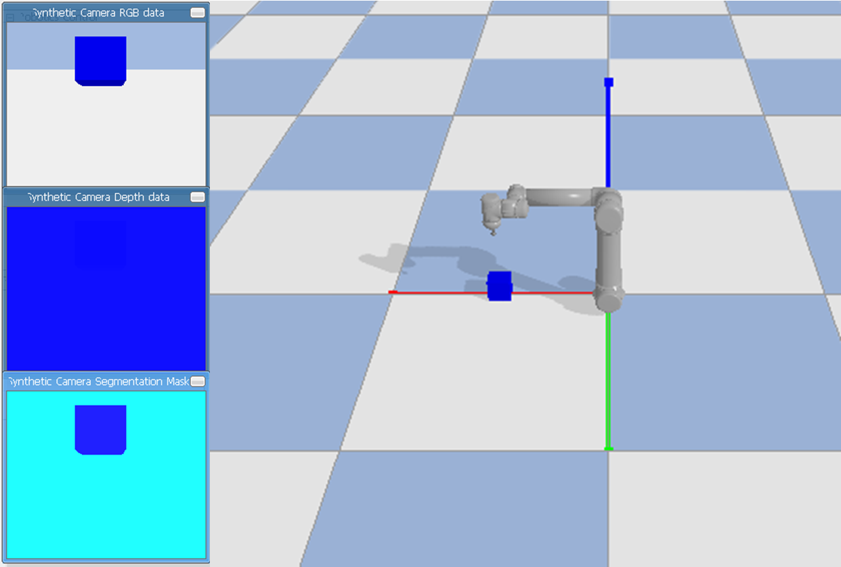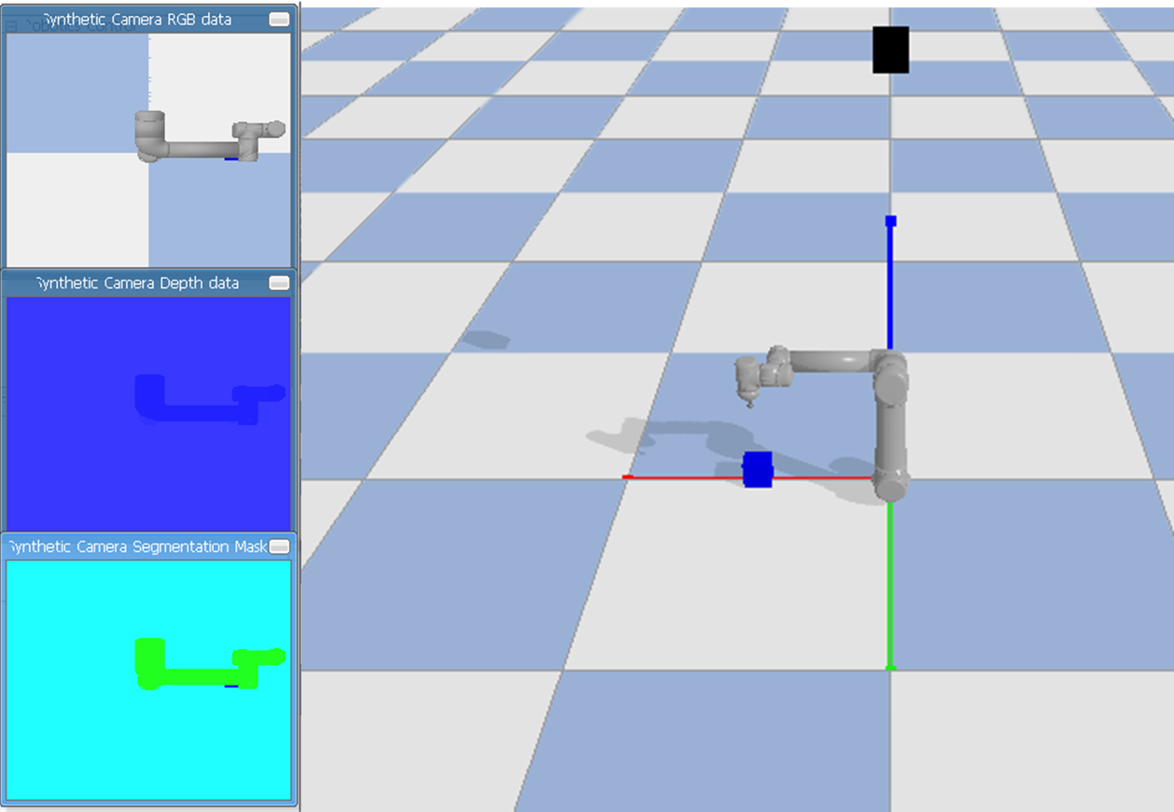
- (b)
Fig 1: PyBullet simulation environment for different camera configurations (a) Eye-in-hand (camera mounted on robot arm) (b) Eye-to-hand (fixed camera in workspace)

- Please start the assignment on time. A viva-based interaction will be conducted for evaluation. Refer to lecture notes for theoretical background.

We hope that this assignment deepens your understanding of vision-based estimation and control for manipulators!

Exercises:
The starter code and specific tasks to be carried out are provided in the form of a Github repository at this link. Please follow the description provided. If you find any kind of error in basic code, please correct yourself

The assignment has 4 exercises
- Part 1: Eye-in-hand object position estimation
- Part 2: Eye-to-hand object position estimation
- Part 3: Image-based visual-servoing (IBVS) for reaching the static object
- Part 4: Image-based visual-servoing for tracking the moving object

For Part 1 and Part 2, estimate the position (x, y, z) of a target object using the provided camera setup (end-effector-mounted for eye-in-hand, fixed external camera for eye-to-hand). Display the estimated object position and true position in the environment or terminal.
For Part 3, the goal is to control the robot end-effector so that it reaches a desired pose relative to a static object. You should also plot the error in the image space (pixel error vs time).
For Part 4, extend your IBVS implementation to track a moving object.
For parts 1-4, you are expected to deliver the following:
- Code implementation

Extra Credits:
- Implement occlusion handling using robust estimation or filtering.

Instructions:
- This assignment is to be done individually or in pairs or in trios. Working in trios is encouraged and will receive a bonus. Pairs will receive a smaller bonus relative to trios, and individual submissions will incur a penalty.
- We will create a google group for discussion. Please post your queries and also help others by responding to their queries (This will be rewarded too!)
- Please submit it on google form as a single zip file named <A1_StudentID>.zip or <A1_StudentID1_StudentID2>.zip or <A1_StudentID1_StudentID2_StudentID3>.zip. The zip file should contain a full code and running instructions
- The submission date is 5:00 pm IST on Wednesday, 18th November, 2025. Late submission will incur a daily 10% score adjustment for up to two days.
- This assignment will carry ~5-15% weightage overall. As mentioned, the instructor will provide the final weightage after closure of all assignments.
- Your first submission within the prescribed time period is final. Please do not ask for replacing the files later (e.g., on account of any incorrect upload). Such tampering beyond the submission time is not fair to other students in class who submit on time.
- The assignment must be done only from your own original efforts. Do not use any existing implementation/report from online sources. Do not violate the academic honesty code.
- Please write your implementation without use of AI code generators (e.g., GPT). Taking assistance from such tools will take away the opportunity to deeply understand the working of the algorithms. Hence, it is important to do this exercise on your own. A standard AI code generated solution will be part of automated code similarity checking, Submissions that resemble similarity beyond acceptance to standard AI-generated code will be flagged and treated as external assistance beyond your own effort.

