Data Analytics for Inpatient Prospective Payment System.
Analysis of the health care provider data to optimise the payment methods and health care.
By Dileesh Chandra Bikkasani,
Guide: prof. Jeongkyu Lee
Department of Technology Management, University of Bridgeport.
126 Park Ave, Bridgeport, CT 06604
dbikkasa@my.bridgepoort.edu

Abstract – The main aim of this paper is to analyse the data on inpatient prospective payment system which is a payment system used in hospitals to record the data of the payments for patients. The data used for analysis is from data.gov. This paper provides an in-depth sight of how MapReduce is used to analyse the data, details of implementation are provided clearly. For comparing and evaluating the results, Implementation of Hadoop Eco System tools like spark and Hive are done. Finally, this paper provides an insight to various patterns in the data selected after analysis.
- Introduction
The inpatient prospective payment system is a mechanism of payment which is used to reimburse the hospitals by a rate which is predetermined for the treatment of only some specific illnesses. This type of system is developed by Federal government of the U.S for treating of Medicare recipients,

To eliminate the payments of hospitals as scheduled by The Deficit Reduction Act which are because of certain complications of the inpatients, the payment system has been developed which is named for hospital-acquired conditions (HAC). “The Medicare centres defined that there are 11 types of complications based on several components, and the hospital-acquired conditions are not considered and removed from severity of Medicare which is termed as DRG diagnosis related groups” {Fuller, 2011 #1} [1].

DRG which is syllabic abbreviation of Diagnosis-related group is a system which classifies the cases in hospital to 467 groups and a group which is classified as ungroupable. This system to classify is developed by Robert B Fetter and John D. Thompson, with an intension to verify the provided products by the care. Appendectomy is the examples of the product which are provided by a hospital. To replace the reimbursement which is based on cost, this DRG system was developed to convince congress to use this system for reimbursing. Since 1982 the DRG system is being used to determine the amount which is being reimbursed by the hospitals, the hospital resources are expected to be used in the same level for the patients who are in a similar category. To identify the reimbursements the standard practice is DRG for any health care providers in home.

The main objective of the IPPS and DRGs is to make division system which will differentiate the items and services which the patient has got in the hospital. Since the development of such services the evolution and development of health care industry, which in turn demanded a need of a classification system for patients with an objective of providing higher level of accuracy. To satisfy this needs the system of DRG has evolved, there are several types systems which use DRG they are:
- DRG which has Medicare.
- DRGs which are refined
- All Patient DRGs which has All patients
- DRGs which are severe
- Severity-Adjusted which has all patients DRGs

As described by Rick Mayes in 2007 payment system is defined as:

The main influential innovation which happened after war in Medicare financing is the Prospective payment system, which is cause for the rise of economy of the medical field after the inflation, the prospective payment system saved the Medicare program from getting in to insolvency. The Reagan and the congress had their eyes on the method which could replace the current reimbursement system, rather than to treat the Medicare patients and reimbursing them with whatever the costs that are being charged, the new system is to set a predetermined cost based on diagnosis of the patient. With the DRG of the new prospective payment system there has been shift in the powers of politics and economy of the people who paid for the health care and the providers.
.
- Problem
The Health care has been one of the most underrated field, with almost many terabytes of data being generated every month, some of the problems that are being faced this health care system is that some of the treatments that patients get will remain uncompensated, medical education and payments have been losing the balance between themselves. And through the PPS the claims or the payments that are being made to the hospitals are cost-based retrospective, by which from the hospitals point of view is determined as revenue that is being generated by the costs. On the first day, the patient is supposed to pay a deductible except for that the patient receives free care. “Thus, the incentive was to provide any all services that had some benefit to the patient” {Sloan, 1988 #11}[2]

Below are some of the problems that are faced by the IPPS, which should be analysed and for which the solutions must be generated by evaluating and Analysing the data:

- To accommodate uncompensated care payments, while keeping up the harmony between the medical education and correct payments.
- By knowing the patterns and Analysing the data new technologies for the payment system must be developed.
- The quality of the service provided in the health care system should be improved by improving the way which patients get reimbursed for the treatment they get.
“we projected nationwide cost savings from eliminating payments associated with conditions that occurred after admission” (Lezzoni 2009) [3]. Research done by Lezzoni proved that the cost of payment services can be done.

After Analysing the data through Hadoop HDFS and different tools like Spark, MapReduce, HIVE, PIG the insights that will be shown are:

- From a single city how many providers are there?
- How many cities there are a single provider will be providing the services, in a given single state.
- In a single city who is the top service provider?
- Who is the least service provider?
- In one city, the money charged by the total service providers?

- DATA SET.
After doing research in various data driven websites where you can find many terabytes of data the field which I felt most interesting is health care system, IPPS inpatient prospective payment system is a payment service developed to reimburse the uncompensated care. After research from websites like the data.gov health records, Data mob, Quandl.com the data I got from Data.gov health records, the link for the data I selected is provided below:

https://www.data.gov/health/highlights
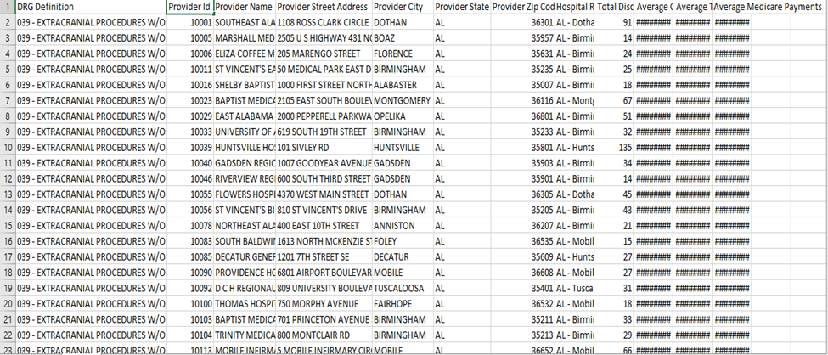

Above is the screenshot of the data I have selected

My data set has more than 160,000 records and it has various attributes it has a total of 12 columns, for which provides the service provider data is explained in terms of various aspects.

- Provider id: which provides the identification code of the provider, a string value with certain number of digits and letters combined.
- Provider name: this attribute provides the name of the provider which is a string value, every attribute in this gives the name of the provider.
- Provider street: street of the provider is given in string format
- Provider city: this gives the city of the provider.
- Provider State: State of the Provider which is a string.
- Provider Zip: zip code which includes an integer value.
- Provider Address: The Address of the provider is provided by this attribute.
- Hospital referrer: this attribute provides the one who referred the hospital.
- Total charges: total charges that are being charged.
- Average covered: Average amount which is covered.
- Average total payments: total payments which are made which is an integer value.
- Average Medicare payments: this is also a integer value.
Many interesting insights can be drawn by using the above provided attributes, we use the providers name and provider’s city to evaluate in which city has highest number of single providers. By knowing the averages covered and providers name, the least provider in the city can be known. By Analysing the average covered and providers in the city, money charged by the providers can be known.

Finally, by Analysing this data the average amount that can be reimbursed can be known, which would provide a basic knowledge for the Medicare providers what would be the average payments that would be provided for a person with certain DRG definition

- MAPREDUCE PROGRAMMING.
A simple model of MapReduce is provided in this analysis, this provides the usage of various classes in MapReduce how he various classes have been assigned to get the desired result. A MapReduce library can be written in many programming languages which include java and python, in the project python scripting is used for executing a small MapReduce program. One part of the Apache Hadoop is a popular implementation which is open-source and which has support for the shuffles which are distributed.
There are three classes in the model of a MapReduce which are Mapper class, Reducer class and a driver class. Mapper configuration is provided in a mapper class which does the work of how the input should be read, in which way the data should be converted into small pieces or chunks and parsing logic. In the reducer in-order to capture the output in a single file we will mention how we will group the data and provide the separated input. And in the driver class the configuration of classes, input, output directories information, mapper, reducer will be provided.
Now after the development of the three classes is done the entire code of the MapReduce will be exported as a JAR file and which will be placed in a Hadoop Distributed File System, using the workflow scheduler the job will be scheduled, we can see the output in the directory mentioned after the job is Analyzing service providers based on a particular area the code for the mapper, reducer and driver will be written as

Mapper code:

package org;

import java.io.IOException;
import java.util.StringTokenizer;
import org.apache.hadoop.io.Text;
import org.apache.hadoop.mapreduce.Mapper;

public class PatientMapper extends Mapper<Text,Text,Text,Text> {

private Text word = new Text();

public void map(Text key, Text value, Context context) throws IOException, InterruptedException
{
StringTokenizer itr = new StringTokenizer(value.toString(),",");
while (itr.hasMoreTokens())
{
word.set(itr.nextToken());
context.write(key, word);
}
}
}

Reducer code:

package org;

import org.apache.hadoop.io.Text;
import org.apache.hadoop.mapreduce.Reducer;
import java.io.IOException;

public class PatientReducer extends Reducer<Text, Text, Text, Text> {

private Text result = new Text();

@Override
protected void reduce(Text key, Iterable<Text> values, Context context) throws IOException, InterruptedException {
String translations = "";

for (Text val : values) {
translations += "|" + val.toString();
}

result.set(translations);
context.write(key, result);
}
}

Driver Code:
package org;

import org.apache.hadoop.mapreduce.Job;
import org.apache.hadoop.mapreduce.lib.input.FileInputFormat;
import org.apache.hadoop.mapreduce.lib.output.FileOutputFormat;
import org.apache.hadoop.mapreduce.lib.output.TextOutputFormat;
import org.apache.hadoop.conf.Configuration;
import org.apache.hadoop.fs.Path;
import org.apache.hadoop.io.Text;
import org.apache.hadoop.mapreduce.lib.input.KeyValueTextInputFormat;

public class PatientDriver {

public static void main(String[] args) throws Exception
{
Configuration conf = new Configuration();
Job job = new Job(conf, "Patientinfo");
job.setJarByClass(PatientDriver.class);
job.setMapperClass(PatientMapper.class);
job.setReducerClass(PatientReducer.class);
job.setOutputKeyClass(Text.class);
job.setOutputValueClass(Text.class);

job.setMapOutputKeyClass(Text.class);
job.setMapOutputValueClass(Text.class);

job.setInputFormatClass(KeyValueTextInputFormat.class);
job.setOutputFormatClass(TextOutputFormat.class);
FileInputFormat.addInputPath(job, new Path(args[0]));
FileOutputFormat.setOutputPath(job, new Path(args[1]));
boolean result = job.waitForCompletion(true);
System.exit(result ? 0 : 1);
}
}

After the analysis using MapReduce is done, Spark, Hive and Pig will be used to analyse the data selected. The queries that are provided for the implementation are as follows,

Spark:
spark using Python source code:

rdd = sc.textFile("/FileStore/tables/y9p0n5601490966121118/Patientinfo.csv") //creation of object and reading the input file
print rdd.collect() //command to print the output
print rdd.take(4) // command to take only few records from entire output.

PIG:
PIG Source code:

//Loading data from HDFS to PIG and creating the schema
A = LOAD '/user/hue/Patientinfo.csv' USING PigStorage(',') AS
(DRGDefinition:chararray, ProviderId:int, ProviderName:chararray, ProviderStreetAddress:chararray, ProviderCity:chararray, ProviderState:chararray, ProviderZipCode:int, HospitalReferralRegionDescription:chararray, TotalDischarges:int, AverageCoveredCharges:int, AverageTotalPayments:int, AverageMedicarePayments:int);

//Applying filter conditions
B = FILTER A BY (TotalDischarges > 100);

//Display the output
DUMP B;

- DATA ANALYSIS:

After the analysis, the results we get from executing the above Spark, HIVE and PIG may provide some solutions for some providers who have problem with the IPPS, also it may find patterns in the data. I have analysed the data using the tools like HDFS using the virtual machine of the Cloudera and uploaded the data into it. Using the putty manager, I have connected the local host and VM virtual machine.

After executing the MapReduce code as we provided mapper code, reducer code and driver class code the output after executing the code will be as below:
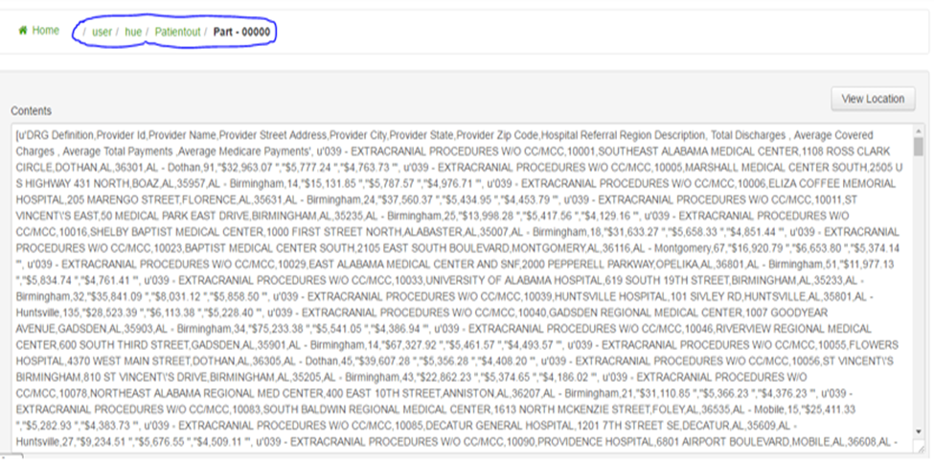

To analyse the large data sets Apache Pig is used for performing, for expressing the data analysis PIG consist of a language which is high level and which can be coupled to get the programs evaluated. One of the main feature of the PIG is that it is structured to handle data parallelly, which allows parallelization of data. Which is used for handling very large data sets.

Here, I have created schema for PIG to load input data and to perform some validation on top of it. Below is a snippet of the result I got after executing the pig script:

.
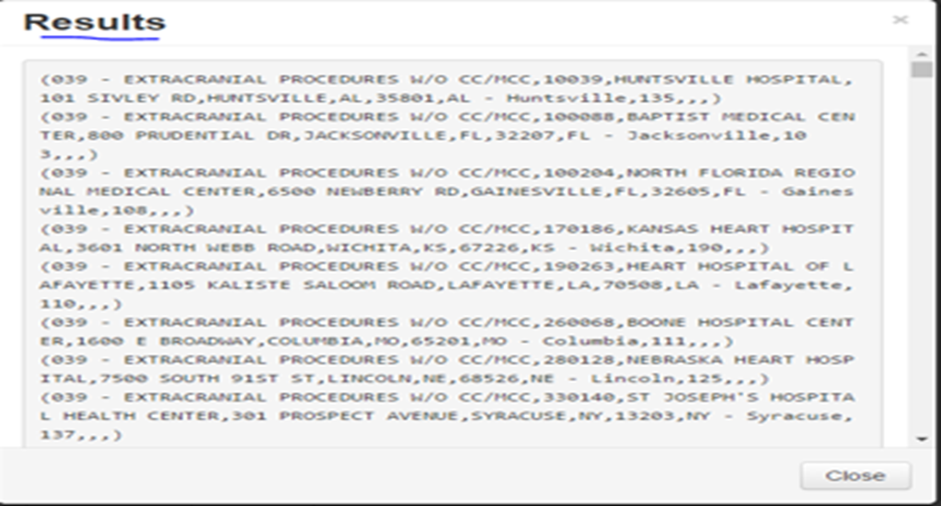

Using the Spark, I have implemented with the python I have worked with the same input file, rather than competing with the entire Hadoop ecosystem spark competes more with the MapReduce as it is a cluster-computing framework. Spark can use the distributed file system as it does not have its own distributed file system. MapReduce is a disk-based system, whereas spark uses memory and disk will be used for disk processing.
After executing the spark the output will be as shown as below:

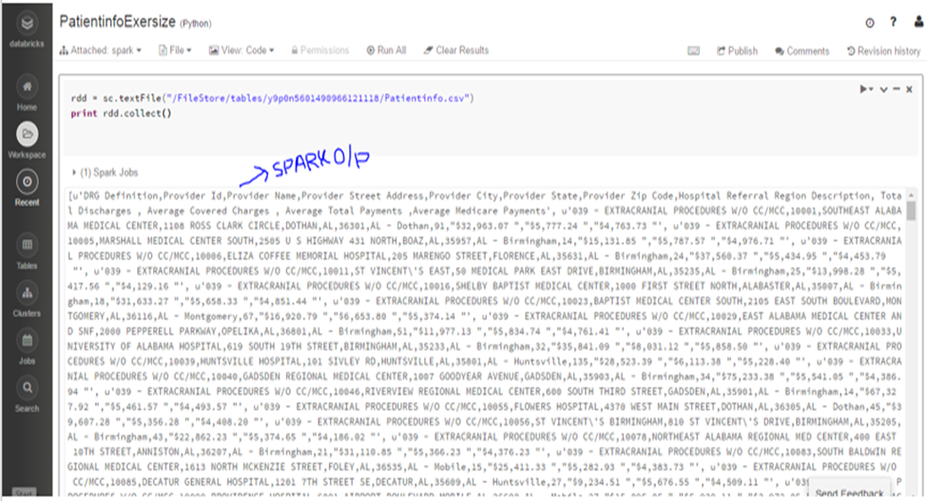

- CONCLUSION

The data in the field of health care is ever growing these days due to the complication of the health care procedures, such data should be processed and analysed for better results. IPPS payment system should be considered for covering the uncompensated care. By evaluating the results, the providers can identify and fix certain amount for covering the care of patients, initially the patients should be paying some co-pay amount which will later be covered in the care. The DRG system which is developed should have some benefits using the results in this paper. The service quality can be increased by using the results in the paper, which is the way in which the patients get reimbursed.
- References
[1] Fuller, R. L., et al. (2011). "A New Approach to Reducing Payments Made to Hospitals with High Complication Rates."
[2] Iezzoni, L. I. (2009). "Reinvigorating the Quality Improvement Incentives of Hospital Prospective Payment."
[3] Sloan, F. A., et al. (1988). "Effects of the Medicare Prospective Payment System on Hospital Cost Containment: An Early Appraisal." The Milbank Quarterly 66(2): 191-220.
In 1983 federal efforts to contain hospital costs were coalesced under the Medicare prospective payment system (PPS)-a "self-interest" approach to administered prices. Diagnosis-related groups (DRGs) and the tougher peer review organizations (PROs) serve to define "products"; PPS sets the price on each. The effects of PPS go beyond Medicare; they have been system-wide.

