HOW TO JOIN MERCHANT NAVY AFTER 12TH?
A 2026 SEO-Optimized Career Guide
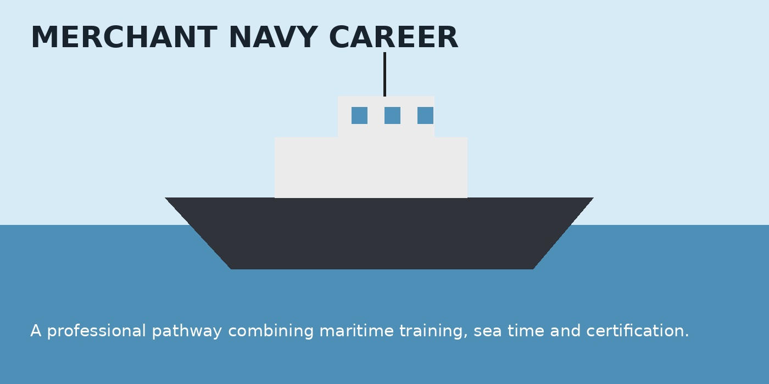
Image: Merchant Navy career and shipboard environment
SEO CONTENT BRIEF
Primary keyword | how to join Merchant Navy after 12th
Secondary keywords | Merchant Navy after 12th; Merchant Navy eligibility; Merchant Navy courses after 12th; IMU-CET; B.Sc Nautical Science; DNS; B.Tech Marine Engineering
Search intent | Informational / career guidance
Meta title | How to Join Merchant Navy After 12th? 2026 Guide
Meta description | Learn how to join Merchant Navy after 12th, including PCM eligibility, courses, IMU-CET, medical fitness, training and career pathways.
Introduction
Wondering how to join Merchant Navy after 12th? The Merchant Navy offers a specialised career at sea in navigation, marine engineering and ship operations. For students who enjoy technical subjects, discipline and an international working environment, it can be a rewarding professional path. The first step is choosing the right course and checking the latest official eligibility rules.
1. Check Your Eligibility
For officer-level programmes, students typically need Class 12 with Physics, Chemistry and Mathematics (PCM), along with the required English qualification. For example, IMU’s 2026 prospectus lists 60% aggregate in PCM and 50% in English for relevant UG maritime routes. Candidates must also satisfy prescribed medical, eyesight and hearing standards. Always check the latest prospectus before applying.
2. Choose the Right Merchant Navy Course
If you want a deck career focused on navigation, consider B.Sc. Nautical Science or Diploma in Nautical Science (DNS). If you prefer engines, machinery and technical systems, B.Tech Marine Engineering is the relevant route. Your course determines the training structure and the type of onboard career you pursue.
3. Clear the Admission Process
For B.Sc. Nautical Science and DNS, IMU states that IMU-CET is mandatory for admission. Depending on the route, candidates may also need institute-level requirements or company sponsorship. Compare course duration, fees, placement support and approval status before paying any institute.
4. Train at an Approved Institute
Choose a maritime training institute approved by India’s Directorate General of Shipping (DGS). After academic and practical training, candidates complete the required sea training and progress toward the examinations and certification needed for officer-level service.
Career Outlook
With the right qualifications and sea experience, a deck officer can progress through ranks toward Chief Officer and Master, while marine engineers can advance toward senior engineering roles. Progress depends on certification, performance, sea time and employer requirements.
Final Takeaway
To join the Merchant Navy after 12th, follow a simple path: meet PCM and medical requirements, select the right maritime course, complete the required admission process, train at an approved institute and build the sea experience needed for certification. Use official IMU and DGS sources when making your final decision.
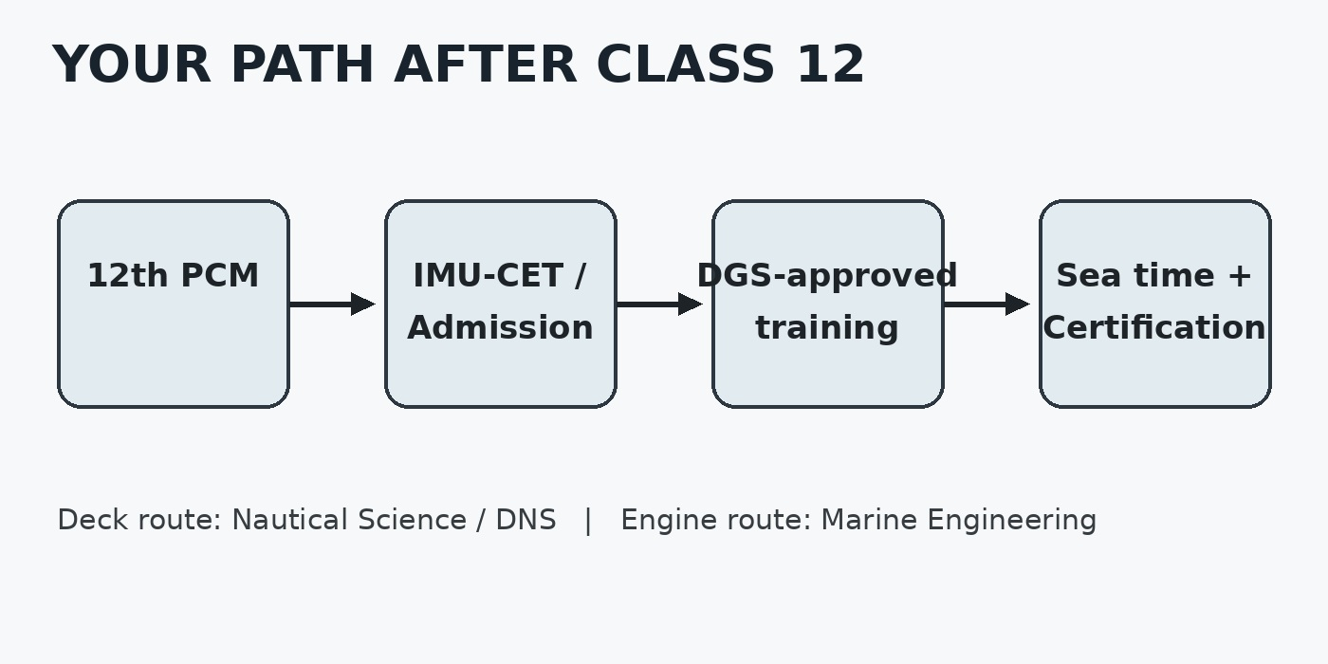
Image: Typical pathway from Class 12 to a Merchant Navy career
EDITORIAL & SOURCE NOTE
Information was aligned with current official Indian Maritime University (IMU) 2026–27 admission/prospectus information and the Directorate General of Shipping (DGS) approved-training guidance. The article deliberately avoids guaranteed salary or placement claims because outcomes vary by rank, company, certification and experience.
Official references: Indian Maritime University (IMU) — Admissions 2026–27; Directorate General of Shipping (DGS) — Approved Training Institutes.
Prepared as an SEO content writing assignment | 2026

