1.What are the two values of the Boolean data type? How do you write them?

Answer:

**boolean type is one of the built-in data types provided by Python, which represents one of the two values i.e. True or False**

2. What are the three different types of Boolean operators?

Answer: **AND, OR, and NOT**

3. Make a list of each Boolean operator's truth tables (i.e. every possible combination of Boolean values for the operator and what it evaluate ).

Answer:

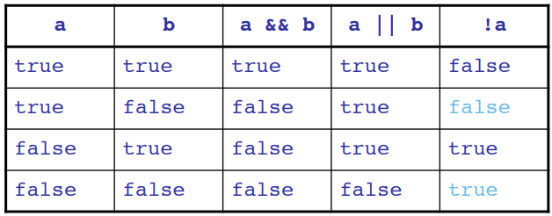

4. What are the values of the following expressions?

(5 > 4) and (3 == 5)

not (5 > 4)

(5 > 4) or (3 == 5)

not ((5 > 4) or (3 == 5))

(True and True) and (True == False)

(not False) or (not True)

Answer:

(5 > 4) and (3 == 5)🡪 **False**

not (5 > 4)🡪**False**

(5 > 4) or (3 == 5)🡪**True**

not ((5 > 4) or (3 == 5))🡪**False**

(True and True) and (True == False)🡪**False**

(not False) or (not True)🡪**True**

5. What are the six comparison operators?

Answer:

**Python has six comparison operators, which are as follows:**

* **Less than ( < )**
* **Less than or equal to (<=)**
* **Greater than (>)**
* **Greater than or equal to (>=)**
* **Equal to ( == )**
* **Not equal to ( != )**

6. How do you tell the difference between the equal to and assignment operators? Describe a condition and when you would use one.

Answer:

**Assign operator are used to assign value and in other side Comparison operator is used for compare two values. For Example:-**

**x=12 #assign the value of x**

**y=13 # assign the value of y**

**print(x==y) #comparing the values of x and y**

**In the above code we can see that in the first line we are assigning value of x and same in second line of code but in third line we are comparing the values of x and y and it will return True or False according to values.**

7. Identify the three blocks in this code:

spam = 0

if spam == 10:

print('eggs')

if spam > 5:

print('bacon')

else:

print('ham')

print('spam')

print('spam')

Answer:

**The three blocks are everything inside the if statement and the lines print('bacon') and print('ham').**

8. Write code that prints Hello if 1 is stored in spam, prints Howdy if 2 is stored in spam, and prints Greetings! if anything else is stored in spam.

Answer:

**spam = int(input())**

**if spam == 1:**

**print('Hello')**

**elif spam == 2:**

**print('Howdy')**

**else:**

**print('Greetings!')**

9.If your programme is stuck in an endless loop, what keys you’ll press?

Answer:

**Ctrl + C**

10. How can you tell the difference between break and continue?

Answer:

**break and continue statements can alter the flow of a normal loop. Loops iterate over a block of code until test expression is false, but sometimes we wish to terminate the current iteration or even the whole loop without checking test expression. The break and continue statements are used in these cases.**

**Break: Jumps out of the closest enclosing loop (past the entire loop statement)**

**Continue: Jumps to the top of the closest enclosing loop (to the loop’s header line)**

11. In a for loop, what is the difference between range(10), range(0, 10), and range(0, 10, 1)?

Answer: **There is no difference and result will be range(0, 10)**

12. Write a short program that prints the numbers 1 to 10 using a for loop. Then write an equivalent program that prints the numbers 1 to 10 using a while loop.

**Answer:**

**Using for loop:**

**for i in range(1,11):**

**print(i)**

**Using while loop:**

**i = 1**

**while i <= 10:**

**print(i)**

**i += 1**

13. If you had a function named bacon() inside a module named spam, how would you call it after importing spam?

Answer:

**spam. bacon().**