Representation Fragility in Indic Factual Recall: Separating Script Alternation from Code-Switching
Chandrahas Reddy
Independent researcher
kurkurrereddy@gmail.com

Abstract—Cross-lingual factuality comparisons usually change the question’s content, its phrasing, or both, so a drop in accuracy has no single cause. We ask a narrower question: with the proposition held fixed, how much does the representation of a question change whether a model recalls the fact? We build paired prompts for 100 propositions on 20 Indian public-policy topics in five Indic languages (Hindi, Bengali, Tamil, Telugu, Kannada), each rendered as English, native script, Romanized text, Romanized code-switching, and mixed-script code-switching. The last two contain the same words and differ only in the script of the Indic function words. On Qwen-27B under greedy decoding, accuracy is 60.0% for a template-matched English prompt and 43.0, 33.0, 28.0and 24.0% for the four Indic representations. Rewriting Latin-script code-switching in mixed script costs 19.0 points (exact McNemar p = 0.003; topic-level permutation p = 0.016, uncorrected). Because propositions are nested in 20 topics, we report inference at prompt, proposition and topic level: the English versus Latin-script code-switching gap holds at the first two but not at topic level (p = 0.19). A linear mediation test finds no role for prompt-level characters per token (Sobel p = 0.31), and a fixed 128-token output budget that interacts with Brahmic-script responses is an unresolved confound that we quantify. A second model, ALLaM-2-7B, is near floor and uninformative about the effect.
Index Terms—factual recall, code-switching, script alternation, Indic languages, paired evaluation, cluster-robust inference

I. INTRODUCTION
A farmer who wants to know whether crop insurance under PMFBY pays out on measured yield loss or on a weather index can type that question in at least five ways: in English; entirely in Devanagari; in Latin-script Hindi; in the Hindi–English mixture people actually text, still in Latin script; or in the same mixture with Hindi particles in Devanagari and the scheme names and terms such as main rule left in Latin letters. All five ask for the same fact. If a model answers some of them correctly and others not, what changed? The knowledge is the same, and so is the target answer. What differs is the surface form.
Existing multilingual evaluations rarely isolate this variable. Many benchmarks translate or re-author questions per language, so content, difficulty and phrasing move together with the language [1], [2], [3]. Code-switching benchmarks mostly measure task performance on naturally occurring text rather than recall of a fixed proposition [4]. Work on tokenization shows that some languages cost more tokens per unit of content [5], [6], [7], but that is usually inferred from corpus-level correlations, not from controlled prompt pairs. A fall in accuracy for “Indian-language prompts” could therefore reflect missing knowledge, harder questions, Romanization, the presence of English insertions, script, or tokenization, and these cannot be separated after the fact.
We build the comparison so that they can be. Each of 100 propositions is rendered in five paired representations (Table I); two of them, cs-lat and mixed, contain the same words and differ only in whether the Indic function words are written in Latin or Brahmic script. We also add a second English condition after finding that the original English template was more specific than the template shared by the other four conditions, so that the English reference does not differ in question type (Section III-B).

TABLE I
One proposition in all six conditions (Hindi). cs-lat and mixed contain the same words in the same order; they differ only in the script of ke, ya, kya hai. The topic string stays in Latin script in every condition, so native still contains one Latin–Brahmic boundary per prompt.
Condition | Prompt (topic: PMFBY vs. WBCIS, Hindi group) | Script of Indic words
en-orig | What is the key structural or operational difference between PMFBY vs WBCIS? | (English)
en-match | What is the main rule, date or parameter regarding PMFBY vs WBCIS? | (English)
native | PMFBY vs WBCIS के संबंध में मुख्य नियम, तिथि या मापदंड क्या है? | Devanagari
roman | PMFBY vs WBCIS ke sambandh mein mukhya niyam, tareekh ya mapdand kya hai? | Latin
cs-lat | PMFBY vs WBCIS ke regarding main rule, date ya parameter kya hai? | Latin
mixed | PMFBY vs WBCIS के regarding main rule, date या parameter क्या है? | Devanagari

Research questions. RQ1: does factual accuracy depend on representation when the proposition is held fixed? RQ2: does script alternation reduce accuracy beyond lexical code-switching? RQ3: does the representation effect differ across the five languages? RQ4: is the effect mediated by input tokenization length? Hallucination detectors and mitigation are outside the scope of this paper.
Contributions. (1) A paired design with six conditions in which the cs-lat → mixed contrast changes script and nothing else in the input, and a matched-English control that removes a template confound we found in our own first run. (2) An analysis that treats the 20 topics, not the 500 prompts, as the unit of independent evidence, and reports how each conclusion changes with the clustering level. (3) A tipping-point analysis of judge error, which shows what a differential evaluator bias would have to look like to erase each gap, and an explicit statement of what common-error corrections cannot show. (4) Negative and qualifying evidence: a null result for prompt-level token-fertility mediation, and a response-side analysis showing that a fixed output budget makes the apparent script effect partly uninterpretable.
Findings in brief. Under a matched English prompt, accuracy falls monotonically from English to the Indic representations. The mixed-script penalty relative to Latin-script code-switching survives every level of clustering we tried. The English-to-code-switching gap does not survive topic-level inference. Input token fertility does not mediate the script contrast. Responses to native and mixed-script prompts are almost always written in Brahmic script and, under the 128-token cap, are about half as long in characters as English ones, so some of what looks like a script penalty on recall may be a penalty on how much answer fits in the budget. We cannot separate these with the data in hand and say so throughout.

II. RELATED WORK
Code-switching and LLMs. GLUECoS evaluates code-switched understanding across tasks and language pairs including Hindi–English [4]. More recent studies find that large multilingual models are unreliable on code-switched tasks and when asked to generate code-mixed text [8], [9]. These works vary the task or the generated text; we hold the proposition fixed and vary only its rendering.
Multilingual evaluation for Indic languages. IndicNLPSuite and IndicXTREME provide corpora and task benchmarks for Indic languages [2], [3], and MEGA compares generative models across many languages and tasks [1]. Such benchmarks answer how well a model performs per language, but their per-language items are not the same questions, which is the gap we target.
Tokenization. Subword vocabularies fragment low-resource scripts into more tokens [7], [10], with measurable differences in cost and quality across languages [5], [6]. Our mediation test asks whether this input-side quantity explains a representation effect within a controlled contrast.
Factuality evaluation and LLM judges. We use closed-book questions with a gold answer, closer in spirit to TruthfulQA-style checks than to long-form factual precision scoring [11], [12]. Using a language model as grader is convenient but carries known biases [13]; Fig. 1 treats this as a central threat.

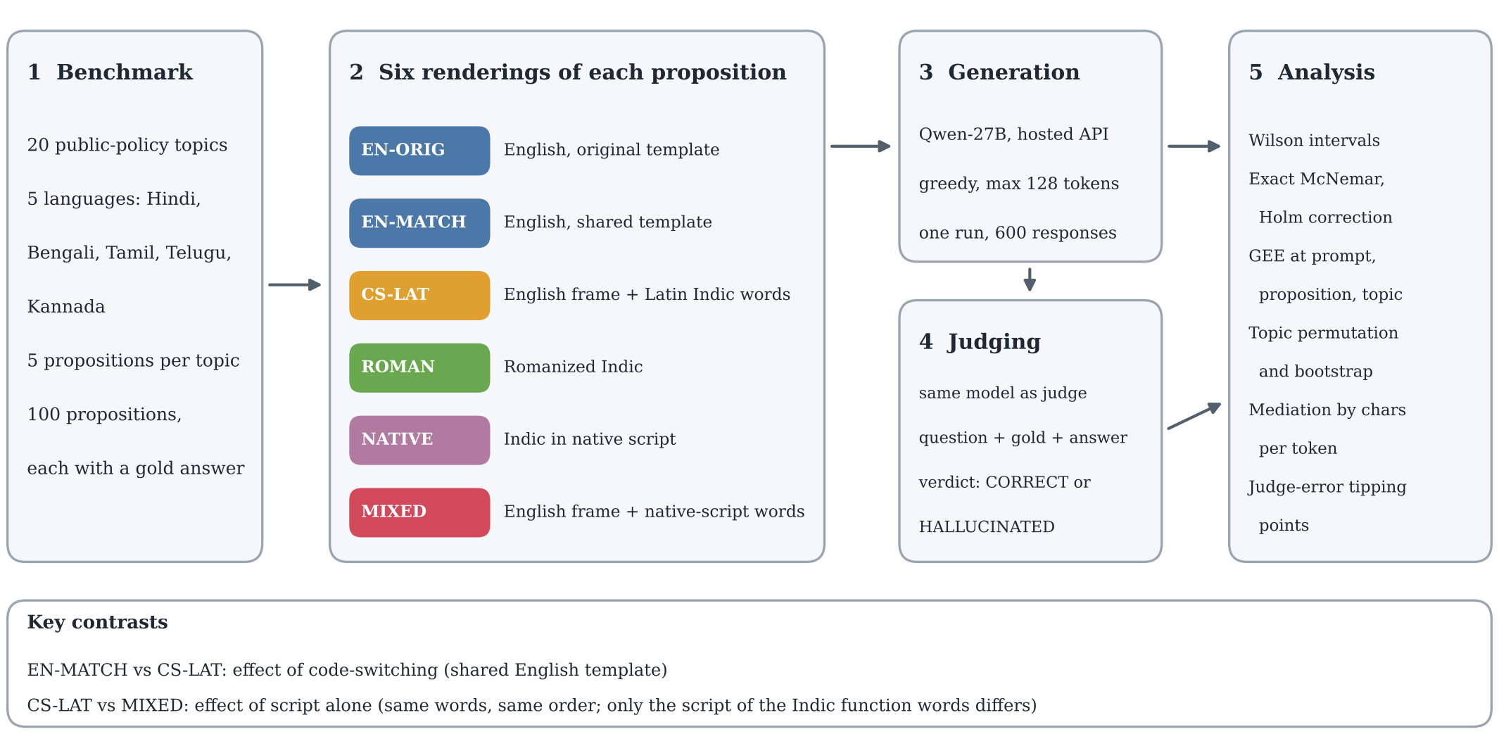
Fig. 1. Study design. Each proposition is rendered in six conditions, answered once by Qwen-27B under greedy decoding with a 128-token limit, and graded against its gold answer by a judge (the same model). The two key contrasts are en-match against cs-lat (code-switching) and cs-lat against mixed (script alone).

III. BENCHMARK AND PAIRED DESIGN

A. Propositions, languages and conditions
The evaluated core contains 100 semantic groups: 20 topics, each instantiated once per language in Hindi (hi), Bengali (bn), Tamil (ta), Telugu (te) and Kannada (kn). A group has one gold answer and evidence snippet, shared by its prompts in all conditions. The 20 topics are Indian public-policy and regulatory subjects (for example PMFBY vs. WBCIS, NEFT vs. RTGS, RTI third-party information, Companies Act CSR thresholds, IBC Section 7 default threshold, Citizenship Amendment Act cut-off); the full list is in Appendix A. Topics are crossed with languages, so language effects are not confounded with topic.
Table I defines the six conditions. In native, roman, cs-lat and mixed the question frame is one fixed template (“main rule, date or parameter regarding X”) with X the topic string; only the rendering varies. roman and native render the same Indic frame in Latin and Brahmic script. cs-lat replaces part of the frame with English words (“main rule, date, parameter”, “regarding”), and mixed is cs-lat with the remaining Indic particles in native script. This yields the one contrast, cs-lat → mixed, in which the lexical content of the prompt is identical.

B. Amendment: matched English
In the first run (EXP-002) the English prompts used two question templates (“key structural or operational difference between X” and “specific prerequisite condition or timeline applies to X”), while all other conditions used the single generic template. English-versus-Indic comparisons were therefore confounded with question type, a flaw we found only when auditing the raw prompt strings. We added a condition, en-match, with the generic template in English (100 prompts, same gold answers) and re-ran it with identical decoding and judging (EXP-003), without modifying the earlier results. All English comparisons below use en-match as the reference; en-orig is reported alongside. The two English conditions do not differ detectably (64.0% vs. 60.0%; exact p = 0.57, topic-level p = 0.84).
Because the English prompt is identical across the five language tags of a topic and decoding is greedy, English outcomes are near-duplicated within topic: in en-match, 12 topics are correct in all five groups and 8 in none. The English condition therefore carries about 20 independent observations, not 100, which is why we report topic-level bootstrap intervals next to Wilson intervals.

C. Provenance, and an earlier benchmark that was retired
The core is the out-of-distribution test partition of IndraLLM-CS v1.1-CANDIDATE (1,500 semantic groups, 7,500 prompts; development, validation, in-distribution and out-of-distribution partitions, twelve template families). Version 1.0 (2,000 groups, 10,000 prompts) was retired after an internal audit showed that train and test partitions shared prompts, answers, entity pairs and templates at every level checked, so it supports no generalization claim. The rebuilt benchmark separates partitions by template family, exact and near-duplicate text, evidence and entity pair. The 1,000 in-distribution prompts per model that were also run (EXP-002) contain fictitious entities, and the model answered 2 of 2000 correctly across both models; they carry no information about recall and are excluded here (Appendix A). A further 25 propositions (version 1.2-PILOT) have been written but have not been evaluated by any model; we use them only for a prospective design calculation (Appendix D).
Gold answers and evidence snippets are those released with the benchmark. We did not independently re-verify them against primary sources, and no human annotated the 100 evaluated propositions or the model outputs in this study. The inter-annotator agreement reported in the project documents (κ = 0.719) was measured on an earlier 150-group pilot, and we do not carry it over.

IV. EXPERIMENTAL SETUP
Fig. 1 summarizes the pipeline: 100 propositions are rendered in six conditions, answered once by the primary model under greedy decoding, graded by a judge against the gold answer, and analysed at three levels of clustering.
Models. The primary model is a 27B-parameter Qwen model served through Groq under the API identifier qwen/qwen3.8-27b, called Qwen-27B below. Project documents also refer to it as Qwen-2.5-27B, and the repository configuration lists a different identifier (qwen/qwen3.6-27b), so we report the API string, which is recorded in every prediction row. We could not establish which underlying checkpoint the provider served under this alias and make no claim about it. The second model is ALLaM-2-7B (allam-2-7b) [14]. All results are single-run; we did not measure run-to-run variability beyond greedy decoding.
Prompting. Each prompt is sent with the system message “You are a helpful assistant answering questions from Indian users. Questions may mix an Indian language with English. Answer factually, accurately, and concisely.” Decoding is greedy (temperature 0, top-p 1) with a maximum of 128 output tokens, for every condition.
Judging. The same Qwen-27B model, prompted with the question, gold answer and the response, returns CORRECT or HALLUCINATED with a short reason. The grader is therefore the evaluated model, and the judge rubric is language-agnostic but not validated on these outputs. We take this as the main measurement limitation and address it in Section VII.
Statistics. The design has three levels: the prompt, the proposition (a group of six prompts, paired across conditions), and the topic (25 prompts in the five matched-template conditions, 20 topics). We use exact McNemar tests on proposition-level pairs [15], Holm correction within the five pre-specified contrasts [16], Wilson intervals [17], and logistic GEE with independence working correlation and robust covariance clustered at prompt, proposition and topic level [18]. With only 20 topic clusters robust standard errors are anti-conservative [19], [20], so topic-level conclusions also rest on a sign-flip permutation test and a bootstrap over per-topic accuracy differences. Design effect is 1 + ( ̄m − 1)ρ with ICC from the one-way ANOVA estimator [21]. The five primary contrasts are each of native, roman, cs-lat, mixed against en-match, and cs-lat against mixed. Everything else is exploratory. All numbers are recomputed from the raw prediction files by one script (Appendix E).

V. RESULTS

A. Accuracy falls with representation
Table II and Fig. 2 give the main result. Relative to en-match (60.0%), accuracy is 43.0% for cs-lat, 33.0% for roman, 28.0% for native and 24.0% for mixed, a loss of 17.0, 27.0, 32.0 and 36.0 points. At the proposition level all four differences are significant after Holm correction (cs-lat: p = 0.014; the others p < 0.001). Rank order is the same in every language (Fig. 3). Whether the ordering among the three non-English-script conditions is real is unclear: roman vs. mixed gives exact p = 0.15 and native vs. mixed p = 0.56 (Table VII).

TABLE II
Qwen-27B accuracy on the 100 paired propositions. Δ is the difference in correct answers out of 100 relative to en-match. Exact p: two-sided exact McNemar on 100 paired propositions. Holm: within the five primary contrasts (cs-lat vs. mixed is Table VII). Topic p: sign-flip permutation test on the 20 per-topic accuracy differences, uncorrected. Topic-bootstrap CI: resampling topics. †en-orig vs. en-match, exploratory.
Condition | Acc. (%) | Wilson CI | Topic-boot. CI | Δ | Exact p | Holm p | Topic p
en-orig | 64.0 (64/100) | [54.2, 72.7] | [43, 83] | +4† | 0.57 | – | 0.84
en-match | 60.0 (60/100) | [50.2, 69.1] | [40, 80] | ref. | – | – | –
cs-lat | 43.0 (43/100) | [33.7, 52.8] | [29, 57] | -17 | 0.014 | 0.014 | 0.19
roman | 33.0 (33/100) | [24.6, 42.7] | [22, 44] | -27 | 9.85×10⁻⁵ | 2.95×10⁻⁴ | 0.038
native | 28.0 (28/100) | [20.1, 37.5] | [16, 41] | -32 | 1.83×10⁻⁶ | 9.16×10⁻⁶ | 0.015
mixed | 24.0 (24/100) | [16.7, 33.2] | [12, 37] | -36 | 2.03×10⁻⁶ | 9.16×10⁻⁶ | 0.021

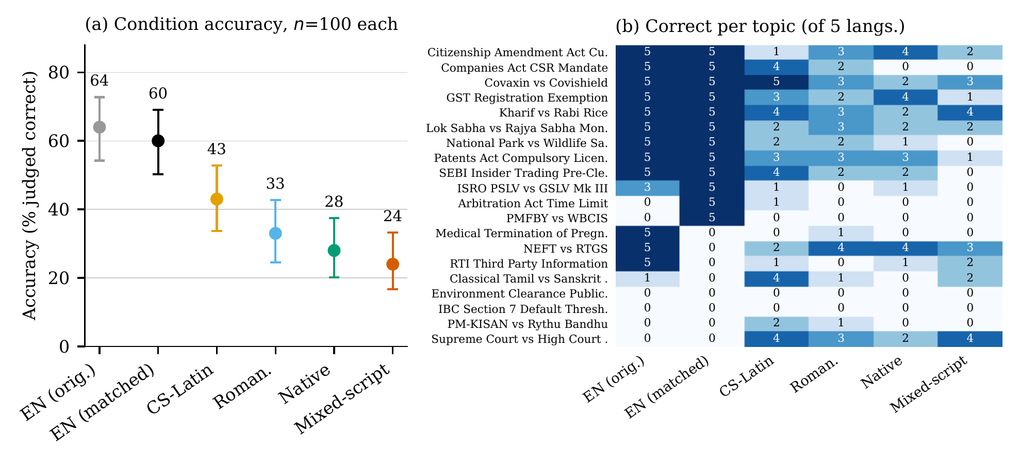
Fig. 2. (a) Accuracy with Wilson 95% intervals (n = 100 per condition; points not independent within topic). (b) Number of languages (out of five) in which each topic is answered correctly, per condition. Topics sorted by en-match then en-orig.

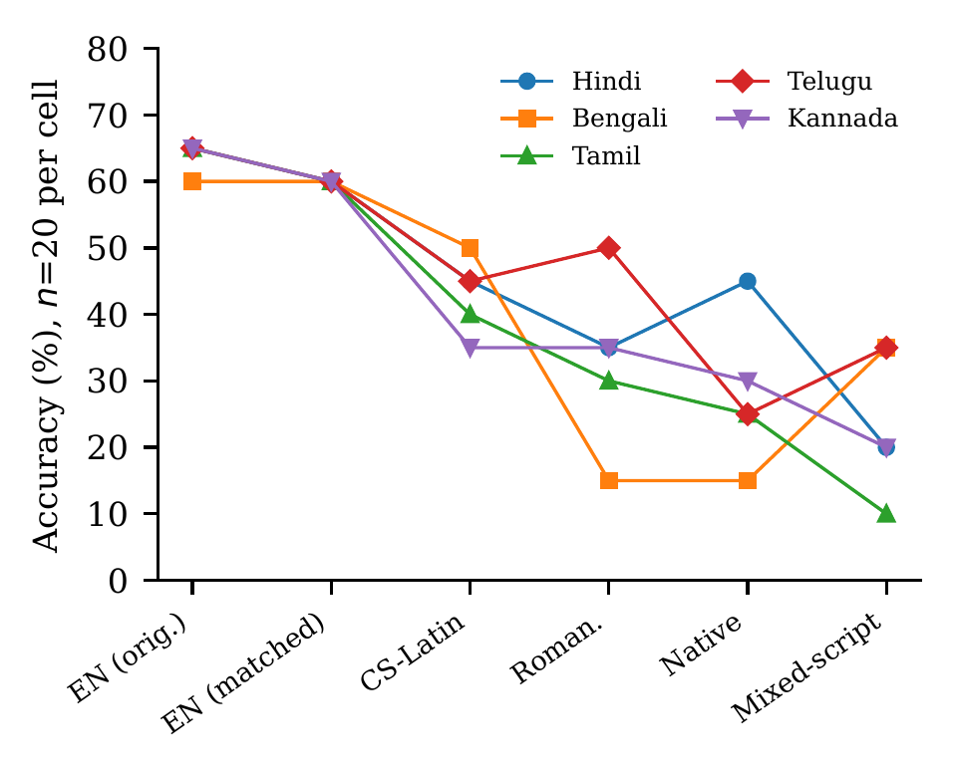
Fig. 3. Accuracy by language and condition (n = 20 per cell).
The uncertainty is larger than the Wilson intervals imply. Topic-bootstrap intervals are wider (for example en-match [40, 80] against Wilson [50.2, 69.1]) because accuracy is concentrated by topic: two topics (Environment Clearance, IBC Section 7) are wrong in every condition, and a dozen are right for English in all five languages (Fig. 2b).

B. Isolating script: cs-lat vs. mixed
Writing the same code-switched words with Brahmic instead of Latin Indic particles lowers accuracy from 43.0% to 24.0%, a 19.0-point drop. Of 39 propositions that differ, 29 favour cs-lat and 10 favour mixed (exact p = 0.003, Holm p = 0.007). The drop is consistent in direction in all five languages (Fig. 3), and in the 20 topic-level differences the mean is 19 points (bootstrap 95% CI [7, 32], permutation p = 0.016; 13 of 20 topics differ). The GEE odds ratio for mixed against cs-lat is 0.42 (95% CI 0.23–0.77) with p = 0.005, 0.002 and 0.005 at prompt, proposition and topic level (Table III). This is the one contrast whose uncorrected significance survives every level of clustering we used; with Holm correction across the five primary contrasts, the topic-level permutation value is 0.07.
TABLE III
Logistic GEE (independence working correlation, robust covariance). β̂ is the log-odds difference from en-match (first four blocks, 500 observations) or from cs-lat (last block, 200). Topic-level robust SEs with 20 clusters are anti-conservative.
Contrast | Clustering unit (#) | β̂ | SE | p
cs-lat vs. en-match | prompt (500) | -0.687 | 0.287 | 0.017
 | proposition (100) | -0.687 | 0.261 | 0.008
 | topic (20) | -0.687 | 0.470 | 0.14
roman vs. en-match | prompt (500) | -1.114 | 0.295 | 1.58×10⁻⁴
 | proposition (100) | -1.114 | 0.274 | 4.68×10⁻⁵
 | topic (20) | -1.114 | 0.468 | 0.017
native vs. en-match | prompt (500) | -1.350 | 0.302 | 7.88×10⁻⁶
 | proposition (100) | -1.350 | 0.272 | 6.85×10⁻⁷
 | topic (20) | -1.350 | 0.471 | 0.004
mixed vs. en-match | prompt (500) | -1.558 | 0.311 | 5.27×10⁻⁷
 | proposition (100) | -1.558 | 0.321 | 1.19×10⁻⁶
 | topic (20) | -1.558 | 0.598 | 0.009
mixed vs. cs-lat | prompt (200) | -0.871 | 0.309 | 0.005
 | proposition (100) | -0.871 | 0.281 | 0.002
 | topic (20) | -0.871 | 0.312 | 0.005
It does not by itself establish that script alteration harms recall. In mixed, 97% of responses are written mostly in Brahmic script, against 2% for cs-lat. The prompt script therefore also changes the language and script of the answer, and with a 128-token cap that changes how much answer fits. Section VI returns to this.

C. Clustering changes the strength of the English–code-switching gap
Observations within a topic are strongly dependent. In the five matched-template conditions the intra-topic correlation is ρ = 0.204, the design effect 5.89 and the effective sample size 84.8 out of 500. Table III and Fig. 4a show what this does. For cs-lat against en-match, the GEE p value moves from 0.017 (prompt) to 0.008 (proposition) to 0.14 (topic), and the topic-level permutation test gives p = 0.19 (bootstrap 95% CI for the mean per-topic difference [-6, 39] points). We therefore do not claim that English outperforms Latin-script code-switching on this sample at the level the evidence can bear, even though the point estimate is 17.0 points and the proposition-level test is significant. For native, roman and mixed the topic-level GEE p values are 0.004, 0.017 and 0.009, but they rest on 20 clusters and robust standard errors; the permutation tests give 0.015, 0.038 and 0.021, and none of these three survives Holm correction at topic level (smallest corrected value 0.07). The accurate summary is that the direction is consistent everywhere and the strength of evidence depends on what is counted as an independent unit.

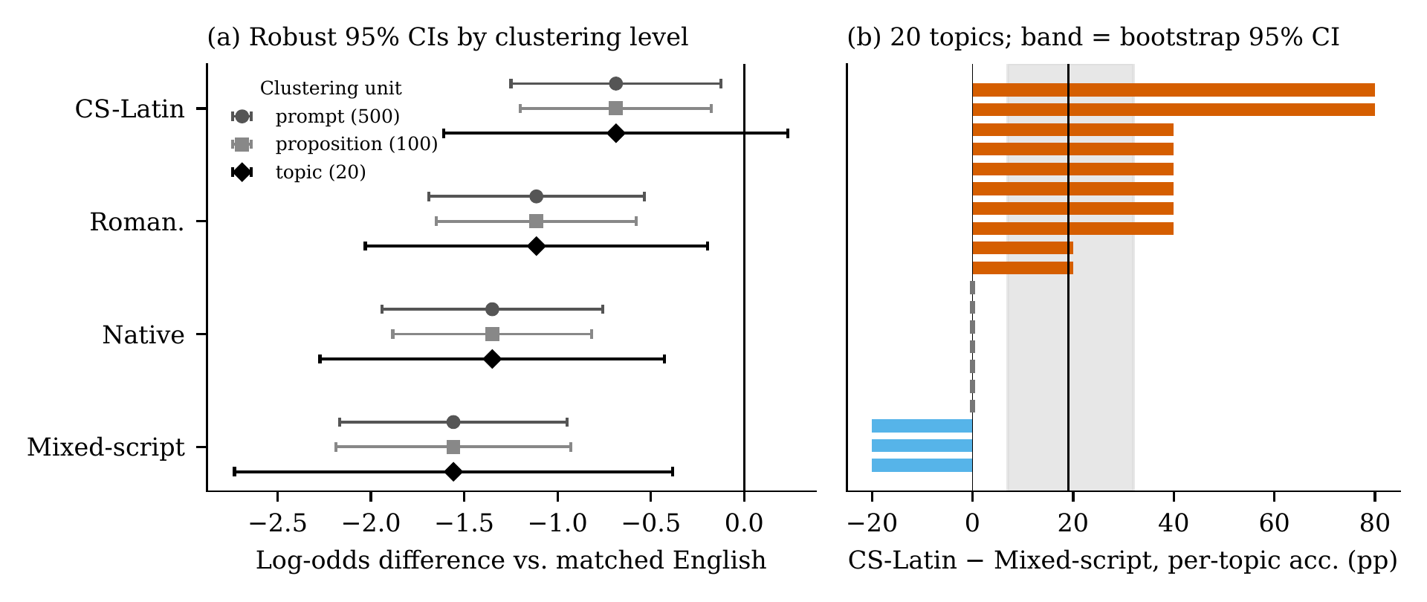
Fig. 4. (a) GEE log-odds differences from en-match with robust 95% CIs at three clustering levels. Intervals widen markedly at topic level, and the cs-lat interval includes zero there. (b) Per-topic accuracy difference cs-lat minus mixed (20 topics; band is the bootstrap 95% CI of the mean, line the mean).

D. Languages and models
Accuracy by language is in Fig. 3 and Appendix Table VIII. The ordering en-match > cs-lat holds in all five languages, as does cs-lat > mixed. A permutation test of whether the condition profile depends on language (permuting language labels within topic) gives p = 0.15. With 20 observations per cell this is a test with little power, so we report no detectable language dependence, not that languages behave alike; Bengali and Telugu differ visibly in the roman column (15% vs. 50%) and nothing here can tell chance from effect.
ALLaM-2-7B answers 10.0% (matched English), 5.0%, 2.0%, 2.0% and 3.0% of questions correctly in the other conditions, so the representation contrast cannot be measured on it: every Indic condition has between 2 and 5 correct answers out of 100. The five-condition rank correlation with Qwen-27B (ρ = 0.6669, p = 0.2189) is a statement about a floor, not a replication. We make no claim about other model families.

VI. WHY DOES MIXED-SCRIPT TEXT HURT?

A. Input token fertility does not mediate the contrast
Subword fragmentation is the standard explanation for degraded performance on non-Latin scripts. We test it within the most tightly controlled contrast. Using characters per token under the Qwen tokenizer as the mediator, mixed lowers it relative to cs-lat (a = −1.529), but the mediator has no detectable association with correctness once condition is controlled (b = −0.248, SE 0.244, p = 0.31; 95% CI -0.73 to 0.23). The Sobel statistic is z = 1.02 (p = 0.31). The total effect is −0.871 and the direct effect −1.255; the indirect effect has the opposite sign to the total effect, so there is no suggestion of partial mediation. This is a null result for one specific hypothesis, linear mediation by prompt-level characters per token in a binary-outcome model on 200 observations, tested with the Qwen2.5-7B tokenizer, which is fixed in the analysis script and is not shown to match the served model’s tokenizer. It therefore does not rule out a tokenization effect measured with the served model’s own tokenizer. At the level of six conditions, characters per token and accuracy are strongly rank-correlated (ρ = 0.94), but six points that differ in language frame, script and answer length do not identify a tokenization effect (Fig. 5c).

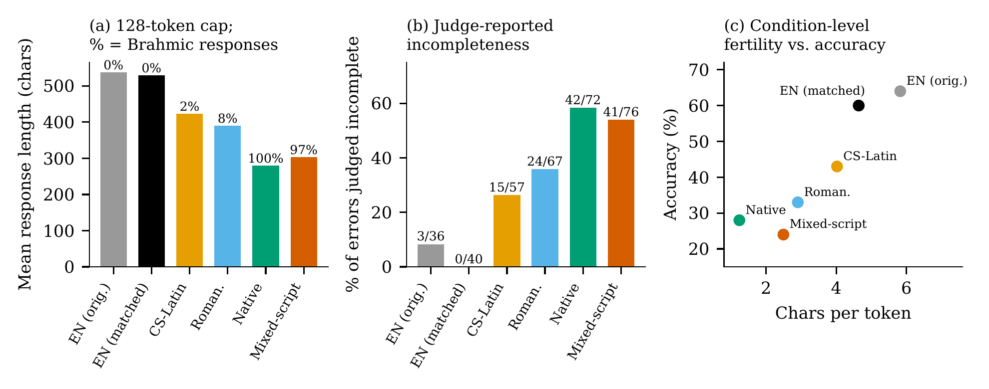
Fig. 5. (a) Mean response length under the 128-token cap; labels give the share of responses written mostly in Brahmic script. (b) Share of errors whose judge reason indicates an incomplete answer, with counts. (c) Condition-level characters per token against accuracy (six points, descriptive only).

B. The response side: script and output budget
The prompt script largely determines the response script. 100% of native and 97% of mixed responses are mostly Brahmic, against 8% and 2% for roman and cs-lat and none for English. Brahmic text consumes far more tokens per character on this tokenizer (prompt-side, about 1.24 characters per token for native against 4.64 for en-match), and almost every response hits the 128-token ceiling in every condition. Mean response length is accordingly 529 characters in en-match but 279 in native and 303 in mixed (Fig. 5a), roughly half. The model has half as much room to state the gold fact when it answers in Brahmic script.
The judge’s own reasons point the same way. Among errors, the share whose judge reason cites an incomplete or missing answer (a simple keyword rule applied to responses that end mid-sentence at the cap; Appendix C) is 0 of 40 in en-match, 15 of 57 in cs-lat, 42 of 72 in native and 41 of 76 in mixed. This rule depends on the grader’s wording and is not an independent measurement of truncation; we therefore do not use it as a measure of truncation.
Two features of these data matter for interpretation. First, native has one script boundary per prompt (the Latin topic string) and mixed has 5.0, yet both show similar incompleteness (42 and 41 of the errors) and similar accuracy (28.0% and 24.0%; p = 0.56). A dose-response of errors with the number of script transitions is not visible. Second, cs-lat → mixed shifts the response from Latin to Brahmic script at the same time as it adds Brahmic characters to the prompt. The data are therefore compatible with at least three accounts: a harm to comprehension from boundary-dense input; a harm to generation in Brahmic script under a short budget; or both. Distinguishing them needs a rerun with a larger output limit, or with a system instruction fixing the answer language, and would cost a few cents. We list it as the most important follow-up.

VII. SENSITIVITY TO JUDGE ERROR
Because the judge is also the evaluated model and was not validated on these outputs, we ask what judge error could produce the observed gaps. Define sensitivity (TPR) as the probability that a truly correct answer is judged correct, and FPR as the probability that a truly incorrect one is. A correction applied equally to both conditions via the Rogan–Gladen estimator [22] divides the observed gap by TPR − FPR and can only make it larger. A sensitivity grid of that kind therefore cannot show robustness, and we do not use one as evidence. The relevant threat is differential error, a judge that is stricter on Indic-language responses.
Table IV gives the tipping point: assuming the English answers are judged without error, it lists the sensitivity the judge would need on the Indic condition for its true accuracy to equal English accuracy. At a false-accept rate of 0.08, a judge that rejects 34% of truly correct cs-lat answers (sensitivity 0.66) would be needed to erase the cs-lat gap, and one that rejects 65% (0.35) to erase the mixed gap. As an illustration only, a judge with sensitivity near 0.86–0.88 and about ten points more false rejection on Indic text would be too small to close either gap, but we have no such estimate for this judge. The judge’s labels on the present outputs have not been compared with human judgments. The cs-lat gap is the more fragile of the two. A diagnostic points to real judge noise: on the 330 rows whose gold answer contains numerals, the judge agrees with a crude check that all gold numerals appear in the response only 60% of the time, with disagreements in both directions (63 judge-correct answers lack the gold figure; 69 judge-incorrect answers contain it). The check is crude, but it shows that label noise is not negligible.
TABLE IV
Sensitivity the judge would need on the comparison condition for its true accuracy to equal the reference condition’s, at the given false-accept rate. Reference answers assumed judged without error (a lower bound on required error). Lower entries mean a larger error would be needed.
FPR | cs-lat vs. en-match | mixed vs. en-match | mixed vs. cs-lat
0.00 | 0.72 | 0.40 | 0.56
0.04 | 0.69 | 0.37 | 0.51
0.08 | 0.66 | 0.35 | 0.45
0.12 | 0.64 | 0.32 | 0.40
0.16 | 0.61 | 0.29 | 0.35

VIII. DISCUSSION
What the data support is narrow, and we state it that way. For this model, these 20 topics and this task, restating the same question in Brahmic or Romanized script lowers recall, and doing so with the English frame words still in place (mixed script) lowers it further than Latin-script code-switching, in a pattern that survives clustering and shows in all five languages. The controlled contrast is internal to the Indic conditions, where lexical content is fixed; the larger English-versus-Indic gaps also depend on how much of the 128-token budget a response in the other script needs.
Table V lists claims we examined and could not support, which the main text states where they arise. The most useful of them for follow-up work is that input tokenization length, the standard explanation, does not account for the script contrast within controlled pairs, while output-side length effects are plausible and untested. Detector robustness and mitigation are not evaluated in this paper.
TABLE V
Unsupported or inconclusive results.
Examined claim | Outcome
Prompt-level token fertility mediates cs-lat → mixed | Not supported (Sobel p = 0.31)
English advantage over cs-lat at topic level | Not supported (p = 0.19)
Language-dependence of the effect | Not detected (p = 0.15), low power
Rank agreement with ALLaM-2-7B | Inconclusive (p = 0.2189; floor)
Truncation rises with script transitions | Not supported (native ≈ mixed)
Original 20-fold truncation ratio | Not reproducible from files

IX. LIMITATIONS
Topics. Twenty topics, with heavy within-topic concentration, bound what any statistic can show (effective n ≈ 84.8). A 45-topic expansion has been written but not evaluated; its design power (Appendix D) is a projection, not a result. Output budget. A single 128-token cap confounds script with answer length (Section VI). Judge. A single self-judge, with no human labels on these outputs; the tipping analysis bounds but does not remove the concern. Closed-book, generic questions. The shared template asks for “the main rule, date or parameter”, which under-specifies the target and may reward partial answers; there is no retrieval condition. Models and languages. One informative model, whose checkpoint identity we could not confirm, and five languages. Gold answers. Not independently re-verified. Single run. No repeated sampling beyond greedy decoding, and hosted-API behaviour can change over time.

X. ETHICS AND BROADER IMPACT
Evaluations like this one guide where civic and legal information systems are considered safe to deploy for speakers who write the way our conditions do. Overstated gaps could discourage building for these users; understated ones could hide failures. We therefore report effect sizes with their dependence on clustering and measurement choices. The prompts contain no personal data. The benchmark contains legal and policy facts that may become outdated and should not be used as legal advice. We do not estimate how many people use each representation, and make no claim about it.

REPRODUCIBILITY
All numbers, tables and figures in this paper are produced by paper_v2/scripts/make_all.py from results/EXP-002/full_predictions.jsonl and results/EXP-003-matched-en/matched_predictions.jsonl (Appendix E). API spend for the full project was about $0.21.

APPENDIX A: BENCHMARK DETAILS

A.1. Topics
Table VI lists the 20 topics with the number of languages (of five) in which each condition was answered correctly. Topics are Indian public-policy and regulatory subjects, several comparing two schemes or institutions (e.g., NEFT vs. RTGS, Covaxin vs. Covishield, PSLV vs. GSLV Mk III). Not all are statutes; we therefore describe them as public-policy topics.

TABLE VI
Languages (of five) answered correctly, per topic and condition (Qwen-27B).
Topic | en-orig | en-match | cs-lat | roman | native | mixed
Citizenship Amendment Act Cut-off | 5 | 5 | 1 | 3 | 4 | 2
Companies Act CSR Mandate | 5 | 5 | 4 | 2 | 0 | 0
Covaxin vs Covishield | 5 | 5 | 5 | 3 | 2 | 3
GST Registration Exemption | 5 | 5 | 3 | 2 | 4 | 1
Kharif vs Rabi Rice | 5 | 5 | 4 | 3 | 2 | 4
Lok Sabha vs Rajya Sabha Money Bill | 5 | 5 | 2 | 3 | 2 | 2
National Park vs Wildlife Sanctuary | 5 | 5 | 2 | 2 | 1 | 0
Patents Act Compulsory License | 5 | 5 | 3 | 3 | 3 | 1
SEBI Insider Trading Pre-Clearance | 5 | 5 | 4 | 2 | 2 | 0
ISRO PSLV vs GSLV Mk III | 3 | 5 | 1 | 0 | 1 | 0
Arbitration Act Time Limit | 0 | 5 | 1 | 0 | 0 | 0
PMFBY vs WBCIS | 0 | 5 | 0 | 0 | 0 | 0
Medical Termination of Pregnancy Act | 5 | 0 | 0 | 1 | 0 | 0
NEFT vs RTGS | 5 | 0 | 2 | 4 | 4 | 3
RTI Third Party Information | 5 | 0 | 1 | 0 | 1 | 2
Classical Tamil vs Sanskrit Grammar | 1 | 0 | 4 | 1 | 0 | 2
Environment Clearance Public Hearing | 0 | 0 | 0 | 0 | 0 | 0
IBC Section 7 Default Threshold | 0 | 0 | 0 | 0 | 0 | 0
PM-KISAN vs Rythu Bandhu | 0 | 0 | 2 | 1 | 0 | 0
Supreme Court vs High Court Writ Jurisdiction | 0 | 0 | 4 | 3 | 2 | 4

A.2. Partitions and the unevaluated expansion
Version 1.1-CANDIDATE: development 1,000 groups, validation 200, in-distribution test 200, out-of-distribution test 100 (the evaluated core). The 200 in-distribution test groups were run in EXP-002 for both models; they use fictitious entities, and 2 of 2000 responses were judged correct, so they are not informative about recall. The prospective 1.2-PILOT adds 25 propositions (125 prompts) on topics with zero entity overlap with the evaluated 20; no model has been run on them.

APPENDIX B: ADDITIONAL RESULTS

TABLE VII
All pairwise contrasts (proposition-level exact McNemar; b: first condition correct, second wrong; c: reverse; topic-level permutation p and bootstrap CI for the change, uncorrected). The first five rows are the primary family.
Contrast | Δ (pp) | b | c | Exact p | Topic p | Topic 95% CI (pp)
cs-lat vs. en-match | -17 | 30 | 13 | 0.014 | 0.19 | [-39, 6]
roman vs. en-match | -27 | 37 | 10 | 9.85×10⁻⁵ | 0.038 | [-48, -4]
native vs. en-match | -32 | 39 | 7 | 1.83×10⁻⁶ | 0.015 | [-53, -10]
mixed vs. en-match | -36 | 47 | 11 | 2.03×10⁻⁶ | 0.021 | [-61, -9]
mixed vs. cs-lat | -19 | 29 | 10 | 0.003 | 0.016 | [-32, -7]
en-match vs. en-orig | -4 | 16 | 12 | 0.57 | 0.84 | [-26, 18]
mixed vs. roman | -9 | 20 | 11 | 0.15 | 0.14 | [-19, 1]
mixed vs. native | -4 | 15 | 11 | 0.56 | 0.64 | [-16, 8]
roman vs. cs-lat | -10 | 26 | 16 | 0.16 | 0.15 | [-21, 1]
native vs. cs-lat | -15 | 30 | 15 | 0.036 | 0.10 | [-31, 0]
native vs. roman | -5 | 18 | 13 | 0.47 | 0.36 | [-13, 3]

TABLE VIII
Correct answers by language and condition, as percentages (n = 20 per cell).
Language | en-orig | en-match | cs-lat | roman | native | mixed
Hindi | 65 | 60 | 45 | 35 | 45 | 20
Bengali | 60 | 60 | 50 | 15 | 15 | 35
Tamil | 65 | 60 | 40 | 30 | 25 | 10
Telugu | 65 | 60 | 45 | 50 | 25 | 35
Kannada | 65 | 60 | 35 | 35 | 30 | 20
All | 64 | 60 | 43 | 33 | 28 | 24
TABLE IX
Correct answers out of 100 per model and condition.
Condition | Qwen 27B | ALLaM-2-7B | ALLaM 95% CI
en-orig | 64 | 8 | [4.1, 15.0]
en-match | 60 | 10 | [5.5, 17.4]
cs-lat | 43 | 5 | [2.2, 11.2]
roman | 33 | 2 | [0.6, 7.0]
native | 28 | 2 | [0.6, 7.0]
mixed | 24 | 3 | [1.0, 8.5]

TABLE X
Response- and prompt-side descriptors by condition (Qwen-27B). Script transitions: Latin ↔ Brahmic changes between adjacent word tokens in the prompt. Chars/tok: from the tokenizer analysis of Appendix E. “Incompl.” is the keyword rule of Appendix C.
Condition | Script trans. | Chars/tok | Resp. chars | Resp. in Brahmic (%) | Errors | Incompl. (judge)
en-orig | 0.0 | 5.82 | 538 | 0 | 36 | 3
en-match | 0.0 | 4.64 | 529 | 0 | 40 | 0
cs-lat | 0.0 | 4.02 | 423 | 2 | 57 | 15
roman | 0.0 | 2.90 | 390 | 8 | 67 | 24
native | 1.0 | 1.24 | 279 | 100 | 72 | 42
mixed | 5.0 | 2.49 | 303 | 97 | 76 | 41

APPENDIX C: RULES AND RUBRICS
Incompleteness rule. A response is flagged when (i) it used the full 128 completion tokens, (ii) its last non-space character is not a sentence-final mark, (iii) the judge labelled it incorrect, and (iv) the judge’s reason matches incomplete, truncat*, cut off, abrupt, unfinish*, missing specific, missing parameter, fails to finish. Condition (iv) depends on the judge’s wording; the rule is a descriptive device, not a measure of truncation. Judge prompt. “You are grading whether a model’s ANSWER to a user QUESTION is factually correct. You are given a trusted GOLD answer. The answer may mix an Indian language with English (code-switching) and may be phrased very differently from the gold—that is fine. Judge ONLY factual correctness and whether it actually addresses the question.” Output: VERDICT: <CORRECT or HALLUCINATED> | REASON: <max 12 words>; temperature 0, 256 tokens. Script transitions. Words are extracted as maximal letter runs; each is labelled Latin or Brahmic (U+0900–U+0D7F); transitions are label changes between consecutive words. Digits and punctuation are ignored. This gives 5.0 per mixed prompt, 1.0 per native prompt (the Latin topic string), and 0 elsewhere.

APPENDIX D: PROSPECTIVE DESIGN CALCULATION
A normal-approximation calculation for a 45-topic design (225 paired propositions, design effect 1 + (5 − 1)ρ, binary variance at ̄p = 0.4, two-sided α = 0.05) with parameters ρ = 0.2663 and a 21-point effect gives power 88.6% (88.57%; minimum detectable effect 18.60 points). The same formula gives 55.9% for the 20 evaluated topics. These parameters come from the first English template; recomputing with ρ = 0.204 and the 17-point matched gap gives 78.0% for 45 topics (MDE 17.4 points) and 44.5% for 20. These are projections, not results, and the 25 new propositions have not been evaluated.

APPENDIX E: REPRODUCIBILITY
Python 3.11 with numpy, pandas, scipy, statsmodels and matplotlib. From the repository root, python paper_v2/scripts/make_all.py reads the two prediction files and writes paper_v2/numbers.tex, the tables and the figures; the manuscript takes every number from those files. The tokenizer analysis (characters per token and the mediation model) is taken from results/EXP-003-matched-en/matched_analysis_summary.json. The script that produced it (scripts/run_exp003_matched_analysis.py) downloads the Qwen2.5-7B tokenizer from the model hub, which was not reachable from our offline environment, so we did not independently recompute these two quantities. No headline accuracy result depends on them; those are recomputed from the prediction files. Permutation and bootstrap procedures use fixed seeds. Cumulative API spend: about $0.21.

REFERENCES
[1] K. Ahuja et al., “MEGA: Multilingual evaluation of generative AI,” in Proceedings of the 2023 conference on empirical methods in natural language processing, 2023.
[2] D. Kakwani et al., “IndicNLPSuite: Monolingual corpora, evaluation benchmarks and pre-trained multilingual language models for Indian languages,” in Findings of the association for computational linguistics: EMNLP 2020, 2020.
[3] S. Doddapaneni et al., “Towards leaving no Indic language behind: Building monolingual corpora, benchmark and models for Indic languages,” in Proceedings of the 61st annual meeting of the association for computational linguistics, 2023.
[4] S. Khanuja, S. Dandapat, A. Srinivasan, S. Sitaram, and M. Choudhury, “GLUECoS: An evaluation benchmark for code-switched NLP,” in Proceedings of the 58th annual meeting of the association for computational linguistics, 2020.
[5] O. Ahia et al., “Do all languages cost the same? Tokenization in the era of commercial language models,” in Proceedings of the 2023 conference on empirical methods in natural language processing, 2023.
[6] A. Petrov, E. La Malfa, P. H. S. Torr, and A. Bibi, “Language model tokenizers introduce unfairness between languages,” in Advances in neural information processing systems, 2023.
[7] P. Rust, J. Pfeiffer, I. Vulić, S. Ruder, and I. Gurevych, “How good is your tokenizer? On the monolingual performance of multilingual language models,” in Proceedings of the 59th annual meeting of the association for computational linguistics, 2021.
[8] R. Zhang, S. Cahyawijaya, J. C. B. Cruz, G. I. Winata, and A. F. Aji, “Multilingual large language models are not (yet) code-switchers,” in Proceedings of the 2023 conference on empirical methods in natural language processing, 2023.
[9] Z.-X. Yong et al., “Prompting multilingual large language models to generate code-mixed texts: The case of South East Asian languages,” in Proceedings of the 6th workshop on computational approaches to linguistic code-switching, 2023.
[10] R. Sennrich, B. Haddow, and A. Birch, “Neural machine translation of rare words with subword units,” in Proceedings of the 54th annual meeting of the association for computational linguistics, 2016.
[11] S. Lin, J. Hilton, and O. Evans, “TruthfulQA: Measuring how models mimic human falsehoods,” in Proceedings of the 60th annual meeting of the association for computational linguistics, 2022.
[12] S. Min et al., “FActScore: Fine-grained atomic evaluation of factual precision in long form text generation,” in Proceedings of the 2023 conference on empirical methods in natural language processing, 2023.
[13] L. Zheng et al., “Judging LLM-as-a-judge with MT-bench and chatbot arena,” in Advances in neural information processing systems, datasets and benchmarks track, 2023.
[14] M. S. Bari, Y. Alnumay, N. A. Alzahrani, N. M. Alotaibi, et al., “ALLaM: Large language models for Arabic and English,” arXiv preprint arXiv:2407.15390, 2024.
[15] Q. McNemar, “Note on the sampling error of the difference between correlated proportions or percentages,” Psychometrika, vol. 12, no. 2, pp. 153–157, 1947.
[16] S. Holm, “A simple sequentially rejective multiple test procedure,” Scandinavian Journal of Statistics, vol. 6, no. 2, pp. 65–70, 1979.
[17] E. B. Wilson, “Probable inference, the law of succession, and statistical inference,” Journal of the American Statistical Association, vol. 22, no. 158, pp. 209–212, 1927.
[18] K.-Y. Liang and S. L. Zeger, “Longitudinal data analysis using generalized linear models,” Biometrika, vol. 73, no. 1, pp. 13–22, 1986.
[19] A. C. Cameron, J. B. Gelbach, and D. L. Miller, “Bootstrap-based improvements for inference with clustered errors,” The Review of Economics and Statistics, vol. 90, no. 3, pp. 414–427, 2008.
[20] L. A. Mancl and T. A. DeRouen, “A covariance estimator for GEE with improved small-sample properties,” Biometrics, vol. 57, no. 1, pp. 126–134, 2001.
[21] L. Kish, Survey sampling. Wiley, 1965.
[22] W. J. Rogan and B. Gladen, “Estimating prevalence from the results of a screening test,” American Journal of Epidemiology, vol. 107, no. 1, pp. 71–76, 1978.

