There are 3 parts in the task. Use Angular 9. Achieve same look and feel. Please complete all parts.

**Part 1:**

* Simulate login with LOGIN – SUCCESSFUL option in <https://reqres.in/>

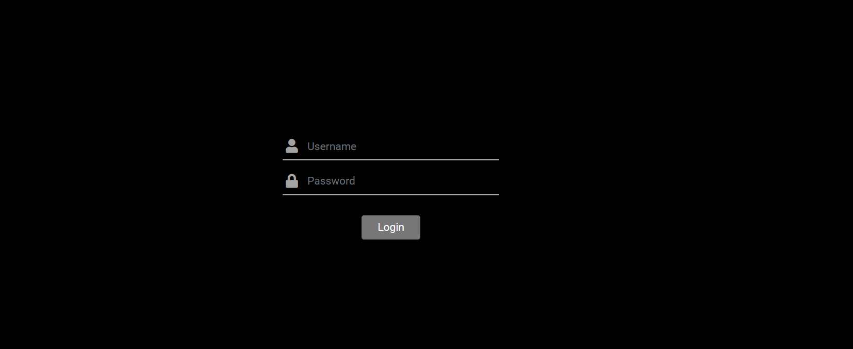

**Part 2:**

* Load the following page after login
* Try to use <https://reqres.in/> or any public REST API’s to get data for following screen
* Build chart with following data



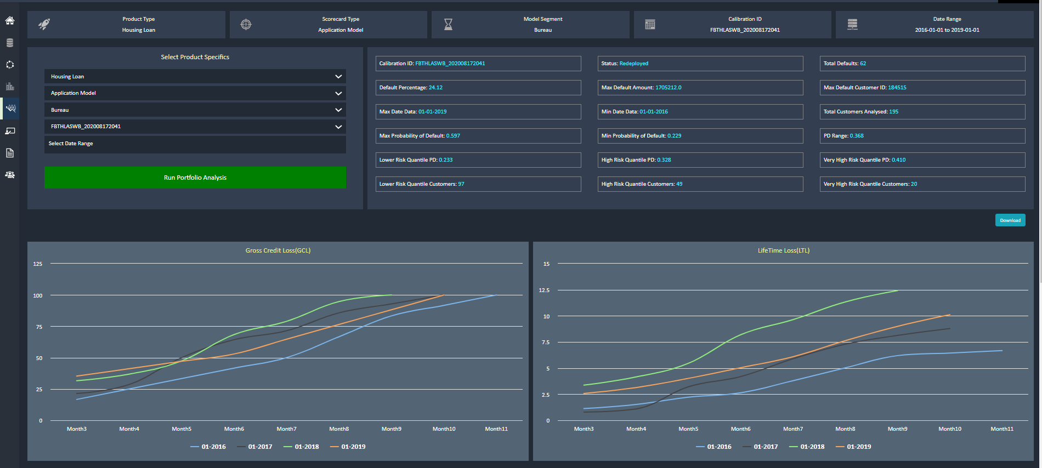

**Part 3:**

* Generate following UI with data mentioned below

