Late Delivery Risk Prediction
Executive Summary — APL Logistics | July 2026
APL Logistics can now flag, before an order ships, whether it's at risk of arriving late — with 82% accuracy at separating risky orders from safe ones, and a clean three-tier risk score (Low / Medium / High) that operations can act on directly. More importantly, the analysis identified the real driver of late deliveries, and it isn't what most teams assume.
172,762  orders analyzed | 0.82  model accuracy (ROC-AUC) | 88%  actual late rate in “High Risk” tier | 25%  actual late rate in “Low Risk” tier

The Core Finding
Late delivery risk is driven almost entirely by one thing: how aggressive the promised delivery window is for the shipping mode selected — not the region an order is going to, not the product category, not order size. Counter-intuitively, faster promised shipping is far riskier than slower shipping, because tight windows are simply harder to hit.
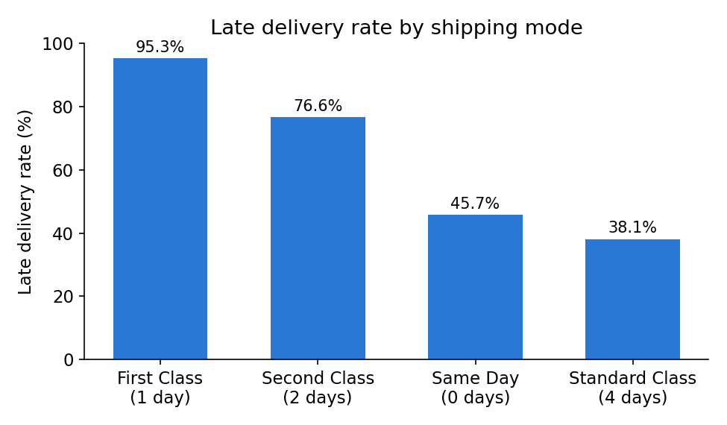
First Class orders (1-day promise) are late 95% of the time; Standard Class (4-day promise) is late 38% of the time.

What This Means for the Business
- This is not primarily a fulfillment or carrier performance problem — it's a promise-setting problem. The delivery windows attached to expedited shipping options are structurally very hard to meet.
- Region, market, and product category — the factors ops teams often investigate first — showed almost no relationship to late delivery risk in this data.
- The risk score is well-calibrated: orders flagged “High Risk” are actually late 88% of the time, vs. 25% for “Low Risk” — reliable enough to drive real operational decisions.

Recommendations
- Use the risk score to proactively flag High Risk orders for priority handling or earlier carrier hand-off, before they ship — not after they're already late.
- Revisit the delivery-time promises on expedited shipping modes; either tighten fulfillment capacity to match the promise, or reset customer expectations to match reality.
- Invest in better data going forward — specifically order timestamps and order IDs — to unlock seasonal analysis and more precise risk modeling than is currently possible.

Deliverables
- Trained prediction model (XGBoost) with documented performance and explainability
- Interactive Streamlit dashboard for order-level risk lookup, region/mode analysis, and a daily operations action list
- Full research paper detailing methodology, findings, and limitations

