Predicting Late Delivery Risk in E-Commerce Logistics
A Machine Learning Approach for APL Logistics
Research Paper — Data Science Project
July 2026

Table of Contents
Abstract3
1. Background and Problem Statement3
2. Dataset Description3
3. Methodology4
3.1 Leakage Detection and Removal4
3.2 Deduplication and Cleaning4
3.3 Order Disposition Filtering4
3.4 Exploratory Data Analysis4
3.5 Feature Engineering5
3.6 Model Development6
4. Results7
4.1 Model Comparison7
4.2 Explainability8
4.3 Risk Scoring8
5. Limitations9
6. Recommendations10
7. Conclusion10

Abstract
Late deliveries erode customer trust and drive up operational cost. This paper documents an end-to-end machine learning pipeline built to predict, before an order ships, whether it is at risk of arriving late. Working from 180,519 historical orders across 40 fields, we identified and removed two columns that leaked the outcome, engineered four candidate features, and benchmarked three models. The final XGBoost classifier achieves a ROC-AUC of 0.818 and F1 of 0.750 on a held-out test set, and its output probabilities separate cleanly into Low, Medium, and High risk bands with actual late rates of 25%, 46%, and 88% respectively. The dominant driver of late risk is not geography, product, or order size — it is the gap between a shipment's promised delivery window and what the logistics network can realistically achieve, with expedited shipping modes counter-intuitively showing the highest late rates because their promised windows are hardest to meet.

1. Background and Problem Statement
APL Logistics ships orders across multiple markets and regions, each with its own delivery promise depending on the shipping mode selected at checkout. When an order arrives after its promised window, it counts as a late delivery — a costly outcome in both customer satisfaction and rework. The business goal of this project is to give operations teams a proactive signal: for a given order, before it ships, what is the probability it will be late, and which of its attributes are driving that risk?
A model that only flags lateness after the fact has no operational value. The central methodological discipline in this project was therefore to build a feature set using only information that is genuinely available at order time — and to actively test for and remove any column that, on inspection, was actually encoding the outcome rather than predicting it.

2. Dataset Description
The raw dataset (Apl_Logistics.csv) contains 180,519 order-item records across 40 fields, covering order and customer identifiers, geography (customer and order-destination location, latitude/longitude), product and category information, pricing and discount fields, shipping mode and scheduled shipping days, order and delivery status, and the binary target, Late_delivery_risk.

2.1 Data Quality
- Missing data was minimal: 8 missing customer last names and 3 missing zip codes out of 180,519 rows.
- No duplicate rows were found.
- Target balance was healthy from the start: 54.8% late vs. 45.2% not late, so no resampling (e.g. SMOTE) was necessary.
- The dataset contains no order date/timestamp and no order-identifier column linking multiple line items to a single order — each row was treated as an independent order-item observation, which ruled out time-based validation splits and multi-item order aggregation.

3. Methodology

3.1 Leakage Detection and Removal
Before any modeling, every column was checked for whether it could plausibly be known at order time. Two columns failed this test decisively:
- Delivery Status — cross-tabulation showed this field is 100% redundant with the target: it reads “Late delivery” if and only if Late_delivery_risk = 1. It is a relabeling of the answer, not a predictor.
- Days for shipping (real) — the actual number of days a shipment took is only known after it arrives. A single-rule check (real days > scheduled days) reproduced the target with 97.5% accuracy on its own, confirming this field is generated from — not predictive of — the outcome.
Both columns were dropped entirely. This is the single most consequential methodological decision in the project: retaining either would have produced a model that appears near-perfect in testing but is useless in production, since neither value exists at prediction time.

3.2 Deduplication and Cleaning
Four pairs of columns were found to be exact duplicates under different names (Sales per customer / Order Item Total, Product Price / Order Item Product Price, Benefit per order / Order Profit Per Order, Customer Id / Order Customer Id); one column from each pair was dropped. Category Id was dropped as a 1:1 duplicate of Category Name. Customer first name, last name, and street address were dropped as personally identifying fields with no predictive value. The three rows with missing zip codes were dropped.

3.3 Order Disposition Filtering
Order Status values CANCELED and SUSPECTED_FRAUD (7,754 rows combined, matching exactly the row count of the “Shipping canceled” category in the now-removed Delivery Status field) never actually ship, and are therefore trivially labeled “not late.” Including them would let the model learn an easy shortcut (cancelled/fraud ⇒ not late) that has nothing to do with genuine delivery-time risk. These rows were excluded from training, leaving 172,762 modeling-eligible orders with a target balance of 57.3% late / 42.7% not late.

3.4 Exploratory Data Analysis
Late delivery rate was cross-tabulated against every categorical field. The results were striking in their asymmetry: one variable carries almost all of the signal, and most others carry almost none.
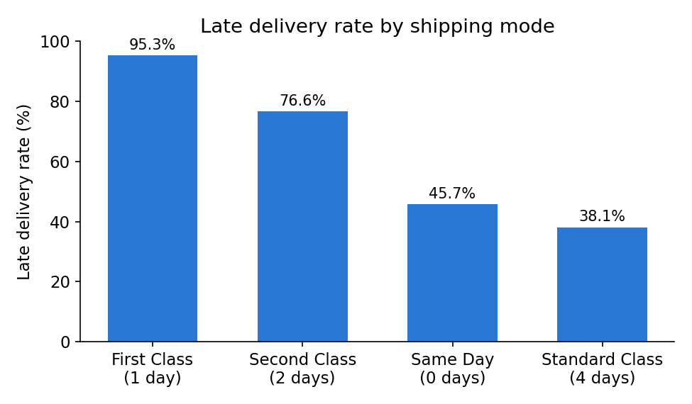
Figure 1. Late delivery rate by shipping mode. Faster promised shipping modes have far higher late rates because their delivery windows are hardest to meet.
Shipping Mode and Days for shipment (scheduled) turned out to be the same variable expressed two ways (First Class = 1 day, Second Class = 2 days, Same Day = 0 days, Standard Class = 4 days, with matching row counts for each pairing). The counter-intuitive direction of the effect — expedited modes being far more likely to be late than Standard Class — makes sense once “late” is understood as relative to the promised window rather than absolute delivery speed: a 1-day promise is simply harder to hit than a 4-day one.
By contrast, Market, Order Region, Customer Segment, and Category Name each showed late rates clustered tightly in the 54–58% range regardless of category — essentially flat. Correlation of every other numeric field (profit, price, quantity, discount, sales) with the target was under 0.004 in magnitude. The practical implication is that this is not a dataset where many features each contribute a little; predictive power is concentrated almost entirely in the shipping-mode / scheduled-days variable.

3.5 Feature Engineering
Four candidate features were engineered and each was validated against the target before being accepted into the model:
- is_express_shipping — a binary flag for scheduled shipping ≤ 2 days. Strong signal (39.8% late for standard vs. 83.3% for express).
- shipping_pressure_index — order quantity divided by scheduled shipping days, capturing how much needs to move in how little time. This showed a genuine gradient beyond the raw shipping-mode signal (see Figure 2).
- region_congestion_tier — regions bucketed into Low/Medium/High historical order volume, as a congestion proxy. Flat late rates (57.4% / 56.7% / 57.8%) showed this added no signal, consistent with the EDA finding that region does not meaningfully affect lateness in this dataset.
- order_complexity_score — a composite z-score of quantity, discount rate, and price. Also flat (~57% in every quartile) — no signal as constructed.
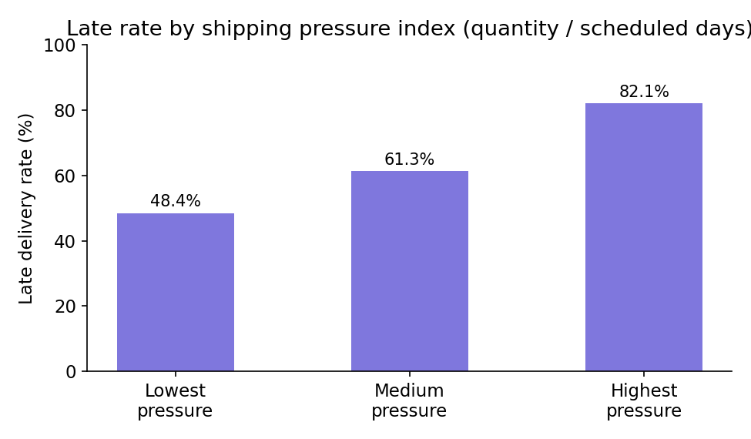
Figure 2. Late rate rises with shipping pressure index (order quantity per scheduled shipping day).
Rather than discard the two non-predictive features outright, they were retained in the modeling dataset: tree-based models handle non-informative features gracefully (they simply receive low importance), and their absence of signal is itself a useful, honestly-reported finding rather than a modeling failure.

3.6 Model Development
Categorical fields were split by cardinality: low-cardinality fields (Shipping Mode, Market, Order Region, Customer Segment, Order Status, Department Name, Type, Customer Country, region_congestion_tier) were one-hot encoded; high-cardinality fields (Category Name, Customer/Order City, Customer/Order State, Order Country, Product Name) were target-encoded with smoothing, fit on the training split only to avoid leakage. Numeric fields were standardized for the logistic regression model (tree-based models used raw values). Data was split 80/20 into train and test sets with stratification on the target.
Three models were trained and compared on the held-out test set:
- Logistic Regression — an interpretable linear baseline.
- Random Forest — 300 trees, max depth 12, min leaf size 5.
- XGBoost — 300 trees, max depth 6, learning rate 0.1, with subsampling for regularization.

4. Results

4.1 Model Comparison
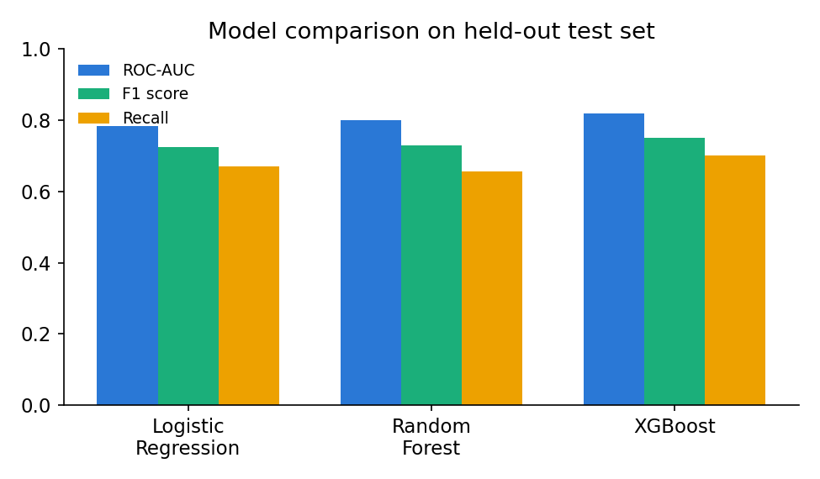
Figure 3. ROC-AUC, F1, and Recall for all three models on the held-out test set.
Model | ROC-AUC | Precision | Recall | F1
Logistic Regression | 0.784 | 0.789 | 0.670 | 0.725
Random Forest | 0.800 | 0.821 | 0.656 | 0.729
XGBoost | 0.818 | 0.806 | 0.701 | 0.750
Table 1. Full metric comparison. XGBoost leads on every metric and was selected as the production model.
An ROC-AUC of 0.818 is a meaningful, honest result precisely because the two leakage columns were removed and cancelled/fraud orders were excluded. A dramatically higher score (0.95+) on this dataset would be a red flag for residual leakage, not a sign of a better model. Recall — the share of genuinely late orders the model successfully flags — is the metric most aligned with the business cost of a miss, and XGBoost leads here too at 70.1%.

4.2 Explainability
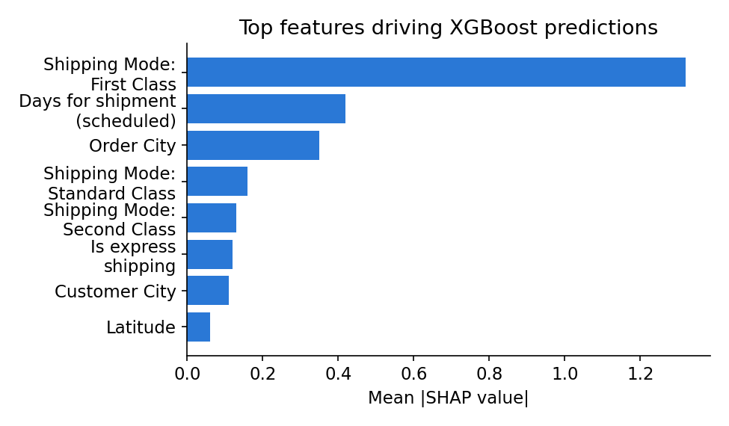
Figure 4. Top features by mean absolute SHAP value on a 5,000-row test sample.
Gain-based feature importance from the trained XGBoost model attributes roughly 94% of total predictive gain to Shipping Mode and its derivatives (Days for shipment scheduled, is_express_shipping). SHAP analysis confirms this ranking and additionally surfaces a modest secondary signal from Order City and Customer City (via target encoding) — finer-grained geography that the coarser Market/Region aggregates in the EDA did not reveal, though its contribution is an order of magnitude smaller than shipping mode.

4.3 Risk Scoring
Predicted probabilities were bucketed into three operational risk tiers: Low Risk (< 0.35), Medium Risk (0.35–0.65), and High Risk (≥ 0.65). Calibration on the held-out test set is monotonic and well-separated:
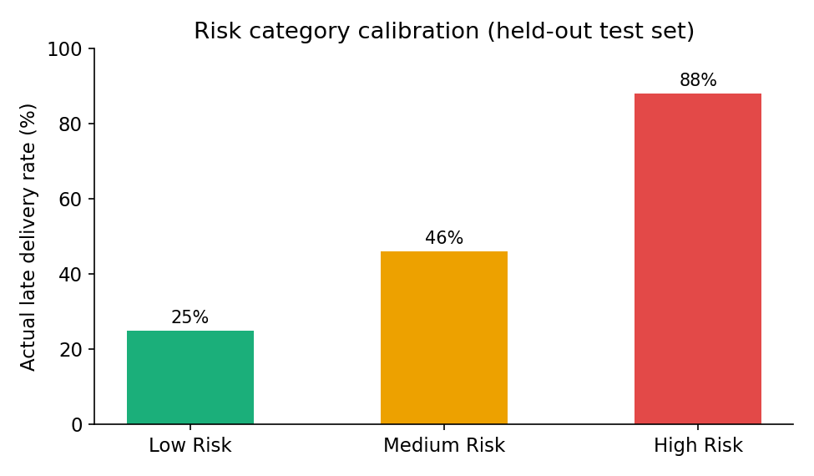
Figure 5. Actual late-delivery rate observed within each predicted risk category, held-out test set.
Risk Category | Predicted Probability Range | Actual Late Rate
Low Risk | < 0.35 | 25%
Medium Risk | 0.35 – 0.65 | 46%
High Risk | ≥ 0.65 | 88%
Table 2. Risk category calibration — the monotonic separation makes this score directly usable for operational triage.

5. Limitations
- No order date or timestamp field exists in the dataset, which ruled out time-based train/test splitting and any seasonal or trend analysis. A production deployment should validate that performance holds up under a genuine temporal split once dated data is available.
- No order-identifier field links multiple line items into a single order, so “order complexity” could only be approximated from within-row signals rather than true multi-item order structure; this likely explains why the engineered complexity score carried no signal.
- Region, market, and product category — variables that intuitively should matter for logistics risk — showed almost no linear or grouped relationship with lateness in this dataset. This may reflect a genuine business reality (this carrier's network is equally reliable everywhere), or it may reflect that the dataset lacks the granularity (specific carrier, route, warehouse capacity, weather) needed to detect real regional effects. This distinction cannot be resolved with the fields currently available.
- Target encoding of high-cardinality city fields, while fit only on the training split to avoid leakage, can still be noisy for cities with few historical orders; the smoothing applied (equivalent to 20 prior orders) mitigates but does not eliminate this.

6. Recommendations
- Deploy the XGBoost risk score to flag High Risk orders (88% historical late rate) for proactive intervention — e.g., prioritized handling, earlier carrier hand-off, or proactive customer communication — before they ship.
- Revisit the delivery-time promises attached to expedited shipping modes. A 95% late rate on First Class is not primarily a fulfillment failure; it indicates the promised window is structurally unrealistic given current logistics capacity. Either the promise or the capacity needs to change.
- Prioritize collecting order timestamps and an order/order-item identifier in future data. These two additions alone would unlock temporal validation, seasonality analysis, and genuine multi-item order-complexity features — all currently unavailable.
- If deeper regional or carrier-level risk analysis is a business priority, augment the dataset with carrier, route, and warehouse-capacity fields; the current fields are not granular enough to confirm or rule out a real regional effect.
- Monitor the Low/Medium/High risk calibration in production on a rolling basis — calibration can drift if shipping-mode mix, promised windows, or regional operations change over time.

7. Conclusion
This project delivered a late-delivery risk model that is both accurate (ROC-AUC 0.818, F1 0.750) and, more importantly, honest: leakage was actively hunted down and removed rather than left to inflate results, and the modeling dataset was scoped to match the real business question of orders that are actually going to ship. The resulting risk score is well-calibrated and operationally actionable, and the analysis surfaces a clear, non-obvious insight for the business: late delivery risk in this dataset is overwhelmingly a function of how aggressive the promised delivery window is relative to shipping mode, not of where an order is going or what is being shipped. That reframes the business lever available to APL Logistics — from asking “which regions need better logistics” to asking “which delivery promises need to be reset.”

