Week 3 Task
Advanced Data Analysis and Visualization in Logistics
Exploratory analysis of a simulated shipment network using Python
Prepared by: [Your Name]
Course / Batch: [Course name]
Date: October 2026

1. Introduction and Objectives
Logistics performance is shaped by many interacting factors: how long shipments wait in warehouses, how fast each transport mode moves freight, how distance and volume drive cost, and whether carriers keep their promises. Managers rarely see these factors in isolation. The purpose of this analysis is to explore them together, identify where the process is slow or expensive, and turn those findings into recommendations.
The work pursues four objectives: to define a hypothetical shipment dataset with realistic structure; to conduct an exploratory data analysis covering central tendency, distribution and correlation; to produce and justify a set of visualisations; and to interpret the results in terms of operational efficiency, cost drivers and bottlenecks.

2. Data Simulation

2.1 Structure of the dataset
The dataset represents 5,000 shipments dispatched from five regional hubs across calendar year 2025. Each record describes one shipment's origin, carrier, mode, size, timing, and cost. The variables fall into four groups: identifiers and dimensions, physical attributes, time components, and financial components.
Variable | Type | Description | Role in analysis
shipment_id | Text | Unique shipment identifier | Key
ship_date | Date | Dispatch date (2025) | Time trends, weekday effects
origin_hub | Category | Nagpur, Mumbai, Pune, Delhi or Chennai hub | Bottleneck location
carrier | Category | Carrier A, B, C or D | Performance comparison
transport_mode | Category | Road, Rail, Air or Sea | Speed and cost trade-off
volume_units | Integer | Units in the shipment (1 to 59) | Handling workload
weight_kg | Numeric | Consignment weight | Cost and handling
distance_km | Numeric | Route distance (50 to 2,000 km) | Primary transit driver
dwell_hours | Numeric | Time waiting in the origin warehouse | Bottleneck measure
transit_hours | Numeric | Time on the road, rail, air or sea leg | Carrier and mode speed
total_delivery_hours | Numeric | Dwell plus transit | Core service metric
sla_hours | Integer | Promised delivery window by mode | Service benchmark
on_time | Category | Yes if total hours are within the SLA | Service outcome
transport_cost_inr | Numeric | Freight charge | Cost driver
handling_cost_inr | Numeric | Warehouse handling charge | Cost driver
total_cost_inr | Numeric | Transport plus handling | Financial outcome

2.2 Embedded operational patterns
A simulation is only useful if it reflects the kinds of pressure real networks experience. Four patterns were built into the generator so that the analysis has genuine signals to find. These are documented here so the findings can be checked against the design.
- Warehouse dwell penalty at Mumbai on Mondays. Shipments leaving the Mumbai hub on Mondays receive an additional 14 hours of dwell, representing a weekend backlog clearing.
- Peak-season congestion from October to December. All hubs add six hours of dwell during these months, mimicking festival and year-end demand.
- Carrier C transit delay. Carrier C adds five hours to every transit, reflecting slower operations.
- Mode-specific speed, rate and service targets. Air is fastest and most expensive per kilometre. Sea is slowest and cheapest. Road and rail sit between them, and each mode has its own SLA.

2.3 Generation logic
# Dwell: gamma baseline, plus Mumbai Monday backlog and peak-season congestion
dwell = rng.gamma(shape=2.0, scale=5.0, size=n)
dwell += np.where((df["origin_hub"] == "Mumbai Hub") & (df["ship_date"].dt.dayofweek == 0), 14, 0)
dwell += np.where(df["ship_date"].dt.month.isin([10, 11, 12]), 6, 0)

# Transit: distance over mode speed, plus carrier delay and noise
speed = df["transport_mode"].map({"Road": 45, "Rail": 38, "Air": 350, "Sea": 22})
carrier_delay = df["carrier"].map({"Carrier A": 0, "Carrier B": 2, "Carrier C": 5, "Carrier D": 1})
transit = df["distance_km"] / speed + rng.normal(0, 4, n) + carrier_delay

# On-time: total delivery hours within the mode SLA
sla = df["transport_mode"].map({"Road": 28, "Rail": 32, "Air": 16, "Sea": 44})
df["on_time"] = np.where(df["total_delivery_hours"] <= sla, "Yes", "No")

Two realistic gaps were added: 40 missing weights and 25 missing transit times. These are handled in the EDA stage so the analysis demonstrates a complete workflow.

3. Exploratory Data Analysis

3.1 Data preparation
Missing weights were replaced with the overall median, and missing transit times were replaced with the median transit time. The median was chosen because weight is strongly right-skewed, so the mean would be pulled upward by heavy consignments. Total delivery hours were recalculated after imputation so that every record is internally consistent. Derived fields for month, weekday and on-time flag were then added for grouping.

3.2 Central tendency and dispersion
The table summarises the core operational and cost variables. The coefficient of variation (standard deviation divided by mean) allows variables measured in different units to be compared on relative spread.
Variable | Mean | Median | Std dev | Min | Max | Skewness | CV (%)
Volume (units) | 30.1 | 30.0 | 17.1 | 1 | 59 | -0.01 | 57
Weight (kg) | 25.6 | 20.3 | 20.7 | 1.2 | 333.4 | 3.69 | 81
Distance (km) | 600.2 | 594.0 | 257.6 | 50 | 1,521 | 0.17 | 43
Dwell (hours) | 11.9 | 10.4 | 7.8 | 0.0 | 49.8 | 1.11 | 65
Transit (hours) | 16.4 | 15.7 | 9.6 | 1.0 | 78.2 | 0.87 | 59
Total delivery (hours) | 28.3 | 27.3 | 12.3 | 1.8 | 93.8 | 0.68 | 43
Transport cost (INR) | 4,032.9 | 3,688.3 | 2,352.9 | 57 | 20,075 | 1.56 | 58
Total cost (INR) | 4,622.7 | 4,297.3 | 2,373.2 | 430 | 20,850 | 1.52 | 51

Three points stand out. First, weight has a skewness of 3.69, far heavier-tailed than any other variable; a few very heavy consignments dominate its mean, which is why median-based reporting is more representative. Second, dwell time has a mean of 11.9 hours against a median of 10.4, showing that a minority of long waits lifts the average. Third, cost variables are right-skewed with means above medians, so the typical shipment is cheaper than the average suggests. Total delivery time is more symmetric than dwell or transit time taken alone, which is consistent with its being a sum of two components that partly offset each other.

3.3 Distributions
Distributions show the shape behind the averages. Total delivery time has one dominant peak with a secondary shoulder around 45 to 55 hours, and the middle half of shipments completing between about 20 and 35 hours, 80% completing within roughly 14 to 44 hours, and a tail extending to 94 hours. Using an IQR rule, 82 shipments (1.6%) fall outside the fences of -4.1 and 59.1 hours. Of these outliers, 45% occurred during the October to December peak, even though that period accounts for only 25% of volume. This concentration is the first signal of a bottleneck, examined in Section 5.

3.4 Correlations
The correlation matrix (Pearson coefficients) quantifies how the variables move together. Several relationships carry operational meaning.
Relationship | Correlation | Interpretation
Transport cost vs total cost | 0.99 | Transport dominates total cost (87% of spend)
Distance vs total cost | 0.73 | Distance is the main cost driver
Transit hours vs total delivery hours | 0.77 | Transit is the largest contributor to cycle time
Dwell hours vs total delivery hours | 0.63 | Warehouse waiting materially lengthens delivery
Distance vs transit hours (Spearman) | 0.65 | Longer routes take longer, though not linearly
Total delivery hours vs on-time flag | -0.69 | Slower deliveries are strongly linked to missed SLAs
Weight vs total cost | 0.00 | Weight does not currently influence cost
Volume vs handling cost | 0.13 | Handling cost rises only modestly with volume

The weak link between weight and cost is a finding in its own right. In a real pricing model, heavier consignments usually cost more to move, so a zero correlation suggests the current cost structure ignores weight. This is worth checking against the rate card before any cost forecast is built on it.

3.5 Segment comparison
Transport mode | Median hours | SLA hours | On-time rate | Mean total cost (INR) | Cost per km (INR)
Air | 14.4 | 16 | 58.6% | 8,950 | 14.11
Road | 26.4 | 28 | 56.5% | 4,838 | 7.09
Rail | 29.2 | 32 | 60.4% | 3,318 | 4.61
Sea | 40.0 | 44 | 60.3% | 2,734 | 3.58

Air is roughly 1.8 times faster than road in median terms (14.4 against 26.4 hours), yet its on-time rate is no better, because its 16-hour window is very tight. Air costs about 14 INR per kilometre against about 7 for road, so the premium buys speed without buying reliability. Sea is cheapest and slowest, but its on-time rate is comparable to rail because its window is generous. The on-time rate is therefore driven as much by how each mode's SLA is set as by the mode's physical speed.

4. Visualisations
Eight charts were produced using matplotlib and seaborn. For each, the choice of chart type is justified and its interpretive value for logistics performance is explained. The code used to generate the charts is shown in Section 4.9 and in the accompanying script.

4.1 Distribution of total delivery time
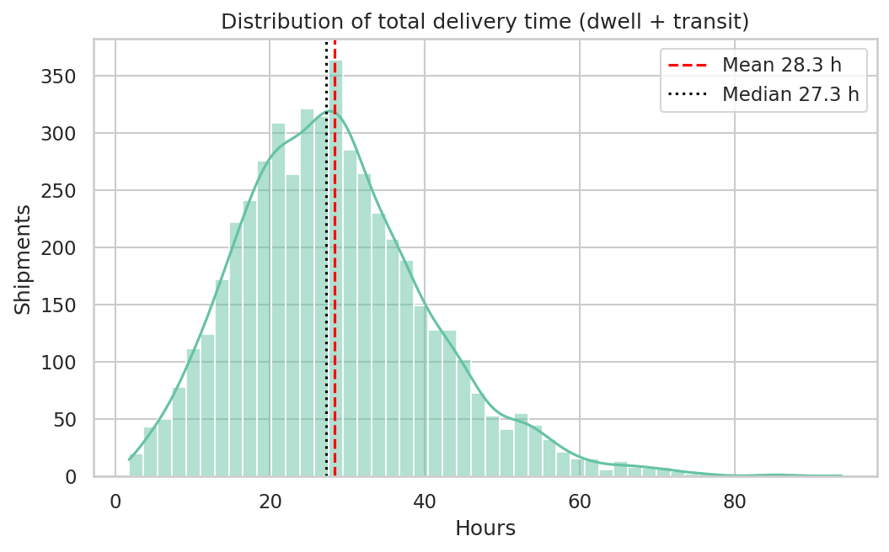
Figure 1. Distribution of total delivery time with mean and median marked.
Why a histogram with a density curve. A histogram shows the full shape of a continuous variable, including skew and multiple peaks, which a single average cannot. The kernel density overlay makes the shape easier to read, and the mean and median lines expose the gap between them. What it shows. The right tail is visible, and the mean (28.3 hours) sits above the median (27.3 hours). For planning, the median describes a typical shipment and the tail describes the cases that generate complaints.

4.2 Delivery time by transport mode
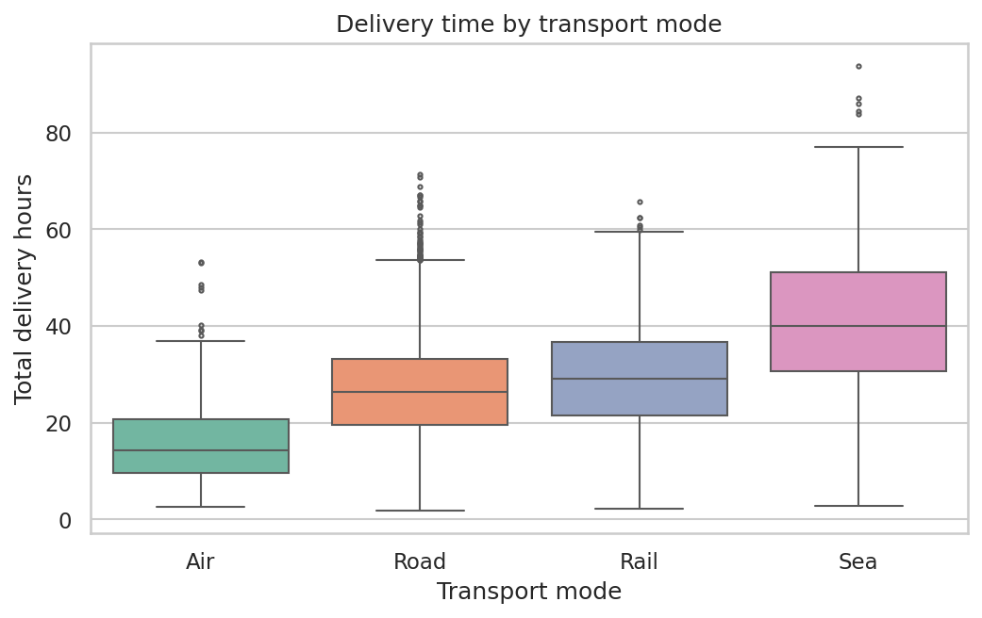
Figure 2. Total delivery hours by transport mode.
Why box plots. Box plots compare distributions across categories compactly. They show median, interquartile range and outliers simultaneously, so the reader can judge both typical performance and consistency. What it shows. Air has the tightest middle half (about 11 hours wide) and the lowest median, Sea is slowest with the widest spread (about 20 hours), and Road and Rail overlap substantially. Consistency matters as much as speed: a mode with a wide box produces unpredictable promise dates even if its median is acceptable.

4.3 Correlation matrix
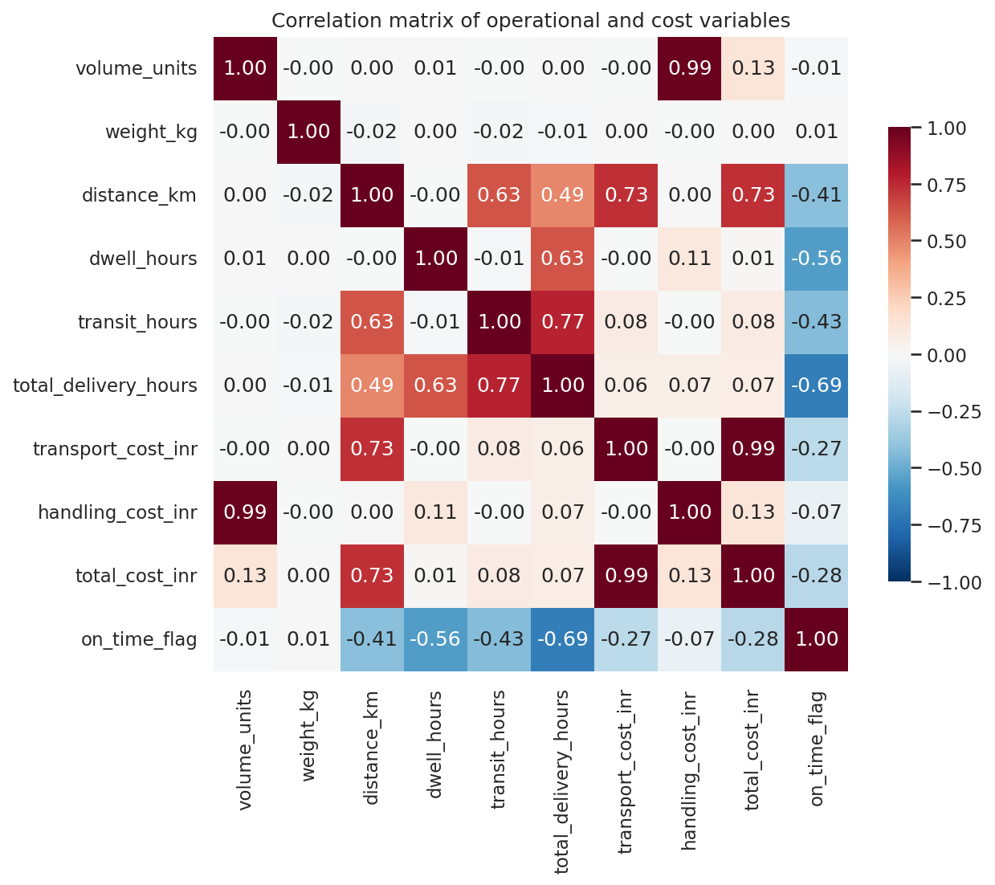
Figure 3. Pearson correlation matrix of operational and cost variables.
Why a heatmap. With ten variables, a table of pairwise coefficients is hard to scan. A diverging colour scale makes the strong positive and negative relationships immediately visible, and the annotated values allow precise reading. What it shows. The bright red block linking distance, transit and total cost confirms that distance drives both time and money. The blue link between on-time status and total hours confirms that delay is the main cause of service failure. The near-white row for weight shows that weight is not reflected in cost.

4.4 Distance against transport cost
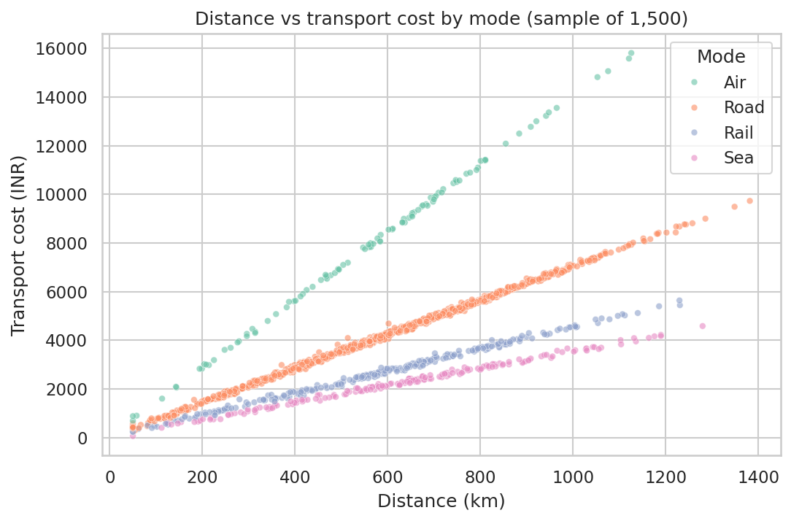
Figure 4. Distance against transport cost by mode (random sample of 1,500 shipments).
Why a scatter plot coloured by mode. A scatter plot reveals the functional form of a relationship and any clusters or outliers, while colour adds a third dimension without a separate chart. Sampling 1,500 points keeps the plot legible. What it shows. Each mode forms its own band. The slope is steepest for Air and shallowest for Sea, which matches the per-kilometre rates in the simulation. For rate negotiation, this tells a manager that the cost of moving freight over distance differs sharply by mode, and that shifting suitable long-haul volume from Air to Rail or Road is the largest single cost lever.

4.5 On-time delivery rate by carrier
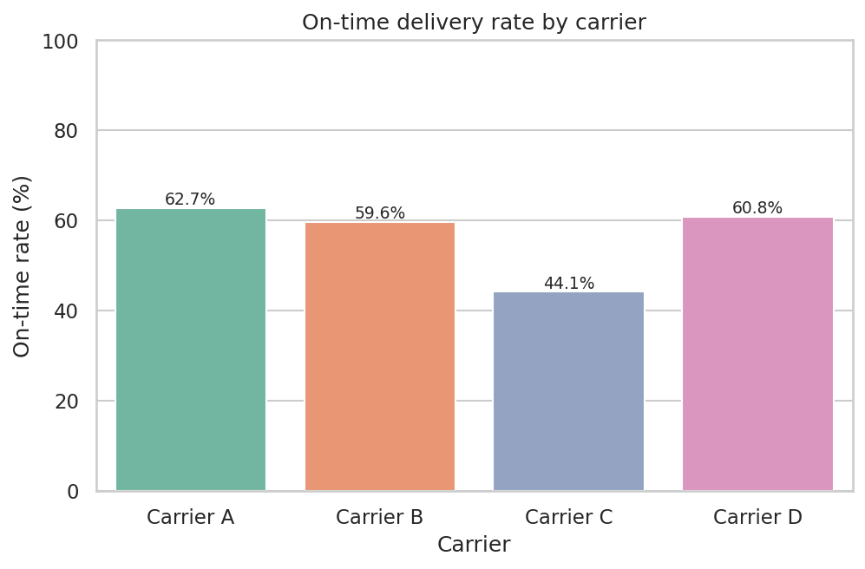
Figure 5. On-time delivery rate by carrier, with labelled values.
Why a labelled bar chart. Ranking entities against a single metric is the bar chart's strength. Labels remove the need to estimate values from the axis. What it shows. Carrier C achieves 44% on time, against roughly 60% to 63% for the other three carriers. Because Carrier C also handles 20% of volume but accounts for 28% of delivery-time outliers, its underperformance is material. It is a clear candidate for a service review or a penalty clause discussion.

4.6 Monthly volume and delivery time
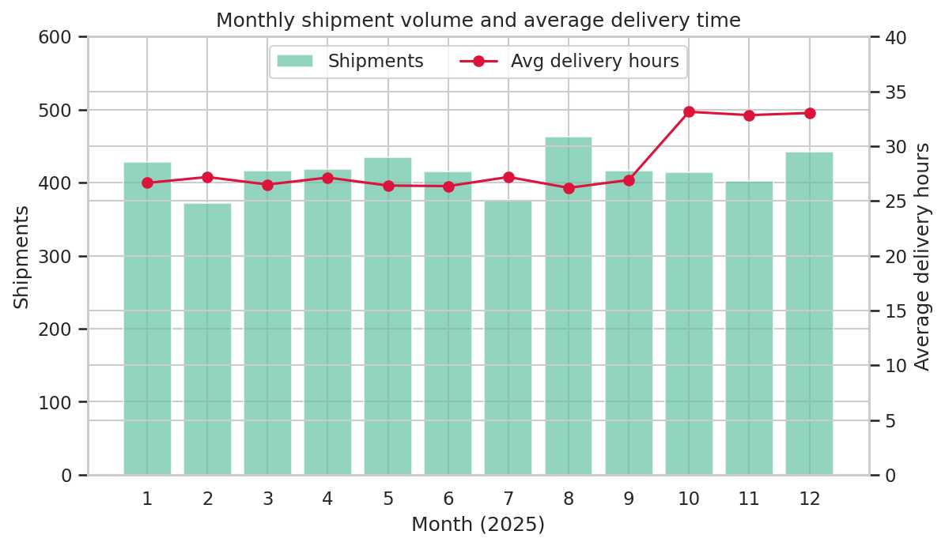
Figure 6. Monthly shipment volume (bars) and average delivery hours (line).
Why a dual-axis combination chart. Volume and delivery time are different units, but both change over the same time axis, so a combined chart shows whether they move together. The delivery-time axis starts at zero so the change is not exaggerated. What it shows. Volume is flat across the year, so demand alone does not explain the problem. Average delivery time sits near 26 to 27 hours from January to September and jumps to about 33 hours from October. Congestion, not demand, is the trigger, which points to capacity and warehouse processes rather than sales forecasting.

4.7 Warehouse dwell by hub and weekday
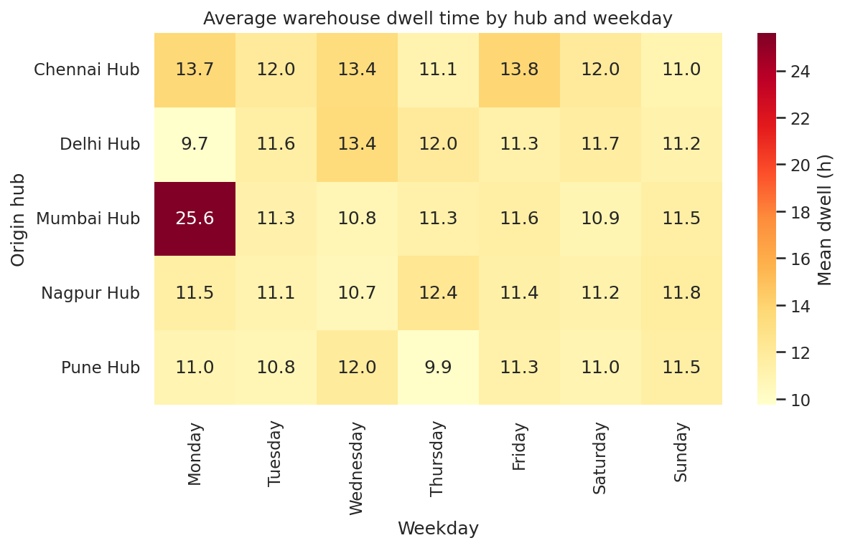
Figure 7. Mean warehouse dwell hours by origin hub and weekday.
Why a heatmap of group means. The question is about an interaction: does the effect depend on both hub and day? A grid lets a reader scan two categorical dimensions at once, and colour makes an isolated hotspot obvious. What it shows. Most cells sit roughly between 10 and 14 hours. The single exception is Mumbai on Monday, at 25.6 hours, more than double the typical value. This is a localised bottleneck rather than a general slowdown, and it is exactly the kind of pattern an aggregate average would hide.

4.8 Cost composition by mode
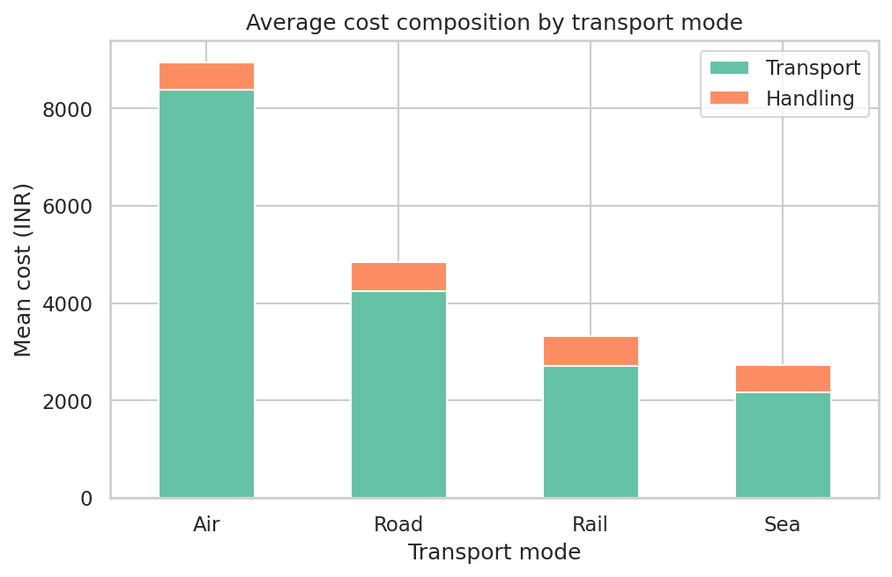
Figure 8. Mean transport and handling cost by transport mode.
Why a stacked bar chart. Stacking shows both the total for each mode and how it splits into components, which answers two questions at once. What it shows. Transport accounts for almost all cost in every mode, and the gap between modes comes almost entirely from the transport component. Handling cost is roughly constant across modes, so savings efforts should concentrate on freight rates and mode mix rather than on warehouse handling charges.

4.9 Selected code
The full script (04_eda_and_charts.py) generates all eight figures. Representative excerpts are shown below, using the same libraries and conventions throughout.
import matplotlib.pyplot as plt
import seaborn as sns

sns.set_theme(style="whitegrid", context="notebook")

# Histogram with KDE and reference lines
fig, ax = plt.subplots(figsize=(8, 4.5))
sns.histplot(df["total_delivery_hours"], bins=50, kde=True, ax=ax)
ax.axvline(df["total_delivery_hours"].mean(), color="red", ls="--")
ax.axvline(df["total_delivery_hours"].median(), color="black", ls=":")
fig.savefig("charts/fig01_delivery_hours_distribution.png")

# Heatmap of mean dwell by hub and weekday
pivot = df.pivot_table(index="origin_hub", columns="weekday",
values="dwell_hours", aggfunc="mean")[weekday_order]
sns.heatmap(pivot, annot=True, fmt=".1f", cmap="YlOrRd")

# Dual-axis chart with a zero baseline on the hours axis
ax1.bar(monthly.index, monthly["volume"], alpha=0.7)
ax2 = ax1.twinx()
ax2.plot(monthly.index, monthly["avg_hours"], color="crimson", marker="o")
ax2.set_ylim(0, 40)

5. Analytical Insights
The visualisations and statistics point to five insights. Each is stated with the evidence supporting it.

5.1 Peak season is the largest operational bottleneck
On-time performance falls from 64% in January to September to 39% in October to December. Average total delivery time rises from 26.7 to 33.0 hours. Dwell time explains most of this: it rises from 10.4 to 16.7 hours, and during the peak it accounts for 51% of total cycle time, against 42% over the year. Since volume is essentially unchanged, the constraint is warehouse throughput. Operational efficiency would most likely improve by adding handling capacity or staffing ahead of October, rather than by changing carriers, although this should be tested against warehouse capacity data.

5.2 A single hub-day combination causes a severe, isolated delay
Mumbai Monday shipments average 25.6 hours of dwell, compared with 11.5 hours for all other shipments. Only 14.5% of Mumbai Monday shipments meet their SLA, against 59.3% for everything else. This group represents 166 shipments (3.3% of the total) but accounts for 13% of delivery-time outliers. The pattern is consistent with a weekend backlog that is not cleared before Monday dispatch. The pattern is concentrated, so it is also inexpensive to address through a targeted intervention.

5.3 Carrier C is a service risk that worsens under pressure
Carrier C is on time for 44% of its shipments overall. Its performance drops from 50% off-peak to 26% during the peak, a sharper fall than Carrier A (from 69% to 46%). Carrier C handles 20% of volume but accounts for 28% of outliers. A carrier that is weak in normal conditions and weaker still under load is a strong candidate for a performance improvement plan or a shift of some volume to better-performing carriers.

5.4 Cost is driven by distance and mode, not weight
Transport represents 87% of total cost, and distance explains most of the transport component. The cost per kilometre ranges from 3.6 INR for Sea to 14.1 INR for Air. Weight has essentially no correlation with cost (0.00). Because the rate structure appears to ignore weight, heavy consignments may be under-priced and light ones over-priced. Verifying this against the actual rate card is the most valuable next step for the cost model.

5.5 Faster is not automatically more reliable
Air has the shortest median delivery time (14.4 hours) and the highest cost per kilometre, yet its on-time rate of 58.6% is no better than road or rail. The explanation is the SLA: a 16-hour window leaves little tolerance for dwell variation. Speed purchased at a premium does not buy reliability unless the surrounding warehouse process is also fast. Promises should be set from the observed distribution of performance rather than from the mode's physical speed.

6. Recommendations
The recommendations are ordered by expected impact against implementation effort. Each is tied to the insight that supports it, and each names a measure to track.
Priority | Recommendation | Supporting insight | Metric to track
1 | Add warehouse handling capacity and staffing from September, ahead of the October to December peak | 5.1: peak dwell rises 6 hours; on-time falls to 39% | Peak on-time rate and peak dwell hours
2 | Clear the Mumbai weekend backlog before Monday dispatch, or stagger Monday release | 5.2: Monday dwell is 25.6 hours; on-time 14.5% | Mumbai Monday dwell and on-time rate
3 | Open a service review with Carrier C, with a target on-time rate and a phased volume shift if it is not met | 5.3: 44% on time; disproportionate outliers | Carrier C on-time rate by month
4 | Audit the rate card for weight sensitivity, and incorporate weight into the cost model | 5.4: weight-to-cost correlation of 0.00 | Cost error on a holdout sample
5 | Reset SLA windows for Air from observed performance distributions, and use Air only where its speed is required | 5.5: Air 58.6% on time despite 14-hour median | On-time rate and cost per km by mode

7. Limitations
The dataset is simulated, so the patterns found are those built into the generator. The analysis demonstrates the method and the reasoning; it does not establish how a real network behaves. The correlations describe association, not cause, and the Mumbai Monday and Carrier C effects would need to be confirmed against operational records before action. Only one year of data is available, so seasonality is observed once and may not repeat exactly. The SLA windows are assumed definitions and would normally come from contracts. In a production setting, the same analysis should be repeated with real data, a confidence interval for each on-time rate, and a check that the effects are stable across months.

8. Conclusion
The analysis finds that the logistics network's performance problems are concentrated rather than general. Volume is steady, but delivery performance collapses during the October to December peak, driven by warehouse dwell. A specific hub-day combination creates the most severe localised delay, and one carrier underperforms consistently and worsens under pressure. Cost is dominated by distance and mode, and the current rate structure does not appear to account for weight. Visualisations were central to finding these patterns: the monthly chart separated congestion from demand, the heatmap isolated the Mumbai Monday hotspot, and the carrier bars made the service gap visible at a glance. Together they show that data-driven decision-making in logistics depends on looking at the process in its operational context, not only at summary averages.

