Week 5 Task
Evaluation of Cultural Integration in Language Learning
A critical evaluation framework and recommendations for German A1 courses
Prepared by: [Your Name]
Course / Batch: [Course name]
Target context: CEFR A1 German courses
Date: October 2026

1. Introduction
This final report evaluates how well cultural content supports language learning in German A1 courses. Across Weeks 1 to 4 this project designed a cultural strategy, a virtual cultural event, a module on German traditions, and a virtual field trip to German landmarks. Each of these was planned with care, but planning is not evidence. The purpose of this report is to ask a harder question: how would we know whether any of these designs works, and what should change if it does not?
The report makes four contributions. It reviews the main strategies for integrating culture into language teaching, drawing on published theory and research. It proposes an evaluation framework with quantitative and qualitative metrics, organised around intercultural competence as defined by Byram. It demonstrates the framework with a clearly labelled hypothetical case study. Finally, it critically assesses the project's own designs and recommends specific, feasible enhancements for A1 learners.
Important note on the data: The case study in Section 5 uses synthetic data generated for illustration. It does not report any real learners, and its results must not be read as evidence that any strategy works. Its purpose is to show how the framework would be applied and what kinds of conclusions it can and cannot support.

2. Scope and Method
The evaluation draws on three kinds of material. The first is published theory and research on intercultural communicative competence and on telecollaboration. The second is the Council of Europe's CEFR Companion Volume (2020), which sets the descriptor framework that A1 courses are commonly measured against. The third is the project's own four deliverables from Weeks 1 to 4, which are treated as cases to be assessed rather than as successes to be defended.
Sources were selected for their relevance to A1 teaching and for their status as academic publications or official frameworks. Where a source is a secondary summary, this is noted. The review is not a systematic literature review, and the hours recorded for this work should reflect the author's own reading and analysis.

3. Review of Cultural Integration Strategies

3.1 Theoretical foundation: intercultural communicative competence
Byram's (1997) model of intercultural communicative competence (ICC) is the most widely used framework in this area. Byram argued that language teaching should not aim only at native-like linguistic accuracy, but at developing the learner as an intercultural speaker and mediator. The model describes five components, known as savoirs: knowledge of self and others (savoirs), attitudes of curiosity and openness (savoir être), skills of interpreting and relating (savoir comprendre), skills of discovery and interaction (savoir apprendre/faire), and critical cultural awareness (savoir s'engager). A review of Byram's 1997 book notes that he treats learners as ethnographers rather than applied linguists, and that he criticises models of intercultural competence that give little importance to language learning.
The CEFR Companion Volume (Council of Europe, 2020) reflects a parallel shift. It adds a new Pre-A1 level, enriches the description at A1, and introduces a scale for pluricultural and plurilingual competence. For an A1 course, this means that intercultural outcomes can be linked to recognised descriptors, rather than being left as general aspirations.
Not all researchers accept this model without question. Dervin, as summarised in a conference paper on problematising ICC, has argued that Byram's model is paradoxical, and that its categories can hide the diversity and flexibility of real intercultural communication. This critique is important for the evaluation framework in Section 4, because it warns against treating the five savoirs as a checklist of fixed traits.

3.2 Evidence on telecollaboration and virtual exchange
Telecollaboration, or virtual exchange, connects learners in different locations through online tools. A synthesis of studies published between 2010 and 2015 by Ciftci and Savaş (2018, ReCALL) found that telecollaboration can support both language and intercultural learning, but that outcomes depend on the design of the exchange and on the challenges participants face. O'Dowd (2017) describes the range of models used in higher education, and notes that the approach has evolved in different contexts with very different structures and goals. A Cambridge Core article on virtual exchange in language teaching (2021) reflects on where research has been underexplored or over-applied in formal education, which is a useful caution for practitioners at school and A1 level.
The field is not uncritical of itself. In a seminar on learning outcomes of virtual exchange, O'Dowd notes that the approach has been criticised by commentators such as Kramsch (2014) and Liddicoat and Scarino (2013), who are sceptical of its effectiveness in developing intercultural awareness. The implication for this project is clear: virtual formats are not automatically intercultural. They need explicit design for comparison, reflection and critical awareness.

3.3 Comparison of five strategies
The table compares five strategies that are common in German A1 courses. The strategies differ in how much learners do, how much they reflect, and how directly they connect culture to language.
Strategy | Typical form | Strengths | Weaknesses | Evidence base
S1: Textbook cultural notes | A short text or box on culture, followed by comprehension questions | Low cost; easy to add; provides an accurate base of facts | Passive; little practice of language in use; knowledge decays quickly | Widely used; little outcome research at A1
S2: Task-based culture | Cultural situation used as the context for speaking or writing tasks (for example, ordering at a bakery) | Language is used functionally; links facts to communication | Can remain at the level of role-play; comparison with learners' own culture is often missing | Consistent with communicative and task-based approaches; limited A1 outcome data
S3: Thematic project | Learners research and present a tradition, or produce a cultural product such as a menu or a postcard | High engagement; supports discovery (savoir apprendre/faire) | Time-intensive; quality of language output varies widely | Supported by ICC theory; outcome studies mainly above A1
S4: Virtual cultural events and field trips | Live online tours, demonstrations, games and quizzes (Weeks 2 and 4 of this project) | Engaging; social; access to places learners cannot visit; strong sense of occasion | Dominated by teacher talk; participation can be uneven; technical risk | Telecollaboration research supports engagement; critics question intercultural depth
S5: Virtual exchange with a partner class | Regular asynchronous or synchronous contact with learners in a German-speaking country | Authentic interaction; intercultural encounters with real peers | Requires partner, scheduling, safeguarding and consent; hard to sustain | Strongest intercultural evidence base among the five, mainly from secondary and higher education

The comparison suggests that the strategies are not in competition. S1 supplies accurate content, S2 gives language a purpose, S3 builds discovery, S4 creates engagement, and S5 provides authentic intercultural encounter. The weakness common to most of them, as the Byram critique would predict, is the gap between knowing about a culture and reflecting critically on one's own assumptions. Section 5 returns to this point.

4. Evaluation Framework

4.1 Evaluation criteria
The framework evaluates each cultural module against five criteria. Four are learning outcomes and one is practicality, since a strategy that cannot be sustained by a teacher with limited time is unlikely to be used at all.
Criterion | Question it answers | Why it matters for A1
1. Engagement | Do learners take part actively and willingly? | A1 learners disengage quickly when input outpaces their understanding
2. Language gain | Do learners produce target language with more accuracy and range? | Culture must support language, not replace it
3. Knowledge retention | Do learners remember cultural content and vocabulary after a delay? | Immediate recall can mask forgetting; delayed tests reveal whether learning lasted
4. Intercultural competence | Do learners show curiosity, interpretation, discovery and critical awareness? | Byram's model defines the aim beyond facts
5. Practicality | Can the strategy be run repeatedly with the available time, staff and resources? | Determines whether good design survives contact with a real timetable

4.2 Metrics: quantitative and qualitative
Each criterion is measured by at least one quantitative and one qualitative metric. Quantitative metrics show how much change occurred; qualitative metrics explain why and how it occurred. The table sets out the measures, the instruments and the targets.
Criterion | Quantitative metric | Qualitative metric | Instrument | Provisional target
Engagement | Share of learners with at least one spoken or typed turn per session; number of turns per learner | Teacher observation notes on participation quality and withdrawal | Session log; observation checklist | At least 90% speak or type once; at least 3 turns each
Language gain | Change in score on a pre- and post-test of target phrases (0 to 100) | Quality of spoken or written output, rated on a rubric | Phrase test; speaking rubric (Appendix A) | Gain of at least 15 points; rubric level 3 or above for most
Knowledge retention | Score on a delayed test four weeks after the module (0 to 100) | Learner explanations of what they remember and how | Delayed quiz; short interview | At least 70% of immediate post-test score retained
Intercultural competence | Change on a 1 to 5 appreciation scale; scores on ICC indicators | Coded reflection journal entries across the five savoirs | Likert items; reflection journal codebook (Appendix A) | Positive change; reflections show comparison and questioning in most entries
Practicality | Teacher preparation time per session; proportion of sessions delivered as planned | Teacher reflection on workload and sustainability | Time log; end-of-term review | Under 3 hours preparation per session; at least 80% delivered as planned

4.3 Indicators of intercultural competence at A1
Byram's five savoirs are abstract, and A1 learners can only show them in simple ways. The table translates each savoir into an indicator that a teacher can observe at this level. The indicators are deliberately modest, because an A1 learner cannot be expected to produce sophisticated cultural analysis.
Savoir (Byram) | Indicator at A1 | Example of evidence
Attitudes (savoir être): curiosity and openness | Asks at least one question about a German practice | „Warum sind die Läden sonntags zu?“
Knowledge (savoirs) | Recalls and uses at least three facts about a tradition | „Sankt Martin ist am 11. November.“
Interpreting and relating (savoir comprendre) | Connects a German practice to one from their own culture | „Bei uns gibt es auch Laternen, aber im Sommer.“
Discovery and interaction (savoir apprendre/faire) | Finds or describes a new practice with help from a peer or a prompt | Pair task where a learner explains a custom to a partner
Critical cultural awareness (savoir s'engager) | Notes that a generalisation may not apply to everyone | „Nicht alle Deutschen trinken Bier auf dem Fest.“

4.4 Data collection schedule
Data are collected at three points: a pre-module baseline, an immediate post-module assessment, and a delayed assessment four weeks later. The delayed point is the most important addition, because a module that produces a strong immediate score but no retention has not achieved durable learning.
Timepoint | Instruments | Purpose
Baseline (week before module) | Phrase pre-test; appreciation scale; consent and background form | Establish starting point and check comparability of groups
Immediate (end of module) | Phrase post-test; appreciation scale; speaking rubric; reflection journal | Measure short-term gain and immediate intercultural response
Delayed (four weeks later) | Delayed quiz; short interview; postcard or portfolio task | Measure retention and whether learning transferred

4.5 Analysis approach
Quantitative data are analysed by comparing groups with means, standard deviations and effect sizes (Cohen's d). Because sample sizes in A1 classes are small, effect sizes and confidence intervals should be reported alongside p-values, and results should be interpreted cautiously. Qualitative data are coded using a codebook built from the five savoirs, with at least two coders independently coding a sample of entries. Agreement should be reported (for example, Cohen's kappa), and disagreements discussed rather than averaged away.

5. Hypothetical Case Study
To show how the framework works in practice, four hypothetical A1 course designs were compared. Each design corresponds to one of the strategies in Section 3. The design is hypothetical: the groups, scores and effects are invented for illustration, and the numbers were generated with a fixed random seed so that the example can be reproduced.

5.1 Design
Design | Strategy | Hypothetical sample | Key feature
A: Textbook notes | S1 | 30 learners | Culture as a reading box; comprehension questions
B: Task-based culture | S2 | 30 learners | Cultural situations as the context for speaking tasks
C: Thematic project | S3 | 30 learners | Learners research and present a tradition over two weeks
D: Virtual exchange | S5 (approximated) | 30 learners | Four live sessions with a partner class plus asynchronous voice messages

Design D is labelled as an approximation of S5 because a full partner-class exchange is hard to stage in a hypothetical single-group study. The four live sessions and voice messages are intended to represent its core elements.

5.2 Simulated data
The simulation generates a pre-test score for each learner, an immediate post-test score, a four-week retention score, an engagement percentage, and appreciation scores before and after the module. Each design has a different assumed effect on these measures, drawn from the qualitative pattern in the literature (for example, that passive designs produce faster forgetting and lower engagement). The core of the simulation is shown below.
designs = {
"A: Textbook notes": dict(post_bonus=0, decay=22, engage=45, appr_gain=0.10),
"B: Task-based culture": dict(post_bonus=5, decay=16, engage=68, appr_gain=0.45),
"C: Thematic project": dict(post_bonus=8, decay=12, engage=78, appr_gain=0.70),
"D: Virtual exchange": dict(post_bonus=9, decay=11, engage=74, appr_gain=0.80),
}
post_vocab = (pre_vocab + 20 + p["post_bonus"] + rng.normal(0, 8, N)).clip(0, 100)
retention = (post_vocab - p["decay"] + rng.normal(0, 7, N)).clip(0, 100)

Caution: The effects were chosen by the author, so the results follow from those choices. A real study would not know these effects in advance, and the main value of the simulation is to show what the analysis produces, not what the strategies achieve. A sensitivity analysis would vary these assumed effects to see how robust the conclusions are, and is recommended in Section 8.

5.3 Results
Design | Immediate post-test (mean, SD) | 4-week retention (mean, SD) | Retention vs A (d, p) | Engagement (mean %) | Appreciation change (pre to post)
A: Textbook notes | 63.7 (9.9) | 40.6 (11.7) | Reference | 43.8 | +0.17 (p = 0.08)
B: Task-based culture | 65.8 (14.5) | 49.1 (16.2) | 0.61 (p = 0.02) | 72.1 | +0.42 (p < 0.001)
C: Thematic project | 69.4 (13.8) | 57.8 (12.7) | 1.41 (p < 0.001) | 76.2 | +0.80 (p < 0.001)
D: Virtual exchange | 68.7 (14.6) | 58.5 (14.7) | 1.35 (p < 0.001) | 71.3 | +0.81 (p < 0.001)

Three patterns emerge from the hypothetical data. First, the differences between designs are small on the immediate post-test (63.7 to 69.4), but large on the four-week retention measure (40.6 to 58.5). This is the reason the delayed measure matters: an immediate test would suggest that the designs perform similarly, while the delayed test separates them clearly. Second, engagement and retention are both lowest for design A, but the ordering among designs B to D differs between the two measures, which shows that they are related without being the same thing. Third, the change in appreciation is small for the textbook design and largest for the project and virtual exchange designs. Because the appreciation change for design A does not reach conventional significance, it should not be interpreted as a real effect.
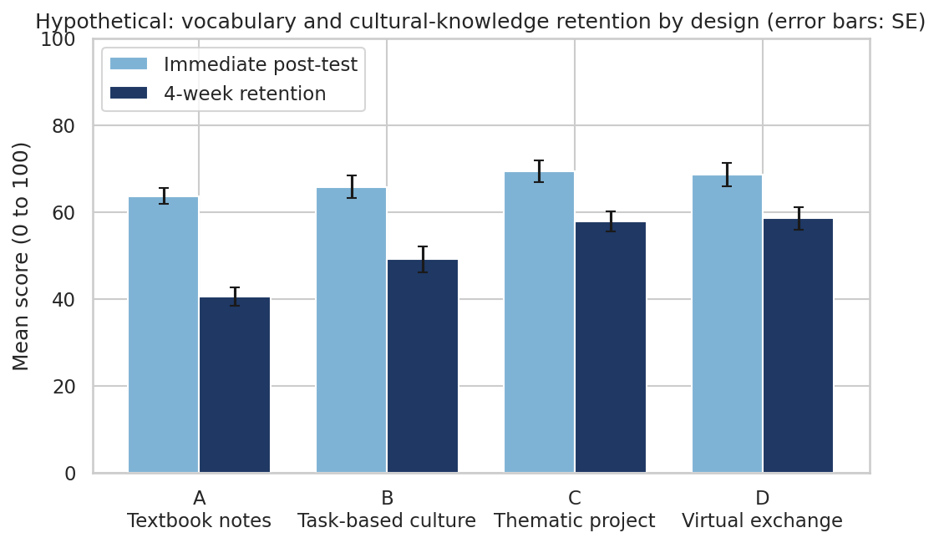
Figure 1 (hypothetical data). Immediate post-test and four-week retention scores by design, with standard errors.
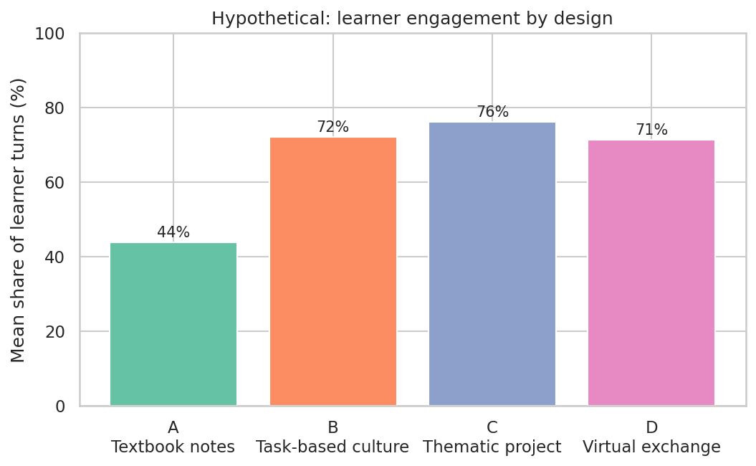
Figure 2 (hypothetical data). Mean share of learner turns by design.
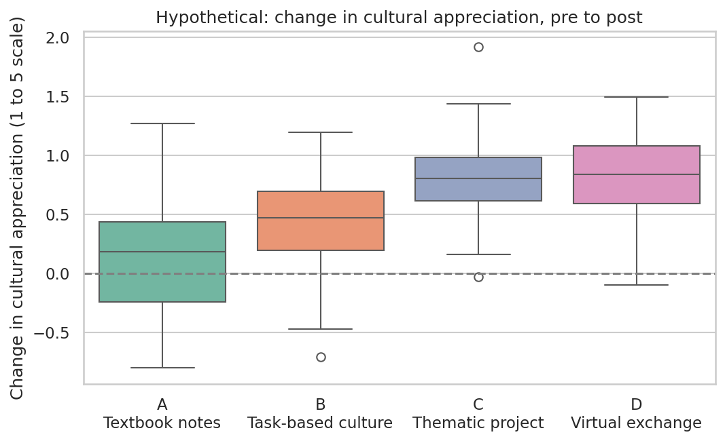
Figure 3 (hypothetical data). Change in cultural appreciation from pre- to post-module, by design.

5.4 What the case study teaches about the framework
- Delayed measures change the picture. An immediate post-test alone would have led to the conclusion that the designs were similar. The delayed test reveals the difference in durable learning.
- Engagement is a necessary but not sufficient condition. Design C has higher engagement than design D (76% against 71%), yet the two designs have almost identical retention (57.8 against 58.5). Engagement opens the door to learning but does not guarantee it, so engagement should always be read alongside outcome measures.
- Effect sizes matter more than p-values. With 30 learners per group, small effects may not reach significance, while large effects can appear significant with little practical meaning. The report recommends reporting effect sizes and confidence intervals.
- Appreciation is the hardest outcome to change. Even in the simulation, the textbook design produced little change. Intercultural attitudes appear to need interaction and reflection, not only information.

6. Critical Analysis of the Project's Designs
The report would be incomplete without examining the designs this project produced. Each of Weeks 1 to 4 is assessed against the framework, with its strengths, its weaknesses and the evidence it lacks. The assessment is deliberately self-critical, because critical cultural awareness, one of the five savoirs, applies to a course designer as much as to a learner.
Week and design | Main strengths | Main weaknesses | Evidence still missing
Week 1: Cultural strategy (S2 and S4 elements) | Clear source criteria; four topics matched to A1 structures; sensitivity notes in each topic | Mostly presents facts; comparison with learners' own culture is suggested but not built into tasks; stereotype awareness is noted rather than practised | No outcome measures; no delayed assessment; no pilot data
Week 2: Virtual cultural event (S4) | Highly engaging format; sequenced agenda; alcohol-free refreshment guidance; accessibility options | Long teacher-led segments; cooking demonstration makes most learners spectators; live timing excludes learners in some time zones | Participation data; post-event retention; fairness across time zones
Week 3: Traditions module (S2 and S3 elements) | Graded exercises with answer keys; clear grammar focus; role cards; speaking rubric | Cultural depth limited to descriptions; little reflection on regional or generational variation; the Oktoberfest content needs careful framing to avoid promoting alcohol | Trial with learners; reliability of the rubric; retention data
Week 4: Virtual field trip (S4) | Strong sense of place; six-step pattern gives predictability; reflection question at each stop; copyright and privacy guidance | German narratives may exceed A1 listening capacity without pre-teaching; long narrative segments risk teacher-centred delivery; the reflection prompts are not coded | Listening comprehension data; engagement logs; learner reflections

6.1 The central weakness across all four designs
Across the four designs, culture is largely presented as information, and learners are asked to recall it or to use it in a role-play. The designs contain comparison prompts and sensitivity notes, but these are supplementary. The result is that the designs are strongest on the savoirs (knowledge) and savoir apprendre/faire (discovery through interaction), and weakest on savoir s'engager (critical cultural awareness) and savoir être (attitudes), which the framework identifies as the outcomes most likely to change through reflection and sustained interaction.

6.2 What the project did not do
- It did not measure learning. Every design relied on the assumption that a well-planned activity produces learning. The framework in Section 4 addresses this directly.
- It did not test any design with real learners. The narratives, quizzes and rubrics are untested, and their difficulty for A1 learners is an estimate.
- It gave limited attention to the perspectives of learners from outside the German-speaking world, whose own traditions could enrich comparisons and reduce the risk of presenting German culture as the norm.

7. Strengths, Weaknesses, Opportunities and Threats
The table summarises the position of cultural integration in German A1 courses, drawing on the review in Section 3, the case study in Section 5 and the critical analysis in Section 6.
 | Helpful to the goal | Harmful to the goal
Internal | **Strengths:** strong engagement potential of events and projects; clear fit with CEFR A1 descriptors; practical, reusable materials; accessible formats | **Weaknesses:** outcome data rarely collected; teacher-centred delivery; limited critical reflection; untested materials; reliance on immediate recall
External | **Opportunities:** free online partner schemes; growing evidence base on telecollaboration; CEFR Companion Volume supports intercultural assessment; learners' own cultures can enrich comparisons | **Threats:** time pressure in courses; technical and connection barriers; stereotyping if content is shallow; safeguarding and consent demands on virtual exchange; criticism that virtual exchange is not automatically intercultural

8. Recommendations
The recommendations are ordered by expected impact against effort. Each is specific to A1 learners, can be implemented without a large budget, and is linked to a metric in Section 4 so that its effect can be checked.
No. | Recommendation | Rationale | Metric | Effort
R1 | Add a delayed retention check four weeks after every cultural unit, using a short quiz and one postcard or spoken task | Immediate tests hide forgetting; the case study shows the largest differences at delay | Four-week retention as a share of post-test | Low
R2 | Build one comparison task into each unit, using fixed sentence frames (Bei uns ... / In Deutschland ...) | Comparison develops interpreting and relating (savoir comprendre) and is the most direct route to intercultural awareness | Frequency of comparison in learner output; reflection codes | Low
R3 | Limit teacher talk to about two minutes per segment, pre-teach six key words before each narrative, and give each learner a speaking role | Participation is the precondition for learning; A1 listening load is high | Share of learners speaking; turns per learner | Low
R4 | Introduce a light virtual exchange: one asynchronous voice-message exchange per unit with a partner class, with consent and safeguarding procedures | Authentic intercultural encounter is the strongest route to attitudes and discovery | Exchange completion; quality of exchanged messages | Medium to high
R5 | Add a stereotype-check prompt to every unit: Stimmt das für alle? Wer sagt das? Gibt es Unterschiede? | Builds critical cultural awareness (savoir s'engager) and counters the risk of presenting one German culture as the norm | Frequency of critical comments in journals | Low
R6 | Align assessment with the CEFR Companion Volume descriptors and the indicators in Section 4.3, combining the quiz with a portfolio | Makes intercultural outcomes visible and comparable across courses | Coverage of indicators in portfolios | Medium
R7 | Provide captions, transcripts, audio-only and low-bandwidth options for every virtual session, and offer two session times where learners are in different time zones | Removes access barriers that otherwise fall unevenly on learners | Attendance and completion by access group | Low
R8 | Run a two-hour teacher training on facilitating intercultural talk and on using the framework | Teacher facilitation quality is the main determinant of the outcomes in S4 and S5 | Teacher confidence rating; observed facilitation quality | Medium
R9 | Pilot the modules with two groups, run a sensitivity analysis on the assumed effects, and report results openly | Turns planning into evidence and exposes weak designs early | Completed pilot; sensitivity results | Medium

8.1 Implementation roadmap
Phase | Timing | Actions | Output
1. Baseline | Weeks 1 to 2 of the term | Set up consent forms; create the phrase pre-test and appreciation scale; train coders | Instruments ready and piloted
2. Pilot | Term unit 1 (two groups) | Apply R1, R2, R3 and R5; collect baseline, immediate and delayed data | First data set; revised materials
3. Extend | Term unit 2 onwards | Add R4 (partner exchange) and R7; deliver R8 training | Full course with the framework in use
4. Review | End of term | Analyse results with effect sizes and sensitivity checks; revise the designs | Evaluation report and updated course

8.2 Risks to the recommendations
- Time: the framework adds data collection. Keep instruments short (under 15 minutes each) and reuse classroom time where possible.
- Consent and privacy: learner data, recordings and partner-class contact need clear consent, secure storage and a deletion date. These requirements should be settled before any exchange begins.
- Small samples: single classes produce unstable estimates. Report results as indicative, and combine data across terms before drawing firm conclusions.
- Over-claiming: the case study should not be presented as evidence. Any real findings should be reported with their limits.

9. Limitations
The report has several limitations, which are stated here so that its conclusions are read accurately. The case study is synthetic, and its results follow from assumptions chosen by the author. The literature review is selective and draws heavily on a small number of sources, some of which are secondary summaries. No strategy was tested with real learners, so none of the recommendations has been validated in practice. The framework measures intercultural competence only at a modest A1 level, and the indicators in Section 4.3 are a starting point that would need refinement. Finally, the perspectives of learners and teachers from outside the German-speaking world are under-represented, and this could bias the choice of content and comparisons.

10. Conclusion
Cultural content makes German A1 courses more meaningful, but meaning alone does not guarantee learning. The review in this report suggests that the most engaging strategies, such as events, projects and virtual field trips, are not necessarily the most effective for durable knowledge or intercultural awareness. The case study illustrates why: the immediate results of different designs look similar, while retention and engagement reveal differences that a single test would miss.
The strongest contribution of this project is the framework itself. It asks what each cultural module is for, how its success will be seen, and whether the success lasts. The recommendations follow from that discipline: test retention, build comparison and critical reflection into every unit, make participation possible for every learner, and treat virtual exchange as a serious intercultural tool rather than a novelty. The most important next step is not another design, but a pilot that replaces the hypothetical numbers in this report with real evidence from real learners.

Appendix A: Sample Instruments

A.1 Cultural appreciation scale (five-point Likert, German or English)
- Ich finde es interessant, wie Menschen in Deutschland feiern. (1 = stimme überhaupt nicht zu, 5 = stimme völlig zu)
- Ich möchte mehr über deutsche Traditionen erfahren. (1 to 5)
- Ich kann verstehen, warum Menschen in Deutschland diese Bräuche pflegen. (1 to 5)
- Ich habe über meine eigene Kultur nachgedacht, während ich über deutsche Bräuche gelernt habe. (1 to 5)

A.2 Delayed retention quiz (sample items, four-week check)
- Woraus ist das Brandenburger Tor gebaut? (a) Holz (b) Sandstein (c) Glas
- Wann war der Kölner Dom fertig? (a) 1248 (b) 1880 (c) 1996
- Was ist eine Maß? (a) ein Festzelt (b) ein Maß für Bier (c) ein Lied
- Wann ist Sankt Martin? (a) 11. November (b) 1. Mai (c) 24. Dezember

A.3 Reflection journal codebook (excerpt)
Code | Definition | Example
CUR | Expresses curiosity or a question about a practice (savoir être) | „Warum gibt es Martinsgänse?“
COM | Compares a German practice with the learner's own culture (savoir comprendre) | „Bei uns ist das anders.“
GEN | Recognises that a generalisation may not apply to everyone (savoir s'engager) | „Nicht jeder feiert so.“
FAC | Reports a fact without comparison or reflection (savoirs only) | „Der Dom ist alt.“
STE | Repeats a stereotype without questioning it (critical gap) | „Alle Deutschen trinken Bier.“

Coding rule: each journal entry may receive more than one code. Two coders code a sample of 20% of entries independently, and agreement is reported before the rest are coded.

A.4 Observation checklist for breakout sessions
- Did every learner speak or type at least once? (yes / no)
- Did any learner use a comparison frame? (yes / no)
- Did the teacher or a peer prompt a stereotype check? (yes / no)
- Approximate proportion of talk: teacher (%) / learners (%)

Appendix B: Sources
The sources below were consulted for the review in Section 3. Web pages change, and the reader should check current versions before citing them in a formal submission.
Byram, M. (1997). Teaching and Assessing Intercultural Communicative Competence. Clevedon: Multilingual Matters. Review and summary: LINGUIST List 32.2158, https://linguistlist.org/issues/32/2158/
Council of Europe (2020). Common European Framework of Reference for Languages: Learning, Teaching, Assessment. Companion Volume. Strasbourg: Council of Europe Publishing. https://rm.coe.int/16809ea0d4
Ciftci, E.E. & Savaş, P. (2018). The role of telecollaboration in language and intercultural learning: a synthesis of studies published between 2010 and 2015. ReCALL, 30(3), 278–298. https://publires.unicatt.it/en/publications/ee-ciftci-psavas-the-role-of-telecollaboration-in-language-and-in-3/
O'Dowd, R. (2017). Virtual Exchange and internationalising the classroom. Training, Language and Culture, 1(4), 8–24. https://doi.org/10.29366/2017tlc.1.4.1
Research into practice: Virtual exchange in language teaching and learning (2021). Cambridge Core. https://www.cambridge.org/core/product/022539C1A95D665F8792D92D1E63E091
O'Dowd, R. Learning outcomes of virtual exchange in higher education (seminar summary, which cites Kramsch, 2014, and Liddicoat & Scarino, 2013). https://ciel.unige.ch/?p=11340
Problematising intercultural communicative competence in language teaching and learning (conference paper, summarising Dervin's critique of Byram's model). https://conference.pixel-online.net/files/ict4ll/ed0012/FP/6082-QIL4170-FP-ICT4LL12.pdf
Goethe-Institut and other public sources used in Weeks 1 to 4 are listed in the respective reports.

