Requirement:

Java includes a rich library for Exception handling. Using the program from the first assignment, select any 5 different types of Java exception. Add to your code exception handling for those 5 different types. Test each type with one test case and report results.

**TestCase1:**

**Program Input:**

* weight in pounds =120
* height in inches = 1.7976931348623157E308

**Program Expected Output**: Run time Exception occurred: Weight of the person exceeds the range of double data type..

**Output Screenshot**: Below is the screenshot

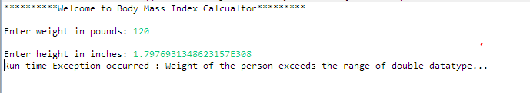

**Test case 2**:

**Program Input**:

* weight in pounds = 120
* height in inches = abc

**Program Expected Output**: Number Format Exception has occurred please check for input string: "abc"

**Output Screenshot**: Below is the screenshot

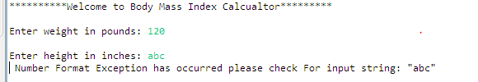

**Test case 3**:

**Program Input**:

* weight in pounds =-120
* height in inches = -50

**Program Expected Output**: Input Mismatch Exception has occurred please enter positive value

**Output Screenshot**: Below is the screenshot

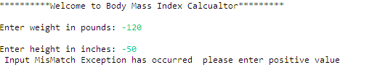

**Test case 4**:

**Program Input**:

* weight in pounds =155
* height in inches = 65

**Program Expected Output**: Arithmetic Exception occurred java.lang.ArithmeticException: height cannot be zero

**Output Screenshot**: Below is the screenshot

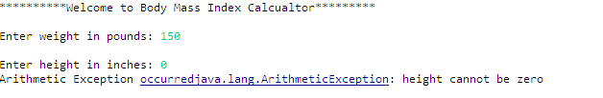

**Test case 5**:

**Program Input**:

* weight in pounds =0
* height in inches = 120

**Program Expected Output**: Exception occurred BMI cannot be zero : please check input weight parameter

**Output Screenshot**: Below is the screenshot

