1. Login page

<http://localhost:8080>

password is encrypted in db

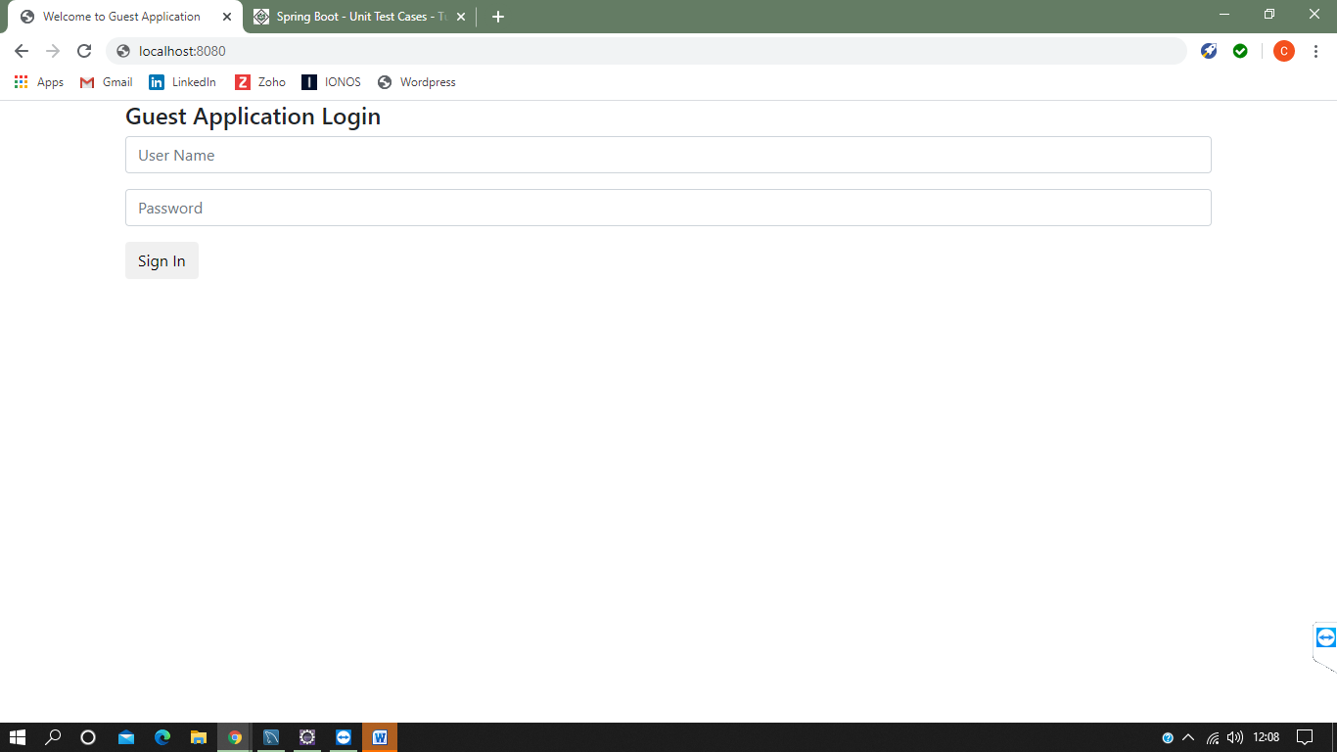

2) if user is guest user.. after login show guest notes entry page

Username: chandra pw: guest@123

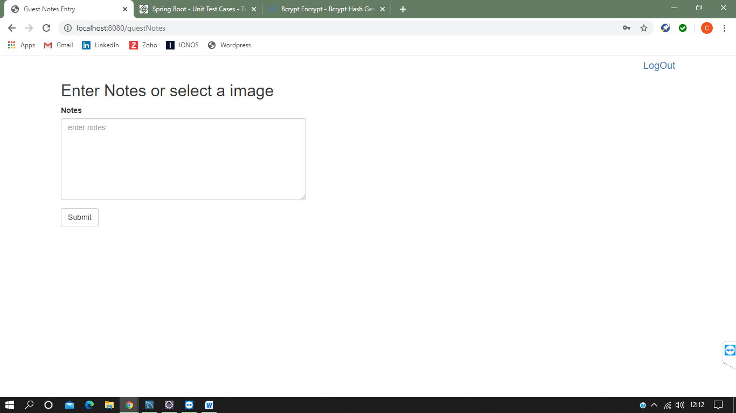

3) 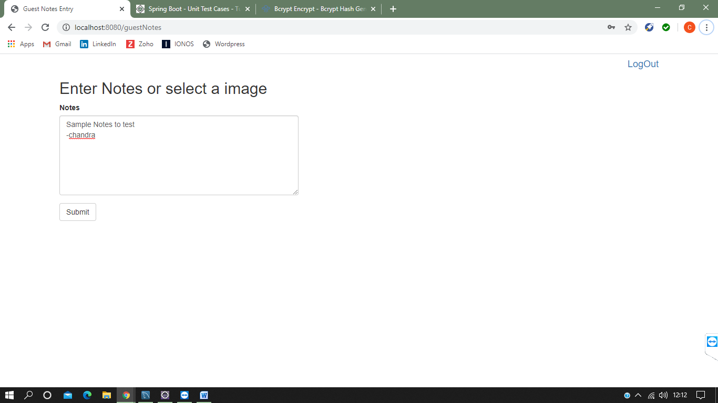



Notes added successfully….

4)

Logout to login as admin

Username: admin pw: admin@123

After login as admin approve/remove notes page will be shown

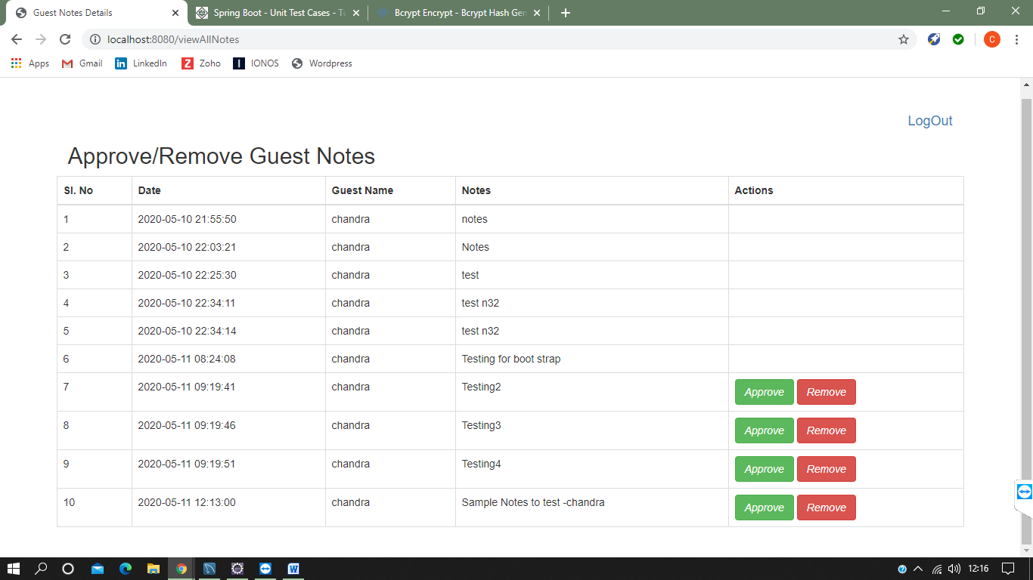

5) confirm to approve notes

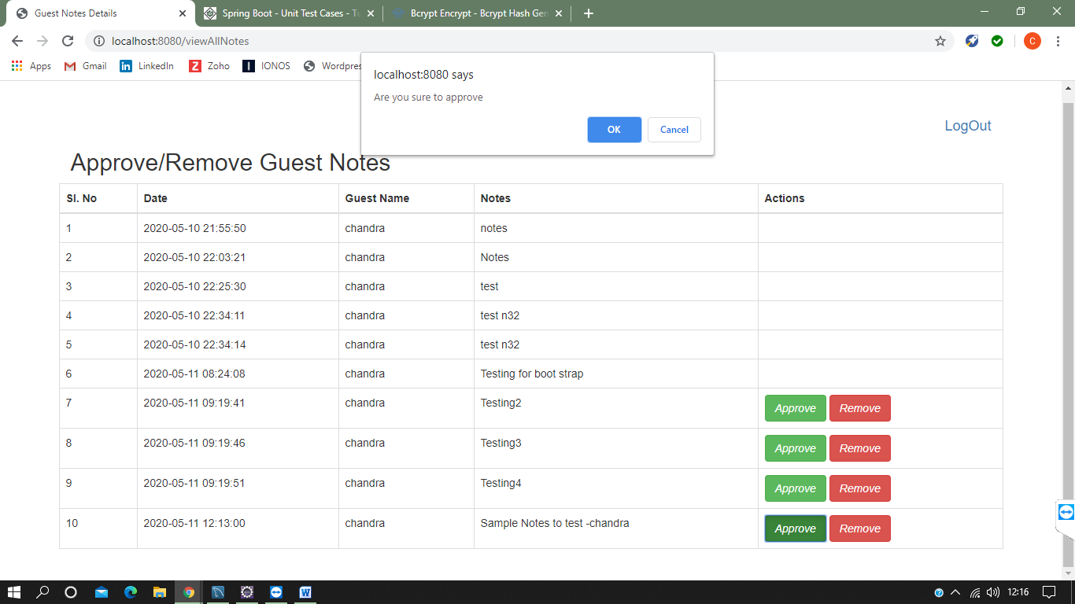

6) Once the Notes approved successfully

Approve/remove button is disabled

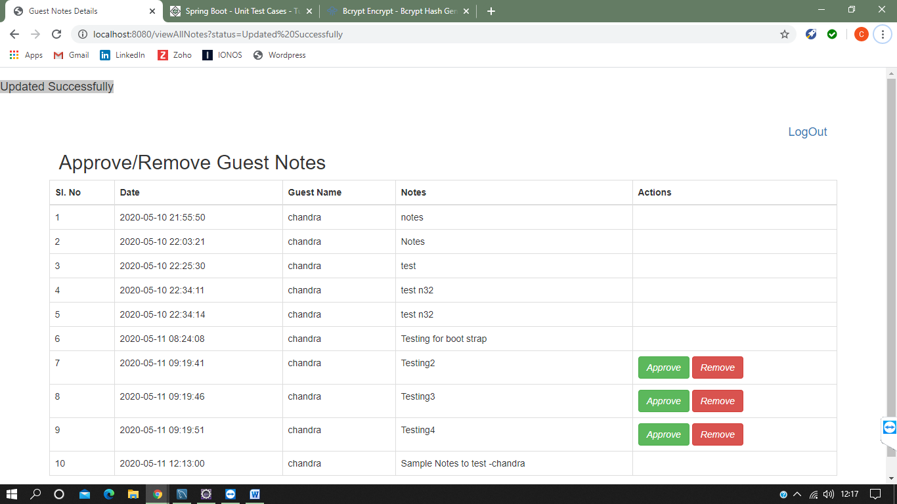

6) click remove to remove notes, confirm to go ahead

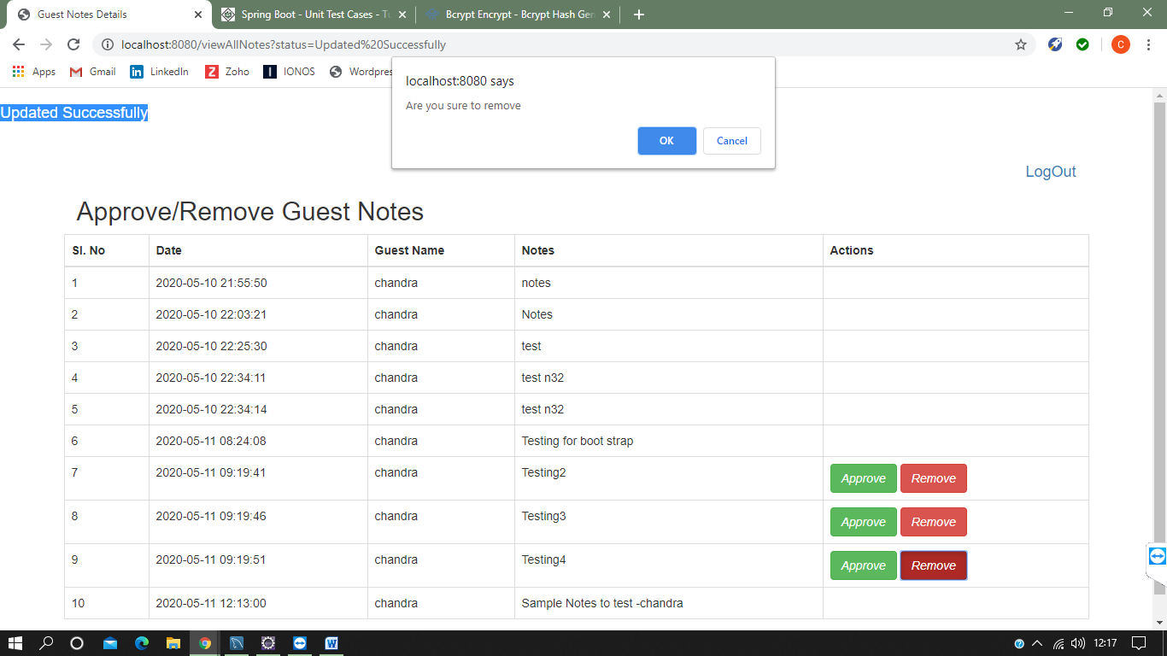

7) notes removed successfully

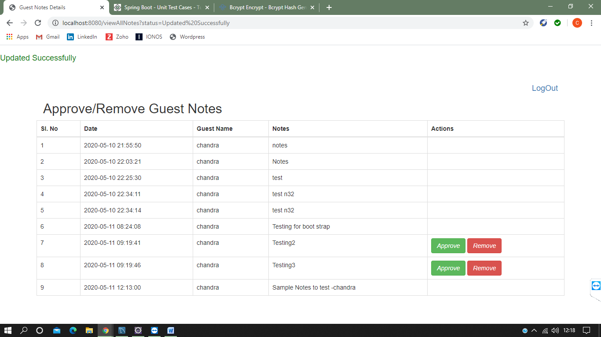

8) Logout application

9) Image update as a “GUEST” role [Image format : image/jpeg]

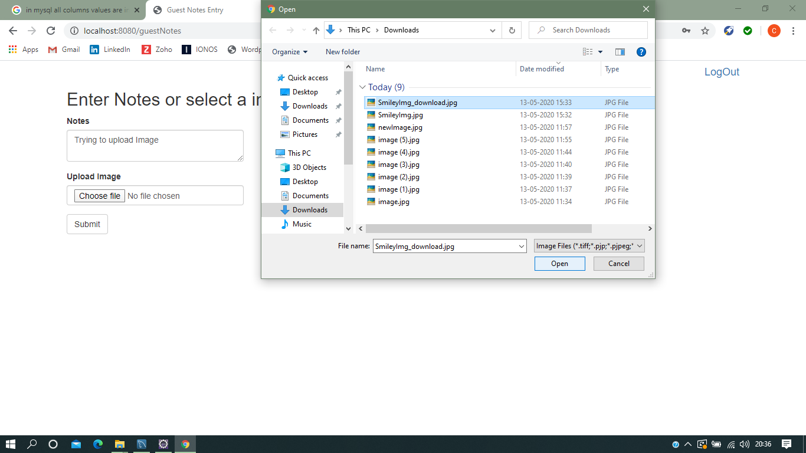

10. Once Image is selected it will display the file name of select “image/jpeg” appear in Upload Image field as below:

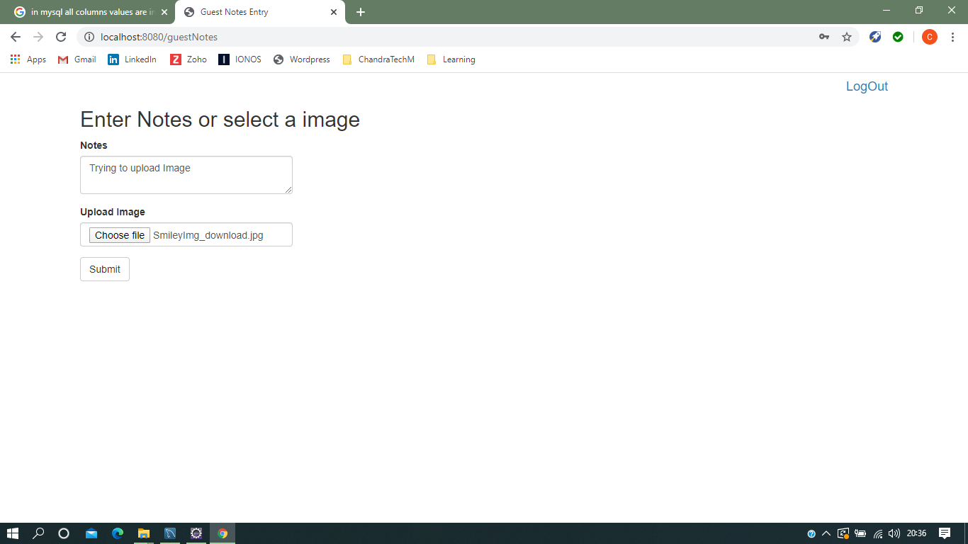

11. Once click on “Submit”, the will “Added Successfully”, below screen shot for the same

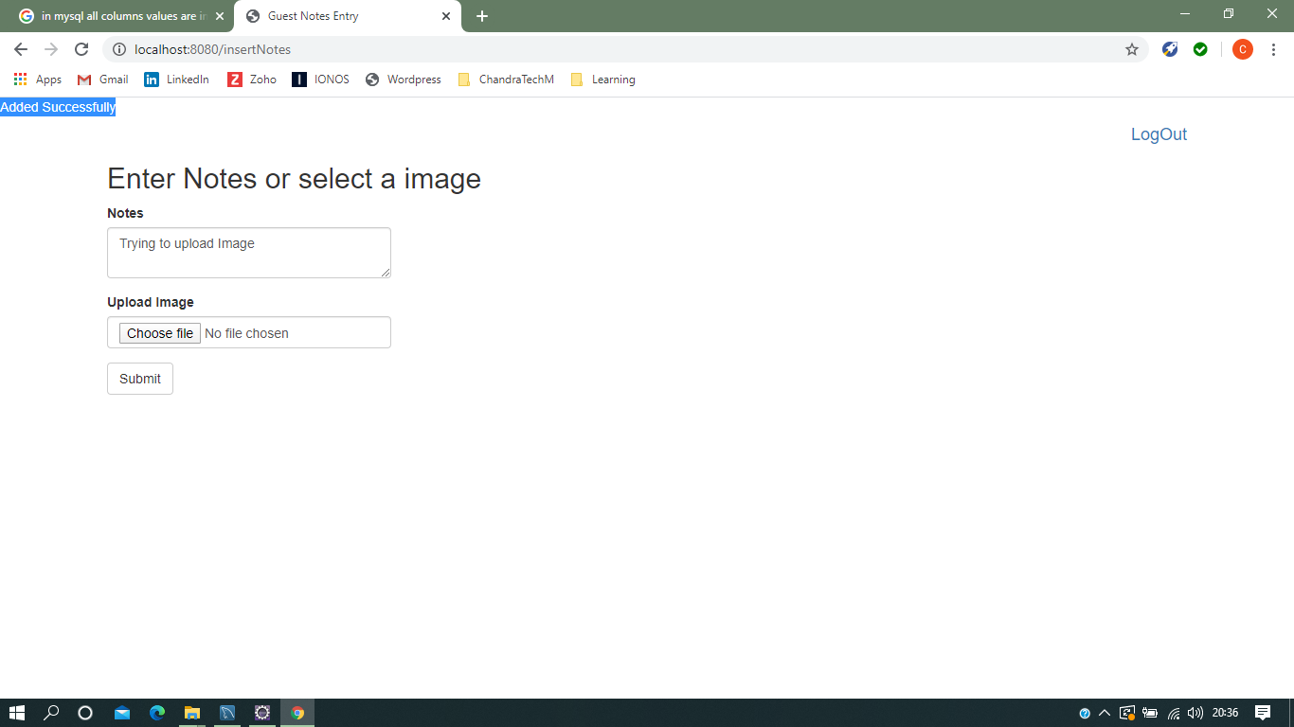

12. To view the same login as admin role

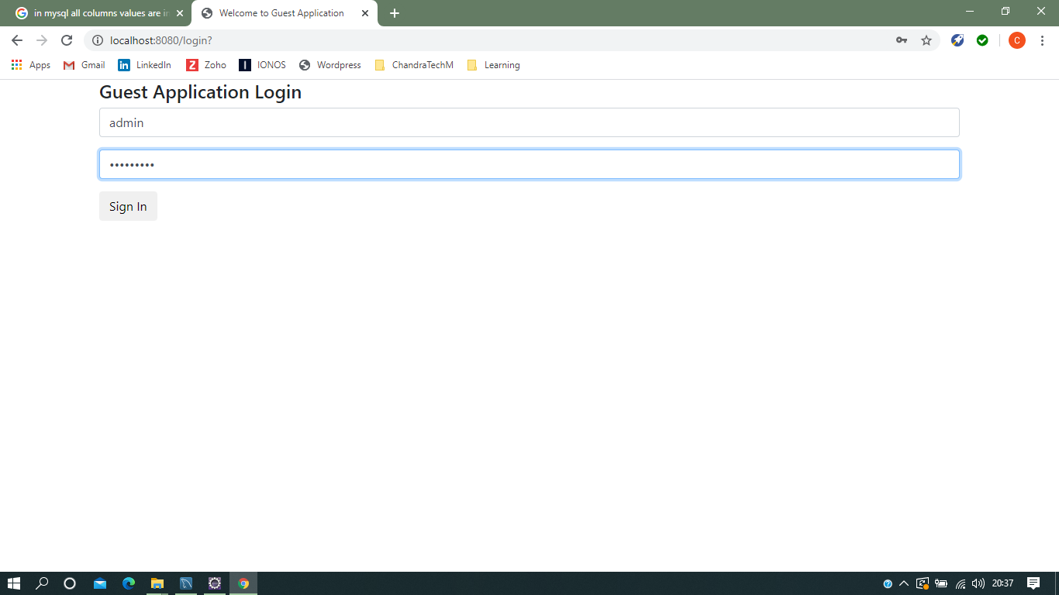

13. Once you to redirect “View Guest Notes Details” screen as below [last record is image uploaded record:

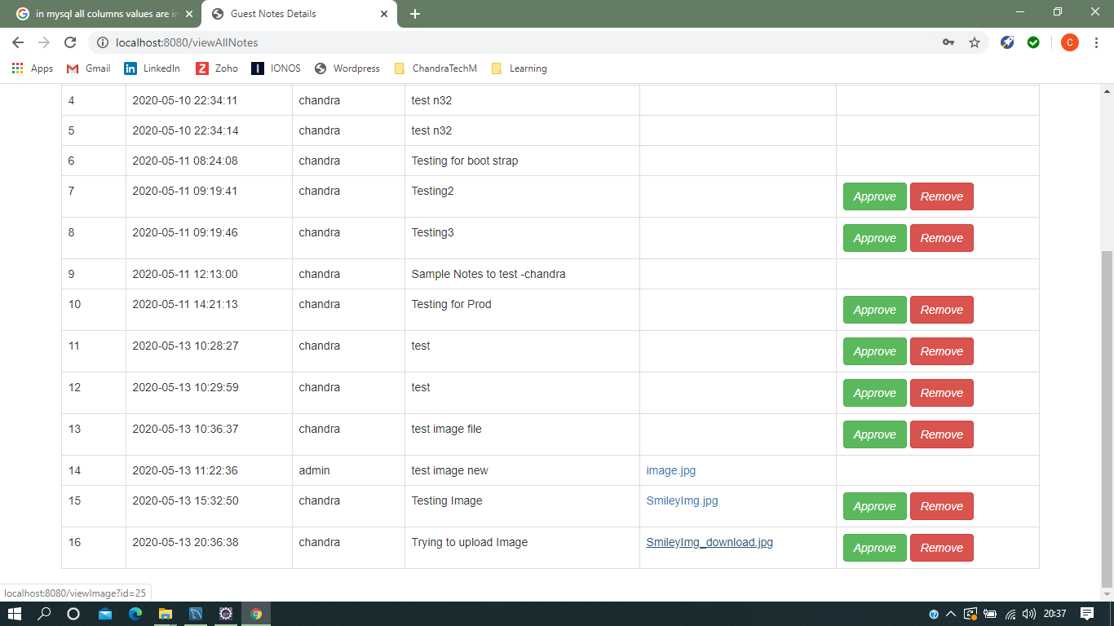

14. Once you click on that image, it will pop a dialogue box to download and save the image

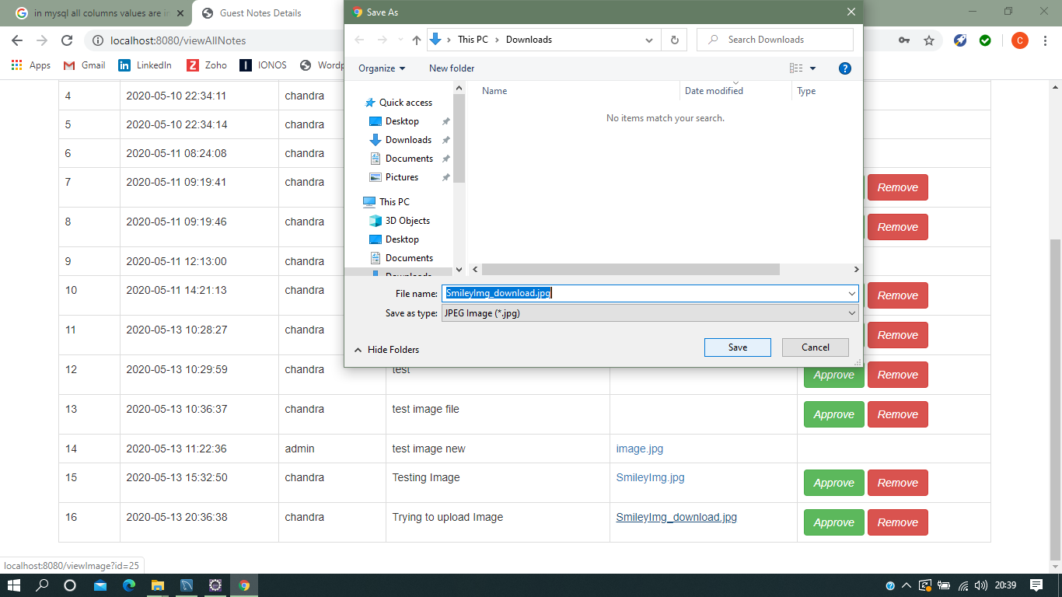

15. Once download and save the image, click on saved image it open, below is the screenshot for the same:

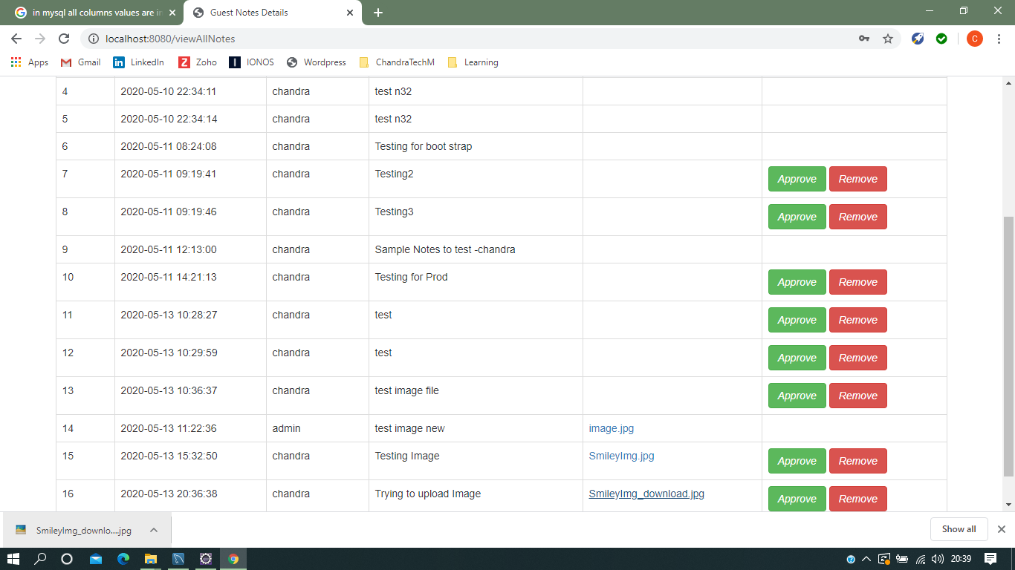

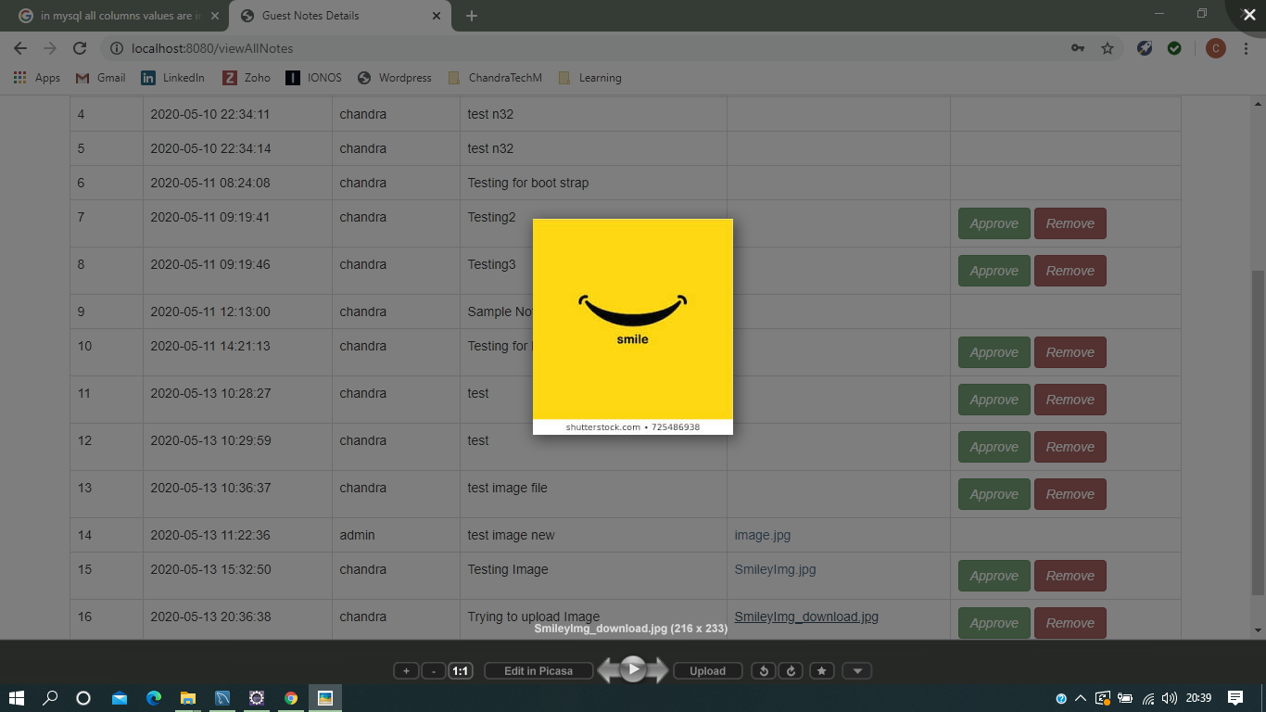

16. Below is the screen shot for Junit test cases, which is run successfully

