Wine Quality Prediction Using Decision Tree, Random Forest, and Gradient Boosting
  - A Practical and Explainable Comparison of Tree-Based Models on Physicochemical Wine Data
M. CharanTej Reddy (2520030422) | Chandrakanth Reddy (2520030290)
Department of Computer Science and Engineering, Koneru Lakshmaiah Education Foundation (KLH)
B.Tech CSE | Academic Year 2026-27
Under the guidance of Dr. Jyothsna Datti, Professor, CSE
________________________________________________________________________

Abstract
Wine quality is influenced by a mixture of chemical properties rather than by a single measurement. That makes it a useful problem for supervised machine learning, especially when the aim is to turn routine physicochemical measurements into a consistent quality estimate. This study develops a practical prediction system around three tree-based algorithms named in the project specification: Decision Tree, Random Forest, and Gradient Boosting. The work begins with exploratory data analysis, duplicate checking, missing-value inspection, feature distribution analysis, correlation analysis, and outlier review. The supplied red-wine dataset contains 1,599 records and 11 physicochemical input features; 240 duplicate rows were removed, leaving 1,359 unique samples, with no missing values. Quality is converted into a binary target using the project threshold of 6.5. The models are first trained as baselines and then tuned within the same three model families using stratified three-fold cross-validation and randomized hyperparameter search. The final evaluation is performed on a held-out 20% test set using accuracy, precision, recall, F1-score, balanced accuracy, ROC-AUC, and PR-AUC. An additional weighted consensus layer combines the probabilities of the three tuned models, with weights derived from their cross-validation F1 performance and a decision threshold selected from training-only out-of-fold predictions. On the supplied dataset, the tuned Gradient Boosting model achieved the highest tuned accuracy (88.97%), ROC-AUC (0.893), and PR-AUC (0.578), while the weighted three-model consensus achieved the highest F1-score among the tuned models and consensus system at 0.532, with recall of 0.568. The results show that there is no single metric that tells the whole story; the main value of the system is the transparent comparison of the three required algorithms, together with an interpretable consensus mechanism.
Keywords: wine quality prediction, decision tree, random forest, gradient boosting, classification, exploratory data analysis, feature importance, ensemble consensus

1. Introduction
Wine quality assessment is a familiar example of a problem where the outcome is important but the underlying process is not easy to reduce to one rule. A wine sample can have a measurable acidity, sugar level, sulphate concentration, alcohol level, and several other chemical properties, yet its final quality score still reflects a combination of these factors. The original project proposal therefore treats wine quality prediction as a supervised learning problem in which the measured properties are used to predict an associated quality label. [1,9]
This study deliberately stays close to that original idea. Rather than replacing the requested methods with a different family of models, the work keeps Decision Tree, Random Forest, and Gradient Boosting at the center of the system. The improvement comes from making the comparison more careful: the data are cleaned before training, the class imbalance is made explicit, hyperparameters are tuned using stratified cross-validation, and several complementary performance metrics are reported. [2-7]
A second motivation is practical. A model that reports only accuracy can appear strong even when the less common quality class is difficult to detect. For that reason, the study gives special attention to precision, recall, F1-score, balanced accuracy, ROC-AUC, and PR-AUC. A weighted consensus step is also included so that the final application can use the probability outputs of all three models instead of relying on a single classifier.

1.1 Research Questions
1. How do Decision Tree, Random Forest, and Gradient Boosting behave on the supplied red-wine quality data?
2. Does hyperparameter tuning within the same three model families change the balance between accuracy and minority-class detection?
3. Can a transparent weighted consensus of the three models provide a more balanced final decision than any one tuned model alone?

2. Related Work
Cortez et al. (2009): The foundational wine-quality work in the supplied review models wine preferences from physicochemical properties and considers regression, neural networks, and support vector machines. Its main limitation for the present study is that it does not evaluate the three tree-based classifiers used here. [1]
Jain et al. (2023): The review reports a broader comparison that includes Decision Tree, Random Forest, AdaBoost, Gradient Boosting, and XGBoost on the UCI red-wine data. This supports the relevance of tree-based methods while also showing how easily wine-quality studies can expand into many model families. [2]
Dahal et al. (2021): This study compares regression and ensemble methods, including Random Forest and Gradient Boosting. The supplied review notes its focus on red wine and its regression framing, which makes direct comparison with the binary classification formulation in this paper less straightforward. [3]
Ye (2023): The supplied review describes a classification comparison involving Decision Tree and Random Forest. The review also notes that the reported evaluation is centered on accuracy, leaving less room to inspect minority-class behavior through precision, recall, and F1-score. [4]
Kaur et al. (2025): A fuzzy-logic and machine-learning hybrid is reported in the review. The additional complexity may improve flexibility, but it also makes the system harder to explain than a compact three-model tree-based design. [5]
Udorji (2024) and Liu (2024): The review highlights hyperparameter tuning, stratified validation, and class-weighting ideas in Random Forest studies. These ideas directly motivate the more disciplined training and evaluation pipeline adopted here. [6,7]

2.1 Research Gap Addressed by This Study
The literature review supplied with the project contains several studies that use the same or related wine-quality datasets, but they differ in task formulation, model family, evaluation detail, and validation practice. The present work narrows the scope intentionally: it keeps the three algorithms required by the course project, compares baseline and tuned versions of those same algorithms, and adds a transparent consensus stage. The goal is not to claim that one approach is universally superior, but to make the experimental comparison more reproducible and easier to interpret on the supplied dataset.

3. Dataset and Exploratory Data Analysis
The dataset used in this study contains 1,599 red-wine records and 11 physicochemical predictors: fixed acidity, volatile acidity, citric acid, residual sugar, chlorides, free sulfur dioxide, total sulfur dioxide, density, pH, sulphates, and alcohol. The target column is quality. The EDA notebook supplied with the project checks data types, duplicates, missing values, distributions, correlations, boxplots, pairwise relationships, and potential outliers before model development. [9]
Item | Observed value
Raw records | 1,599
Duplicate rows | 240
Records after duplicate removal | 1,359
Missing values | 0
Quality range | 3 to 8
Standard quality (quality < 6.5) | 1,175 (86.5%)
Premium quality (quality >= 6.5) | 184 (13.5%)
Train/test split | 80% / 20%, stratified
Table 1. Summary of the supplied dataset and preprocessing quantities.
The duplicate check is important here because 240 repeated rows appear in the raw file. Removing them reduces the dataset from 1,599 to 1,359 unique records. No missing values were found, so the project does not need an imputation step for this dataset. The original quality labels are concentrated around scores 5 and 6, while scores 3 and 8 are rare. After applying the 6.5 threshold, the classification target becomes imbalanced, with 184 premium samples against 1,175 standard samples. That imbalance is one reason accuracy alone is not enough to interpret the models.
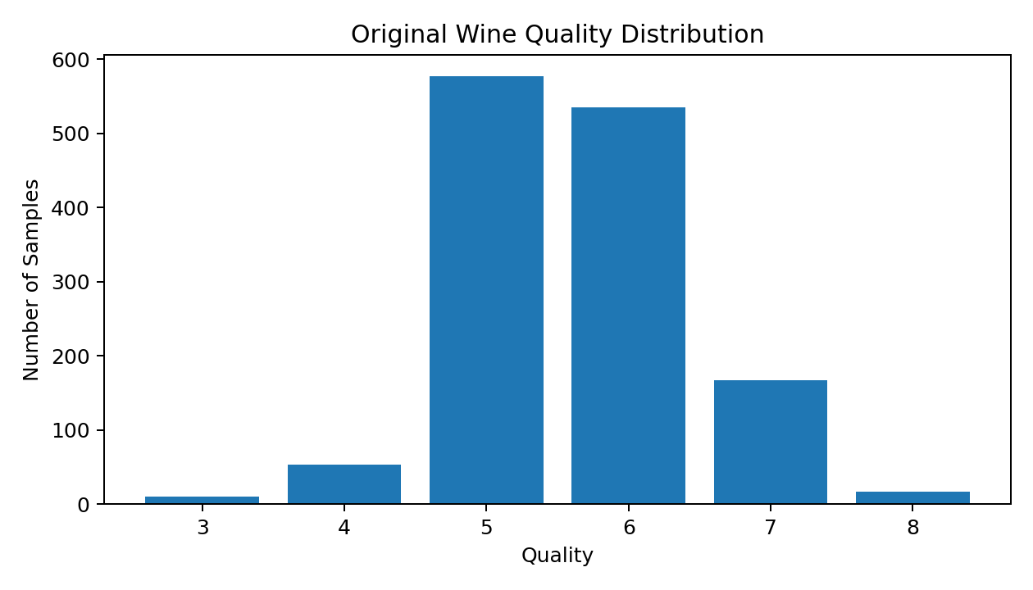
Figure 1. Original distribution of wine quality scores in the supplied dataset.
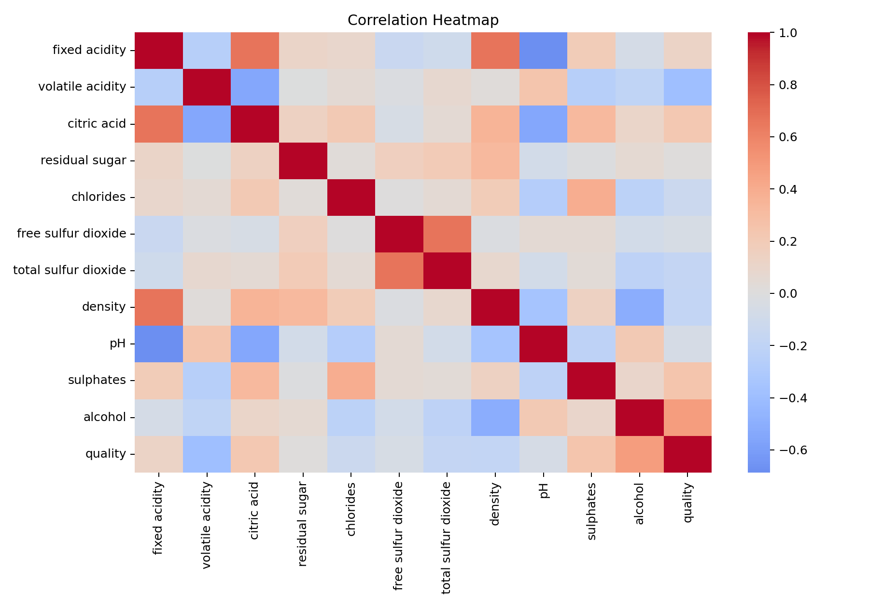
Figure 2. Correlation heatmap used to inspect relationships among the physicochemical variables and quality.
The EDA also points to a few patterns that are consistent with the project motivation. In the supplied data, alcohol has a positive relationship with quality, while volatile acidity has a negative relationship. Sulphates and citric acid also show positive relationships, while density and total sulfur dioxide show negative relationships. These are associations within the dataset, not proof of causation, and the tree models are used precisely because the relationship between several features and quality need not be purely linear.

4. Methodology
The modelling pipeline was designed to preserve the original course-project scope while improving validation and interpretability. The process can be viewed as a sequence: clean the data, define the binary target, split the data, train the three baseline models, tune the same three model families, evaluate them on the untouched test set, and then combine their probability outputs using a weighted consensus.

4.1 Target Definition
The target is converted from the original quality score to two classes using the project threshold of 6.5: Standard Quality for scores below 6.5 and Premium Quality for scores at or above 6.5. Because the supplied quality values are integers from 3 through 8, the positive class corresponds to scores 7 and 8 in practice.

4.2 Train-Test Discipline
After duplicate removal, the data are divided into an 80% training portion and a 20% held-out test portion using stratification. The test set is kept out of hyperparameter selection. Within the training set, stratified three-fold cross-validation is used during randomized hyperparameter search. This setup makes the final test-set metrics a cleaner estimate of how the selected models behave on unseen records.

4.3 Baseline Models
- Decision Tree: a single tree is trained with a controlled maximum depth. It is easy to trace because a prediction follows a sequence of learned splits.
- Random Forest: multiple randomized decision trees are combined through bagging. The ensemble reduces the variance associated with relying on one tree.
- Gradient Boosting: trees are added sequentially so that later trees focus on correcting the errors left by earlier trees.

4.4 Hyperparameter Tuning
The upgraded implementation uses RandomizedSearchCV with five sampled configurations per model and stratified three-fold cross-validation. The search remains inside the same three model families. Decision Tree tuning includes split criterion, depth, minimum sample constraints, and class weighting. Random Forest tuning includes tree count, depth, feature sampling, minimum sample constraints, and class weighting. Gradient Boosting tuning includes estimator count, learning rate, tree depth, minimum leaf size, and subsampling. F1-score is used as the search objective because the positive class is relatively uncommon.
Model | Selected configuration | Best CV F1
Decision Tree | entropy; depth 3; min split 10; min leaf 4; class_weight=balanced | CV F1 = 0.460
Random Forest | 200 trees; depth 14; min split 5; min leaf 4; max_features=0.7; balanced_subsample | CV F1 = 0.491
Gradient Boosting | 200 trees; learning rate 0.03; depth 4; min leaf 1; subsample=0.7 | CV F1 = 0.453
Table 2. Best tuned configurations found by the implemented search.

4.5 Weighted Three-Model Consensus
The final application includes a consensus layer rather than forcing the user to trust a single classifier. The tuned models each produce a Premium-class probability. These probabilities are combined using weights proportional to the corresponding cross-validation F1-score. The weights produced by the training run were 0.327 for Decision Tree, 0.350 for Random Forest, and 0.323 for Gradient Boosting. The consensus decision threshold was selected from training-only out-of-fold predictions, rather than from the held-out test set. This keeps the threshold-selection process separate from the final evaluation.

5. Results
Table 3 reports the results of the tuned models on the held-out 20% test set. The results illustrate an important point about this dataset: the model with the highest accuracy is not automatically the model with the highest recall or F1-score. That is exactly why the project reports several metrics together.
Model | Accuracy | Precision | Recall | F1 | Bal. Acc. | ROC-AUC | PR-AUC
Decision Tree | 0.776 | 0.357 | 0.811 | 0.496 | 0.791 | 0.833 | 0.482
Random Forest | 0.868 | 0.515 | 0.459 | 0.486 | 0.696 | 0.876 | 0.558
Gradient Boosting | 0.890 | 0.667 | 0.378 | 0.483 | 0.674 | 0.893 | 0.578
Weighted 3-Model Consensus | 0.864 | 0.500 | 0.568 | 0.532 | 0.739 | 0.867 | 0.601
Table 3. Held-out test-set performance of the tuned models and the weighted consensus.
The tuned Gradient Boosting model produced the highest tuned accuracy at 88.97%, together with the highest tuned ROC-AUC (0.893) and PR-AUC (0.578). Random Forest reached 86.76% accuracy and had the highest cross-validation F1 mean (0.491). The Decision Tree gave the highest tuned recall (0.811), which means it detected more of the premium class but also generated more false positives. The weighted consensus achieved an F1-score of 0.532, recall of 0.568, and PR-AUC of 0.601. These numbers suggest that combining the models provides a different trade-off rather than universally improving every metric.

6. Explainability and Feature Importance
A prediction system is easier to trust when it can give some indication of what drove the decision. Because all three core models are tree-based, the project can expose native feature importance as well as permutation importance. Native importance measures how frequently and effectively a feature is used by the fitted trees, while permutation importance checks how much performance changes when a feature is disturbed on held-out data. The two views are complementary and should not be interpreted as causal effects.
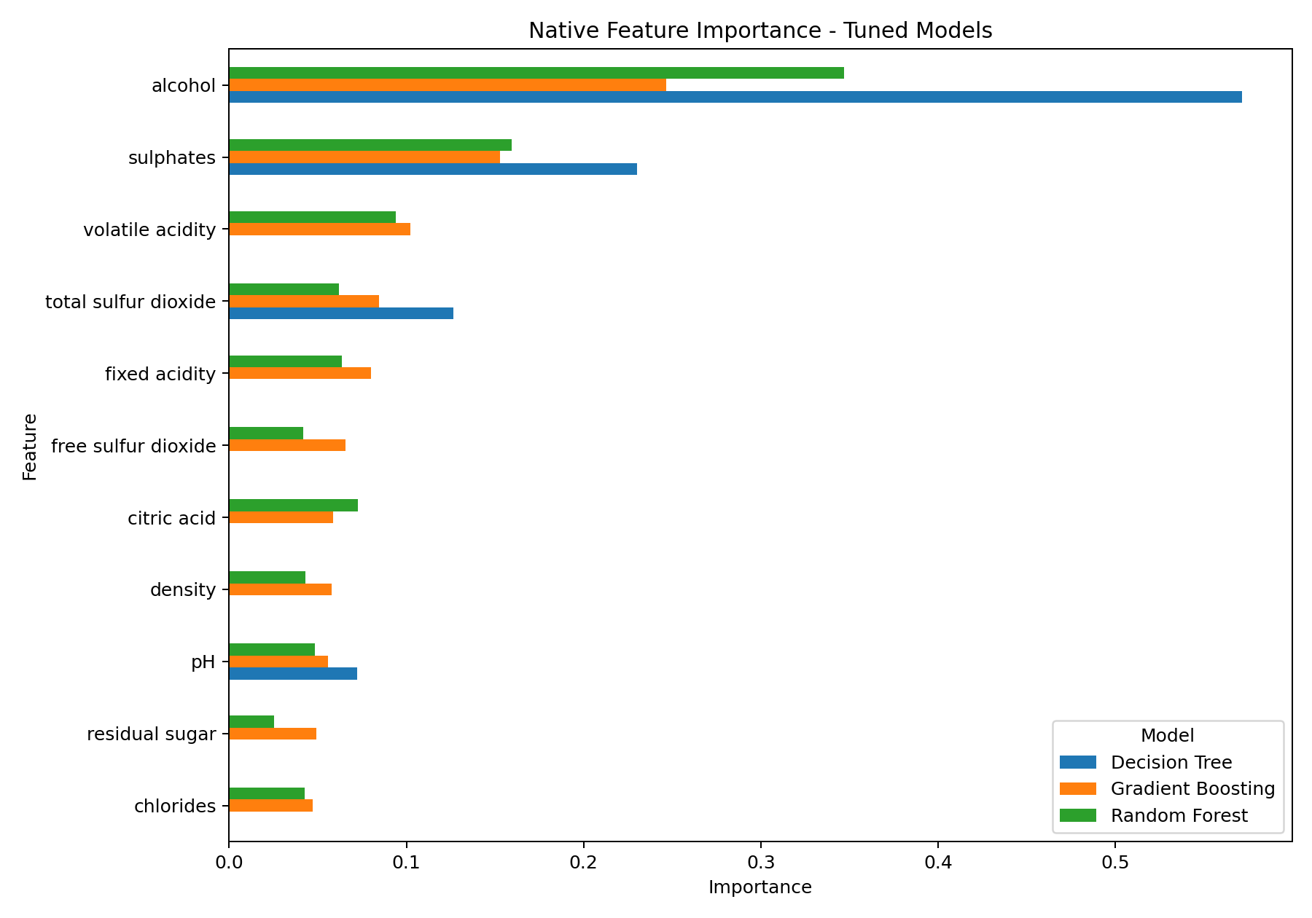
Figure 3. Native feature importance across the three tuned tree-based models.
Across the three tuned models, alcohol is consistently the most important feature. Sulphates is also consistently high, while volatile acidity and total sulfur dioxide become important in the ensemble models. This consistency supports a simple story for the application: the model is responding to a combination of acidity, sulphate, alcohol, and sulfur-related measurements rather than a single input field.
Model | Top native features | Importance values
Decision Tree | alcohol, sulphates, total sulfur dioxide, pH | 0.571, 0.230, 0.127, 0.072
Random Forest | alcohol, sulphates, volatile acidity, citric acid | 0.347, 0.160, 0.094, 0.073
Gradient Boosting | alcohol, sulphates, volatile acidity, total sulfur dioxide | 0.246, 0.153, 0.102, 0.085
Table 4. Top native feature-importance values from the tuned models.

7. Web Application and Practical Workflow
The final system is exposed through a Streamlit web application so that the project can be demonstrated without opening the training notebook. The interface accepts the 11 physicochemical inputs, loads the saved Decision Tree, Random Forest, and Gradient Boosting models, and displays each model's probability together with the final weighted consensus. The app also exposes model agreement and feature-importance information, which makes the prediction process more transparent for a classroom demonstration.

7.1 Application Flow
1. User enters wine measurements.
2. The saved preprocessing/model pipelines transform the inputs in the same way used during training.
3. Decision Tree, Random Forest, and Gradient Boosting each produce a class probability.
4. The probabilities are combined using the stored cross-validation-derived weights.
5. The consensus threshold converts the combined probability into Standard or Premium Quality.
6. The interface displays the three model outputs, consensus result, and supporting explainability information.

7.2 Reproducibility
The implementation uses Python and the scikit-learn ecosystem, with a fixed random state of 42, an 80/20 stratified split, and three-fold stratified cross-validation. The project stores trained models as joblib files and exports evaluation metrics and figures to the outputs directory. The same project can therefore be rerun from VS Code after activating the virtual environment and running `python train_model.py`, followed by `python -m streamlit run app.py` for the web interface.

8. Discussion
The most useful result of this experiment is not a single leaderboard number. The three tuned models make different trade-offs. Gradient Boosting is strongest when ranking quality likelihood is measured by ROC-AUC and PR-AUC, while the tuned Decision Tree catches a larger share of the premium class at the cost of precision. Random Forest sits between these behaviors and has the strongest cross-validation F1 mean among the tuned models. The weighted consensus improves the tuned-model F1 and recall balance, although it does not exceed Gradient Boosting on every ranking metric.
The class imbalance also changes how the results should be read. With only 184 premium samples after duplicate removal, a classifier can obtain a high overall accuracy while still missing many premium wines. For that reason, the consensus F1-score of 0.532 is meaningful even though its accuracy is lower than the best individual tuned model. In an actual quality-control setting, the preferred operating point would depend on whether the user cares more about catching premium candidates or avoiding false premium classifications.

8.1 What the Results Mean in Plain Language
- The model learns useful patterns from chemical measurements, but the measurements do not determine quality perfectly.
- Different tree methods see the same data slightly differently, so their errors are not identical.
- Using several metrics gives a more honest picture than reporting accuracy alone.
- Combining the three models can provide a more balanced final decision, but it is not a guarantee of a better result for every metric.

9. Limitations
- Dataset scope: the experiments use the supplied red-wine dataset. Performance on white wines, other regions, or different production styles is not established.
- Target simplification: converting the original 0-10 quality score into two classes makes classification easier to explain but removes finer-grained quality information.
- Class imbalance: premium samples are much less common than standard samples, which makes minority-class prediction difficult.
- No external validation: the reported metrics come from a single held-out split of the supplied dataset. An external dataset would be needed to study broader generalization.
- Modeling is not a substitute for laboratory or sensory assessment. The application should be treated as a data-driven support tool rather than as a final certification mechanism.

10. Conclusion
This study presents an end-to-end wine quality prediction system that remains faithful to the original project title while making the experimental design more rigorous. Decision Tree, Random Forest, and Gradient Boosting are used throughout as the core algorithms. The work adds duplicate removal, stratified splitting, cross-validation, hyperparameter tuning, richer evaluation metrics, feature importance, and a weighted consensus layer without moving the project into an unrelated model family. On the supplied red-wine dataset, the tuned Gradient Boosting model produced the strongest tuned ranking metrics and accuracy, while the three-model consensus provided the highest F1-score within the tuned/consensus group. These results reinforce the central lesson of the project: model comparison should consider the whole performance profile rather than a single percentage.
For a future version, the most useful extensions would be external validation on an independent wine dataset, a more systematic hyperparameter search budget, calibration analysis of predicted probabilities, and a multi-class formulation that preserves the original quality scale. Those extensions would strengthen the scientific evaluation without changing the project's core focus on tree-based learning.

Acknowledgement
The authors acknowledge the guidance of Dr. Jyothsna Datti and the Department of Computer Science and Engineering at Koneru Lakshmaiah Education Foundation. The experiments were developed using the dataset, abstract, presentation, EDA notebook, and literature-review materials supplied as part of the course project.

References
[1] Cortez, P., Cerdeira, A., Almeida, F., Matos, T., and Reis, J. (2009). Modeling Wine Preferences by Data Mining from Physicochemical Properties. Source listed in the supplied literature review.
[2] Jain, P., Kaushik, A., et al. (2023). Machine Learning-Based Predictive Modelling for the Enhancement of Wine Quality. Source listed in the supplied literature review.
[3] Dahal, K. R., Dahal, J. N., Banjade, H., and Gaire, S. (2021). Prediction of Wine Quality Using Machine Learning Algorithms. Source listed in the supplied literature review.
[4] Ye, K. (2023). Wine Quality Prediction by Several Data Mining Classification Models. Source listed in the supplied literature review.
[5] Kaur, N., Kaur, G., Aruchamy, P., and Chaudhary, N. (2025). An Integrated Approach Based on Fuzzy Logic and Machine Learning Techniques for Reliable Wine Quality Prediction. Source listed in the supplied literature review.
[6] Udorji, P. (2024). Predicting White Wine Quality: A Machine Learning Approach. Source listed in the supplied literature review.
[7] Liu, J. (2024). Predicting Wine Quality Using Random Forest Classifier. Source listed in the supplied literature review.
[8] Cortez, P., Cerdeira, A., Almeida, F., Matos, T., and Reis, J. (2009). Wine Quality Data Set (UCI Machine Learning Repository). Source listed in the supplied literature review.
[9] M. CharanTej Reddy and Chandrakanth Reddy (2026-27). Wine Quality Prediction project abstract, EDA notebook, and course presentation supplied for the KLH Machine Learning project.

Appendix A. Input Features Used by the Predictor
1. fixed acidity
2. volatile acidity
3. citric acid
4. residual sugar
5. chlorides
6. free sulfur dioxide
7. total sulfur dioxide
8. density
9. pH
10. sulphates
11. alcohol

