Quicksort Algorithm: Implementation, Analysis, and Randomization
Sorting is one of the most frequently executed operations in computing. Database engines sort to build indexes and evaluate joins, distributed frameworks such as Apache Hadoop and Apache Spark sort intermediate key-value pairs during their shuffle phases, and search services sort candidate results by relevance before returning them. Quicksort, first described in the early 1960s, remains one of the most important sorting algorithms because it sorts in place, has small constant factors, and runs in Θ(n log n) time on average. Its weakness is equally well known: a poor choice of pivot can push the running time to Θ(n²) (Cormen et al., 2022; Roughgarden, 2022). The algorithm is still an active subject of research and engineering, from hybrid variants that defend against bad input patterns (Peters, 2021) to parallel sorters (Axtmann et al., 2021) and sorting routines discovered with machine learning (Mankowitz et al., 2023).
This report documents a Python implementation of Quicksort in two forms: a deterministic version that always uses the last element of the subarray as the pivot, and a randomized version that chooses the pivot uniformly at random. It presents the theoretical analysis of the best, average, and worst cases; examines space complexity and practical overheads; explains how randomization changes the guarantees; and compares both versions empirically on four input distributions. The source code, raw measurements, and figures are available in the accompanying GitHub repository.

Implementation

Algorithm Overview
Quicksort is a divide-and-conquer algorithm. To sort a subarray A[low..high], it (a) selects a pivot element, (b) partitions the subarray so that every element to the left of the pivot is less than or equal to it and every element to the right is greater, placing the pivot in its final sorted position p, and (c) recursively sorts A[low..p − 1] and A[p + 1..high]. No combine step is needed, because once both sides are sorted the whole subarray is sorted (Cormen et al., 2022).

Partition Scheme and Pivot Selection
Both versions share the Lomuto partition routine described by Cormen et al. (2022). The routine stores the pivot in A[high] and scans the subarray once with an index j, maintaining an index i that marks the end of the region of elements less than or equal to the pivot. When A[j] ≤ pivot, i is advanced and A[i] is swapped with A[j]. After the scan, the pivot is swapped into position i + 1. The loop invariant is that A[low..i] ≤ pivot, A[i + 1..j − 1] > pivot, and A[high] is the pivot. Partitioning a subarray of m elements makes exactly m − 1 comparisons and uses O(1) extra memory.
Lomuto partitioning was chosen over Hoare's original scheme because it is simpler to state and verify, its invariant maps directly onto the analysis, and its comparison count is easy to predict exactly, which makes it convenient to check measurements against theory. The deterministic version, quicksort, uses the last element as the pivot. The randomized version, randomized_quicksort, first draws an index uniformly from [low, high], swaps that element into position high, and then calls the same partition routine. Because the two versions differ only in this one step, any difference in measured behavior can be attributed to pivot selection alone.

Bounding the Recursion Depth
A straightforward implementation that recurses on both partitions needs a call stack as deep as the recursion tree, which is Θ(n) frames in the worst case. In Python this is a practical problem, not only a theoretical one: the default recursion limit is 1,000 frames, so a naive deterministic Quicksort raises RecursionError on an already-sorted list of only a few thousand elements. To avoid this, the shared driver recurses only into the smaller of the two partitions and handles the larger one with a while loop, a technique known as manual tail-call elimination (Cormen et al., 2022). Because each recursive call receives at most half of the current subarray, the stack depth never exceeds log₂ n frames, even when the running time is quadratic.

Instrumentation and Testing
Both functions sort a Python list in place and return the same list for convenience. They accept an optional SortStats object that records element comparisons, swaps, and the maximum recursion depth; when it is omitted, an uninstrumented loop is used so that timing measurements are not inflated by counter updates. The randomized version also accepts an optional seed so that runs can be reproduced exactly. A suite of nine unit tests verifies correctness on empty, single-element, sorted, reverse-sorted, duplicate-heavy, and random lists, as well as on floats and strings; checks the partition invariant on 200 random arrays; confirms that sorted input produces exactly n(n − 1)/2 comparisons in the deterministic version; and confirms that the stack depth stays logarithmic. The key source code is reproduced in Appendix A.

Time Complexity Analysis

The General Recurrence
Let T(n) be the running time on a subarray of n elements, and suppose the pivot ends up at a position that leaves q elements on its left and n − q − 1 on its right. Partitioning costs Θ(n), so
T(n) = T(q) + T(n − q − 1) + Θ(n).
The total work is therefore determined entirely by how balanced the splits are, which in turn depends on the pivot.

Best Case: Θ(n log n)
The best case occurs when every pivot is the median of its subarray, so each partition produces two halves of size at most n/2. The recurrence becomes T(n) = 2T(n/2) + Θ(n), which by case 2 of the master theorem solves to Θ(n log n). Intuitively, the recursion tree has about log₂ n levels and the partitions on each level together touch every element once, costing Θ(n) per level (Cormen et al., 2022).

Worst Case: Θ(n²)
The worst case occurs when every pivot is the smallest or largest element of its subarray, so one side of each split is empty and the other contains n − 1 elements. The recurrence becomes T(n) = T(n − 1) + Θ(n), and the comparisons sum to
(n − 1) + (n − 2) + … + 1 = n(n − 1)/2 = Θ(n²).
For the last-element pivot this happens on exactly the inputs that are most common in practice. On an already-sorted array the pivot is always the maximum, and on a reverse-sorted array it is always the minimum, so the recursion only peels off one element per level. The worst case is therefore not a rare curiosity for deterministic Quicksort; it is triggered by sorted data, nearly sorted data, and data that has been sorted and then appended to. Because the pivot rule is fixed and public, an adversary can also construct a bad input deliberately (Cormen et al., 2022; Peters, 2021).

Average Case: Θ(n log n)
The average case assumes that all n! orderings of distinct keys are equally likely. Two complementary arguments explain why the result is Θ(n log n) rather than something between the best and worst cases.
The first argument is about balance. A split does not need to be perfect to be good. If every pivot produced even a 9-to-1 split, the recursion tree would have depth log₁₀/₉ n = O(log n), still with Θ(n) work per level, giving O(n log n). Under random ordering, the pivot is equally likely to have any rank, so half of all pivots fall in the middle half of the values and produce splits no worse than 3-to-1. Bad splits occur but are interleaved with good ones, and a bad split followed by a good split costs only a constant factor more than a good split alone (Cormen et al., 2022).
The second argument counts comparisons exactly. Let z₁ < z₂ < … < zₙ be the keys in sorted order. Two keys zᵢ and zⱼ (i < j) are compared at most once, and only if one of them is the first pivot chosen from the set {zᵢ, …, zⱼ}; if any key strictly between them is chosen first, they are separated into different subarrays and never meet. Each of the j − i + 1 keys in that set is equally likely to be chosen first, so the probability that zᵢ and zⱼ are compared is 2/(j − i + 1). Summing over all pairs by linearity of expectation gives
E[C(n)] = Σ (over 1 ≤ i < j ≤ n) 2/(j − i + 1) < Σ (over 1 ≤ i, k ≤ n) 2/k = 2nHₙ = O(n log n),
where Hₙ = 1 + 1/2 + … + 1/n ≈ ln n is the nth harmonic number. Evaluating the sum exactly gives E[C(n)] = 2(n + 1)Hₙ − 4n ≈ 2n ln n ≈ 1.39 n log₂ n (Roughgarden, 2022). Quicksort's average case is therefore only about 39% more comparisons than the information-theoretic lower bound of log₂ n! ≈ n log₂ n for comparison sorting, and because its inner loop is so simple, it is often faster in practice than algorithms that make fewer comparisons.

Space Complexity and Overheads
Quicksort is an in-place algorithm: partitioning rearranges elements within the input list and needs only a constant number of index variables, so the auxiliary memory other than the call stack is O(1). The stack is the real cost. Each active call holds its own low, high, and pivot index, so memory use is proportional to the recursion depth. With naive two-sided recursion, the depth equals the height of the recursion tree: Θ(log n) in the best and average cases but Θ(n) in the worst case.
The smaller-side recursion used in this implementation reduces the worst-case stack depth to O(log n), regardless of how unbalanced the splits are. The instrumented runs confirm this. On sorted input the deterministic version never exceeded a depth of one frame, because the smaller side of every split was empty and the larger side was handled by the loop; on random input of 8,000 elements, the maximum depth was 8 or 9 frames, well under log₂ 8,000 ≈ 13. Importantly, this optimization changes only the space bound; the running time on sorted input is still Θ(n²).
Several additional overheads matter in practice. First, Python executes each comparison and swap through the interpreter, so the constant factors are far larger than in a compiled language; the built-in sorted function, which uses Timsort implemented in C, is one to two orders of magnitude faster than either version here and should be preferred in production Python code. Second, Lomuto partitioning performs more swaps than Hoare's scheme, roughly three times as many on random input. Third, the randomized version calls the random number generator once per partition, which adds a fixed cost per call; this cost is visible in the measurements reported below. Finally, Quicksort is not stable: equal keys may change their relative order, which matters when sorting records by one field after another.

Randomized Quicksort

Implementation
The randomized version changes a single step. Before partitioning A[low..high], it selects an index r uniformly at random from [low, high] using random.randint, swaps A[r] with A[high], and proceeds exactly as the deterministic version does. The rest of the algorithm, including the partition routine and the smaller-side recursion, is shared.

Expected Running Time for Every Input
The crucial difference is where the randomness comes from. The deterministic average-case analysis assumes that the input is randomly ordered, an assumption about the world that the algorithm cannot enforce. The randomized analysis instead relies on the algorithm's own coin flips. Because each pivot is chosen uniformly from its subarray, every key in the range {zᵢ, …, zⱼ} is equally likely to be selected first no matter how the input is arranged, so the comparison argument above holds for every input. The expected number of comparisons is 2(n + 1)Hₙ − 4n = Θ(n log n) for sorted, reverse-sorted, random, or deliberately adversarial data alike (Cormen et al., 2022; Roughgarden, 2022). There are no longer any bad inputs, only unlucky sequences of random choices.

How Unlikely Is the Worst Case?
The randomized algorithm can still make n(n − 1)/2 comparisons, but only if it picks the minimum or maximum of its subarray at every step. For a subarray of k distinct elements this happens with probability 2/k, so the probability of hitting the full worst case is
∏ₖ₌₂ⁿ 2/k = 2ⁿ⁻¹ / n!,
which is about 1.4 × 10⁻⁴ for n = 10, 2.2 × 10⁻¹³ for n = 20, and 6.8 × 10⁻¹²⁹ for n = 100. More useful than the probability of the single worst execution is the fact that randomized Quicksort runs in O(n log n) time with high probability: standard tail-bound arguments show that, for any constant c, there is a constant a such that the running time exceeds a n log n with probability at most n⁻ᶜ. In practical terms, quadratic behavior on a large array is less likely than a hardware failure during the sort.

Costs and Limits of Randomization
Randomization is not free and does not fix every problem. It adds a random-number-generator call per partition, which slows the algorithm slightly on inputs that were already random; Tahsin et al. (2024) likewise found random pivot selection to be slower than median-of-three and median-of-seven pivots in their experiments because of this overhead. It makes run times vary slightly between executions, which is why the implementation accepts an optional seed for reproducible experiments. Most importantly, it does nothing for inputs with many equal keys. With Lomuto partitioning, all keys equal to the pivot are placed on the same side, so a subarray that contains only copies of one value is split 0 to m − 1 no matter which copy is chosen as the pivot. The empirical results below demonstrate this limitation directly; the standard remedy is to give keys equal to the pivot special treatment, for example by three-way partitioning into less-than, equal-to, and greater-than regions (Afereidoon, 2025; Peters, 2021).

Empirical Analysis

Method
Both versions were run on four input distributions: uniformly random integers from 0 to 10n; already-sorted integers 0 to n − 1; reverse-sorted integers n down to 1; and a duplicate-heavy distribution with only 10 distinct values. Input sizes doubled from 500 to 8,000 elements. The largest size was capped at 8,000 because the deterministic version takes more than two seconds per run on sorted input at that size, and its time quadruples with each doubling. For each combination, the same input array was sorted five times on fresh copies, and the median wall-clock time measured with time.perf_counter is reported to suppress noise from the operating system and garbage collector. The output of every run was checked against Python's built-in sorted. A separate instrumented run recorded the number of comparisons and the maximum recursion depth. All random generators were seeded with 2026 for reproducibility. Measurements were taken with Python 3.13 on a Linux x86-64 virtual machine with two virtual CPUs; absolute times will differ on other machines, but the ratios and growth rates should not.

Results
Table 1 reports the median running times, and Figure 1 plots them on logarithmic axes, where a polynomial nᵏ appears as a straight line with slope k. Table 2 compares the measured comparison counts with the two theoretical predictions, and Figure 2 shows the same comparison graphically. Table 3 summarizes how quickly each measurement grows each time the input size doubles.
Table 1
Median Running Time (Milliseconds) of Deterministic and Randomized Quicksort
 | Random |  | Sorted |  | Reverse-sorted |  | Few unique keys
n | Det. | Rand. | Det. | Rand. | Det. | Rand. | Det. | Rand.
500 | 0.37 | 0.70 | 7.25 | 0.57 | 5.89 | 0.84 | 1.02 | 1.36
1,000 | 0.91 | 1.36 | 34.13 | 1.20 | 28.60 | 1.65 | 3.71 | 4.48
2,000 | 1.84 | 2.88 | 122.49 | 3.61 | 126.45 | 2.84 | 13.71 | 14.58
4,000 | 4.12 | 9.58 | 526.35 | 5.66 | 404.82 | 5.85 | 50.55 | 60.37
8,000 | 12.34 | 17.19 | 2,146.07 | 12.81 | 1,610.64 | 12.38 | 212.99 | 226.27
Note. Det. = deterministic (last-element pivot); Rand. = randomized pivot. Each value is the median of five runs on the same input. Few unique keys = 10 distinct values.

Table 2
Measured Comparisons Compared With Theoretical Predictions
n | Expected 2(n+1)Hₙ − 4n | Rand. random | Rand. sorted | Rand. reverse | Det. random | Det. sorted | n(n − 1)/2
500 | 4,806 | 5,125 | 4,580 | 6,003 | 4,345 | 124,750 | 124,750
1,000 | 10,986 | 10,851 | 11,536 | 10,394 | 11,410 | 499,500 | 499,500
2,000 | 24,730 | 25,102 | 23,443 | 24,757 | 23,209 | 1,999,000 | 1,999,000
4,000 | 54,989 | 52,205 | 56,544 | 56,619 | 54,966 | 7,998,000 | 7,998,000
8,000 | 121,051 | 124,852 | 122,561 | 124,777 | 115,895 | 31,996,000 | 31,996,000
Note. Det. = deterministic; Rand. = randomized. The deterministic count on reverse-sorted input is identical to its count on sorted input.

Table 3
Average Growth Factor per Doubling of n
Input distribution | Det. time | Det. comparisons | Rand. time | Rand. comparisons
Random | 2.40 | 2.27 | 2.23 | 2.22
Sorted | 4.15 | 4.00 | 2.18 | 2.27
Reverse-sorted | 4.07 | 4.00 | 1.96 | 2.14
Few unique keys | 3.80 | 3.88 | 3.59 | 3.86
Note. Each value is the geometric mean of the four ratios f(2n)/f(n) for n = 500 to 4,000. An n log n algorithm grows by about 2.2 per doubling at these sizes; an n² algorithm grows by 4.0.

Figure 1
Median Running Time Versus Input Size for Each Input Distribution
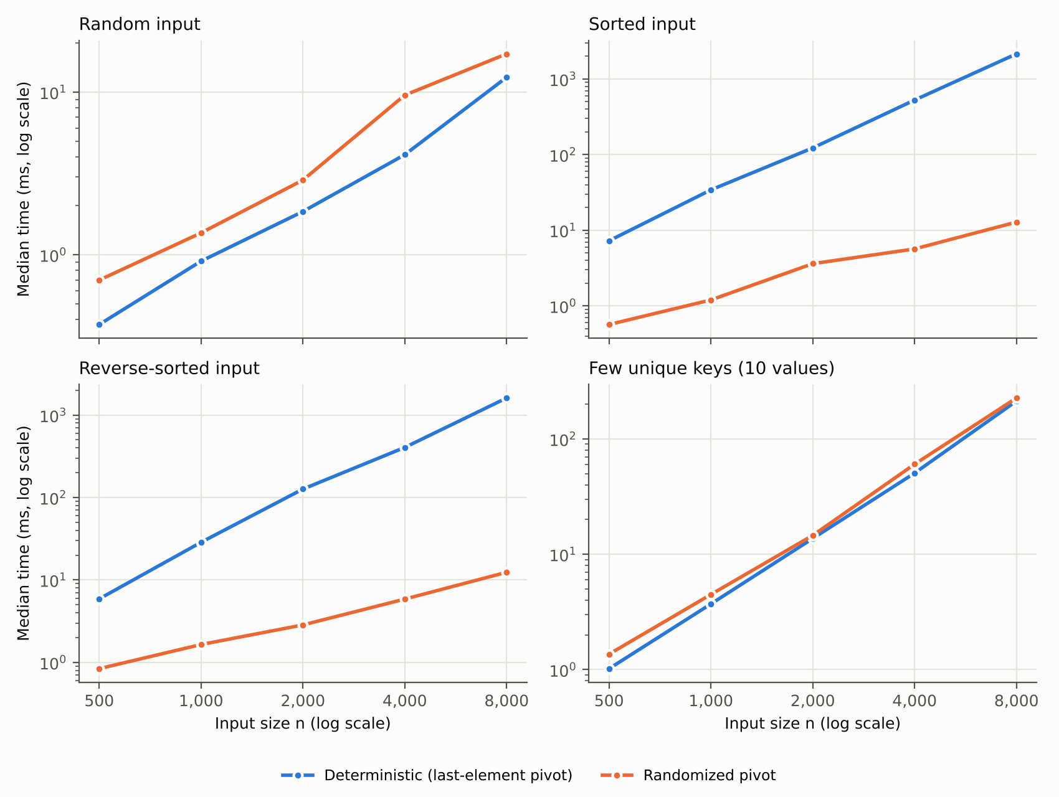
Note. Both axes use logarithmic scales, so a steeper line indicates a higher-order growth rate. Blue = deterministic; orange = randomized.

Figure 2
Comparison Counts Versus Input Size With Theoretical Curves
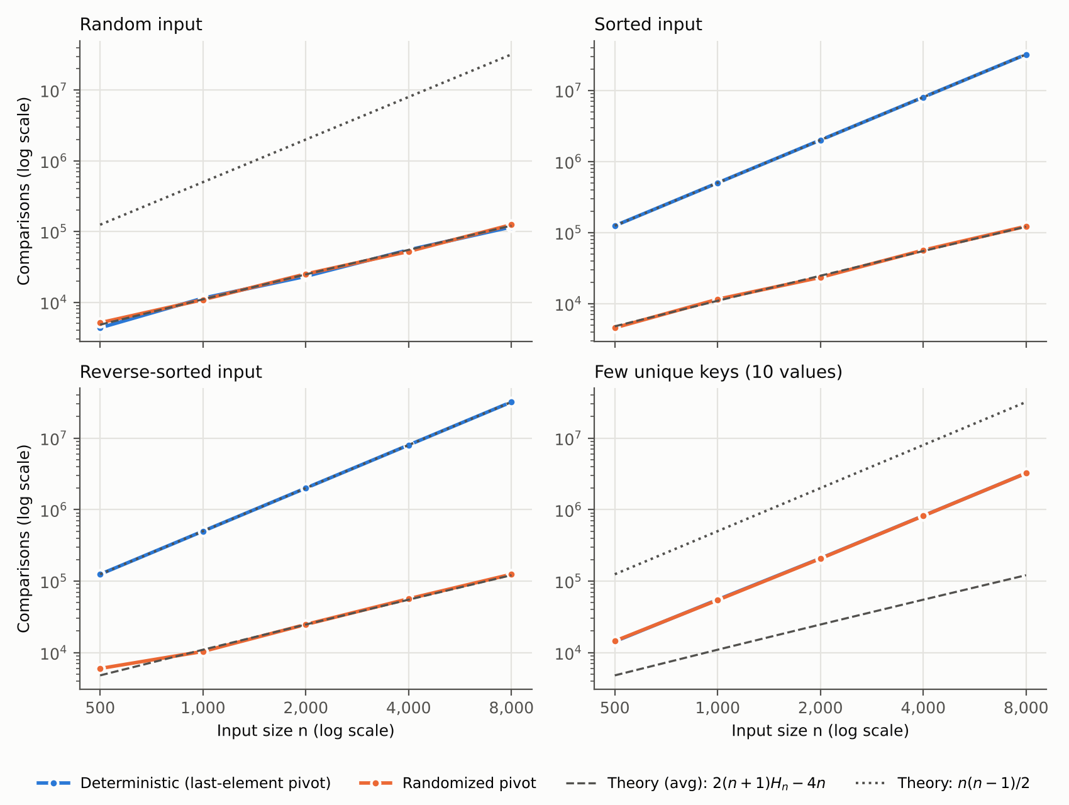
Note. The dashed line is the exact expected count 2(n + 1)Hₙ − 4n; the dotted line is the worst-case count n(n − 1)/2. In the few-unique-keys panel, the two measured lines overlap.

Discussion

Sorted and Reverse-Sorted Input Confirm the Worst Case.
The deterministic version made exactly n(n − 1)/2 comparisons on both sorted and reverse-sorted input at every size, from 124,750 at n = 500 to 31,996,000 at n = 8,000, precisely matching the worst-case analysis. Its running time grew by a factor of about 4.1 per doubling (Table 3), the signature of quadratic growth, reaching 2,146 ms on sorted input and 1,611 ms on reverse-sorted input at n = 8,000. The randomized version sorted the same arrays in 12.8 ms and 12.4 ms, making it roughly 168 and 130 times faster. The gap widens with n, as theory predicts, because one curve grows as n² and the other as n log n.

Randomized Quicksort Is Insensitive to Input Order.
The randomized version's comparison counts on random, sorted, and reverse-sorted input were nearly indistinguishable and stayed within about 6% of the exact expected value 2(n + 1)Hₙ − 4n for every n of at least 1,000 (Table 2). At n = 8,000, for example, the prediction is 121,051 comparisons and the measured counts were 124,852, 122,561, and 124,777. Its growth factor per doubling was 2.1 to 2.3 for comparisons, matching the 2.2 expected of n log n growth. This is the central practical consequence of randomization: the expected cost depends only on n, not on how the data happens to be arranged.

On Random Input, Randomization Costs a Little.
On uniformly random input, both versions made essentially the same number of comparisons (both close to the expected value), but the deterministic version was faster, with the randomized version taking 1.4 to 2.3 times as long. The input was already random, so the deterministic pivot was effectively a random pivot, and the extra call to random.randint in each partition was pure overhead. That overhead is proportionally large in Python because a library call costs far more than a single comparison; it would be much smaller in a compiled language. One measurement, the randomized time at n = 4,000, is noticeably higher than its neighbors even though its comparison count is normal, which suggests timing noise from the shared virtual machine rather than algorithmic behavior. Comparison counts are immune to this kind of noise, which is why they are reported alongside times.

Many Duplicate Keys Defeat Both Versions.
With only 10 distinct values, both versions grew by about 3.6 to 3.9 per doubling, close to quadratic, and their comparison counts were virtually identical (3,231,139 and 3,231,290 at n = 8,000). This matches a simple model: each of the k = 10 values occurs about n/k times, and once Quicksort reaches a subarray containing only copies of one value, Lomuto partitioning peels off one element per call, costing about (n/k)²/2 comparisons per value, or n²/(2k) = 3,200,000 in total. The measured count is within 1% of this estimate. Because every copy of a value compares equal to the pivot, no choice of pivot helps, so randomization cannot repair this case. Three-way partitioning, which groups keys equal to the pivot into their own region and excludes them from further recursion, removes this quadratic behavior and would be the next improvement to make; Peters (2021), for instance, describes a partitioning method that bounds Quicksort's running time at O(nk) for inputs with k distinct values, and Afereidoon (2025) proposes a simple single-pivot variant designed specifically for equal keys.

Agreement Between Theory and Observation.
Overall, the experiments agree closely with the theoretical analysis. Every prediction was confirmed: Θ(n²) behavior with exactly n(n − 1)/2 comparisons for the deterministic version on sorted and reverse-sorted input; Θ(n log n) behavior with approximately 1.39 n log₂ n comparisons for the randomized version on every distribution; O(log n) stack depth for both versions; and the documented limitation of Lomuto partitioning on duplicate keys. Comparison counts tracked the theory more tightly than wall-clock times did, which is expected because times also include interpreter overhead, memory effects, and system noise.

Practical Implications
These results explain the design choices made in production sorting libraries. Because sorted and nearly sorted data are common, no serious library uses a fixed first- or last-element pivot. Practical implementations choose pivots by random selection, by the median of three or more sampled elements, or by a combination of both; a recent experimental comparison found median-of-three and median-of-seven pivots to be fastest on average, with random selection paying a small overhead (Tahsin et al., 2024). Hybrid algorithms such as pattern-defeating Quicksort begin with Quicksort, detect bad partitions, and fall back to heapsort when progress is poor, which guarantees O(n log n) worst-case time while preserving Quicksort's average-case speed; they also handle sorted runs and duplicate keys efficiently (Peters, 2021). Libraries also switch to specialized routines for very small subarrays, and some of these routines are still being improved: deep reinforcement learning has discovered faster fixed-size sorting routines that were integrated into the LLVM C++ standard library (Mankowitz et al., 2023).
The same ideas appear at larger scales. Distributed systems such as Apache Spark sort data across many machines by sampling keys at random to choose the boundaries that divide the data among workers, which is the distributed analogue of choosing a random pivot: random sampling makes balanced partitions likely regardless of how the input is ordered. The same idea underlies samplesort, a generalization of Quicksort that uses many sample-based pivots at once and is among the fastest parallel in-place sorting algorithms on modern multicore machines (Axtmann et al., 2021). In mobile and embedded systems, Quicksort's in-place operation and logarithmic stack bound make it attractive where memory is limited, provided the worst case is guarded against. In any setting where inputs may come from untrusted users, such as a web service sorting submitted data, a deterministic pivot rule is a potential denial-of-service vulnerability, because an attacker can submit inputs designed to trigger quadratic behavior. Randomization, or a hard worst-case fallback such as the heapsort switch used in pattern-defeating Quicksort, removes that risk (Peters, 2021).

Conclusion
This assignment implemented deterministic and randomized Quicksort in Python and analyzed both theoretically and empirically. The analysis showed that Quicksort's running time depends entirely on the balance of its partitions: Θ(n log n) when splits are balanced, even approximately, and Θ(n²) when every pivot is an extreme value. Deterministic last-element pivoting meets that worst case on sorted and reverse-sorted input, which the experiments confirmed with exactly n(n − 1)/2 comparisons and run times more than 100 times slower than the randomized version at n = 8,000. Choosing the pivot at random moves the source of randomness from the input to the algorithm, giving an expected Θ(n log n) running time for every input and making the worst case astronomically unlikely, at the cost of a small per-partition overhead that was visible on already-random input. Recursing on the smaller partition bounded the stack depth at O(log n) for both versions. Finally, the experiments exposed a limitation that randomization cannot fix, namely heavy duplication of keys, pointing to three-way partitioning as the natural next step. Together, these findings show why randomized pivot selection, combined with safeguards such as three-way partitioning and depth-limited fallbacks, is the standard approach in modern sorting implementations.

References
Afereidoon, P. (2025). New simple and fast quicksort algorithm for equal keys (arXiv:2502.06461). arXiv. https://doi.org/10.48550/arXiv.2502.06461
Axtmann, M., Witt, S., Ferizovic, D., & Sanders, P. (2021). Engineering in-place (shared-memory) sorting algorithms (arXiv:2009.13569v2). arXiv. https://doi.org/10.48550/arXiv.2009.13569
Cormen, T. H., Leiserson, C. E., Rivest, R. L., & Stein, C. (2022). Introduction to algorithms (4th ed.). MIT Press.
Mankowitz, D. J., Michi, A., Zhernov, A., Gelmi, M., Selvi, M., Paduraru, C., Leurent, E., Iqbal, S., Lespiau, J.-B., Ahern, A., Köppe, T., Millikin, K., Gaffney, S., Elster, S., Broshear, J., Gamble, C., Milan, K., Tung, R., Hwang, M., . . . Silver, D. (2023). Faster sorting algorithms discovered using deep reinforcement learning. Nature, 618(7964), 257–263. https://doi.org/10.1038/s41586-023-06004-9
Peters, O. R. L. (2021). Pattern-defeating quicksort (arXiv:2106.05123). arXiv. https://doi.org/10.48550/arXiv.2106.05123
Roughgarden, T. (2022). Algorithms illuminated: Omnibus edition. Cambridge University Press.
Tahsin, J., Gomes, D., & Hasan, M. M. (2024). An experimental analysis on different pivot selection approaches for the quicksort algorithm. In 2024 International Conference on Innovations in Science, Engineering and Technology (ICISET) (pp. 1–6). IEEE. https://doi.org/10.1109/ICISET62123.2024.10939753

Appendix A
Source Code: Partitioning and Sorting Functions
The listing below reproduces the core of src/quicksort.py, including the partition routines, the shared driver with smaller-side recursion, and the two public functions. The module header, imports, and the SortStats counter class are omitted here and can be found in the repository, together with the benchmark script and unit tests.
def partition(arr: MutableSequence[T], low: int, high: int,
stats: Optional[SortStats] = None) -> int:
"""Lomuto partition of ``arr[low..high]`` around the pivot ``arr[high]``.

After the call, every element in ``arr[low..p-1]`` is ``<=`` the pivot,
``arr[p]`` is the pivot, and every element in ``arr[p+1..high]`` is
``>`` the pivot. The final pivot index ``p`` is returned.

Loop invariant (for each iteration with index ``j``):
arr[low..i] <= pivot
arr[i+1..j-1] > pivot
arr[high] == pivot

Runs in Theta(high - low) time and O(1) extra space.
"""
pivot = arr[high]
i = low - 1 # boundary of the "<= pivot" region
if stats is None:
for j in range(low, high):
if arr[j] <= pivot:
i += 1
arr[i], arr[j] = arr[j], arr[i]
else:
for j in range(low, high):
stats.comparisons += 1
if arr[j] <= pivot:
i += 1
arr[i], arr[j] = arr[j], arr[i]
stats.swaps += 1
stats.swaps += 1
# Place the pivot between the two regions.
arr[i + 1], arr[high] = arr[high], arr[i + 1]
return i + 1

def randomized_partition(arr: MutableSequence[T], low: int, high: int,
stats: Optional[SortStats] = None,
rng: random.Random = random) -> int:
"""Choose a pivot uniformly at random from ``arr[low..high]``, move it to
position ``high``, then run the ordinary Lomuto ``partition``."""
r = rng.randint(low, high) # inclusive on both ends
arr[r], arr[high] = arr[high], arr[r]
return partition(arr, low, high, stats)

# --------------------------------------------------------------------------- #
# Shared driver #
# --------------------------------------------------------------------------- #
def _quicksort_driver(arr: MutableSequence[T], low: int, high: int,
part: Callable[..., int], stats: Optional[SortStats],
depth: int, **kwargs) -> None:
"""Sort ``arr[low..high]`` in place using the partition function ``part``.

Recurses on the smaller side and loops on the larger side so the stack
depth never exceeds about log2(n) frames.
"""
while low < high:
if stats is not None and depth > stats.max_depth:
stats.max_depth = depth
p = part(arr, low, high, stats, **kwargs)
# Recurse into the smaller partition, iterate over the larger one.
if p - low < high - p:
_quicksort_driver(arr, low, p - 1, part, stats, depth + 1, **kwargs)
low = p + 1
else:
_quicksort_driver(arr, p + 1, high, part, stats, depth + 1, **kwargs)
high = p - 1

# --------------------------------------------------------------------------- #
# Public API #
# --------------------------------------------------------------------------- #
def quicksort(arr: List[T], stats: Optional[SortStats] = None) -> List[T]:
"""Deterministic Quicksort (last element as pivot).

Parameters
----------
arr : list
The list to sort. It is modified in place.
stats : SortStats, optional
If given, comparison/swap/depth counters are recorded into it.

Returns
-------
list
The same list object, now sorted in non-decreasing order.

Complexity
----------
Best / average time: Theta(n log n)
Worst time: Theta(n^2) (e.g. already-sorted or reverse-sorted
input, or all keys equal)
Extra space: O(log n) stack frames (smaller-side recursion)
"""
if len(arr) > 1:
_quicksort_driver(arr, 0, len(arr) - 1, partition, stats, depth=1)
return arr

def randomized_quicksort(arr: List[T], stats: Optional[SortStats] = None,
seed: Optional[int] = None) -> List[T]:
"""Randomized Quicksort (pivot chosen uniformly at random).

Parameters
----------
arr : list
The list to sort. It is modified in place.
stats : SortStats, optional
If given, comparison/swap/depth counters are recorded into it.
seed : int, optional
Seed for a private random generator, for reproducible runs. When
omitted, Python's global ``random`` module is used.

Returns
-------
list
The same list object, now sorted in non-decreasing order.

Complexity
----------
Expected time (for EVERY input): Theta(n log n), about 1.39 n log2 n
comparisons
Worst time (vanishingly unlikely): Theta(n^2)
Extra space: O(log n) stack frames
"""
rng = random.Random(seed) if seed is not None else random
if len(arr) > 1:
_quicksort_driver(arr, 0, len(arr) - 1, randomized_partition, stats,
depth=1, rng=rng)
return arr

