Solar Powered Qudcopter Drone

Drones are a common sight today and are being used in a wide range of applications. From selfies to pesticide spraying to military surveillance. Well the problem with surveillance/monitoring is that many applications require long time surveillance. Drones do provide a good view for surveillance monitoring but have a huge drawback. This is the drone battery life.
The major fear a drone pilot faces in surveillance is that the battery may run out and drone may land on a tree or building or some inaccessible area from where it cannot be retrieved and thus cannot be charged. This is also the case in military surveillance, the possibility of battery life running out and drone being inaccessible creates limitations for drone pilots during surveillance/monitoring.
Well we here develop a drone with solution to these problems using solar power to constantly charge the drone to increase its flight time as well as the ability to land the drone anywhere and automatically its battery remotely to take flight later. This will lead to improved flight time as well as automatic battery charging of drones in inaccessible areas so that it can take off from the same spot on charging.
This solar powered drone provides the following advantages:
- Increased flight time
- Solar changing capability
- Anywhere daytime charging without chargers
- Easy To Use and no manual efforts
- No worries of battery run out over inaccessible areas

The drone is a quad rotor drone that makes use of 4 x high powered drone motors with propellers to provide required lift to the drone. The drone body is integrated with solar panels for high efficiency charging during idle time as well as during flight time for improved flight times.
The drone is integrated with a wifi camera that can be monitored over an android smartphone using wifi connection. It makes use of a rc remote controller to receive control commands for the user. The drone onboard rc receiver is used to receive control commands from the user and operate drone motors to achieve desired flight.

Components:
- Drone Motors
- Solar Cells
- Wifi Camera
- RC Receiver
- RC Controller
- Drone Body
- Controlling Circuitry
- Buttons & Switches
- Electrical & Wirings
- Mounts and Joints
- Supporting Frame
- Screws and Fittings

Applications:
- Filming & Videography
- Military & Other Surveillance

Advantages:
- Increased flight time
- Solar changing capability
- Anywhere daytime charging without chargers
- Easy To Use and no manual efforts
- No worries of battery run out over inaccessible areas

Disadvantages:
- It cannot charge as much as is discharged during flight
- It requires sunlight for charging

Block Diagrams:

Front View
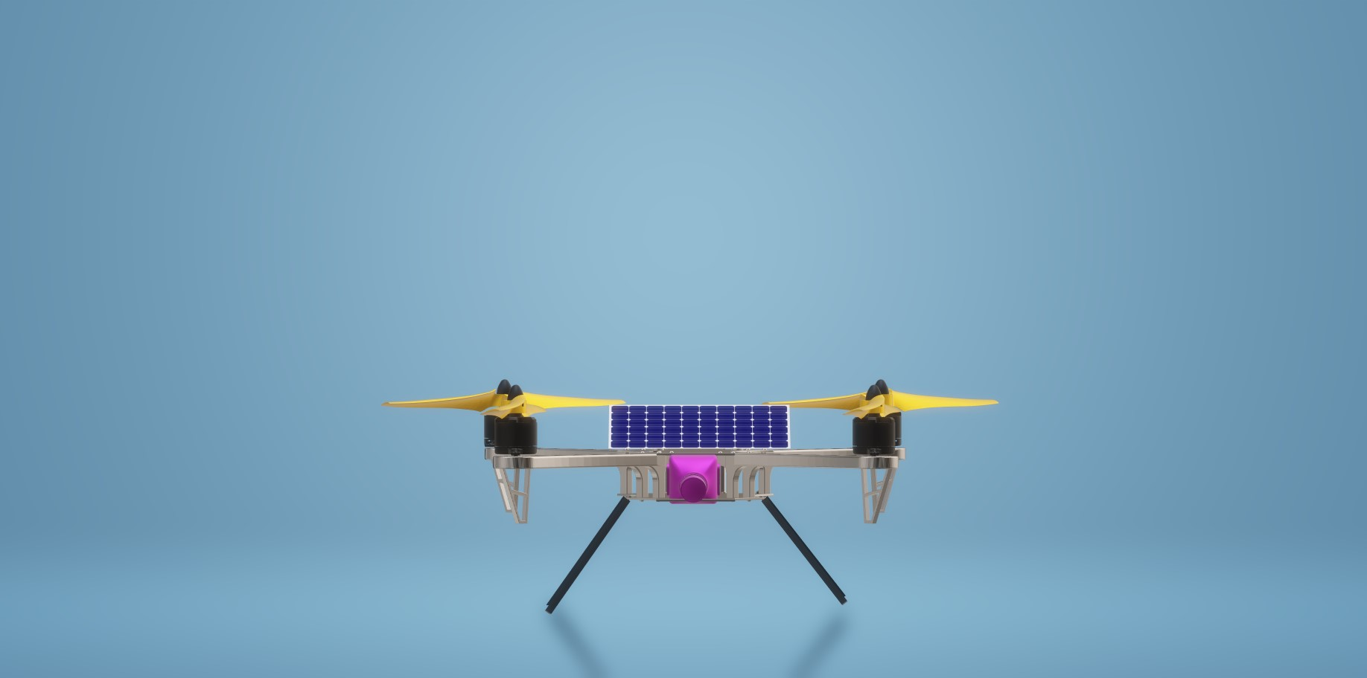

Side View
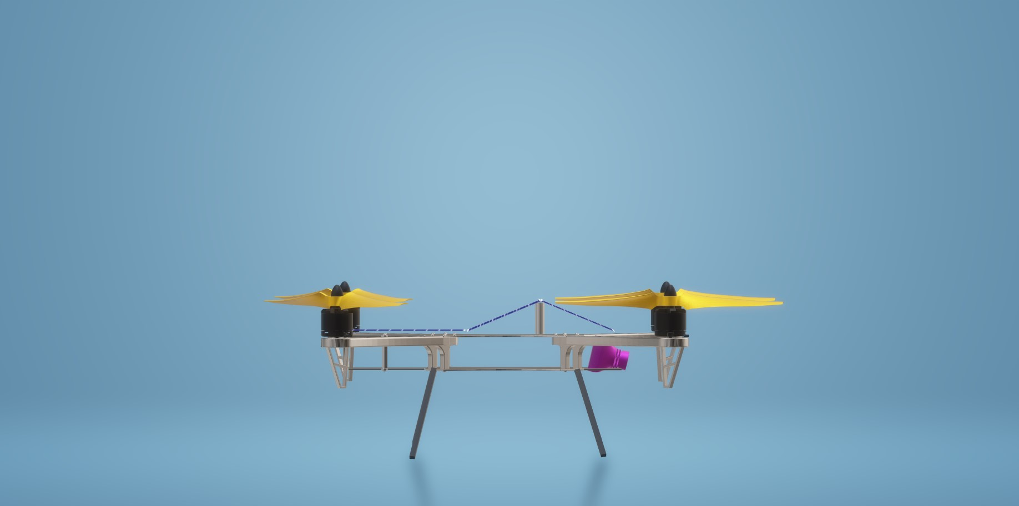

3D View

