SALLI

UI Refresh
Implementation Task
  - Buddy Mode + Pro Mode
Developer handoff for Codex / Claude Code
20 Aug 2026
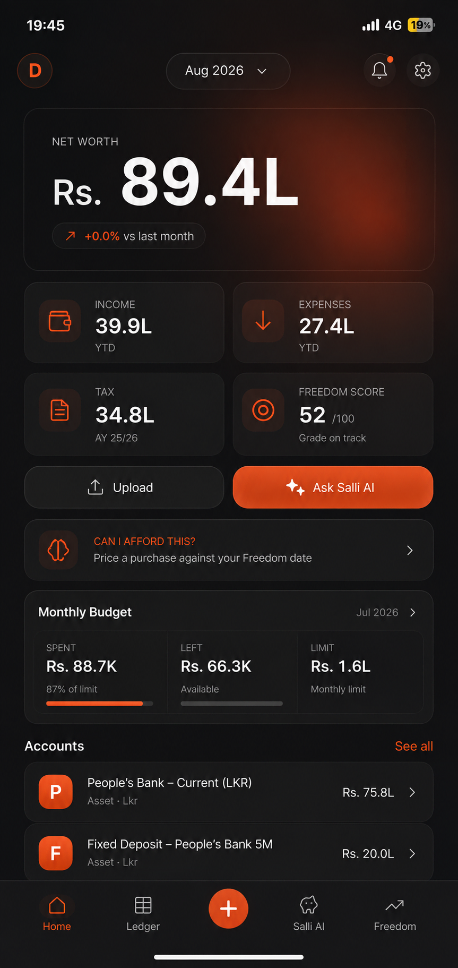 | 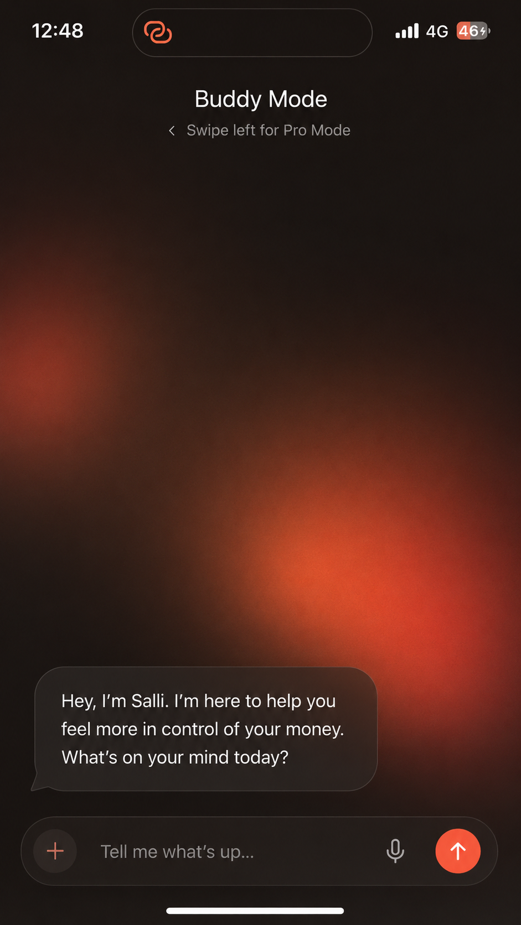 | 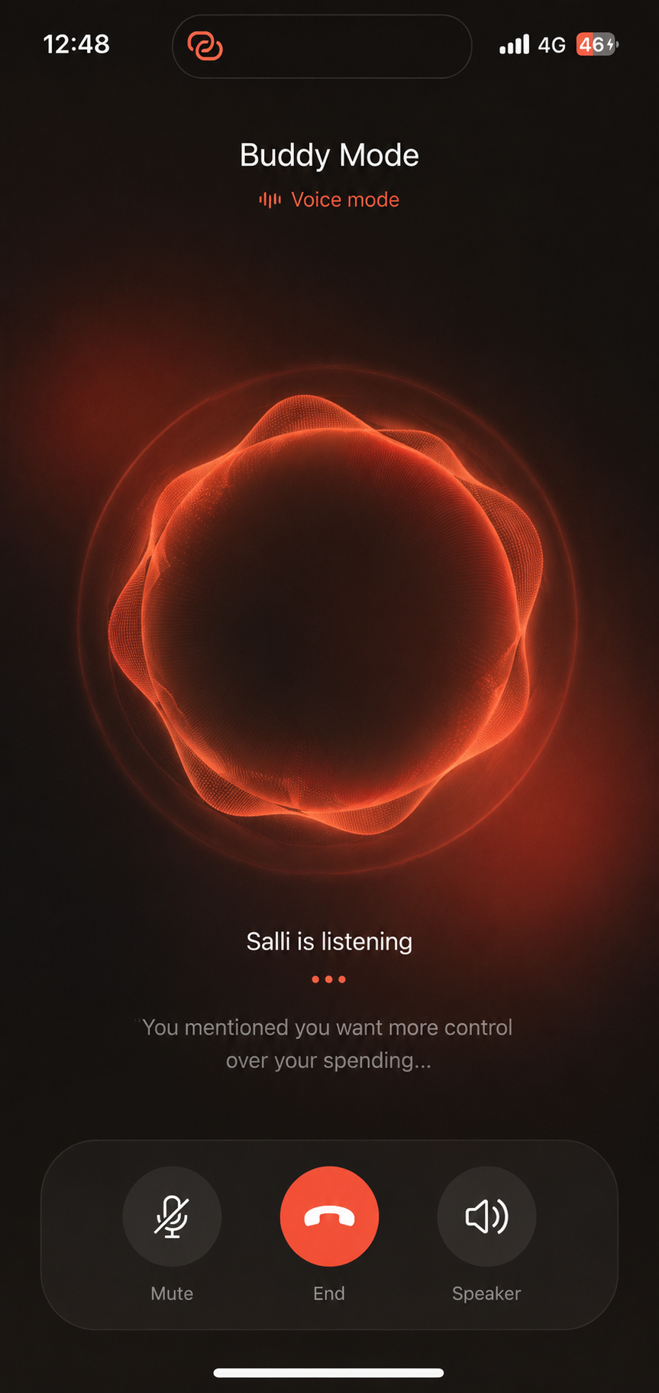
Implementation principle: The reference images define the visual direction. Written requirements define the product behavior and should win if an image contains an AI-rendering artifact.

1. Objective
Refresh Salli so the product feels calm, modern, premium, and AI-native without becoming visually busy. Buddy Mode should feel like a focused conversation with an intelligent money companion. Pro Mode should remain information-rich, but with much lower perceived complexity and a more deliberate hierarchy.
Preserve existing business logic, financial data, account models, ledger behavior, permissions, and API integrations unless a UI state cannot be represented with the current interfaces. Prefer adapters and presentation-state mapping over rewrites.

2. Shared design foundation

Mode architecture
- Buddy Mode is the AI-first conversational surface and has no persistent Pro bottom navigation.
- Pro Mode contains structured finance surfaces and uses a fixed bottom navigation bar.
- Preserve the left-swipe transition from Buddy to Pro; the Salli AI tab in Pro enters Buddy directly.
- Buddy has no hamburger menu, no suggestion chips, and no mascot/smiley treatment.

Color tokens
Token | Value | Usage
bg/base | #100F0E | Warm charcoal app background
surface/1 | #1A1715 | Cards, rows, composer
surface/2 | #211B18 | Raised/active surfaces
text/primary | #F5F2EF | Primary text
text/secondary | #8E8985 | Secondary labels
brand/base | #F15A32 | Red-orange accent
brand/bright | #FF784E | Primary actions/highlights
brand/deep | #7B2A20 | Atmospheric glow

Background + geometry
- Use a warm charcoal base with broad blurred radial red-orange/burgundy fields. No visible circles or hard gradient edges.
- Buddy may use stronger ambient glow; Pro uses the same system at lower intensity so data remains dominant.
- System sans-serif typography; spacing scale 4/8/12/16/20/24/32; card radius ~18-22 px; hero/composer radius ~26-32 px.
- Use subtle 1 px strokes only where needed. Avoid heavy glassmorphism, neon effects, and decorative outlines.
- Minimum interactive target 44x44 pt; responsive to existing supported device sizes and safe areas.

3. Pro Mode - Home Dashboard
01_pro_home_dashboard.png | Intent  Keep the important finance summary, but make the page feel like a single hierarchy instead of a stack of unrelated cards.  Implementation requirements  - Compact top controls: profile, month selector, notifications, settings.  - Net Worth hero is the strongest element on the page.  - Group Income, Expenses, Tax, and Freedom Score into one coherent 2x2 metric section.  - Keep Upload secondary and Ask Salli AI as the clear primary action.  - Keep one low-emphasis affordability shortcut, Monthly Budget, then Accounts.  - Use fewer borders and less repeated label chrome; reserve orange for active/primary states.  Behavior  - Implement a fixed, non-floating bottom navigation attached to the viewport/safe area.  - Items: Home / Ledger / Add / Salli AI / Freedom. Central Add may be circular but must remain visually anchored to the bar.  - Do not hardcode values shown in the reference; bind to existing finance models.

4. Pro Mode - Ledger
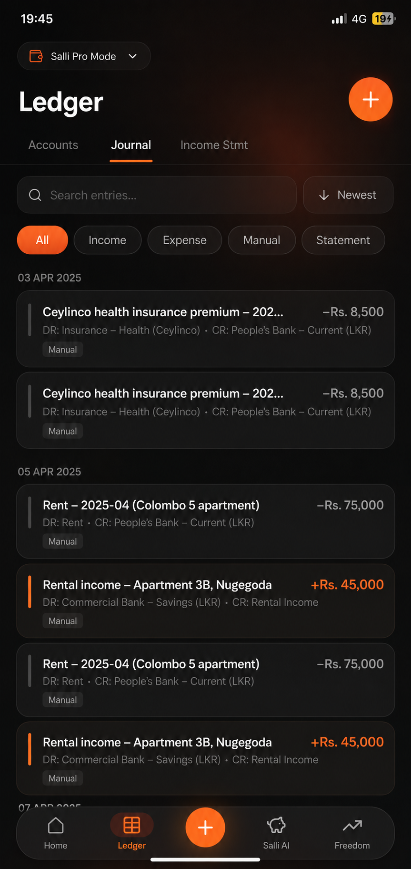  02_pro_ledger.png | Intent  Carry the same warm-dark system into the ledger while preserving fast scanning and existing accounting semantics.  Implementation requirements  - Preserve Accounts / Journal / Income Statement structure.  - Keep search, sort, and filter chips compact.  - Prioritize entry title and amount; debit/credit metadata stays visually secondary.  - Positive/income entries may use the brand accent, but never use color as the only semantic cue.  - Reduce row border noise and oversized card treatment.  - Use the same fixed bottom navigation as Pro Home.

5. Buddy Mode - Default / Welcome
03_buddy_default.png | Intent  The empty state should feel like Salli is already present and waiting to talk, not like a dashboard with prompts.  Implementation requirements  - Show one natural opening Salli message near the bottom, immediately above the composer.  - No suggestion chips, hamburger menu, mascot, smiley, or decorative illustration.  - Use a Messenger-like left-aligned agent bubble with soft asymmetric tail/corner; no decorative side stripe.  - Keep the body intentionally spacious and let the ambient gradient carry the mood.  - Composer includes add/attachment, microphone, and send affordances.  Notes  - Copy should remain flexible/localizable; do not design around one fixed sentence length.

6. Buddy Mode - Thinking / Tool Activity
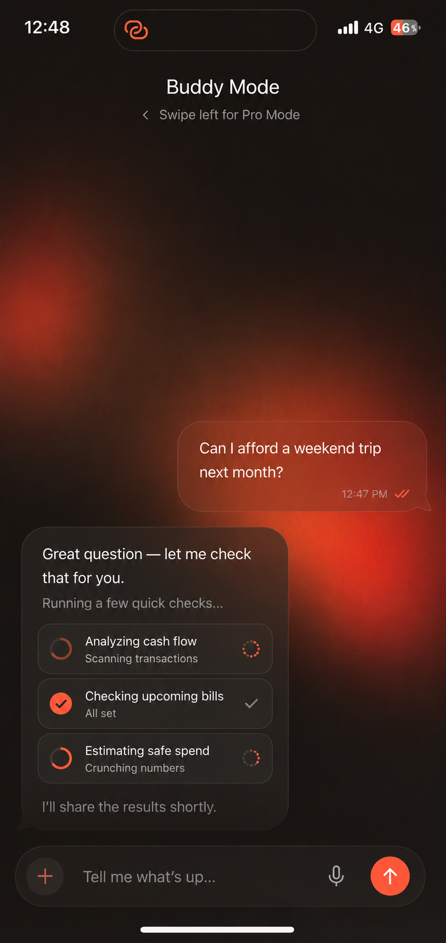  04_buddy_tool_activity.png | Intent  Show that Salli is doing useful work without exposing internal implementation details or creating a technical-looking console.  Implementation requirements  - User messages are compact, right-aligned, brand-tinted translucent bubbles.  - Agent/tool activity remains part of the normal left-aligned conversation thread.  - Each activity row has a plain-language label, brief secondary status, and queued/running/complete/failed state.  - Running states use lightweight motion; completed states de-emphasize after the result is ready.  - Never expose raw tool names, IDs, JSON, prompts, chain-of-thought, or internal reasoning.  Behavior  - Bind activity to real orchestration state. Do not ship fake timers as production behavior.  - When all activity completes, collapse/de-emphasize progress and render Salli's final answer.

7. Buddy Mode - Approval Gate
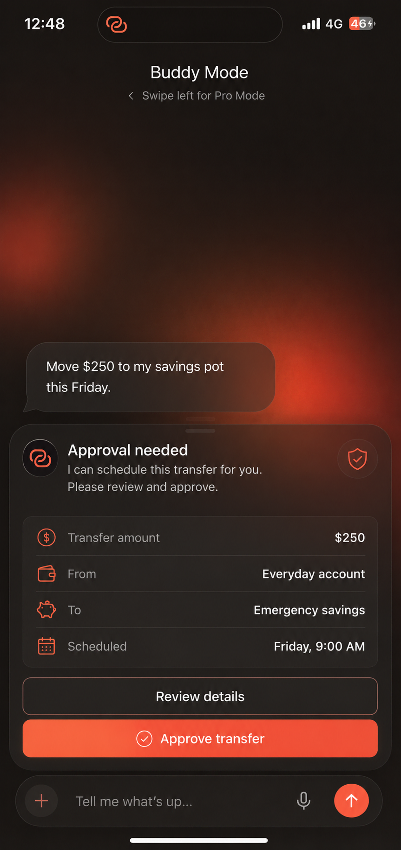  05_buddy_approval_gate.png | Intent  Use an inline approval card when Salli proposes an action that cannot execute without explicit user authorization.  Implementation requirements  - Show a clear approval title, one-sentence explanation, and the critical payload details (amount, from, to, date/time, etc.).  - Provide a secondary Review details action and a primary explicit Approve action.  - Keep the card legible and focused; do not overload it with implementation metadata.  - Allow the user to cancel/back out or continue the conversation without approving.  Behavior  - Never execute before approval of the exact pending payload.  - Invalidate/refresh approval if the underlying action changes.  - After approve/cancel/failure, replace the pending state with a clear conversational result.

8. Buddy Mode - Voice Agent
06_buddy_voice_mode.png | Intent  Voice Mode is a dedicated AI conversation state: visually expressive but operationally simple, with no text input field.  Implementation requirements  - Use the same warm ambient background with an abstract red-orange audio orb/waveform as the focal point.  - Show a concise state label: Listening / Thinking / Speaking.  - Optional short live transcript/caption is allowed, but the user does not type in this mode.  - Bottom controls: Mute, End, Speaker. No text composer.  Behavior  - State loop: idle -> listening -> thinking -> speaking -> listening.  - Respect Reduce Motion; use minimal opacity/scale alternatives.  - If an approval-gated financial action is reached, pause and surface the same explicit approval UI. Voice alone must not silently approve it.

9. Shared components + state integration

Reusable primitives
- Ambient radial background layer
- Surface/card primitive
- Agent and user chat bubbles
- Chat composer
- Tool activity list/row
- Approval gate card
- Voice orb
- Pro metric card
- Fixed Pro bottom navigation
- Account row
- Compact filter chip

Integration rules
- Inspect the existing theme, navigation, chat orchestration, tool execution events, approval model, and voice session model before refactoring.
- Bind UI to real application state. If backend events are coarse, introduce a small presentation adapter and deterministic development fixtures.
- Preserve existing analytics/event tracking and add only necessary events for mode switch, approval shown/confirmed/cancelled, and voice start/end.
- Never hardcode screenshot values. All financial values and account names come from existing models.
- Use native/existing icon libraries; ignore AI-rendered status-bar/icon artifacts.

Accessibility + motion
- Maintain strong text/control contrast and dynamic text support where available.
- Provide screen-reader labels for icon-only controls.
- Do not rely on red-orange alone for state, success, or failure.
- Tool activity announcements should be informative without spamming assistive technologies.
- Respect Reduce Motion and minimum 44x44 pt touch targets.

10. Acceptance criteria
ID | Criterion
AC-01 | Buddy opens with a Salli message near the composer; no suggestions, mascot, or hamburger menu.
AC-02 | Buddy -> Pro left-swipe works without conflicting with normal chat scrolling.
AC-03 | Pro uses warm charcoal + restrained red-orange radial atmosphere.
AC-04 | Pro Home hierarchy is led by Net Worth and is visibly less complex than the legacy layout.
AC-05 | Pro bottom navigation is fixed to the screen edge/safe area and is not a floating pill.
AC-06 | Ledger adopts the new tokens/navigation without losing existing ledger behavior.
AC-07 | User/agent messages use distinct Messenger-like right/left bubbles and remain readable over the background.
AC-08 | Tool activity is human-readable, stateful, and never exposes raw tool payloads or reasoning.
AC-09 | Completed tool activity resolves into a normal final Salli response.
AC-10 | Approval-gated actions cannot execute without explicit approval of the exact pending action.
AC-11 | Approval gate exposes critical details plus review/cancel/continue-conversation behavior.
AC-12 | Voice Mode has no text composer and supports Listening/Thinking/Speaking + Mute/End/Speaker.
AC-13 | Existing financial data/business logic remains intact; screenshots are never used as hardcoded data.
AC-14 | Layouts handle supported phone sizes, keyboard states, and safe areas.
AC-15 | Reduced Motion, screen-reader labeling, contrast, and touch target requirements pass.

11. Suggested implementation sequence
- Audit theme, navigation, chat, approval, tool-state, and voice architecture.
- Add shared design tokens and the ambient radial background component.
- Replace Pro bottom navigation with the fixed version; migrate Home + Ledger to shared tokens.
- Simplify Pro Home hierarchy/card treatment.
- Refactor Buddy default layout and composer.
- Add message bubble variants and real tool-activity state mapping.
- Implement/re-skin the approval gate against existing authorization logic.
- Implement Voice Mode states and controls.
- Add accessibility, Reduced Motion, keyboard, and safe-area handling.
- Add visual/state regression tests and run the existing finance test suite.

12. Definition of done
- All acceptance criteria pass.
- No regression in account, ledger, budget, Freedom, or financial-action flows.
- Screens use shared tokens/components instead of duplicate styling.
- Tool/approval UI is driven by real app state or a clearly isolated adapter.
- No raw reasoning/tool payloads are exposed to users.
- Visual review is completed on at least one small and one large supported phone size.
- Code is formatted/linted and the existing test suite passes.

13. Reference asset map
File | Use
01_pro_home_dashboard.png | Pro Mode Home visual direction and simplified hierarchy.
02_pro_ledger.png | Pro Mode Ledger visual direction.
03_buddy_default.png | Buddy default/welcome state.
04_buddy_tool_activity.png | User message + thinking/tool activity state.
05_buddy_approval_gate.png | Approval-gated financial action state.
06_buddy_voice_mode.png | Voice-only AI interaction state.
Handoff tip: For Codex/Claude Code, use the Markdown file in the handoff package as the task prompt and keep the references folder beside it so relative image paths resolve.

