**Test Cases:**

1. Here User enter 4 items along with the prices, and total amount is 485 and customer gives 1000. The amount to be returned is 515.

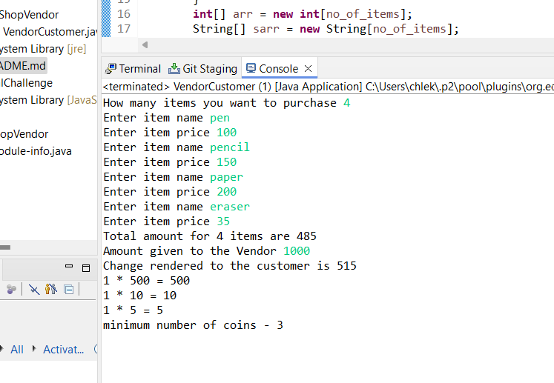

1. When the user is prompted to enter the number of items to be purchased and enters 0, a follow-up prompt asks them to enter 1 or more to proceed with the transaction. The user then enters 3 and provides the item prices. If any item price is entered as 0 or less, an error message indicates that the item price cannot be 0 or less.

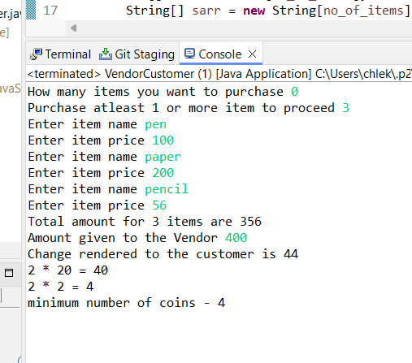

1. The total cost for these 6 items amounts to 352. However, the customer initially gives the vendor only 300, which is insufficient to cover the total amount. The vendor informs the customer that an additional 52 is needed to complete the purchase. The customer then provides the extra 52, bringing the total amount given to the vendor to 352. The customer then gives 60 to the vendor, making the total amount given 360. Since the total cost of the items is 352, the vendor needs to return 8 as change.

