Inventory file

[cshakya@centosserver install]$ cat inventory

[all]

centosserver

centosdesktop

[rhel]

desktop.mylab.com

1. List out the all host of inventory of ansible managed host

ansible all -i inventory --list-hosts

[cshakya@centosserver install]$ ansible **all** -i inventory --list-hosts

hosts (3):

centosserver

centosdesktop

desktop.mylab.com

1. List out particular group hosts e.g rhel

[cshakya@centosserver install]$ ansible **rhel** -i inventory --list-hosts

hosts (1):

desktop.mylab.com

1. Ad-Hoc command examples

ansible all –m command –a id

-m is module – here it is command module which is default

-a is argument



ERRRO : because inventory file is not passed

[cshakya@centosserver install]$ ansible **all** -i inventory -m command -a id

centosdesktop | CHANGED | rc=0 >>

uid=1000(cshakya) gid=1000(cshakya) groups=1000(cshakya) context=unconfined_u:unconfined_r:unconfined_t:s0-s0:c0.c1023

centosserver | CHANGED | rc=0 >>

uid=1000(cshakya) gid=1000(cshakya) groups=1000(cshakya) context=unconfined_u:unconfined_r:unconfined_t:s0-s0:c0.c1023

desktop.mylab.com | CHANGED | rc=0 >>

uid=1002(cshakya) gid=1002(cshakya) groups=1002(cshakya) context=unconfined_u:unconfined_r:unconfined_t:s0-s0:c0.c1023

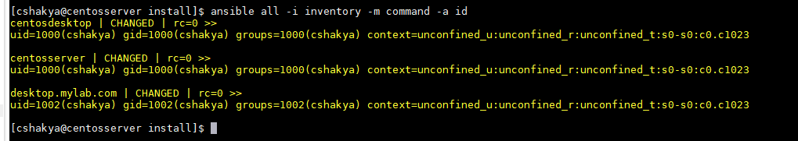

[cshakya@centosserver install]$ ansible **rhel** -i inventory -m command -a id

desktop.mylab.com | CHANGED | rc=0 >>

uid=1002(cshakya) gid=1002(cshakya) groups=1002(cshakya) context=unconfined_u:unconfined_r:unconfined_t:s0-s0:c0.c1023



1. ansible rhel -i inventory -m command -a id –o

This will show command output in one line



1. [cshakya@centosserver install]$ **ansible rhel -i inventory -m command -a ./test.sh**

desktop.mylab.com | CHANGED | rc=0 >>

hello from server desktop.mylab.com at Sat Dec 1 02:20:26 EST 2018

1. [cshakya@centosserver install]$ **ansible rhel -i inventory -m shell -a ./test.sh**

desktop.mylab.com | CHANGED | rc=0 >>

hello from server desktop.mylab.com at Sat Dec 1 02:20:52 EST 2018

1. [cshakya@centosserver install]$ **ansible rhel -i inventory -m shell -a "sh -xv test.sh"**

desktop.mylab.com | CHANGED | rc=0 >>

hello from server desktop.mylab.com at Sat Dec 1 02:21:24 EST 2018 #!/bin/bash

h=`hostname`

hostname

++ hostname

+ h=desktop.mylab.com

d=`date`

date

++ date

+ d='Sat Dec 1 02:21:24 EST 2018'

echo "hello from server $h at $d "

+ echo 'hello from server desktop.mylab.com at Sat Dec 1 02:21:24 EST 2018 '

1. [cshakya@centosserver install]$ **ansible rhel -i inventory -m shell -a "touch test1"**

[WARNING]: Consider using the file module with state=touch rather than running touch. If you need to use command because file is

insufficient you can add warn=False to this command task or set command_warnings=False in ansible.cfg to get rid of this message.

desktop.mylab.com | CHANGED | rc=0 >>

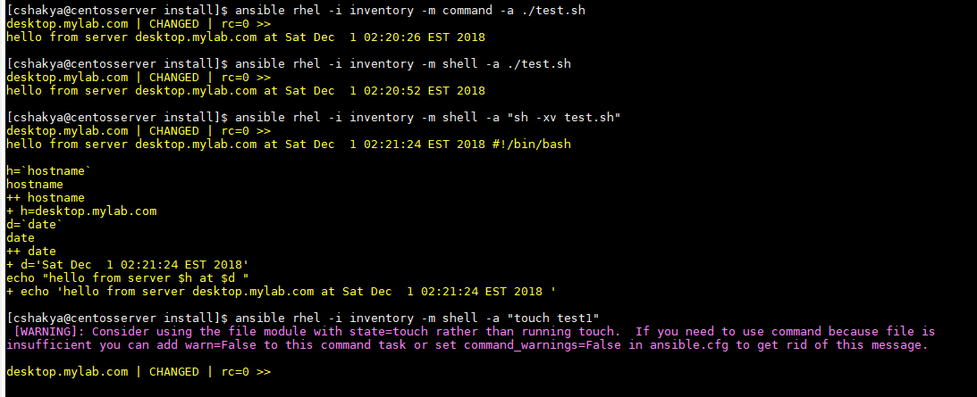

1. [cshakya@centosserver install]$ **cat ansible.cfg**

[privilege_escalation]

become=True

become_method=sudo

become_user=root

become_ask_pass=False

original ansible.cfg is at /etc/ansible/ansible.cfg

**NOTE : user by which we are managing ansible must part of either wheel group or part added as NOPASSWD: ALL in suoders file**



**Here cshakya used as ansible user on controller node and slave machine .**

1. [cshakya@centosserver install]$ **ansible centosdesktop -i inventory -m copy -a 'content="Managed by Ansible \n" dest=/etc/motd'**

centosdesktop | CHANGED => {

"changed": true,

"checksum": "ba3a4b4b9a888ade9c53c478ab2b956ffde75822",

"dest": "/etc/motd",

"gid": 0,

"group": "root",

"md5sum": "56e539eee5d29fc804a8e70547ca7152",

"mode": "0644",

"owner": "root",

"secontext": "system_u:object_r:etc_t:s0",

"size": 20,

"src": "/home/cshakya/.ansible/tmp/ansible-tmp-1543653641.62-277428753227872/source",

"state": "file",

"uid": 0

}

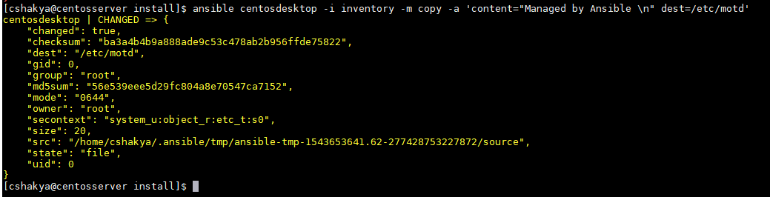

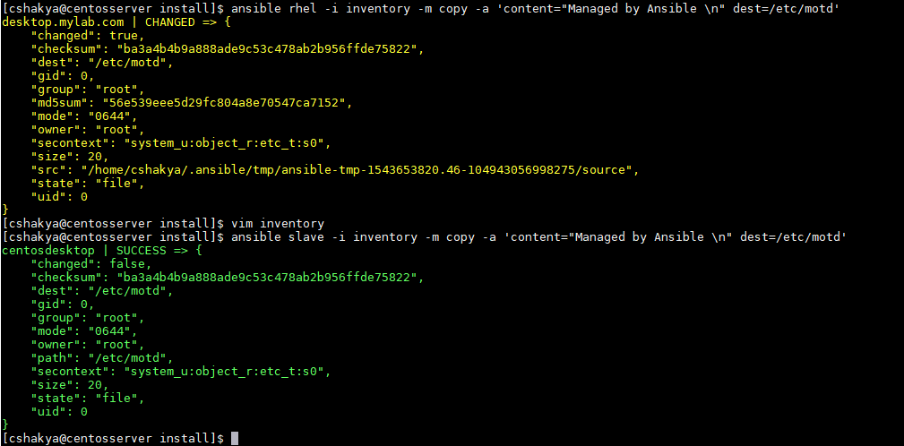

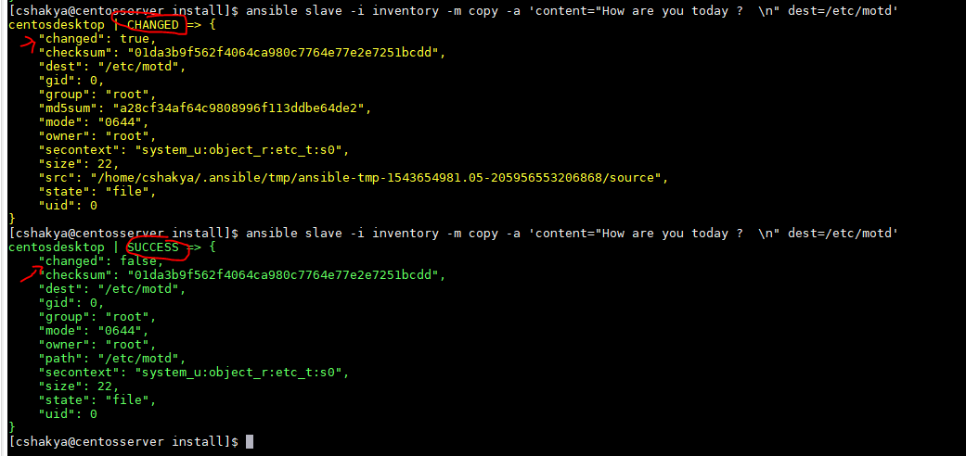

**LESSON 2**

ansible-doc –l **=> to list all module available**

ansible-doc nmcli

**LESSON 3**

**YAML files**

**YAML Ain’t Markup Language**

Structure are represent using indentation

Sample Yaml file , starting with **THREE DASH** and ending with

--- **THREE DOT**

# example YAML file

item1

paramter1

parameter2

option1

option2

item2

paramter3

….

* Dictionaries: a dictionaly is a key/value pair in key:value notation
* List are used to represent a list of items
  + List are enumerated as **– item ,** where space behind the – is mandatory
* Strings can be enclosed in either double or single quotes but that’s not mandatory
  + In a multi-line string , the first line is ended by either a | or a> and the next line is indented
* To verify YAML file syntax , run it with **ansible-playbook –syntax-check <filename.yaml>**

[cshakya@centosserver lab_ansible]$ cat mycode.yaml

---

- cow

- pig

-lion

...

[cshakya@centosserver lab_ansible]$ ansible-playbook --syntax-check mycode.yaml

[WARNING]: provided hosts list is empty, only localhost is available. Note that the implicit localhost does not match 'all'

ERROR! Syntax Error while loading YAML.

could not find expected ':'

The error appears to have been in '/home/cshakya/lab_ansible/mycode.yaml': line 5, column 1, but may

be elsewhere in the file depending on the exact syntax problem.

The offending line appears to be:

-lion

...

^ here

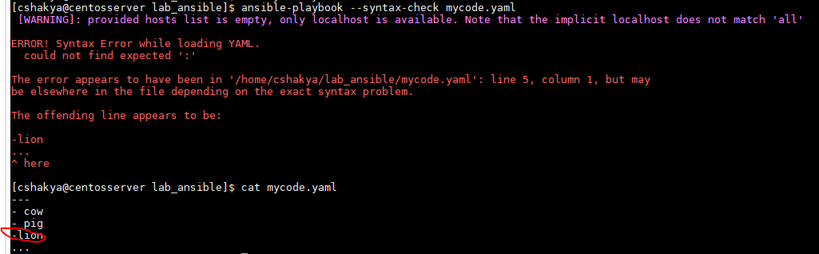

PALYBOOKS

---

#My first playbook

- name: simple playbook

hosts: centosdesktop

user: cshakya

become: yes

become_method: sudo

become_user: root

tasks:

- name: install vsftpd

yum: name=vsftpd

- name: enable vsftpd

service: name=vsftpd enabled=true

- name: create readme file

copy:

content: "Welcome to ftp server"

dest: /var/ftp/pub/RRADME1

force: no

mode: 0444

...

v 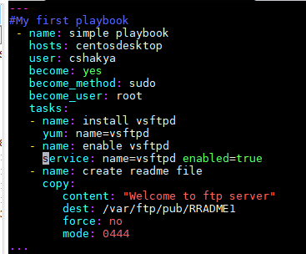

[cshakya@centosserver lab_ansible]$ ansible-playbook myfirst.yml -i inventory

PLAY [simple playbook] ******************************************************************************************************************

TASK [Gathering Facts] ******************************************************************************************************************

ok: [centosdesktop]

TASK [install vsftpd] *******************************************************************************************************************

ok: [centosdesktop]

TASK [enable vsftpd] ********************************************************************************************************************

changed: [centosdesktop]

TASK [create readme file] ***************************************************************************************************************

changed: [centosdesktop]

PLAY RECAP ******************************************************************************************************************************

centosdesktop : ok=4 changed=2 unreachable=0 failed=0

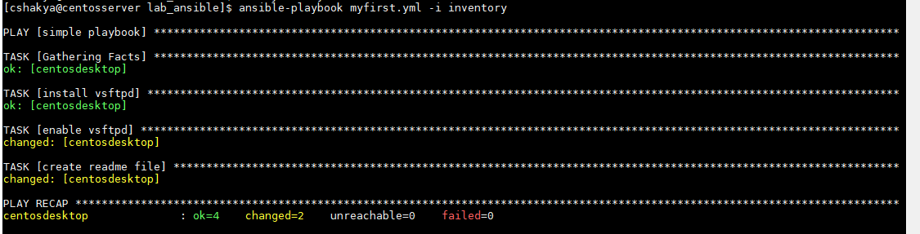

* New start command added

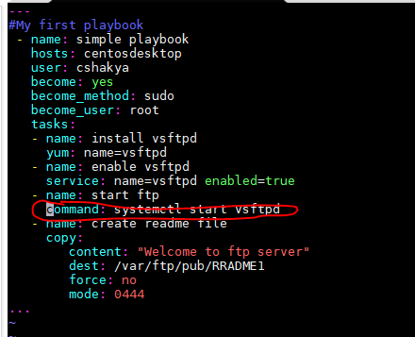

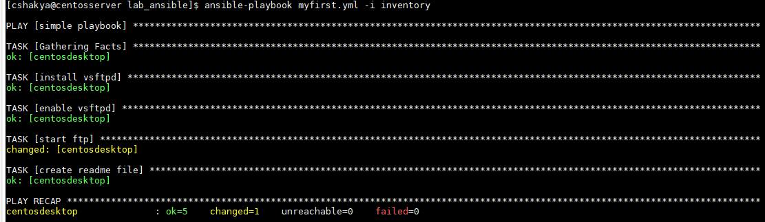

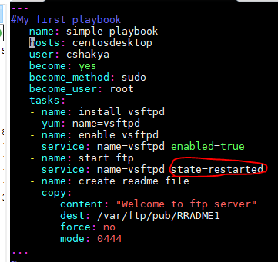

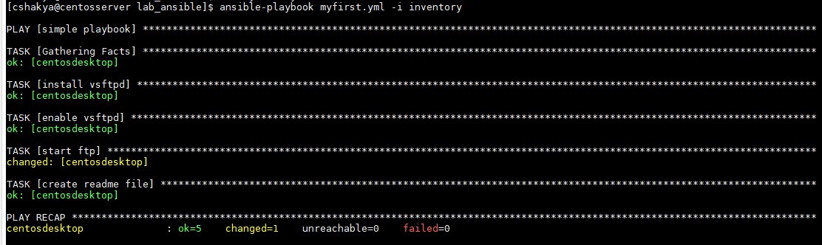

**Removing package**

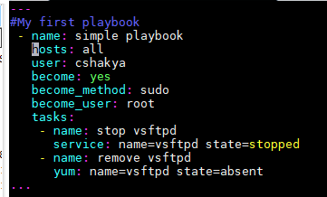

---

#remove package vsftpd playbook

- name: simple playbook

hosts: slave

user: cshakya

become: yes

become_method: sudo

become_user: root

tasks:

- name: stop vsftpd

service: name=vsftpd state=stopped

- name: remove vsftpd

yum: name=vsftpd state=absent

...

~

