https://bmcsites.force.com/casemgmt/sc_KnowledgeArticle?sfdcid=kA33n000000YEUhCAO&type=Solution

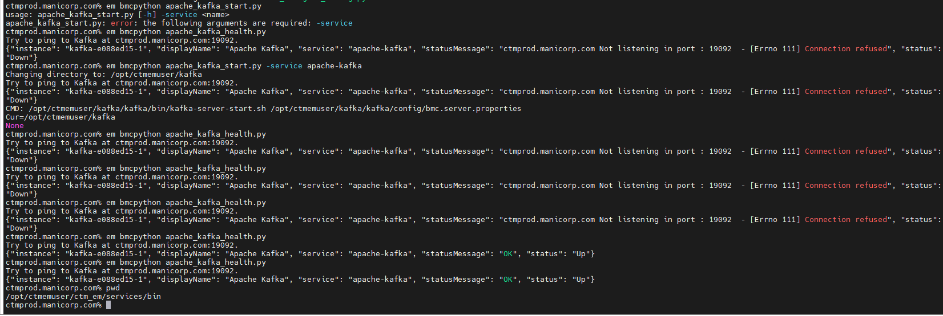
ctmprod.manicorp.com% em bmcpython apache_kafka_start.py
usage: apache_kafka_start.py [-h] -service <name>
apache_kafka_start.py: error: the following arguments are required: -service
ctmprod.manicorp.com% em bmcpython apache_kafka_health.py
Try to ping to Kafka at ctmprod.manicorp.com:19092.
{"instance": "kafka-e088ed15-1", "displayName": "Apache Kafka", "service": "apache-kafka", "statusMessage": "ctmprod.manicorp.com Not listening in port : 19092 - [Errno 111] Connection refused", "status": "Down"}
ctmprod.manicorp.com% em bmcpython apache_kafka_start.py -service apache-kafka
Changing directory to: /opt/ctmemuser/kafka
Try to ping to Kafka at ctmprod.manicorp.com:19092.
{"instance": "kafka-e088ed15-1", "displayName": "Apache Kafka", "service": "apache-kafka", "statusMessage": "ctmprod.manicorp.com Not listening in port : 19092 - [Errno 111] Connection refused", "status": "Down"}
CMD: /opt/ctmemuser/kafka/kafka/bin/kafka-server-start.sh /opt/ctmemuser/kafka/kafka/config/bmc.server.properties
Cur=/opt/ctmemuser/kafka
None
ctmprod.manicorp.com% em bmcpython apache_kafka_health.py
Try to ping to Kafka at ctmprod.manicorp.com:19092.
{"instance": "kafka-e088ed15-1", "displayName": "Apache Kafka", "service": "apache-kafka", "statusMessage": "ctmprod.manicorp.com Not listening in port : 19092 - [Errno 111] Connection refused", "status": "Down"}
ctmprod.manicorp.com% em bmcpython apache_kafka_health.py
Try to ping to Kafka at ctmprod.manicorp.com:19092.
{"instance": "kafka-e088ed15-1", "displayName": "Apache Kafka", "service": "apache-kafka", "statusMessage": "ctmprod.manicorp.com Not listening in port : 19092 - [Errno 111] Connection refused", "status": "Down"}
ctmprod.manicorp.com% em bmcpython apache_kafka_health.py
Try to ping to Kafka at ctmprod.manicorp.com:19092.
{"instance": "kafka-e088ed15-1", "displayName": "Apache Kafka", "service": "apache-kafka", "statusMessage": "ctmprod.manicorp.com Not listening in port : 19092 - [Errno 111] Connection refused", "status": "Down"}
ctmprod.manicorp.com% em bmcpython apache_kafka_health.py
Try to ping to Kafka at ctmprod.manicorp.com:19092.
{"instance": "kafka-e088ed15-1", "displayName": "Apache Kafka", "service": "apache-kafka", "statusMessage": "OK", "status": "Up"}
ctmprod.manicorp.com% em bmcpython apache_kafka_health.py
Try to ping to Kafka at ctmprod.manicorp.com:19092.
{"instance": "kafka-e088ed15-1", "displayName": "Apache Kafka", "service": "apache-kafka", "statusMessage": "OK", "status": "Up"}
ctmprod.manicorp.com%

