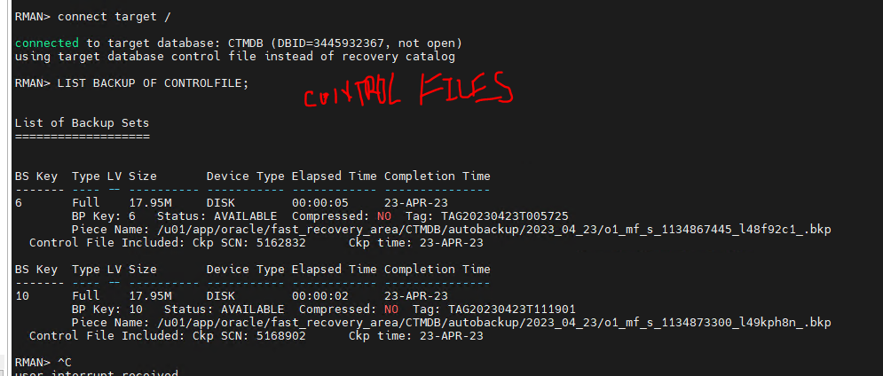
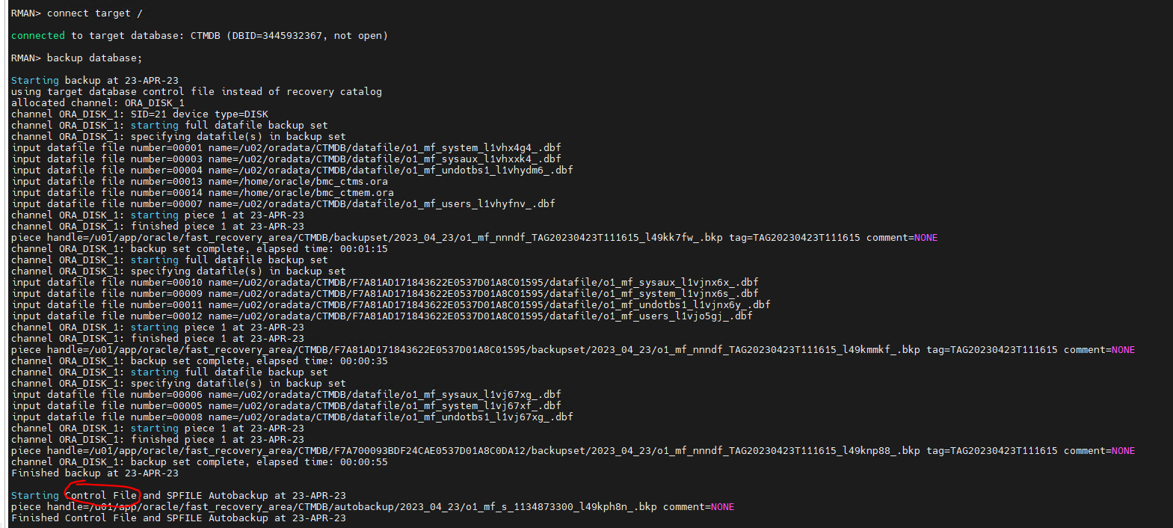
After moving the necessary backup files to the secondary server, you can restore the database using the following steps:
- Connect to the target database instance on the secondary server using SQL*Plus or a similar client tool.
- Set the DBID of the target database to match the DBID of the source database. This can be done using the following command:
RMAN> set dbid <dbid>;
Replace <dbid> with the DBID of the source database.
- Start the instance in NOMOUNT state:
SQL> startup nomount;
- Run the following command to restore the control file:
RMAN> restore controlfile from '<control_file_backup_file>';
Replace <control_file_backup_file> with the path to the control file backup file on the secondary server.
- Mount the database:
SQL> alter database mount;
- Restore the database files using the following command:
RMAN> restore database;
- Recover the database using the following command:
RMAN> recover database;
- Open the database with the RESETLOGS option:
RMAN> alter database open resetlogs;
Note that these steps are a general guideline and may need to be adjusted based on your specific backup and restore needs. It is recommended to consult the Oracle documentation or seek assistance from a qualified Oracle DBA to ensure a successful restore.

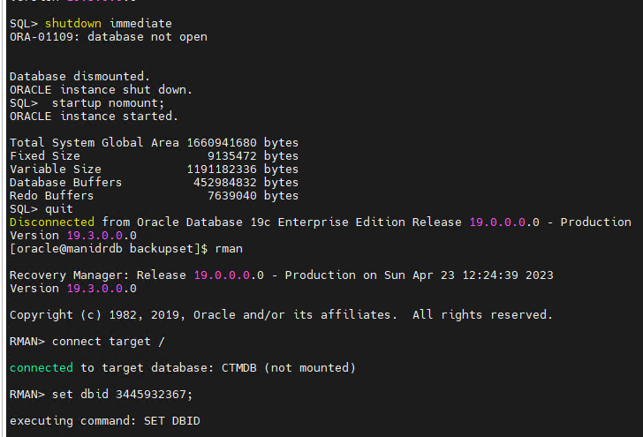
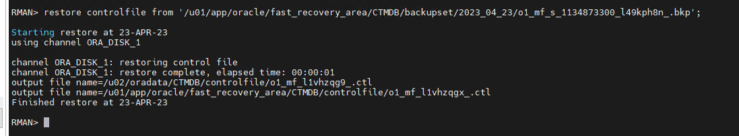
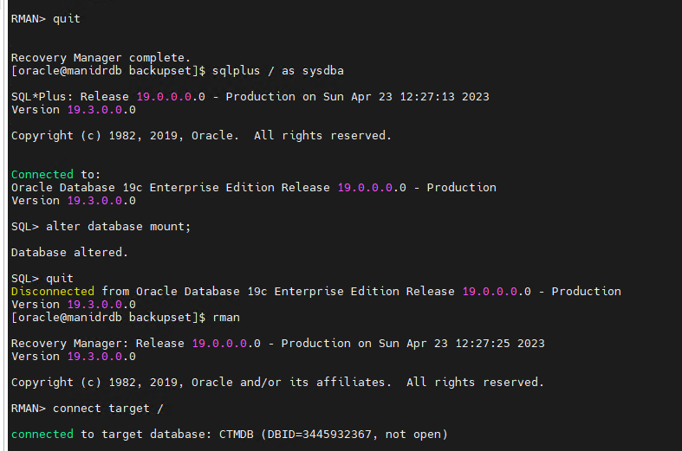
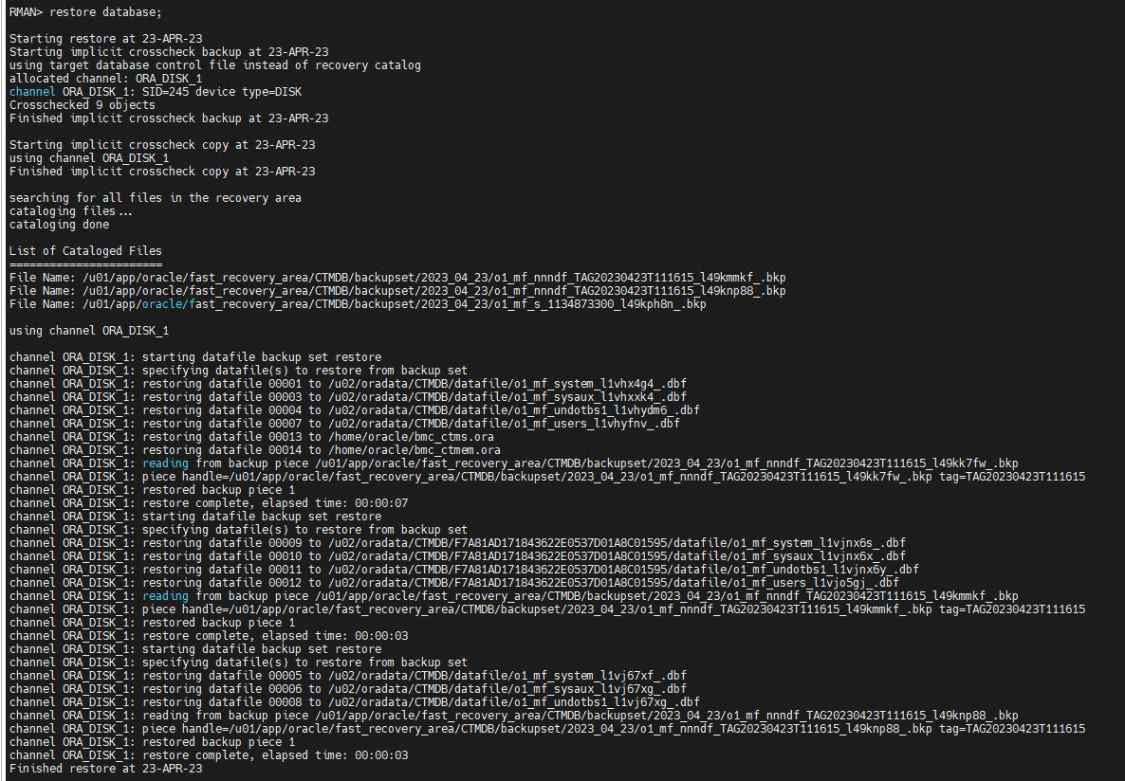
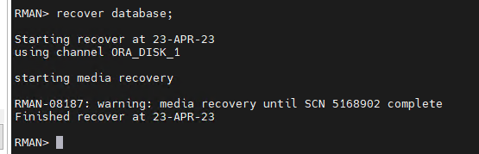
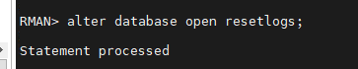

You can use the following SQL query to list all the schemas in an Oracle database:
sqlCopy code
SELECT DISTINCT owner FROM all_objects WHERE object_type IN ('TABLE','VIEW','FUNCTION','PROCEDURE');

