**Dependency Network API** :

This API is developed based on the Richardson maturity model Level-2.

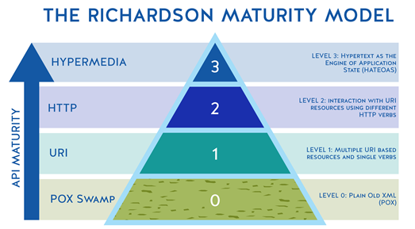

Please find below API according to *functional requirements*:

* dependency network can be retrieved using this request.

*Request:* (GET) /api/<planId>/tasks

*Response*: **200**

{

"Plan id":"NH 5888",

"Tasks":[

{

"debording":[

{

"upstream tasks":[

]

},

{

"downstream tasks":[

{

"1":"unloading"

},

{

"2":"offloadCatering"

},

{

"3":"clening"

},

{

"4":"fueling"

}

]

},

{

"start time":"20CET"

},

{

"end time":"22CET"

}

]

},

{

"unloading":[

{

"upstream tasks":[

{

"1":"debording"

}

]

},

{

"downstream tasks":[

{

"1":"offloadCatering"

},

{

"2":"clening"

},

{

"3":"fueling"

}

]

},

{

"start time":"20.30CET"

},

{

"end time":"23CET"

}

]

}

]

}

* given a task name, you can retrieve all other tasks it depends (upstream)

*Request:* (GET) /api/<planId>/task/<taskName>/upstream

*Reaponse:* **200**

{

"loading":[

{

"upstream tasks":[

{

"unloading":[

{

"start time":"20CET"

},

{

"end time":"22CET"

}

]

},

{

"offloadCatering":[

{

"start time":"21CET"

},

{

"end time":"22CET"

}

]

},

{

"clening":[

{

"start time":"21.10CET"

},

{

"end time":"22.30CET"

}

]

},

{

"fueling":[

{

"start time":"21CET"

},

{

"end time":"22CET"

}

]

}

]

},

{

"start time":"20CET"

},

{

"end time":"22CET"

}

]

}

* given a task name, you can retrieve all other tasks it depends (*downstream*)

*Request:* (GET) /api/<planId>/task/<taskName>/downstream

*Response*: **200**

{

"debording":[

{

"downstream tasks":[

{

"unloading":[

{

"start time":"20CET"

},

{

"end time":"22CET"

}

]

},

{

"offloadCatering":[

{

"start time":"21CET"

},

{

"end time":"22CET"

}

]

},

{

"clening":[

{

"start time":"21.10CET"

},

{

"end time":"22.30CET"

}

]

},

{

"fueling":[

{

"start time":"21CET"

},

{

"end time":"22CET"

}

]

}

]

},

{

"start time":"20CET"

},

{

"end time":"22CET"

}

]

}

* Create a new task it depends

*Request:* (POST) /api/task/create

{

"name":"security check",

"plainId":"NH 5888",

"upstream tasks":[

"unloading",

"offloadcatering",

"cleaning"

],

"downstream tasks":[

"cabin check",

"water",

"bording"

],

"start time":"21.30CET",

"end time":"22.30CET"

}

Response: **201**

{“task created successfully”}

* Create a new dependency between the task.

*Request:* (PUT) /api/task/dependencies/create

{

"plainId":"NH 5888",

"dependency":[

{

"name":"security check",

"upstream tasks":[

"unloading",

"offloadcatering",

"cleaning"

],

"downstream tasks":[

"cabin check",

"water",

"bording"

]

},

{

"name":"loading",

"upstream tasks":[

"unloading",

"offloadcatering",

"cleaning"

],

"downstream tasks":[

"cabin check",

"water",

"bording"

]

}

]

}

Response: **200**

{“dependency added successfully”}

* delete the task.

*Request:* (DELETE) /api/task/delete

{

"name":"security check"

}

Response: **200**

{“task deleted sucessfully”}

* remove dependencies between tasks

*Request:* (DELETE) /api/task/dependencies/delete

{

"plainId":"NH 5888",

"dependency":[

{

"name":"security check",

"upstream tasks":[

"unloading"

],

"downstream tasks":[

"cabin check"

]

}

]

}

Response: **200**

{“dependencies between tasks are removed sucessfully”}