PRPC BULLET POINTS

- PRPC is a combination of BPM ( business process management) and BRE (Business rules engineering )

- The Pega System’s Six “R” s are

  - Receive
  - Route
  - Report
  - Research
  - Respond
  - Resolve

- Services are interfaces from other systems to PRPC. Standard services that come in with PRPC are

  - Rule-Service-COM
  - Rule-Service-CORBA
  - Rule-Service- DOTNET
  - Rule-Service-EJB
  - Rule-Service-Email
  - Rule-Service-JMS
  - Rule-Service-JSR94
  - Rule-Service-MQ

- Connectors are interfaces from PRPC to other systems. Standard connectors that come in with PRPC are

1. Rule-connect-ejb
2. Rule-connect-dotnet
3. Rule-connect-SQL
4. Rule-Connect-Java
5. Rule-Connect-JMS
6. Rule-Connect-SOAP
7. Rule-Connet-MQ

- Process Commander supports a three-level organizational hierarchy consisting of organizations at the top level, divisions at a second level, and units as a third level

- Organization: Organization is on top of the organization hierarchy. It is an instance of Data-Admin-Organization. By Default PRPC is shipped with and Organization called Pega.com.

- Significance of adding rulesets at Organization: We can add one or more rulesets to organization for providing access to all the users belonging to that organization to the specified ruleset. Assume an application like “leave application” which needs to be accessed by all the employees of organization, and then perhaps we may like to add leave application’s rulesets at Organization level.

- Significance of adding top level class at Organization: You can optionally specify a top level class when an organization is created. It does not have much significance except it is used as default top level class when the users belonging to the organization uses application accelerator to create an application

- Division: Divisions is at a second level in the organization hierarchy right after the Organization. It is an instance of the class Data-Admin-OrgDivision.

- While you are creating a new division, you have to specify (Mandatory) to which organization it belongs.

- Significance of adding rulesets at Division: We can add one or more rulesets to division for providing access to all the users belonging to that division. Assume an application like “Loan application” of a bank which needs to be accessed only by the employees of Loans division, then perhaps we may like to add Loan application’s rulesets at Loan division level, so that other divisions in the same organization can not have access the ruleset

- Unit: Unit is at a third level in the organization hierarchy right after the division. It is an instance of the class Data-Admin-OrgUnit.

- While you are creating a new unit, you have to specify (Mandatory) to which organization and division it belongs.

- PRPC default organization structure looks as below



- Access Group controls the security basing on the job functions. It is instance of Data-Admin-Operator-AccessGroup. Various aspects that can be controlled through access group are

  - default and available types of works( also called as work pools ) ,
  - Primary rulesets ( Access Control to rulesets),
  - Assigned roles,
  - Portal layout
  - Default ruleset for making changes ( Default ruleset whenever the user creates/ saves as the rule )

- Portal Layout: The Portal is the standard Internet Explorer-based user interface for Process Commander Workers, managers, and developers. The Portal rule (Instance of Rule-Portal class) defines the tabs, arrangement, and labeling of anchors and features, known as gadgets. We can always create new portal layouts by defining new instances of the class Rule-Portal. Later we can make use of these portals from operator’s access group.

- Significance of adding rulesets at Access Group: We can add one or more rulesets to access group when we think that security needs to be controlled basing on the specific job function. Assume that an application like “Heart allocation request application” is being developed for all the Project Managers in Satyam for making resource requests for their projects. Then we can think of adding this application ruleset in an access group called “PM”, so that all PMs across all the divisions in Satyam can access this application.

- We can add rulesets at either at Organization or at Division or at access group, but not at the unit

- It is not mandatory to add the rulesets either at Organization, division and the access group. We can add at all these places, at the same time we can refrain by not adding at any of these places.

- Access groups are instances of the class Data-Admin-Operator-AccessGroup

- Significance of “Default class group of work” and “all class groups” of work fields in access group form : In “all the class groups” field, we need to add one or more class groups so as to create the work pools in which users associated in this access group are permitted to create the work objects. We can add one class group in the field “Default class group of work”

- Operators are created through instances of Data-Admin-Operator-ID class.

- Important entries while creating the operators are

  - Organization ( Mandatory)
  - Division ( Mandatory )
  - Unit ( Mandatory )
  - Workgroup ( Mandatory )
  - Access Group ( Mandatory )
  - Allow Rule Check Out ( Check box ) ( Optional )

- Checking the “Allow rule check out” check box in operator form , allows that operator to update the rules from the rulesets that require check out

- The PRPC jargon of security and organization hierarchy can be diagrammatically depicted as below.

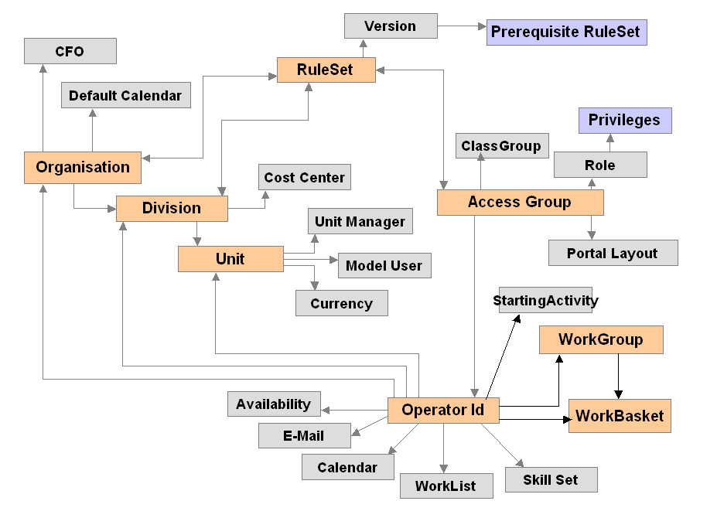

- Ruleset is a container for rules in our application building. And it is what we deploy in production environment or ship to customer.

- An instance of Rule-Ruleset-name is created when we first time create the rule set. An instance of Rule-RuleSet-Version is created whenever the version is upgraded including when the first version is created. The relation between Rule-Ruleset-name and the Rule-RuleSet-Version is one to many.

- All the rules that we create for our application should belong to one or other ruleset. PyRuleSet property in the Rule- Class represents this

- Though we know that all the instances of all the Rule- hierarchy classes will have versions, instances of following classes will not have any version

      - Rule-Obj-Class
      - Rule-Ruleset-Name
      - Rule-Ruleset-Version
      - Rule-Access-Role-Obj
      - Rule-Method

- RuleSet naming Conventions

      - Any Case is Ok but MixedCase is good practice

      - Max 32 characters and no spaces allowed

      - Prefix of Pega or Pega- should not be used as these are restricted for use by Pega Systems. ( Practically, for now Pega prefix is allowed but Pega- prefix produces the error)
      - Special characters, quotes and + signs are not allowed
      - Dash and underscores are not recommended to be used

- Process Commander is shipped with 4 standard rulesets viz,

      - Pega-ProCom – Supports business Process Management

      - Pega-InvSvcs – Supports integration services

      - Pega-WB – Supports portal infrastructure

      - Pega-Rules – Supports rules engine and rule resolution

- RuleSet Format

LoanAppl 01-02-03

01- Version
02 –Minor release within the version
03 – Interim or patch release within minor release

- Private Ruleset : Whenever application developer checks out the rule, it enters/ belongs to private ruleset . Users who have the “Allow Rule Check Out?” check box (on their Operator ID instance) checked can place copies of rule instances into a personal or private RuleSet. The name of this RuleSet is the same as their Operator. system automatically creates the private ruleset whenever required. No explicit instance of the Rule-RuleSet-Name exists for a private RuleSet.

- How a user’s ruleset list is formed ( the logic )? The system adds entries it finds from following sources in the order listed. The system adds entries it finds from these sources in the top of the list,

  - Requestor : (Data-Admin-Requestor class) — Usually this adds the RuleSets named Pega-RULES, and Pega-IntSvcs and a version or version prefix for these
  - Division — As referenced in the Operator-ID instance
  - Organization — As referenced in the Operator-ID instance
  - Access Group : As referenced in the Operator-ID instance
  - Ruleset Versions — Prerequisite RuleSets and Versions to those already compiled
  - Operator ID : If this user has the ability to check out rules, the personal RuleSet (named the same as the Operator ID key) is added last. Also called as private ruleset

- Rule-Admin-Product: Rule-Admin-product instances can be used as a packaging and deployment utility in PRPC. For example, you can specify what are all the rulesets and respective versions, data/other class instances that should become part of the final deployment. You can also specify a install file (html) and an activity (which will run up on installation of the zip file on the target machine) on the product form. Once you define the product form you can click the “Create Zip file” button, which would create the product’s zip file in “Service Export” directory.

- There are two important repetitive things that can be added in Rule-Admin-Product Instance :

    - One or more rulesets and their versions
    - One or more Data- and other ( perhaps non Rule- )concrete classes and respective When filters. The respective data class’s instances are picked up only when these When filters (Rule-Obj-When) true.

- Important options that we can do from “Move Rules Tool”

  - Export Rules option: Copies rules from rulebase to a zip file on a server. The typical screen that appears on using this tool is
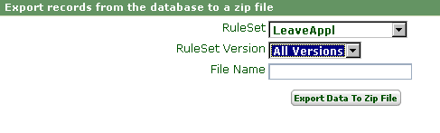
Unlike Rule-Admin-Product, you can only specify one ruleset here, but you can specify all version or a particular version. Then you can give suggested name for the zip file and can click “Export Data to Zip file” to keep the zip file in the “Service Export” directory

  - Load rules to rulebase option : This option can be used to load the rules from the zip file in to your systems if the zip file is already in the Service export directory. The typical screen that appears on using this tool is
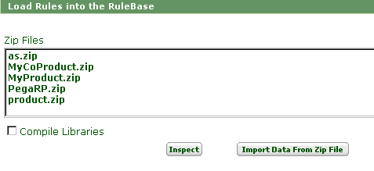

You can select the required zip file and use “Import Data from Zip File” to load rules to the rulebase

  - Upload zip file into the rulebase option : This option can be used when you want to transfer a ZIP file created by the Move Rules tool or the Product rule from your workstation disk to the ServiceExport directory on a target Process Commander system by using FTP. The typical screen that appears up on selecting this option is.
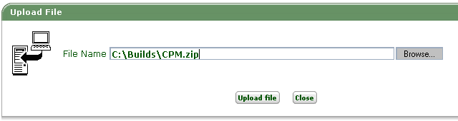

Remember that the source file must be on your system disk and you must be operating this “upload zip file option” from your machine as client and Target machine as PRPC server

  - Download Extracted rules to PC Option : This option is used to download the zip file that contains extracted rules to your workstation. The typical screen that comes upon selecting this option is

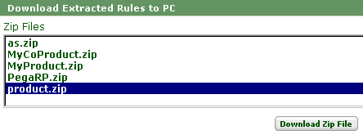
For example you are connecting to a PRPC server as a client and you want to down load the zip file from PRPC server’s “Service export“ directory to your workstation’s hard disk you should use the above option

  - Skim to a new Version Option: Skimming creates rules for a major RuleSet version by copying selected rules of lower numbered versions of the same RuleSet on the same system. Skimming collects the highest version of every rule in the RuleSet and copies them to a new major version of that RuleSet on the same system. The typical screen you will see up on this option is
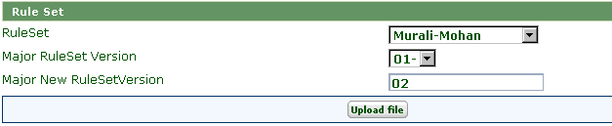

- Remember that during skimming, we altogether get a new major version. It is not possible to skim just to a higher minor version or patch version. For example if we are skimming SatyamLoanAppl : 05-06-07, the only options we have is 06-01-01, 07-01-01….. and so on, but you can not skim to 05-06-08 05-07-07 or 06-02-01

- Availability of the rules: Availability is an important aspect of any rule for it to be considered by Rule resolution algorithm. pyRuleAvailable property represents whether a given rule is available or not ? At any point of time, this property can be set with either of the following four values

    - YES : Indicates that this rule is available. Rules with a Yes value are visible to rule resolution processing and executed.

    - NO : Indicates that is rule is not available and become invisible to the rule resolution algorithm for all users (including yourself). The No setting is useful in experimentation and troubleshooting to assess the effect of two rule versions.

Ex : If you are setting “No” status for a rule of version 01-01-03, still 01-01-01, 01-01-02, 01-01-04 of same rule are visible to rule resolution algorithm

    - BLOCKED : This is a stronger form of No because it affects all lower-numbered versions of the rule and it makes all lowered numbered including this version not to be visible to rule resolution algorithm. Note : A blocked rule does not prevent rule resolution from finding (and running) higher-numbered versions

Ex: If you are setting “BLOCKED” status for a rule of version 01-01-03, only upper versions like 01-01-04….. of same rule are available to rule resolution algorithm. Lower version like 01-01-01 and 01-01-02 are not available for rule resolution algorithm

    - FINAL : We need to set availability to Final if we want this rule to be available (equivalent to Yes), but want to prevent others from overriding this rule in any other RuleSet. A final rule can be superceded by a higher-numbered version (in the same RuleSet), but not by any version in any different RuleSet.

- A rule is said to be available only when it’s availability is either “Yes” or “Final”

- Circumstance: A circumstance is an optional qualification and refinement of the rule resolution algorithm. Different variants of a rule within same version can be created with different flavors to suit for different situations. A rule that references a property in the Circumstance Property field is known as a "circumstance-qualified" rule instance. The one which does not have any circumstances specified is called as “Unqualified rule”

- How does circumstance works during rule resolution: At run time, the system first finds rules based on the class hierarchy and then searches for the rules that a requestor session needs, it compares the values of the RuleSet, Version, and Availability fields with a requestor's own RuleSet list to determine which rule to execute. This part of the rule resolution search may result in multiple candidate rules to execute (there could be one non-circumstance qualified and more than one circumstance qualified rules of same version). The rule resolution algorithm then tests the property values defined in the circumstances fields against the property values on the clipboard. If a match is found, it selects the circumstance-Qualified rule and if no match is found, then unqualified rule is selected

- You can't use circumstances with declarative rules.

- You can't use circumstances with a final rule.

- All rule classes will not have the “circumstance” feature on. Only those rule classes which were created with the option “Allow Selection based on property rules” is checked in

- The circumstance qualified rule looks as below

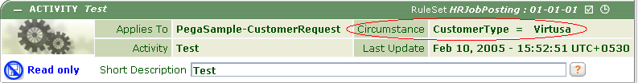

- Time qualified rules: A time-qualified rule is the one which is qualified with a start date and an end date. Regardless of other rule resolution logic, time-qualified rule instances are found and used only between the start date and time and the end date and time. Before or after these moments in time, they are invisible to rule resolution.

- After you've saved a time-qualified rule, a clock appears on the rule form near the Availability check box. To view the start and end times in a ToolTip, hold the pointer over the clock icon. Here is the feel.
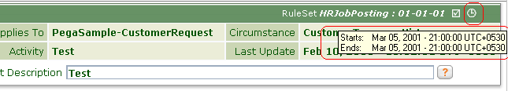

- All rule classes will not have the “Time qualification” feature on. Only those rule classes which were created with the option “Allow rules that are valid only for a certain period of time” is checked in.

- Note on circumstance and time qualified rules: We know that the rules which are qualified either through the Circumstance or through the Time ranges are called “Qualified rules”. We should realize that qualified rules can be created only after a base unqualified rule is created. You can't delete the base-unqualified rule when a qualified rule of the same rule exists.

- Special note on time qualified rules : At any given time, if there are two or more time-based rules, all valid at the current time and date, the system selects the ones with the soonest end date. If there is more than one candidate with the same end date, it picks the one with the most recent start date

- Steps of Rule Resolution algorithm look up:

  - Match Class Hierarchy : Algorithm first looks for appropriate class up the hierarchy

  - Filter by RuleSet List and availability: Algorithm then matches RuleSet and Version associated with the rule instance against the RuleSet list of the user. Also the availability of the rule is taken into consideration at this point. If the rule is not available, rule resolution algorithm can not consider that rule

  - Filter based on time : Algorithm then filters the rules, if they are time qualified versions of the rule

  - Qualify on circumstance : Algorithm then qualifies and selects the appropriate circumstance qualified rule

  - Enforces access roles and Privileges : Algorithm then excludes rules that the user (or requestor process) cannot execute for security or access control reasons

  - Execute the Survivor Rule : If no rule instances survive the above five phases, the user process is notified of the "not found" condition

- Work List : A work list is an outstanding( not complete ) assignments ( work objects ) waiting for a user to perform them.

The worklist appears in the My Work In Progress area of this workspace for every operator.
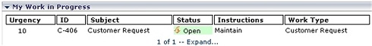

- Work Group : A work group is an instance of Data-Admin-WorkGroup. Workgroup is logical collection of operators and usually workgroup will have a manager. Operator ID data instance (Data-Admin-Operator-ID class) usually identifies a work group to which the user belongs. Also workgroup facilitates for better monitoring and reporting of tasks

- While we define an operator, if the work group is left empty, that operator can enter work objects but not access a worklist or workbaskets.

- Work Basket: A workbasket is an instance of the Data-Admin-WorkBasket class. As work objects progress through a flow execution, the system creates assignments. Assignments may be associated either with individual users (and appear on their worklists) or with a workbasket. All users who are qualified to remove work objects from that work basket may remove an assignment from the workbasket to process the assignment.

- Work pool: Different work types (classes derived from the Work- base class) are grouped in to one class group and when this class group is added to a user in his access group, user can work on through each work type of each class groups. Class groups so added are called as Work pools.

- Instances of Data-Admin-DB-Table are used for mapping the classes and class groups with DB tables. At any point of time, if a class is not mapped to any DB table, it’s instances are stored in it’s super class’s mapped table. The principle is recursive.

- How are the calendars defined in PRPC ? : Calendars can be defined as instances of Data-Admin-Calendar and then these instances can be added at Organization or at Operator level. For example we can define a calendar called “Satyam-2005” ( where we define what are working hours on each day, and what are the holidays and all ), then we can add this calendar ( Satyam-2005) when we define the Organization called “Satyam”

- Work Parties are interested in the progress and resolution of a particular work object, but they need not necessarily perform work on the application. Typical types of work parties are customers (typically the primary party), staff members that are interested in the progress of the work object, but don’t directly act upon the work object and external organizations etc.
13. Process commander comes with various standard work party classes. Eligible standard classes include:
- Data-Party-Gov
- Data-Party-Operator
- Data-Party-Com
- Data-Party-Org
- Data-Party-Person

You can use these classes as it is, or you can create a new class that inherits from Data-Party
- The standard HTML rule “partyDisplay” in work party classes determines which fields appear for each party role

- The Portal always contains two main sections one on left side and another on right side. Left side section is called “navigation panel” which contains expandable navigation bars. Right side section is called “Work Space” and is context sensitive in the sense the contents change based on the selected section on left hand side navigation panel

- The show-java feature on each rule form displays the underlying Java code for the rule

- “Where Am I” feature shows you, at which assignment you are in the flow currently.

- The Initial Setup wizard is usually run by your system administrator to prepare the environment for the application development. He creates the skeleton organization hierarchy, core set of operators and access groups, base ruleset and the top-level class by running the initial setup wizard.

- The application accelerator automates the process commander design methodology. The application accelerator creates the basic components required for any Process Commander application tailored for the business processes. The whole idea is – First use the application accelerator to create the foundation for your application, then use the process commander portal to add further components as the design progresses

- Work- . CorrUpdate activity updates the correspondence

- The application accelerator’s capability includes the creation of

  - initial ruleset,
  - simple class structure including covers and work-related classes,
  - class group( work pool ),
  - prefixes for work objects and cover classes,
  - properties, models
  - work parties,
  - user interfaces,
  - basic flows,
  - workbaskets, worklists and workgroups

- Application accelerator includes following wizard steps

  - Step 1 : define Application name and ruleset name
  - Step 2 : Define Various types of works possible and respective prefixes for work IDs
  - Step 3 : Define the work parties
  - Step 4 : Define properties, default values for properties, display mode for properties
  - Step 5 : Design the UI by choosing the display properties and the section
  - Step 6 : Select the standard flow, create workbaskets, worklists and workgroups

- Application accelerator automatically adds the newly created ruleset and the work pool to your access group. Only thing you need to do is re login to the application so as to see the new work pool in the list

- pyRuleSet property in Rule- class represents, to what ruleset a given rule belongs

- pyRuleSetVersion property in Rule- class represents, to what ruleset version a given rule belongs

- An instance of Rule-RuleSet-Name is created when the first version of ruleset is created

- Work- . AddCovered ( Activity ) creates a new covered work object

- Work-. AddToFolder adds the work item to the folder

- Flow actions specify the choices that user have when performing an assigned work object. Flow actions are mainly of two types i.e., connector actions and local actions.

- Connector actions advance the flow. They are associated with the connector that exists at the assignment, so selecting them causes the flow to advance along with the path

- Local actions allow the user to update the work item, but don’t advance the flow. After the assignment was committed, the flow remains at the same assignment from which the local action was performed

- A when condition is a Boolean expression based on the values in the clipboard.

- The utility activity can return a status value through the TaskStatus-Set method, which can be used for talking paths in the flow

- Work-.ActionNotifyQuick activity creates simple correspondence

- Work-. Add activity creates a new work object ( without a cover object)

- Various standard ( ready to use ) flow actions are defined at work- Class

- Most of the standard flow actions can be used either as a local action or as a connector action. However some flow actions are valid to be used as only one type. Unless otherwise specified, you can use in either way.

- Some of important standard flow actions that come with PRPC are

  - AddToCover( Local only ) – Includes the work object as sub task of cover
  - AddToFloder( Local only ) – Adds the work object to the folder
  - Assign ( Local/ Connector ) – Assigns the work object to the cover
  - AttachAFile ( Local only) - Attaches a file to the work object
  - AttachANote ( Local Only ) – Attaches a note to the work object
  - AttachAURL ( Local Only) – Attaches the URL to the work object
  - CancelAssignment ( Connector only ) – Cancel the current assignment
  - ChangeAssignmentSLA ( Local only ) – Update SLA and related( goal, deadline and urgency) fields for current assignment
  - ChangeWorkSLA ( Local only ) – Update SLA and related( goal, deadline and urgency) fields for current assignment and also for work object
  - Finish ( Local / Connector ) – Update the status with notes and then save and close the work object
  - Notify ( Local / Connector ) – Generate correspondence (notifications ) from the list of templates
  - NotifyExternal ( Connector only) – Generate correspondence ( Notifications ) to a party external to process commander
  - NotifyQuick ( Connector only ) – Initiate correspondence ( Notifications) using quick template for rapid text entry
  - Reject (Connector only) – Reject work object from further consideration, resolving it with Rejection status.
  - RemoveFromCover ( Local Only ) – Remove work object from cover
  - RemoveFromFolder ( Local Only ) – Removes work object from folder
  - Resolve ( Connector only ) – Complete current assignment, resolving work object accordingly
  - Save ( Local Only ) – Update the work object without resolving it , saving the changes to the field values

- Assignment is a pause in the flow and it signifies that a person or external system must act on a work object before the flow can progress. In certain situations assignments can be processed completely or in part by a Process Commander agent rather than by a person

- Assignments are created by a flow operating on a work object, but they are not themselves part of the work object. The system saves data relating to an assignment in instances of the Assign-Workbasket class, Assign-Worklist class, or other subclasses of the Assign- base class. Means whenever a workobject reaches an assignment, it creates an instance of respective Assign-* class. This instance stores all the assignment pertaining information rather than work object itself

- Some of the important properties in the Assign- class, which are used for each assignment.

  - PyAssignmentStatus : A user defined status, initially blank or new

  - PXUrgencyAssign : Urgency value for the assignment. This is not same as the pyUrgency property which is urgency of work object as a whole

- pxUrgencyWork is for whole work object

- 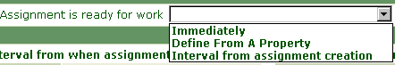

- Important shape properties in the assignment are

  - Assignment rule to use: Name of the assignment activity. Currently 4 types available. You can create your own by making an activity as type of assign
    - WorkList : Causes the assignment to be placed on the worklist of current operator
    - Workbasket : Causes the assignment to be placed in a work basket, determined by an associated router shape

    - External : Starts the direct web access feature
    - Agent : Sends the assignment to the background process rather than to a person

  - Instructions : The text entered may later appear on the worklist or the Review form for the work object

  - StatusWork: We may enter a work object status value that is to appear when the assignment first appears on the worklist or in the workbasket. If you leave this blank, the status value is unchanged as this assignment is created.

  - StatusAssign: Status at this assignment. This is not work object status

  - Confirmation Note: Optionally we can enter the confirmation note. This note appears on the confirmation form presented to the user when the flow action is completed

  - HarnessPurpose : We can enter the Purpose key part of a harness rule (Rule-HTML-Harness rule type) the system is to use to present this assignment

  - Local actions : you can add one or more local flow actions

  - Service Level: You can assign a service level (Rule-Obj-ServiceLevel) rule to this assignment.

- You can assign activities at goal and deadlines of each service level, and these activities will be fired when goal and deadline times are passed on

- Likelihood field appears for connector only when connector type is selected as “Action” or “Status”

- When an assignment is given a service level, it takes precedence than the flow’ s service rule only for that assignment

- The symbol for comments shape is. You can add this at any stage of the flow. It does not have any impact on processing of the flow.

- Connector arrows show as either red or blue. A red arrow indicates that the "from" (tail) or "to" (head) end of the connector is not yet connected to a task shape. A blue color indicates a properly connected connector (Not sure on this .. Need to test )

- PRPC comes with certain standard built in flows which u can use as it is or customize. Some of such flows are
  - Work-Cover-.NewWork
  - Work-. FlowProblems
  - Work-Folder-. NewWork
  - Work-. NewWork
  - Work-.VerifySendCorr

- By default the assignment normally appears on the worklist of the user running the flow. We can add a router task later if you want the assignment to be sent (at least under some circumstances) to any user other than the current user, or sent to a workbasket.

- Important shape properties for connector are

  - Connector: There are five options available here. “Always”, “Action”, “Status” , “Else” and “When”

    - All of the choices may not be available always. It all depends on the shape from which the connector emanates. For example
      - When the connector is from assignment, you will have only “Action”.
      - When the connector is from utility, you will have four options i.e., all except “Action”
      - When the connector is from the decision you will have only Status and Else.
      - When the connector is from fork, you will have four options i.e. all except “Action”

    - Always: When there is to be only one possible path from the connector.

    - Status: If the connector is from a Utility task shape, a Fork task shape or a Decision task shape and you want to perform a comparison. The flow proceeds on this connector only if the value returned at run time matches the value in the text box

    - Action: For a connector that is to be associated with a flow action. In the third box, enter the name of a (non-local) flow action

    - When: The work object is permitted to flow along this connector when only when a certain when condition rule evaluates to true. In the third box, enter the name of a when condition rule.

    - Else : To define a none-of-the above connector that the flow is to use when no other connectors are valid

  - Flow action / When / Status : Whether it is “flow action” or “when” or “Status” depends on the choice in the previous field

    - Flow Action : If you choose “Action” in the connector option, you need to enter the flow action name here

    - Status: If you choose “Status” in the connector option, you need to enter a text value to match the text value returned at run time by the decision task (a map value, decision table or decision tree) or the utility activity.

    - When : If you chose “When”, we need to enter the “When” Condition rule name or you can do a property comparison

  - Set Properties ( Optional ) : You can choose to update some properties whenever the work object follows this connector in the flow rule

  - Add to Audit trail (Optional): Click the plus sign to access a text box. Text entered here appears as a history instance for the work object, recording that this connector was followed

- The summary of actions for connectors when they are coming out of different shapes is

Connector action | Assign  ment | Decision | Utility | Fork | Spin-Off/ Called flow  /Spilt-join  /Split for each | Integrator
Always | No | No | Yes | Yes | Yes | Yes
Action | Yes | No | No | No | No | No
Status | No | Yes | Yes | Yes | No | No
When | No | No | Yes | Yes | Yes | Yes
Else | No | Yes | Yes | Yes | Yes | Yes

- An integrator task in flow is an activity that connects your Process Commander system to an external system to send or receive data

- Integrators on flows use activities (with Connect as the activity type) that call connector rules (Rule-Connect- rule types).

- In decision shape on flows we can refer any of the flowing

  - Map Value
  - Map value pair
  - Decision tree
  - Decision table
At run time, the system evaluates the decision rule based on inputs from the flow and the work object, and chooses one of the outgoing connectors based on the result. No user interaction or input is required.

- If a map is selected on the decision of flow, we need to enter only the row input where as if map value pair is selected, we need to supply both row input as well as column input

You can perhaps use the map value as in the following example in the decision of a flow

Assume you need to move in different directions basing on a grade of a student. You can supply the marks and then get the Grade equivalent from the map. If the map value returns values "A", "B", and "C", the flow could include four connectors flowing from the Decision task shape, all corresponding to Status comparisons. One connector compares the returned value to “A”, one to "B", one to "C", and a fourth could become the default (Else) connector

You can optionally store the value of output of map in a property by using “Store Result Field“

- Fork shape in the flow: We need to use the fork shape in the flow when we want to represent a point where the flow execution chooses one of the few different paths (Connectors) based on the tests on the work object. At run time the system evaluates the conditions on each connector, starting with the connector assigned the highest likelihood.

- Notify shape to an assignment will cause our application to send correspondence to a work party in the work object reflecting the assignment. (The system creates this correspondence as the assignment is created, not when it is performed.). You need to supply one of the notify ( activity of type notify) to the notify shape.

- The difference between the notify, router and comments symbols in flow is very narrow. Be careful ( they look same to some extent)

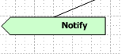

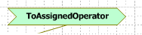

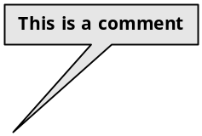

- The various standard activities that can be used in the flows are

  - Assignment Task activities

    - External : Creates an external assignment, an instance of the Assign-External class (or a subclass of this class), part of the Directed Web Access facility
    - Worklist : Creates a normal assignment (Assign-Worklist class) added to a user's worklist.

    - Workbasket : Creates a normal assignment (Assign-Workbasket class) added to a workbasket. If the workbasket doesn't exist, the assignment can be routed to the current user

  - Integrator Task activities : Because these tasks involve external systems, there are no standard rules with this type

  - Notify Task Activities : ( Referred from notify shape )

    - NotifyAll : Send correspondence to each workparty identified in the work object

    - NotifyAssignee : Send correspondence to the user who received the assignment

    - NotifyParty : Notifies specified party

  - Routing activities : ( Referred from Routers )

    - ToAgentWorkBasket : Routes the assignment to the workbasket belonging to an agent
    - ToCorrPartyRole : Route the assignment to the party referenced by the correspondence
    - ToCreateOperator : Route the assignment to the user who entered the work object

    - ToConstCenterManager : Routes the assignment to the worklist of the Cost Center manager (not the manager) of a user's organization unit.
    - ToCurrentOperator : Routes the assignment to the worklist of the user who owns the work object.
    - ToCustomer : Routes to a work party who is identified as a customer
    - ToDecisionMap : Route to the result of decision map
    - ToDecisionTree : Route to the result of the decision tree
    - ToDefaultWorkBasket : Routes the assignment to the workbasket of the work group that this user belongs to.
    - ToOrgUnitManager : Routes the assignment to the worklist of the manager of a user's organization unit.
    - ToOverAllSLA : Routes the assignment to the workbasket named default@xxxx.yyy, where xxxx.yyy identifies the name of the organization that this user belongs to
    - ToWorkbasket : Routes the assignment to a workbasket identified in a parameter.
    - ToWorkGroupManager : Routes the assignment to the worklist of the manager of the work group that this user belongs to.
    - ToWorkList : Routes the assignment to the worklist of a specific user, identified in a parameter
    - ToWorkParty : the assignment to the worklist of a work party in the work object, identified through a parameter

  - Utility Task activities : ( Referred from Utilities )

    - AddHistory : Add a history instance to the history of a work object
    - CheckIfNew : Check whether a work object has an ID assigned
    - CorrNew : Send correspondence (that requires no user interaction), and save it as an attachment to the work object
    - DuplicateSearch : Search for other work objects that might be duplicates of this work object
    - GenerateID : Computes a new work object ID for a new work object
    - RaiseTicket : Sets (turns on) a ticket rule. Identify the ticket name as a parameter
    - Resolved : Updates various properties needed for reporting, when a work object becomes resolved

    - UpdateStatus : Changes the status of a work object (not the status of an assignment), and adds a record of this change to the history of the work object

- The main difference between fork and decision in the flow – Decision executes a decision rule ( like map, map value pair, decision tree and decision map ) and then basing on the output it takes appropriate branch ( basing on the status ). Where as fork does not execute any decision rule, it branches the flow basing on the when condition embedded in the connectors emanating from the fork

- Various portal layouts and the available navigation bars are

 | Administer | Dashboard | Monitor activity | Manage rules | Process work | Tools
Work Manager Layout | No | No | Yes | No | No | No
Process Architect | No | Yes | Yes | Yes | Yes | Yes
System architect | No | Yes | Yes | Yes | Yes | Yes
Administrator Layout | Yes | Yes | Yes | Yes | Yes | Yes

- Process Architect typically creates and maintains the flows

- Spin off Task : When a work object advancing through a flow reaches the Spin-off shape, Process Commander starts execution of a different flow, using the current or a different work object. Processing in the current flow rule continues in parallel, without waiting for the other flow to complete
- There are 11 modes of properties. These 11 modes are broadly categorized to 3 broad categories viz, Values, Pages and Java Objects

- Property Matrix

Type | Single | Array | Group
Value Mode | Single Value | Value List | Value Group
Page Modes | Page | Page List | Page group
Java Object | Java Object & Java Property | Java Object List & Java property List | Java Object Group

- All of the except one ( Single value ) is considered to be aggregate properties

- Difference between Value list and value Group - In Value List value is an ordered, indexed list of strings, sometimes called an array. In Value Group value contains one or multiple strings, unordered, each identified by a unique text index.

- Value modes can take any of the flowing types

      - Text
      - Integer
      - Identifier
      - Password
      - Double
      - Decimal
      - DateTime
      - Date
      - TimeOFDay
      - TruleORFalse

- A Class group is an instance of the Data-Admin-DB-ClassGroup A class group instance causes the system to store the instances corresponding to two or more concrete classes that have a common key format in a single database table. Class groups are commonly used to cause the system to store instances of similar or related Work- concrete classes together in one relational database table

- Every work object has a unique ID (property pyID), an urgency value, and a status (property pyStatusWork)

- Operator ID data instance (Data-Admin-Operator-ID class) usually identifies a work group to which the user belongs

- A property of mode Java Object can contain any Java object while on the clipboard. If the Java class supports the Serializable interface, a page containing this property can be saved into the Process Commander database

- For value list , page list modes the index is integer and starts from 1 , not from 0 like in java

For example you can refer in the following way
1. Budget( 7)
2. Budget( "4")
3. Budget ( .RowNumber)

Note that a String that fits to integer can also be used as example 2 above

- For Value group, page group modes, the index is string.

For example, you can refer in the following way

1. Student( “James”)
2. Population ( "USA")
3. Population (.StateCode)

- <APPEND> index can be used to add the element at the end of the Value list or Page list properties

For example in property set u can add a value to page list as below

- <LAST> index can be used to set or retrieve the last element( Highest indexed number element) for Value list or Page list properties

For example you can set last element value of a page list as below

- <INSERT> index followed by an integer can be used to insert a new element and it’s value into a Value list or Page list properties. Any elements with the same or higher index value are "pushed down" by one.

For example you add an element in the page list at index 2 as below

If the integer is larger than the size of the list by 2 or more, Process Commander creates an exception.

- Html Property rules (Rule-HTML-Property ) control how properties appear on work object forms, correspondence, and other HTML forms, for both display and for input.

- If you leave the Property Stream field on the Property form blank, the system uses HTML Property rule called “Default”.

- A service level rule is an instance of the Rule-Obj-ServiceLevel rule type. Each service level rule defines one or two time intervals, known as goals and deadlines, that indicate the expected or targeted turnaround time for the assignment, or time-to-resolve for the work object. Process Commander detects service levels not achieved — unmet goals or deadlines — promptly. If an assignment isn't completed before the time limit, the system can automatically notify various parties, escalate the assignment, cancel the entire flow, and so on

- A developer can assign the SLA to either the assignment or for entire flow.
- The assignment icon changes to include a clock icon, when you add a SLA at the assignment

- What happens on SLA escalation (When goal or deadline time is reached)?
  - Adds corresponding goal or deadline urgency to original initial urgency
  - Executes the activity in the Activity If Locked field if the work object is locked, or the Activity Name field if the work object is not locked

- If we want to associate the whole SLA for entire work object we need to add the SLA at Model level

- How can we debug / test whether the SLAs are working fine or not?

- Important fields in service level from are

  - Initial urgency ( Optional ) : To set the initial urgency for a work object
  - Assignment is ready for work : Represents when from the time count
to consider SLA, most of the cases it would be immediately. At times, it is beneficial to create an assignment but not expect a user to start work on the assignment for a while. In these cases this field is useful There are 3 options available

    - Immediately : Immediately
    - Define from Property : You can take from property
    - Interval from assignment creation : You can directly set the timing
  - Escalation Event timing :
    - Goal : Goal time details ( Not sequential)
    - Deadline times : Deadline time details( Not Sequential )
    - Repeating interval from deadline : Repeats several times after
Deadline (Sequential)
  - Activities( When work object not locked )
    - Activities to get triggered on goal, deadline and repeat
  - Activities ( When work object locked )
    - Activities to get triggered on goal, deadline and repeat, when work object is locked

- For every class that is created as a class group is also created as instance of Data-Admin-DB-ClassGroup.

- Every work object has a unique ID ( property pyID), an urgency value, and a status ( property pyStatusWork)
- By Default PRPC is shipped with one work basket called default@pega.com

- A work basket is an instance of Data-Admin-Workbasket.
- A work group is an instance of the Data-Admin-WorkGroup class. A work group can identify a user who is, for purposes of your application, a supervisor. Work groups are a primary unit of summarization in standard management reports on the Monitor Activity workspace.
- newDefaults activity get’s automatically called ( if exists in a class ), when its instance is created.
- Procedure to create a cover
  - Initialize AddCover activity
  - Create cover ID – by calling Work-Cover.Add activity
- Each connected Process Commander requestor (including all browser-based users, even if guests) has an associated temporary memory area on the server known as the clipboard
- One individual page can govern an activity and is known as the primary page. If for one step in an activity, a different page is identified, it is known as the step page
- Top level classes are always abstract and inherit from the @baseclass
- An embedded page is a clipboard page that is not a top-level page, but rather is the value of a property of mode Page.
- @baseclass is called as the ultimate base class. And its immediate child classes like Data-, Work-, Assign- etc are called as base classes
- Concrete classes under Rule- and Data- hold the instances of rules and data that the application developers create as a building blocks of the application
- Concrete classes under Assign- and Work- hold dynamic transaction instances that are created during the actual operation of built application
- History- classes are created automatically
- Embed- Classes define the structure of pages embedded within other pages. Pages belonging to classes derived from the Embed- base class cannot be renamed or saved. Often it is a design level decision to choose between the Data- classes and the Assign- classes when want to use the pagelists. If we choose the Data- class, it stores the instances and if we choose Embed- class, it prevents in stances being stored in the process commander
- Index- Classes provide the Secondary access keys defined to provide fast retrieval of other instances
- Top level class is an abstract class that has the ultimate base class @baseclass as parent but is not one of the standard base classes.

- Use following kind of access control by adding the Ruleset as below
  - General use – add at Organization
  - Business Group wise – add at Division
  - Job Function wise – Access Group

- By Convention, abstract classes end with a dash ( - ). Concrete classes must not end with dash. Ex YourCo- , MyCo-
- Normally it is a practice to have a unique top level class for each company/ product that serves as a starting place for the class structure
- While Creating the class, mentioning the direct inheritance is inevitable. Pattern inheritance is optional. If pattern inheritance is mentioned by checking in the check box, Pattern inheritance takes the precedence.
- The server can run two or more process commander systems at a time. The “System Name” uniquely identifies the each process commander system. It’s default value is “wfe”. This is an instance of Data-Admin-System
- While Work- instances are stored in the PegaRules Database, Data- instances can be stored either in PegaRules database or in External database
- Work Objects are the basic units of work. Covers tightly coordinate processing on several distinct ( but closely related ) work objects. Folders loosely package many related work objects, covers, and other folders.
- The PRPC standard activity “GenerateID” is responsible for creating the work object ID. We can override this activity, if we want to have different kind of sequencing for work object Ids
- Typically you should use different Work object prefixes for each workpool
- PRPC uses the W- prefix by default. You change this even. Use the meaningful prefixes such as LW-, LC-, LF-, for work object, cover and folders of a leave application
- Don’t confuse work parties with the actors of the system. Work parties are those who are interested of knowing the execution / progress of the work object, or who should be notified when something happens to the work object.
- Three important aspects that we must specify while we define the work parties are
    - Name of the party role ( Such as originator, contact )
    - Party Type ( Such as person or commercial entity)
    - And data source ( the party class that describes the party)
- PRPC allows to have one work party in repeating mode in a work object
- There are two important parameters in the restrictions tab of the class definition, worth noting
    - Prevent subclassing in other rulesets : Prevents classes in other rulesets from inheriting from this classes.
    - Limit Rules applied to this class to these rulesets : Restrict the rules creation for this class to one or more rulesets
- Always use the pyID as the key for the class definitions that belong to work-.
- All the classes belonging to the class group will have the same keys of the class group and hence there will be no provision of specifieng these sub classes.
- Process Commander comes with a standard flow called “newWork” ( defined in Work- class ) to use as a starting point
- PRPC standard properties are prefixed either with px or py or pz

    - Px – Computed properties that users can see on a form, but can’t directly enter or change ( Such as pxCreateDateTime). To alter this values activities can use a step method called Property-Set-Special metod
    - Py – Properties that users can enter or change via direct input ( such as pyDescription ) . To assign these values programmatically, activities can use step method called Property-Set method
    - Pz – Properties that are reserved for internal use ( such as pzInsKey). User can’t see, enter or change these properties
- Some specific entries while defining the properties are

    - Override Sort Function – Specifies a sort function ( a rule type of Rule –Obj-Function ) to use instead of the natural sort sequence for the string type ( Optional )
    - Special – If checked, property ids for display only and it requires activities for changes. It prevents sensitive e and calculated properties from being changed by UI
    - Edit Input Value: You can specify the Rule-Edit-Input instance here. Rule Edit inputs are basically custom Java routines for converting user input to an internal system format. For example Rule-Edit-Inputs can contain code segments like as below
if (theValue.length() > 0)
{
theValue = theProperty.getStandardText(theValue);
}

theValue is the key in point at Rule-Edit-Inputs
    - Edit Validate: Specifies an Edit validate rule (of type Rule-Edit-Validate) to use in addition to the basic data format check. It validates the format of the use input and works on the value after Rule-Edit-Input has already worked
    - Property Stream: Specifies the HTML formatting ( a rule type of Rule-HTML-Property) to use when we are displaying the property in forms. If left blank, PRPC uses the default stream called “Default” property Stream.
    - Type of table : Defines the list of valid values for user input
      - Local List : Store the text values on the property form itself
      - Field Value : key to the Rule-Obj-Field rules that store the values
      - Remote List : Class with instances that contain the values for the properties, typically a class that inherits from Data-
      - Prompt List: Store the list values on the property form, Specified as a pair of values. One to display as selection and another to store as value
- For Short to medium sized lists that don’t change frequently, choose local list option in the property table edit for defining possible values
- For Short to medium sized lists that change frequently, choose “Field Value” option in the property table edit for defining possible values
- For Long sized lists (such as product catalogues), choose “remote list” or “Class Key Values” option in the property table edit for defining possible values.
- Property qualifiers ( Rule-Obj-Property-Qualifier ) are used for applying additional facts to the value of the property apart from Rule-Edit-Input and Rule-HTML-Property
- Property Aliases can be used to give more meaningful names to the properties. You can create an alias for a property to establish an alternate name more recognizable to the user community for your application.
- Every node has a page called “pxProcess”, which contains the properties that describe the system on which the user is operating. The class for this page is Code-Pega-Process
- Every user that is currently logged in to the process Commander has several user pages to identify the person and organizational affiliation
    - PyPotal
      - PyCommonParams ( All org details)
      - PyGadget ( All gadget details)
      - PyPortalPages ( All portal Pages )
- Every user or an external process that is in the process of making a request to process commander has a page called “pxRequestor”. Class is Code-Pega-Requestor. This page basically identifies the requestor and what it is allowed to do
- For every user, Process Commander Captures the details about the current operations being performed on the “pxThread” page, and the respective class is Code-Pega-Thread
- Activities may use the logical page names, which may not actually exist as they are called in the clipboard. For example Activities may use a working page called “Primary”, a parameter page called “Parameter” and a local parameter page called “Local”
- The current page on which you are operating is called “primary page”. Think of primary page as this page
- In many situations we may be interested to operate on another page in parallel to the primary page. This page is called secondary page or interest page. By using interest page, activates can have different primary page other than the work object page. Interest pages are useful for operating on the objects that are part of repeating group embedded in the work object. When coming to flows, flows use interest pages for supporting branching. Flow processing normally operates on the properties on the primary page, but you can specify a separate interest page to operate on when splitting off to another flow
- When we refer the properties in HTML, activities or declarative rules we need to include the page name before the property name except for primary pages. When you refer the properties for primary pages, Primary.xxx and the .xxx are same
- It is good practice to omit the page name, if we are operating in the context of primary page
- A class can have many models. But we can designate only one model while creating the object. But you can chain together models of the same name in the direct inheritance hierarchy for your class to achieve the cumulative model for the class.
- PRPC comes with a standard model called pyDefault
- Harness ( Rule-HTML-Harness) rules define the form structure and the layout , specifying the sections that include in the harnesses and other elements to be added
- Section ( Rule-HTML-Section) rules define the form content, consisting the discrete section that you include in the harness
- Streams define the class specific content to be included in a section ( Such as dynamic HTML and repeating group ), as well as supporting forms for filed specific user input
- Fragments (Rule-HTML-Fragment) are supporting pieces of HTML that you include in the sections, streams, or other fragments. We need to use fragments if we want to share the html across classes, such as buttons for performing the actions.
- Text files (Rule-File-Text) contain static text that we will include in the streams of fragments such as style sheets and Java script files. They are conceptually same as that of fragments, but rule resolution does not apply for text files.
- Model chaining works only with direct inheritance
- Text files ( CSS and JS etc ) are not subjected to rule resolution where as the binary files ( JPG, JPEG, images etc ) are subjected to rule resolution
- For harness and section rules, process commander automatically generates the HTML source( Which we can tailor as we need ). But we write the HTML for other html rules
- Any class that inherits from Work-Object-, Work-Cover- or Work-Folder- also inherits all the harnesses. When we enter a new work object or review, the harness automatically presents the appropriate form for the object type
- Standard harnesses are,
    - New - For creating new work objects
    - Perform – Performing assignments on existing objects
    - Confirm – Confirming object resolution
    - Review – Reviewing the closed objects
    - Reopen - Reopening the closed objects
    - NewCovered – To open a cover object
- Harness rule basically assembles all required sections, streams and fragments
- Sections typically include other sections, for
- Page-new is used to create a new page in the clipboard. The page-new may be a top-level or embedded page.
- Page-new takes the following parameters
    - Model ( Optional )
    - PageList ( Optional)
    - New Class (Optional): you can specify the class of for which new page is to b e created. If left blank, it creates for class of the step page that is mentioned in the activity step ( it retrieves the respective class from pages-classes tab). If step page filed is also blank, the system creates the new page of the class that is first key of the current activity, which is nothing but primary page
- When using the page-new, if the system finds the page already in the clipboard, it deletes the old one and creates the new one
- pxMethodStatus is the property that can be used to find out the status of a method step
  - Page-Copy method copies the contents of a source clipboard page to a new or previously created destination clipboard page. The source page is not altered. After this method completes, the destination page may contain properties it contained before, plus properties from a model, plus properties copied from the source page. The various parameters are,
    - CopyFrom( Optional ) : If left blank, system uses step page of the current step
    - CopyInto :
    - Model ( Optional )
    - PageList ( Optional ) :
- Page-Copy method works as below
    - If the source page cannot be found, the method does not fail. It does not alter any pages. The resulting method status value is Good
    - If the destination page (identified in the CopyInto parameter value) does not already exist, the system creates a blank page of the same class as the source page. It may be a top-level page or an embedded page
    - IF the Model parameter is not blank, the system finds the model (using rule resolution) and applies the model to the destination page. Properties already on the destination page are never affected by the application of the model
    - Next, the system copies properties from the source page into the destination page. This copying may create new properties on the destination page or update the value of existing properties — both those originally on the destination page and those created through the model. As the copying occurs, each property is validated against its definition (its Rule-Obi-Property instance). If a property value fails validation, the system adds a message to the destination page
- Page-Rename method can be used to rename the existing page to a new name. The parameters are
    - PageNewName : Enter the new page name
- Page-rename works in the following way
    - The system renames the page identified on the Step Page column of the current step to the new name specified in the parameter
    - Page names are unique within the clipboard. If another page with the new name is already present, the system deletes it and replaces it with the renamed page
- Page-Remove method is used to delete one or more pages from the clipboard. The contents of the database are not affected. The method accepts array of one or more pages. This method works in the following way
    - The system finds the pages (top-level or embedded) on the list and deletes them. This method does not alter the contents of the database
    - If a page you specified is not found on the clipboard, the Page-Remove method reports a warning error but does not fail
- Page-Set-Message is used to add a message to a clipboard page. Like a message associated with a property, a message associated with a page normally prevents the page from being saved into the database.. This method has two parameters
    - Page : ( Optional ) : If you leave this blank, the system uses the step page, or the primary page if the Step Page column is blank
    - Message : Enter literal text within quotes, or the name of a message rule (Rule-Message rule type). Smart Prompt is available
- Checking the step status : Method status is stored after each step. Methods update the .pxMethodStatus property with a status such as Good, Warn, or Fail. Often, additional information is stored in the property named pxMethodStatusInfo. As a sound development practice, test this status value against Good in those activity steps that may fail. In the Transition area, reference a when condition rule, and branch or jump to handle the failure. You can use two standard when conditions named @baseclass.StepStatusGood and @baseclass.StepStatusFail in transitions
    - StepStatusFail condition returns True when the status is Fail
    - StepStatusGood condition returns True when the status is Good
Enter a when condition in the transitions as below for proper error handling of the step.. In the If True field, indicate what the processing is to occur when the condition is true.
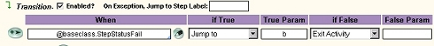
- Page-Validate method forces validation (or revalidation) of the value of all properties on the step page. The system adds a message to each clipboard property that fails validation against the restrictions in its property rule. If the page has hundreds or thousands of properties, this method can be expensive in terms of system resources. Use the Obj-Validate method, not the Page-Validate method, to validate specific properties identified in a Rule-Obj-Validate rule. The Page-validate method works in the following way.

    - system validates each property on the step page against the constraints imposed by that property's definition, such length, type, validate rule, table edit values etc

- Obj-Open method is used to open an instance stored in the rulebase and save it as a clipboard page. If it finds the specified step page, the system clears any data that is on it and re-uses the page. If no existing page has a name matching the specified step page, the system creates a new page as part of the Obj-Open method. When used on a primary page, the Obj-Open method always clears any data on the page and reuses its name. If the key supplied does not match the key of an object in the database, the system creates a page of the indicated class that is empty except for the pxObjClass property, and indicates failure in the pxMethodStatus property. The parameters for this method are
    - Open Class : Identify the class of the instance to be opened
    - Lock : Check this box to acquire a lock. Lock the instance if you plan to change and save the instance or delete it
    - RleaseOnCommit : Check this box if you checked the Lock box and want the system to release the lock whenever the next Commit method occurs for this instance.
    - PropertyName and PropertyValue :Enter in this array the name of each property or properties and the associated values that together make up the key of the instance to be opened. Type a period before the property name
- What is handle? : Handle of an instance is a unique key, in an internal format, assembled by the system that identifies an instance. It differs from the visible key generally used to identify instances. The handle includes system-generated identifying values (including the create date and time) that make it unique. Every instance has a unique handle, but more than one instance may share the same visible key.
- Obj-Open-By-Handle can be used to open the instance , only if you know the unique handle that permanently identifies which instance to open. Otherwise, we need to use the Obj-Open method. Obj-Open-By-Handle method has 3 parameters
    - InstanceHandle :
    - Lock :
    - ReleaseOnCommit :
- Some of the methods, overwrite the existing clipboard pages, if they already exist. If you want the activity to check whether a page with a certain name exists before you open a new page, you can use the following precondition in the step.
    - @PageExists("myPage", tools)
- Obj-Save method requests that the system save a clipboard page to the database. The Obj-Save method uses properties on the page to derive the internal key under which it is to be saved. This method can create a new database instance or overwrite a previous instance with that key. An object that is stored in the database is persistent. method does not always cause the object to be written immediately to the database. Often this method is used to perform a "deferred write" operation. We can use the WriteNow parameter to force this page (and only this page) to be written to the database as part of the Obj-Save method. The whole idea is you can reverse the effect of an Obj-Save method — if it has not yet been committed — with the Obj-Save-Cancel method. The parameters for this method are
    - WriteNow
    - WithErrors : Check this box if the instance is to be saved even when it contains messages, indicating validation errors
- Obj-Save-Cancel method is used to cancel an earlier Obj-Save method or obi-delete method , so that the instance is not written or deleted as part of a subsequent Commit. This method does not take any parameters. This method can be applied only if the previous obj-Save or obj-delete does not use Write-Now option.
- Obj-delete method can be used to delete a database instance corresponding to a clipboard page and optionally to delete the clipboard page too. You can cause the deletion to occur immediately, or defer deletion until a later execution of a Commit method. Unless you check the Immediate check box on the activity form, the database deletion does not occur until the system next processes the Commit method. This method uses the flowing parameters
    - Remove : If checked, it deletes the respective clipboard page also
    - Immediate : If checked the system deleted the DB instance immediately

Word of caution : You can't delete an instance without opening it first (usually with the Obj-Open method). You can't delete an instance while it is locked by another requestor

- Commit method is used to commit all the DB changes. This method writes all the instances specified by one or more earlier Obj-Save methods to the database. The Commit method operates on thread pages that can operate across multiple instances. There are no parameters for this method and all previous pending Obj-Saves and Obj-Deletes will be considered

- Obj-List method is used to retrieve data to the clipboard as an array of embedded pages . You can use this method in two modes.
    - Complete instances as embedded pages
    - Selected properties from the instances placed in embedded pages with shortcut characteristics. Shortcut pages contain only partial instance data and so cannot be re-saved to the database. A rule-Obj-List is used for this purpose of obtaining the partial list of properties

- Various parameters for obj-List are
      - PageName : destination page to contain search results( usually of type Code-Pega-List)
      - ObjClass : Class name that it should search . When this method references a list rule, it uses this value as the Applies To field (first key part) with rule resolution to find the list rule
      - RuleObjList : ( Optional ) : name of a list rule that specifies which properties are to be retrieved.
      - Max Records : Optional : maximum number of instances in the list at run time. The default is 50 instances, if not specified
      - SelectionProperty, SelectFrom, SelectTo, Like are used as search criteria : Like can be used only if the columns is exposed in the DB, But SelectFrom, SelectTo can be used even if we have not exposed the columns in the DB
- Obj-List method also assign the following important properties to the result page
      - pxResultCount — A count of the instances retrieved by this search
      - pyMore — Indicates whether there are more instances not returned. Values are Y or N
      - pxNextKey — indicates the key of the first row (instance) not returned, if pyMore is Y.
      - PyTimeElapsed : Milliseconds of elapsed time spent executing the request
- Obj-Validate method can be used to apply a Validation rule (an instance of the Rule-Obj-Validate rule type) for the object identified on the primary page or step page.
- Page-Validate, validates all the page where as the obj-validate validates as per the validate rule( Rule-Obj-Validate)
- How does the user validation works for properties in PRPC :
A property value that is supplied by user may be valid or invalid. Pages containing one or more invalid values can not be saved to the database. When process commander detects an invalid value, it adds a message to the page to mark this discovery. Two important points here are,
1. The invalid values remain on the clipboard
2. The user is not automatically notified of the invalid value

Five kinds of rules basically support the user validation

- Property Rules ( Rule-Obj-Property ) : It can serve the purpose of validation in 3 ways
  - Table edits constrain the allowable values.
  - Type of property will restrict the format
  - Max allowable length
- Edit Input values ( Rule-Edit-Input ) : These can convert the user entered input values into an internal format
- Edit Validate Rules ( Rule-Edit-Validate ) : these are custom java routine functions which can further test the format of the input
- Field Values ( Rule-Obj-FiledValue ) : These provide configurable list of acceptable values
- Multii property Validation rules (Rule-Obj-Validate): These rules are used to apply multiple edit validate rules to act at once. If a value fails any of these validations, the system notes this in a message associated with the property or with the clipboard page containing the property

- How to make use of the harnesses :
    - We can specify the name of the harness rule for creating the new work object on the process tab of the flow form in the field “ Harness for work object creation “
    - At each assignment of the flow also we can specify the harness to be used for presentation to user
- We can specify the model name for work object creation on each flow, while defining the flow. As we specify the model name in Page-new step of activity for other classes, we can specify the model name in the flow for work classes
- Binary files are subjected to rule resolution where as text files are not
- It is not good practice to hardcode the list of field values inside the Rule-HTML-Property, Instead we have to use Rule-Obj-Field value or Table edit of the property

- Some of the important property streams are
    - CurrencyAmount : Formats the number as currency based on the default locale
    - Date-Time-CalanderHarness : dd-MMM-yy HH:mm format plus calendar control
    - FixedSize : Accepts the input for the no. of characters specified in pyMaxLength
    - TextAreaWithExpand : Default is closed, expandable region.
    - TextAreaWithExpandExpanded : Default is open with two lin e expandable region
    - PickCorrPreferences : Select from list of correspondence preferences
    - PickCountry : Select from list of countries
    - PickResponseMode : Select from the list of preferred ways to be contacted
    - PickState : Select fro list of states
    - CheckBox : Displays an HTML check box reflecting the property value
    - Default : If you leave the Property Stream field on the Property form blank, the system uses this HTML Property rule
    - PickOperator : Displays a drop-down list of all Operator-IDs, for selection.
    - PromptSelect : On input, allows the user to pick from a drop-down list defined in the Table Edit tab of the property form as a Local List or Prompt List. On output, displays the value selected by the user
    - PromptFieldValue : On input, allows the user to pick from a drop-down list defined by Field Value rules.
    - TextArea : Displays an HTML textarea containing the property value
    - TextAreaSmall : Displays a smaller HTML textarea containing the property value
    - Date-Calendar : Date format with calendar control

- The various standard attachments PRPC supports are

      - File ( Data-WorkAttach-File)
      - Note ( Data-WorkAttach-Note)
      - Scanned document ( Data-WorkAttach-ScannDocument)
      - Screenshot ( Data-WorkAttach-ScreenShot)
      - URL ( Data-WorkAttach-URL)

- ToUpperCase is one of the frequently used Rule-Edit-Input for properties

- To work with properties, we can use the flowing directives in the HTML.
    - Reference
    - Lookup
    - With
    - Save

- To add with the HTML rules that provide parts of the form , we can use include directive
- To work with script files and style sheets in HTML, following directives can be used in the HTML
    - Literal
    - Delimiters

- Reference directive is used to display the values of the properties, to allow the users to enter the values for the properties and to insert the parameter values. Syntax for reference directive is
{[REFERENCE][[page].]property[(index)][AS [=]][option]}

- The various ways we can use reference directive is
    - To display the value of single value property on primary page
{.myProperty}
    - To display the value of single value property on another page
{anotherPage.myProperty}
    - To display the value list or value group
{myPage.myProperty(1)}
{myPage.myProperty(mySubscript)}

    - If user has to input the property
{.myProperty INPUT}
{.myProperty AS INPUT}
{.myProperty AS = INPUT}

- Lookup directive can be used retrieve and display a property value of an instance that is stored in the database, but that is not open on the clipboard. If the value is already in the clipboard, we can better use the reference directive. The complete syntax of Lookup directive is,

{LOOKUP property class-name keyName=keyValue}

For example,
{LOOKUP pxCreateOperator Rule-Obj-HTML pyClassName=Work- pyStreamName=New}

- With directive can be used in following cases
    - When we want to replace the primary page with a different page (the base page) throughout a segment of the HTML as an HTML coding convenience
    - To Set the current embedded page
    - Define the active property reference
    - Override an HTML Property rule

Here is an example
{with PAGE myPage}
Enter your HTML and/or directives here.
{end}
- Include directive can be used to include six rule types
    - Fragments ( Rule-HTML-Fragment )
    - HTML Rules ( Rule-Obj-HTML)
    - Correspondence Rules ( Rule-Obj-Corr rule type )
    - Correspondence Fragments ( Rule-Corr-Fragment rule type )
    - HTML Property rules ( Rule-HTML-Property)
    - XML rules ( Rule-Obj-XML )

- Literal directive : Use the Literal directive around JavaScript, VBScript, or Cascading Style Sheet text that contains curly brace characters. The Literal directive identifies a part of the source HTML that is to be copied to the generated stream exactly as entered. The system does not process the text within the directive, except to find the end of the directive.

Example :
{= style sheet or script goes here =}
Optionally you can also add key word called LITERAL
{LITERAL [comments] }
style sheet or script goes here
{/LITERAL [comments] }

- Summary of directives

Assert | Use to make processing more efficient when working with one or more concrete classes and the Obj-List method
Comment | Use for troubleshooting and debugging, to inhibit directive processing within the scope of the comment. This is not a replacement for HTML comments
Delimiters | Change the syntax used for all the other directives
ForEach | Looping and iteration
Include | Incorporate another HTML text instance into the current HTML text
Java | Inline Java, which is to be executed to produce the final HTML
Literal | Bypass curly brace characters when preprocessing HTML
Lookup | Retrieve a property value from an instance not present on the clipboard
Reference | Incorporate a property value on the clipboard as output text
save | Copy a name and value pair to temporary scratchpad during HTML processing
URL | Support <Submit > and Back form navigation
When | Test a true-false condition and include one of two HTML text segments based on the outcome.
With | Designate a clipboard page other than the primary page for a portion of HTML

- Example for a when directive
{when HasBeenResolved}
<font class="dataLabelStyle">Resolved by</font>&nbsp{.pyResolvedUserID}&nbsp
{/when}
- Flow can optionally take the parameters which can be specified in the flow definition form
- “Work Class” fields in Flow definition is to identify work type ( a concrete class derived from Work- class ) that this flow rule usually uses . Except in rare cases this is the same class where the flow is defined.
- “can be added to work object “ field in flow definitions is used for : This flow rule can be associated with and started for an existing (unresolved) work object created by another flow
- The other important fields in flow form are
    - Create a new work object: Check if this flow rule when started creates a new work object. Informally, flow rules which create new work objects are called starter flow rules. If checked, the Short Description field of this flow rule becomes visible on the Process Work workspace
    - Harness for work object creation : You can specify a harness rule that the system is to display when a user begins to enter a work object for this flow rule. This is an optional field. IF left blank, system uses the “New” harness

- There are basically four ways to get into another flow from current flow. These are
      - Called Flow
      - Spin-off Flow
      - Split for Each
      - Split Join

- The “Called Flow “ Shape can be used if we want the current flow to pause until the Called flow ( Sub flow ) is completed

- Spin Off: Process Commander to starts execution of a different flow (Sub flow), using the current or a different work object. Processing in the current flow rule continues in parallel, without waiting for the other flow to complete. Important fields are

    - Define Flow on : Choose Current Object to cause the current work object to start along another flow rule. Choose Different Object to start another flow rule, but for a different work object
    - Flow Type : Mention the flow name either current or different
    - Object class: only applicable when different object is selected. Mention the name of the class of the work object for which new flow should operate

- Split Join guarantee that "sub flows" of your flow are completed before continuing with the current flow. Important fileds are
    - Join When.. Flows are Finished: Choose any or all, to resume your main flow. If all is specified, your main flow will resume only when all sub flows are completed. If any is selected, your main flow will resume when any one of the sub flows are completed
- Split for Each shape is used to send a work object through another flow based on information in the pages of a Page List or Page Group property. Important fileds are
    - Join When.. Flows are Finished : Choose Any or all, to resume your main flow. If all is specified, your main flow will resume only when all sub flows are completed. If any is selected, your main flow will resume when any one of the sub flows are completed
    - Property Reference : the property of mode Page List or Page Group that is the basis of the split.
    - Object Class : the work type of the for-each work objects.
    - Flow Type : flow rule for the for-each work objects
- Use the Ticket shape () to mark the starting point for exceptions that may arise at any point in the flow, such as a cancellation. The ticket is a label for a point in a flow, much like a programming "GOTO" destination.

- Activity-End method in activity can be used to cause the system to end the current activity and continue with the next activity on the requestor's activity list. For example, you can use the Activity-End method to end an activity conditionally in mid-processing and cause the system to start the next activity on the pxActivityList.

Word of Caution: If one activity calls another activity that contains the Activity-End method, both activities end, and the system does not return to the calling activity.

- Branch step method can be used to cause the current activity to find another specified activity and branch to it without a return. When the system executes a Branch step, control transfers to another activity found through rule resolution. To use this method we need to type Branch, a space, and the activity name to branch to. The step page of this step becomes the primary page of the target activity.

- Call step method can be used execute an activity based on the class of the step page being passed to the called activity. When that activity completes, control returns to the calling activity. The calling activity can provide input parameters to the called activity, or or it can share its own parameter page with the called activity, an approach known as call-by-reference.

How to pass pages to called activity

  - The preferred means for passing a single page from one activity to another is to identify the page in the Step Page field of the calling activity. The called activity receives this page as its primary page
  - Use the following steps if you want to pass more than one page
    - In the calling activity, identify an indirect page by the keyword prompt as the Mode field in the Pages & Classes tab.
    - In the steps of the called activity, refer to these pages using the syntax promptpagename. No corresponding entry is required in the Parameters tab.

- The difference between the branch and class is, branch completely branches to new activity and never returns to calling activity, where as call method returns the control to calling activity once called activity is executed

- The Exit-Activity method ends the current activity and returns control to the calling activity. If there is no calling activity, the system starts the next activity in the pxActivityList property. Where as the End-Activity also closes the calling activity

- Show-HTML method to cause the activity to process an HTML rule and send the resulting HTML to a user for display by Internet Explorer. Note : Use the standard activity @baseclass. Show-Harness, not this method, to display a work object form defined by a harness rule (Rule-HTML-Harness rule type).

- Show-Page method is used to send an XML representation of the step page to a user's Internet Explorer browser session, as an aid to debugging or to populate the values in a select box in HTML dynamically

- Show-Property method to send the value of a single property on the clipboard page identified in the Step Page column to a user's Internet Explorer browser session, as an aid to debugging

- Property-Set property is used set the values to the properties on the clipboard pages

- Property-Set-Special is used this method to set the value of one or more special properties. Standard special properties have names that start with the prefix px. The value of special properties cannot be modified through direct user input in an HTML form, nor by the Property-Set activity method

- Property-Set-XML method is used to save the contents of an XML rule (after stream processing) as the value of a Single Value property

- StartNewFlow activity from the Work- class can be used from to start a new flow from an activity

- Flow-New step method can be used to start new flow execution , referencing a flow rule

- RDB-List method can be used to retrieve rows from an external relational database and place the results as embedded pages in a specified step page of class Code-Pega-List. This method references an Connect SQL rule instance, and executes SQL statements stored in the Browse tab of that rule instance. Specify a page of class Code-Pega-List as the step page of the RDB-List method. Also identify this page and class on the Pages & Classes tab of the Activity form. The important parameters are

    - RequestType : Name of Rule-Connect-SQL instance( third key part of the SQL instance

    - Access : Enter the second key part of the Connect SQL rule (by convention MSSQL, Oracle, DB2, UDB, or Sybase, but not restricted to these values)

    - Class Name : Class name where the SQL is defined. We need to identify exact class of the rule. The system does not use class inheritance to find the Rule-Connect-SQL instance. Also this class is different from the class on which you want to perform the search, which you enter in your SQL code

    - Browsepage ( Optional ): Identify the top-level page into which the search results are to be returned. The pxResults pages are embedded in this page. If left blank, the system uses the step page you specified for the RDB-List method in the activity step.

Note: Connect SQL rules only with an external database. Do not use Connect SQL rules or RDB methods for the Process Commander database(s). Because not all properties in the Process Commander databases are individual database columns, you must use the Obj-Open and Obj-Save methods, not the RDB-* methods

- Rule-Connect-SQL converts table, class, and property references on the Browse tab of this rule using clipboard data, and sends the resulting SQL to the external database

- RDB –Open Step method is used to retrieve a single row (record) of data from an external relational database and add the retrieved data into a specified clipboard page as property names and values. You can use this method with rule-connect-SQLs having select statements in the Open tabs. The parameters are pretty much same as that of the RDB-LIST

- Each RDB-Open, RDB-Save, and RDB-Delete method involves an SQL database commit operation. You can't implement SQL transaction commit operations spanning two or more Connect SQL rules.

- RDB-Save method can be used to save the contents of a clipboard page into a row of a relational database. The system saves the properties on the specified step page to the specified table in the database. This method works in conjunction with a Connect SQL rule that contains SQL statements such as INSERT, UPDATE, and CREATE statements on the Save tab. The parameters of this step method are pretty much same as that of RDB-List
- RDB-Delete method can be used to delete a row or rows from an external relational database using SQL. This method operates in conjunction with an SQL statement in the Delete tab of an Connect SQL rule (Rule-Connect-SQL rule type) which contains the DELETE, TRUNCATE or DROP SQL statement. The parameters of this step method are pretty much same as that of RDB-List

- How set break points in tracer

Use break point button to access the break point configuration. After that what you see is
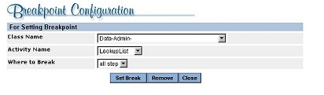
To see a list of activities, select a class. select the step before which you want processing to pause. Select at entry or 1 to break when the activity starts. To break for each step, choose all step.
Click Set Break, and you see the following:
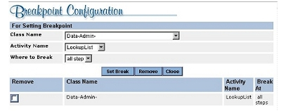
To remove a break, check the Remove box and click the Remove button.

- Watch values can be set on tracer for various properties on the clipboard pages, pretty much in the same way as we set the break points. But break points are set to activity steps and the watch values are set to properties in the clipboard

- A declarative rule describes a computational relationship among property values that is expected to be valid "always" or "often" or "as needed". Declarative rules will be in force automatically and hence you need not call these rules explicitly

- Declarative rules need / should not be refereed from any rule. They are always in force. The primary benefit of declarative processing is that the system, rather than the developer, controls when computations are processed

- There are five types of declarative rules

    - Constraints rules (Rule-Declare-Constraints rule type)
    - Declare Expression rules (Rule-Declare-Expressions rule type)
    - Declare Index rules (Rule-Declare-Index rule type)
    - Declare OnChange rules (Rule-Declare-OnChange rule type)
    - Declare Trigger rules (Rule-Declare-Trigger rule types)

- Remember that other than above five rules , any other rules are not really declarative rules, though containing “Declare” keyword. For example, following are not declarative rules

Rule-Declare-DecisionTree
Rule-Declare-DecisionTable

- Rule-Declare-Expressions : R-D-E ( Rule-Declare-Expressions ) can be created for properties and will have typically same name of the property. R-D-E facilitates automatic computation of the property value, basing on changes of other property values. For example, we can declare a R-D-E for property called “Area” , so that whenever it’s value is accessed from clipboard, it’s value is equal to the product of properties, Length and Width. Once the R-D-E is saved for the property “Area”, any change to a Length or Width value, regardless of how it occurs, causes an immediate recomputation of the value of the Area property. For example following is the R-D-E created for gross salary property

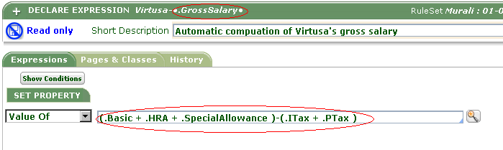

Idea is, Whenever value of any property from Basic, HRA, SpecialAllowance, ITax and PTax is changed, The value of GrossSalary in clipboard automatically changes. For example, if an activity which has Property-Set method for property “Basic” and if this activity is executed, the clipboard value of GrossSalary automatically changes

- Declarative rules are not referenced explicitly in other rules. If you use of an property that is referenced in the declarative rule, it automatically causes the declarative rule to run.

- Forward Chaining : Forward chaining provides the automatic calculation of the property by executing the declarative rule, when any one of the input property value is changed. For example, if the Area property depends on the Length and Width property, then forward chaining causes the Area property to be recomputed each time either Length, or Width value changes

- Backword Chaining : Forward chaining provides the automatic calculation of the property by executing the declarative rule, when a value is needed for a property, rather than when inputs change. For example, if the Area property depends on the Length and Width property, then backword chaining causes the Area property to be recomputed each time the Area property is required/ referred

- What decides the forward chaining / Backword chaining ? : The “Target Property Data “ field in declare expressions decide this

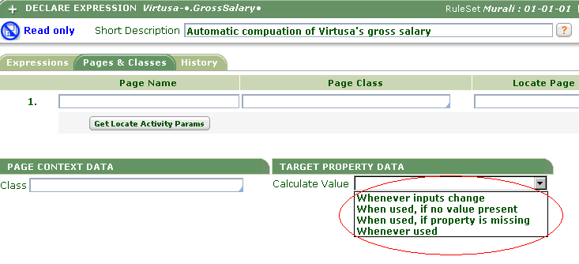

In the above options,

Whenever inputs change – Forward Chaining
When used, if no value present – Backword Chaining
When used, if Property is missing – Backword Chaining
Whenever used – Backword Chaining

- You can use when conditions in the R-D-E. For example we can change the formula for grossSalary for regular employees and contract employees as given below. Contract employees will not have the Special allowance
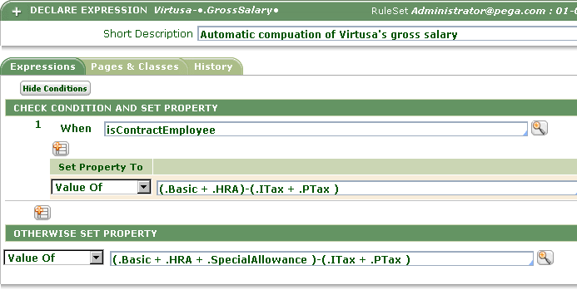

- You need to give the page context value, if the R-D-E is declared for a target property which is embedded in page-List or a page-property . You can leave the page context value as blank, if your target property is of mode single value.

If you give the page context, if you specify the page context, you need to specify the class for this page context, in
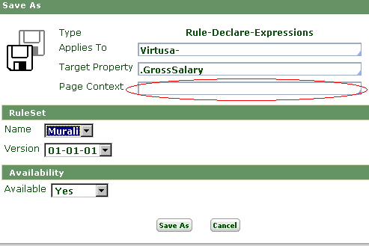

For example, the following may be valid values for page context

wageBill.Employee(“Murali”)
wageBill.Employee(4)
wageBill.Employee()

Assuming, Employee is an embedded page in which we have the GrossPay property for which we are declaring R-D-E

Also, If you give the page context, you need to specify the class for this page context, in class field as given below



- Rule-Declare-Constraints : Constraints rules can provide an automatic form of property validation every time the property's value is "touched", in addition to the validation provided by the property rule or other means. The system evaluates constraints automatically each time a property identified in a Constraints rule is changed. This technique is known as forward chaining. Constraints use the forward chaining. For example we can create a constraint for multiple properties to see that all amount are positive as given below
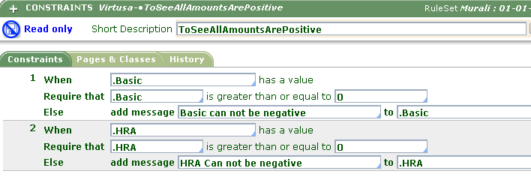

- Same as Declare expressions, we can also declare constraints for the properties inside the embedded page. In that case, we need to specify the page name and it’s class in the pages and classes tab as given below

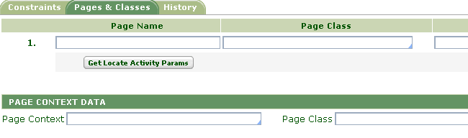

- Rule-Declare-Index : Declare Index rule are defined for defining criteria under which Process Commander automatically maintains index instances for faster access.

- Rule-Declare-OnChange : Declare OnChange rules can be used to run an activity automatically at activity step boundaries whenever the value of a specified property changes. This capability provides a form of automatic forward chaining. If you specify more than one property, they all must be on same page. For example, we can create a declare onchange to call an activity that send a mail to employee when ever either HRA or Basic or SpecialAllowance are changed as below

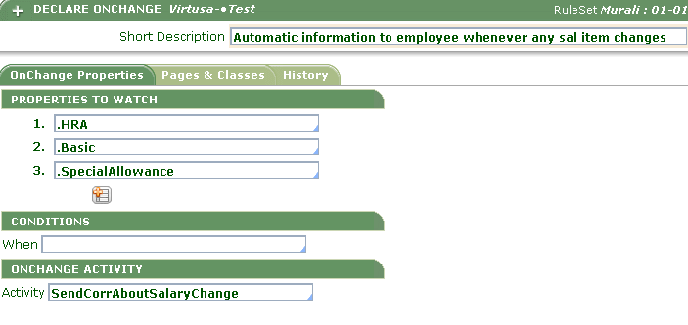
- Same as Declare expressions, we can define declare OnChange rules for the properties inside the embedded page. In that case, we need to specify the page name and it’s class in the pages and classes tab as given below

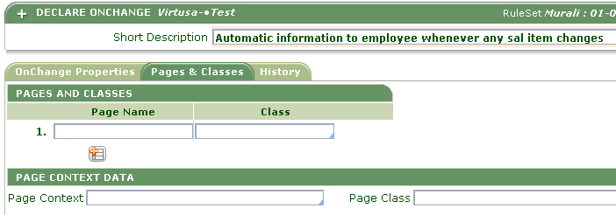

- Rule-Declare-Trigger: A trigger rule identifies an activity that runs automatically whenever an object of a particular class is saved in or deleted or updated from the database.

- Triggers implements forward chaining

- Almost all the declarative rules implement only the forward chaining, except the R-D-E. In R-D-E, we have a choice to decide either we should go to forward chaining or backward chaining

- A Decision Table is an instance of class Rule-Declare-Decision Table. A decision table to derive a value that has one of a few possible outcomes, where each outcome can be detected by a test condition on value of the property. A decision table rule lists two or more rows, each containing test conditions on a property value and a result. For example, following is a decision table defined to get the tax rate basing on the HRA

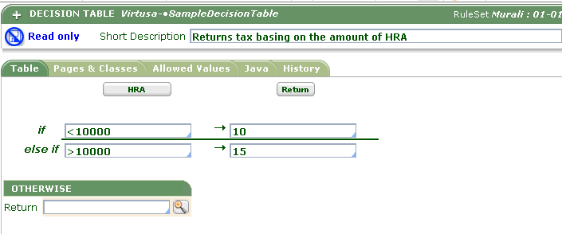

- How to refer the decision table? Decision table can be referred from three other rules
  - From decision shape of flow rule
  - In an activity you can evaluate the decision table using Property-Map-DecisionTable. By doing so, we can set a property value with the return value of the decision table
  - Decision table can be referred from R-D-E

- A decision tree is an instance of Rule-Declare-DecisionTree. Decision tree can be used to record the complex if—then—else logic. For example following is the standard decision tree defined in the Procom ruleset for returning right email address basing on the complex if else conditions

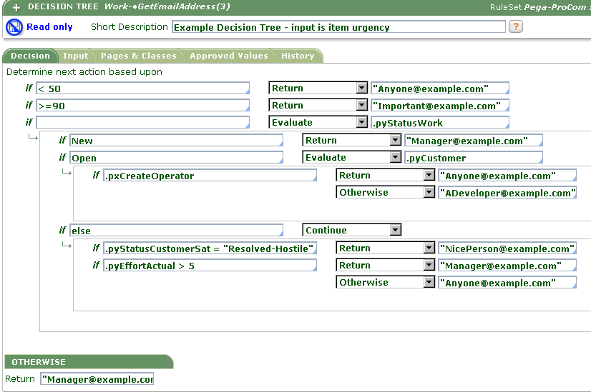

- How to refer the decision tree ? Decision table can be referred from three other rules
  - From decision shape of flow rule
  - In an activity you can evaluate the decision tree using Property-Map-DecisionTree. By doing so, we can set a property value with the return value of the decision table.
  - Decision tree can be referred from R-D-E

- Significance of Default input property in decision tree is : This is an optional field. At run time when the decision tree is referred, if the value of the third parameter to the Property-Map-DecisionTree method is blank, the system evaluates this field and uses the result as the value for comparisons.

- Map Value : We can think of a map value rule to create a table of number, text, or date ranges that converts one or two input values, such as latitude and longitude numbers, into a calculated result value, such as a city name. Map value rules greatly simplify decisions based on ranges of one or two inputs.

Though we can use map value to take a maximum of 2 inputs, through cascading — where one map value calls another — map value rules can provide an output value based on three, four, or more inputs

- Normally maps can be defined in two ways. We can give a row input only which is referred as simple map. The following is example of simple Map

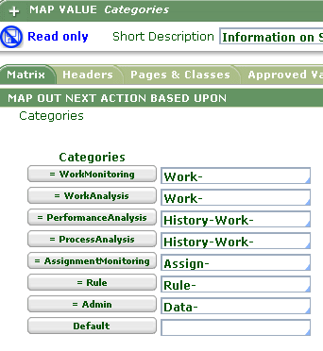

Also we can think of creating a map which takes both row input and column input which is normally referred as Map value pair. Following is an example of map value pair

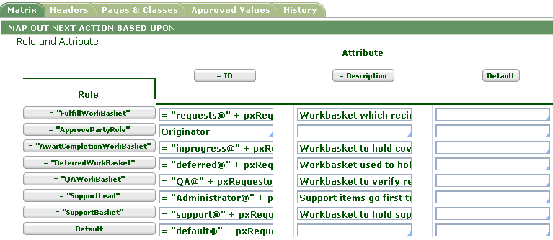

- How and where the maps are referred ?

  - From decision shape of flow rule
  - In an activity you can evaluate the map value using Property-Map-value ( Where you have only row input) or Property-Map-ValuePair( When you have both row and column inputs ). By doing so, we can set a property value with the return value of the map value.
  - Map can be referred from R-D-E
  - A Map value can be referred from other map values

- Important flow symbols ( ** Symbols are very important for exam )

      - Branching to another flow: can branch to start another flow execution anywhere in your current flow. Flow symbol looks as
      - Assignment : Assignment is the place the work object requires some user action and typically assignment can include both local and no local flow actions. Assignment looks as
      - Comment : Comment symbol looks as , where u can add some comments in the flow.
      - Connectors : Connectors look as
      - Integrator : Integrator task is an activity that connects your Process Commander system to an external system to send or receive data. Integrator shape looks as

      - Decision : We can use decision task to reference a map value rule, decision table rule, or decision tree rule that when evaluated produces a value that is the basis of branching in the flow. Decision shape looks as

      - Flow End Shape : Defines the end of the flow. Shape looks as

      - Fork : Fork represents a point where the flow execution chooses one of a few different paths (connectors) based on tests on the work object. fork shape looks ad

      - Notify : Connect a Notify shape to an assignment to cause your application to send correspondence to a work party in the work object reflecting the assignment. The notify shape looks as

      - Router : A router activity computes which workbasket, worklist, or agent is to receives an assignment. The shape looks as .

      - SpinOff : When a work object advancing through a flow reaches the Spinoff shape, Process Commander to starts execution of a different flow, using the current or a different work object. Processing in the current flow rule continues in parallel, without waiting for the other flow to complete. SpinOff shape looks as

      - Spilt-Join : We need to use Split-Join shape to guarantee that "subflows" of your flow are completed before continuing with the current flow. The shape looks as .

      - Split-ForEach : Split-ForEach shape to send a work object through another flow based on information in the pages of a Page List or Page Group property. The shape looks as

      - Utility : Utility task is an activity that can update a work object without human input. It may perform computations, searches, retrieve data from another system, make a decision affecting the course of the flow, and so on. Utility task looks as

304. Important classes

1. Ruleset - Rule-Ruleset-Name
2. Ruleset version - Rule-RuleSet-Version
3. Class - Rule-Obj-Class
4. Property - Rule- Obj-Property
5. HTML Form - Rule-Obj-HTML
6. Harness - Rule-HTML-Harness
7. Harness Section - Rule-HTML-Section
8. Flow - Rule-Obj-Flow
9. Organization - Data-Admin-Organization
10. Division - Data-Admin-OrgDivision
11. Unit - Data-Admin-OrgUnit
12. Flow action - Rule-Obj-FlowAction
13. System - Data-Admin-System
14. Operator - Data-Admin-Operator-ID
15. Access Group - Data-Admin-Operator-AccessGroup
16. Work Object - Work-Object-
17. Cover - Work-Cover-
18. Folder - Work-Folder-
19. Party types - Data-Party
20. Work parties for work class - Rule-Obj-WorkParty
21. Class Group - Data-Admin-Db-ClassGroup
22. Mapping class/ class group
to a table - Data-Admin-DB-Table
23. DB Connection - Data-Admin-Db-Name
24. Field Value lists - Rule-Obj-FieldValue
25. Custom display options
for properties on the form - Rule-HTML-Property
26. Converting user input into
internal format - Rule-Edit-Input
27. Model - Rule-Obj-Model
28. Fragment - Rule-HTML-Fragment
29. Text file - Rule-File-Text
30. Binary File - Rule-File-Binary
31. Property streams ( to - Rule-HTML-Property
control the appearance of
properties on UI )
32. Custom routines for
formatting the properties - Rule-Edit-Input
33. Maintain value lists for
the property - Rule-Obj-FiledValue
34. To validate a property - Rule-Edit-Validate
35. To validate multiple
properties in a page - Rule-Obj-Validate
36. To create calendars - Data-Admin-Calendar
37. Packaging/ shipping - Rule-Admin-Product
products
38. To Contain report structure – Rule-Obj-SummaryView
31. Decision tree - Rule-Declare-DecisionTree
32. Decision table - Rule-Declare-DecisionTable
33. When conditions - Rule-Obj-When
34. Maps - Rule-Obj-Map
35. Declare Expressions - Rule-Declare-Expressions
36. Constraints - Rule-Declare-Constraints
37. Declare onChanges - Rule-Declare-OnChange
39. Declare Indexes - Rule-Declare-Index
40. Delcare Triggers - Rule-Delcare-Triggers

305. An Access Role is an instance of the Rule-Access-Role-Name class. An access role can be assigned to individual users (or requestors) to influence their access control. These roles determine what operations they can perform on what classes. Don't confuse access roles with access groups, which affect RuleSet and Version visibility. Access groups are data instances (of the Data-Admin-Operator-AccessGroup class), while access roles are rules.

306. A Privilege is an application-specific access control element associated with a class and access role. A privilege is a name that corresponds to a Rule-Access-Privilege instance. That class provides a name (and class) for each privilege, but does not cause the system to grant privileges. Use of privileges is optional, but can offer finer tuning of access control than access roles alone. To have access to a privilege, you must have at least one of the access roles that grant access to the privilege in your access role list. The association between access roles and privileges is established in instances of the Rule-Access-Role-Obj class

- The portal layout for System architect and process architect appears
similar

308. PRPC model users

  - Business Users

      - Business User : End user of the application

      - Business Manager : Who monitors the performance of users or user groups

  - Developers and Implementers

      - Process Architect : A business analyst who defines and maintains business rules, service levels, and flows

      - System Architect : An application developer who creates class structure for the application and who builds the interfaces with external systems

      - System Administrator : System engineer who is responsible for installation and setup, security, and high level configurations

309. Portal layouts can be configured as instances of Rule-Portal

- Guardrails
  - Adopt an Iterative Approach
  - Establish a Robust Foundation
  - Do Nothing That Is Hard
  - Limit Custom Java
  - Build For Change
  - Design Intent-Driven Processes
  - Create Easy-To-Read Flows
  - Monitor Performance Regularly
  - Calculate and Edit Declaratively, Not Procedurally
Keep Security Object-Oriented Too

- SMART BUILD
Smart build is the design and development process for PRPC.
It contains 14 sequential steps.

Smart Build Steps
1. Review Road map and Develop Plan
  - Analyze Requirements
  - Prerequisites and set up
  - Design the class structure
  - Create and evaluate sample work objects
  - Identify missing properties and data classes
  - Tailor the user interface
  - Design flows and Identify Flow Actions
  - Create Flows and Process Details
  - Add Communications Capabilities
  - Set up Access and Security
  - Configure Interfaces and Data Sources
  - Business Review and Deploy
  - Continuous Improvement

- Standard Rule-Methods

Method | Description
Activity-End | End the current activity.
Activity-List-Add | Add an activity to an internal dispatch list.
Apply-Parse-Delimited | Execute a Parse Delimited rule in an activity.
Apply-Parse-Structured | Execute a Parse Structured rule in an activity.
Apply-Parse-XML | Execute a Parse XML rule in an activity.
Assign-Delete | Delete an assignment.
Assign-EstablishContext | Retrieve the flow and work object for an assignment.
Commit | Commit all database changes in the thread.
Connect-dotNet | Start a connector to a Web service based on the Microsoft .NET framework
Connect-EJB | Start a connector to an external Enterprise JavaBean.
Connect-Java | Start a connector to call an external Java class or JavaBean.
Connect-JMS | Start a connector to an external system using the Java Message Service application programmer interface.
Connect-MQ | Start a connector for a WebSphere MQ connection.
Connect-SOAP | Start a connector to invoke a Web service.
Connect-Wait | Block (pause) for a time interval to synchronize with child requestor.
End-Validate | End compilation of referencing rules, for a custom rule type.
Exit-Activity | End the current activity.
Flow-New | Start a flow execution instance.
Flow-End | Terminate a flow execution instance.
History-Add | Record your changes to work objects or activities
History-List | List instances of a class.
Link-Objects | Link objects together.
Obj-Delete | Delete an instance from the database, or mark it for later deletion with the Commit method
Obj-List | Search through instances of a class and extract selected properties
Obj-Open | Open an instance stored in the database
Obj-Open-by-Handle | Open an instance using a permanent unique key.
Obj-Save | Save page data to the database, or mark it for saving (commit) later.
Obj-Save-Cancel | Reverse a previous Obj-Save or Obj-Delete method, not yet committed to the database.
Obj-Set-Tickets | Set or reset tickets, interrupting the normal sequential processing of a flow.
Obj-Validate | Run a Validate rule on a set of properties, typically representing user input.
Page-Change-Class | Change the class of a page.
Page-Copy | Copy contents of one page to another page
Page-Clear-Messages | Remove page messages from the step page.
Page-Merge-Into | Merge two or more pages into one page.
Page-New | Create a page.
Page-Remove | Delete a page from the clipboard.
Page-Rename | Rename a page or name a primary page
Page-Validate | Validates all properties on a page.
Page-Set-Messages | Associate a message with a page.
Parse-Byte-Pos | Used only in Parse Structured rules.
Parse-Char-Pos | Used only in Parse Structured rules.
Parse-Fixed-Binary | Used only in Parse Structured rules.
Parse-Packed-Decimal | Used only in Parse Structured rules.
Privilege-Check | Determine whether a user or requestor has a specified privilege.
Property-Map-DecisionTable | Evaluate a decision table rule and assign the result to a property
Property-Map-DecisionTree | Evaluate a decision tree rule and assign the result to a property
Property-Map-Value | Set the value of a property based on a one-dimensional map value rule.
Property-Map-ValuePair | Set the value of a property based on a two-dimensional map value rule.
Property-Remove | Delete a property from a page.
Property-Seek-Value | Use backwards chaining to obtain a value.
Property-Set | Set the value of one or more specified properties
Property-Set-Corr | Save the contents of a correspondence stream as the value of a property.
Property-Set-HTML | Save the contents of an HTML stream as the value of a property.
Property-Set-Messages | Associate a literal text message with a property or a step page.
Property-Set-Special | Set the value of one or more-reserved (px) properties.
Property-Set-Stream | Save the contents of a JSP, XML, or HTML stream as the value of a property.
Property-Set-XML | Save the contents of an XML stream as the value of a property.
Property-Validate | Apply an Edit Validate rule to test user input.
RDB-Delete | Delete an instance from a relational database.
RDB-List | Retrieve rows from an external relational database.
RDB-Open | Open an instance from an external relational database.
RDB-Save | Save the contents of a clipboard page to a relational database.
Requestor-Stop | Stop processing of the requestor.
Show-HTML | Assemble and send an HTML page to a user's browser
Show-Page | Send an XML representation of a page to the browser.
Show-Property | Send a single property value to the browser.
Show-Stream | Apply stream processing to a JSP, HTML, correspondence or XML rule.
Start-Validate | Compile referencing rules for a custom rule type.
StringBuffer-Append | Manipulate string buffer containing local variables
StringBuffer-Insert | Manipulate string buffer containing local variables
StringBuffer-Reset | Manipulate string buffer containing local variables
TaskStatus-Set | Convey results of activity processing to a calling flow
Thread-Clear | Clear the thread page.
Thread-Stop | Stop the current thread.
Wait | Pause a thread for a specified time interval.

- RULE-OBJ_CORR
Create correspondence rules to define, in HTML, templates for the content of outgoing correspondence. We need to select the Correspondence type.

RULE-CORR TYPE
A correspondence type rule indicates whether a piece of correspondence is a printed letter, fax, e-mail, or phone text

RULE-CORR-FRAGMENT
Create a correspondence fragment rule to define reusable or boilerplate HTML text for correspondence. Through the include directive or the equivalent include JSP tag, this text can be incorporated into multiple correspondence rules during stream processing.

- RULE-DECLARE-INDEX
Indexing can improve performance and facilitate reporting. These rules are stored in
index_base table of pega rules.

- RULE-UTILITY-LIBRARY
A library rule is a container for a set of related function rules.

- RULE-UTILITY-FUNCTION
It defines a java function that can be accessed through rule resolution. These rules can be referenced in expressions or java step in an activity. For example,
Exprerssion
@(MyRuleSet:MyGeoLibrary).MyGeographicFunction( Latitude, Longitude)
Java step
myruleset_mygeolibrary.MyGeographicFunction(Latitude, Longitude );

- RULE-PARSE-DELIMITED
Use the Parse Delimited rule to upload data into your Process Commander system from an external file or files. Within an input record, a comma, tab, quote, or other character may separate fields. The rule extracts the text between the delimiter characters and stores it in a Single Value property or as one element of a Value List property.

RULE-PARSE-STRUCTURED
Use a Parse Structured rule in conjunction with a Service File rule or the Apply-Parse-Structured method to import structured data to the clipboard. For example, you can import fixed-format flat files from a variety of external sources and platforms.

RULE-PARSE-XML
Use Parse XML rules with services and connectors to map data from an XML text message into clipboard property values. Each Parse XML rule contains an array of parsing instructions that let Process Commander interpret an incoming XML document or message. The incoming message may arrive using an e-mail protocol or by SOAP over HTTP protocol. The message may be a request for service or a reply from a connector. Within a Parse XML rule, the notation for finding elements and attributes is similar to the World Wide Web Consortium's XPath notation.

- DATA MAPPING IN SOAP
We have two types of mapping mechanisms in PRPC depending on the request/response forms.

For mapping data in SOAP Service

Request → MAP TO → Data from external source to PRPC
Response → MAP FROM → From PRPC to External Source

For mapping data in SOAP Connector

Request → MAP FROM → From PRPC to External Source
Response → MAP TO → Data from external source to PRPC

- JAVA SERVER PAGES TAGS
The Process Commander JSP tag library provides a functional equivalent to a directive, or part of a directive.

Reference tag
<pega:reference name="myPage.myProperty" />

Look up Tag
<pega:lookup classname="Rule-Obj-HTML" property="pxCreateOperator" />
<pega:key name="pyClassName" value ="Work-" />
<pega:key name="pyStreamName" value="Newbook" />
</pega:lookup>

With Embedded
<pega:withEmbedded name="embeddedpagestring" >
Enter <pega:reference name=".Surname" /> here.
</pega:withEmbedded >

With Page
<pega:withPage name="pagename"">
<!-- HTML and/or tags here with pagename as the base page -->
</pega:withPage>

Include
<pega:include
[name="name"]
[ref="indirect reference "]
[type="rule type"]
/>

When
<pega:when
[name="When rule ]
[java="<%=expression=%>"]
[test="keyword"]>
HTML segment to include if true
</pega:when >
For Each
<TABLE>
<pega:foreach name="Operators.pxResults">
<TR><TD>
<pega:reference name="$THIS.pyUserIdentifier" />
</TD></TR>
</pega:foreach >
</TABLE>
- RULE-OBJ-LIST VIEW
Use a List View rule to define a custom report or personal version of a report. This rule generates HTML that provides an attractive interactive display. Following are the steps to create one.
- Use the New dialog to record the rule key.
- Complete the Display Fields tab to record the layout of an HTML <TABLE> display of results.
- Complete the Content tab to define a search of the Process Commander database and exploit
the retrieval, filtering, and sorting power of database software.
- Use the Organize tab to apply further filtering and sorting, and buttons.
- Define interactions and advanced interactions on the Format tab
- RULE-OBJ-SUMMARY VIEW
Use the Summary View rule form to define a simple custom or personal query. This rule generates HTML that provides an attractive, custom interactive display.
Here we can have drilldown options as well.

