NiFi can be downloaded from the [NiFi Downloads page](http://nifi.apache.org/download.html). There are two packaging options available:

* a "tarball" (tar.gz) that is tailored more to Linux
* a zip file that is more applicable for Windows users

Download Version: 1.10.0

Once the tar file is downloaded, unzip the tar file using command **tar -xvf nifi-1.10.0-bin.tar.gz -C $HOME** to home directory.

NiFi requires Java 8 or 11. It is recommended that you have installed one of these Java versions prior to installing NiFi.

Java Downloaded Version: jdk1.8.0_144

After unzipping the folder - go to the bin folder **(/home/cm2506/nifi-1.10.0/bin)** and add java path to nifi-env.sh

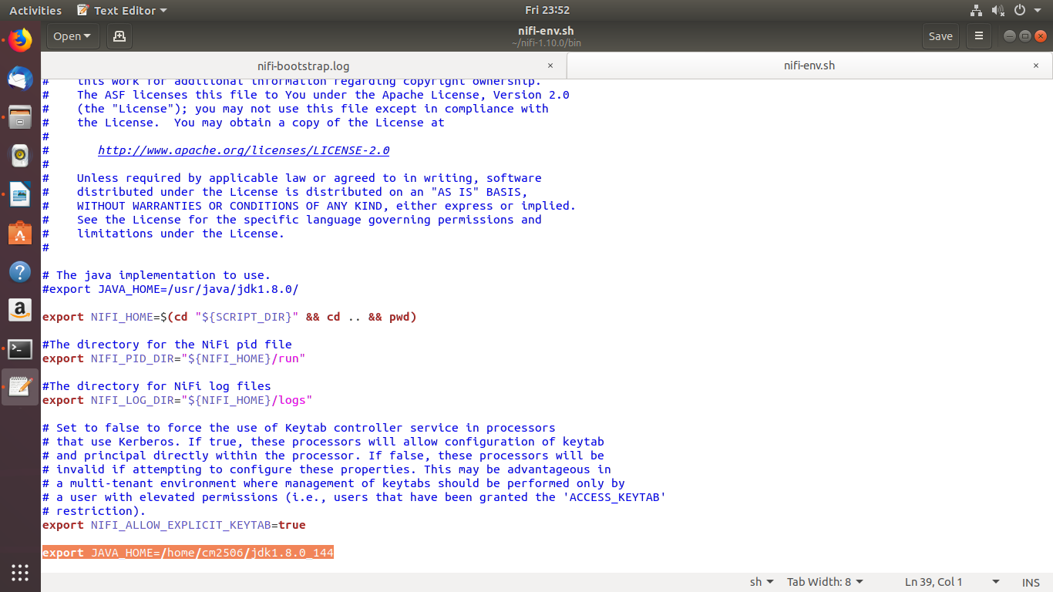

export JAVA_HOME=/home/cm2506/ jdk1.8.0.144

Once the java path is added we can go ahead and start the nifi process using the below command

**Start command:**

cm2506@ubuntu: ~/nifi-1.10.0$ **bin/nifi.sh start**

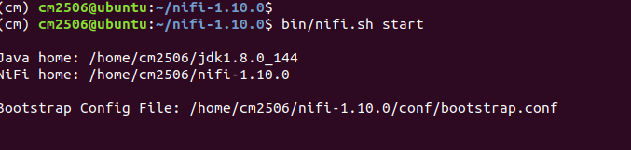

In order to verify whether the nifi service is started or not we can go to

/home/cm2506/nifi-1.10.0/logs folder and check nifi-bootstarp.log

under this folder we have 3 log categories

* nifi-app – application level log tracing
* nifi-user – user level log tracing
* nifi-bootstrap – booting level log tracing

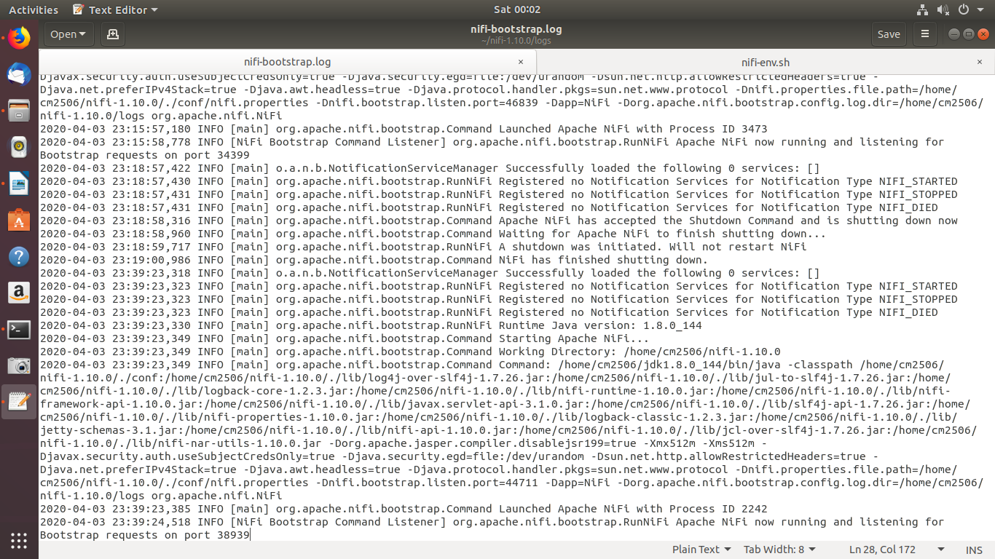

The below message in bootstrap log will confirm that nifi service is started without any issue. If any issue during booting we can view the error trace in the same log.

2020-04-03 23:39:23,385 INFO [main] org. apache. nifi. bootstrap. Command Launched Apache NiFi with Process ID 2242

2020-04-03 23:39:24,518 INFO [NiFi Bootstrap Command Listener] org. apache. nifi. bootstrap. RunNiFi Apache NiFi now running and listening for Bootstrap requests on port 38939

Another way of confirming the same is by using bin/nifi.sh status- this will return the current status whether nifi service is up and running

**Status Command**

(cm) cm2506@ubuntu: ~/nifi-1.10.0$ **bin/nifi.sh status**

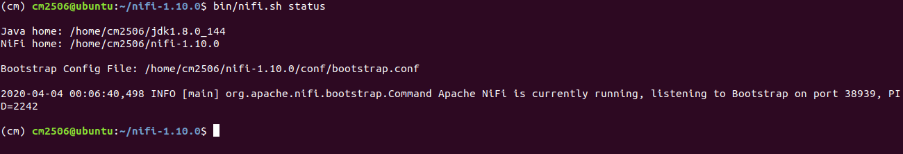

Background Daemons:

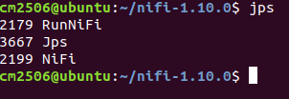

To login to the nifi dash board below URL can be used,

<http://localhost:8080/nifi/>

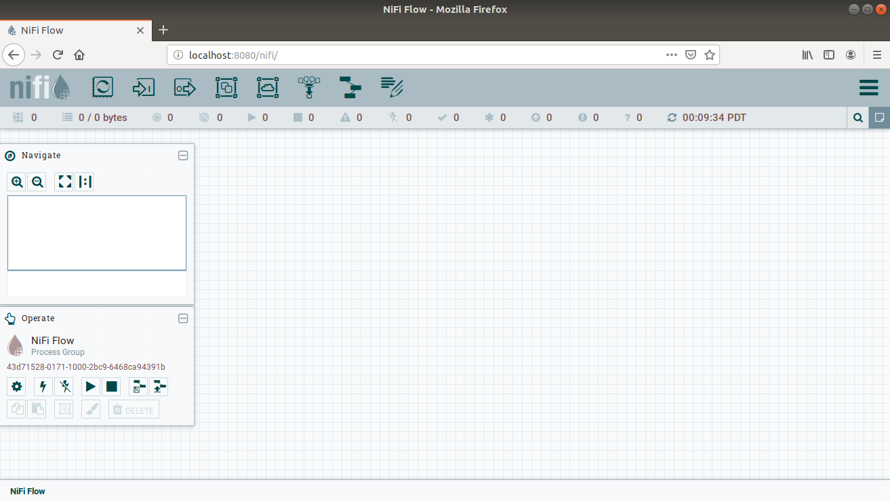

The port can be changed by editing the nifi. properties file in the NiFi conf directory, but the default port is 8080

**Stop command:**

cm2506@ubuntu: ~/nifi-1.10.0$ **bin/nifi.sh stop**

**General Overview:**

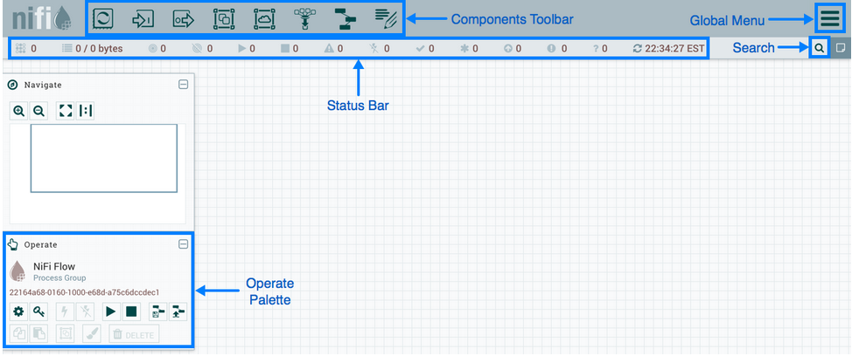

### Adding a Processor

We can now begin creating our data flow by adding a Processor to our canvas. To do this, drag the Processor icon () from the top-left of the screen into the middle of the canvas (the graph paper-like background) and drop it there. This will give us a dialog that allows us to choose which Processor we want to add:

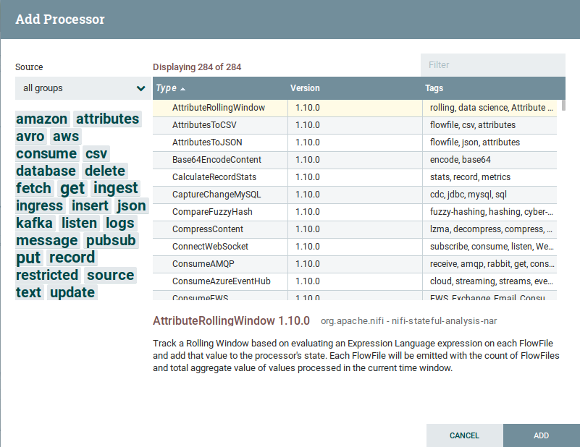

For rest of the components please refer the detailed explanation on the component

https://nifi.apache.org/docs/nifi-docs/html/getting-started.html#downloading-and-installing-nifi

**Small use case on nifi workflow**

Convert csv to json

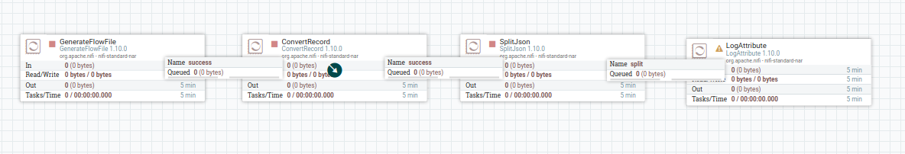

**GenerateFlowFile Processor :**

This processor creates Flow Files with random data or custom content. GenerateFlowFile is useful for load testing, configuration, and simulation.

**ConvertRecord Processor:**

Converts records from one data format to another using configured Record Reader and Record Write Controller Services. The Reader and Writer must be configured with "matching" schemas.

**SplitJson Processor:**

Splits a JSON File into multiple, separate FlowFiles for an array element specified by a JsonPath expression. Each generated FlowFile is comprised of an element of the specified array and transferred to relationship 'split,' with the original file transferred to the 'original' relationship. If the specified JsonPath is not found or does not evaluate to an array element, the original file is routed to 'failure' and no files are generated.

**LogAttribute Processor:**

Emits attributes of the FlowFile at the specified log level. For Logging purpose.

Below is the workflow which is converted as template, this template has all the configuration tailored.

Keeping this template as sample, new workflow can be created.



Note: Demo will be arranged to explain the use of nifi and workflow in a detailed manner.