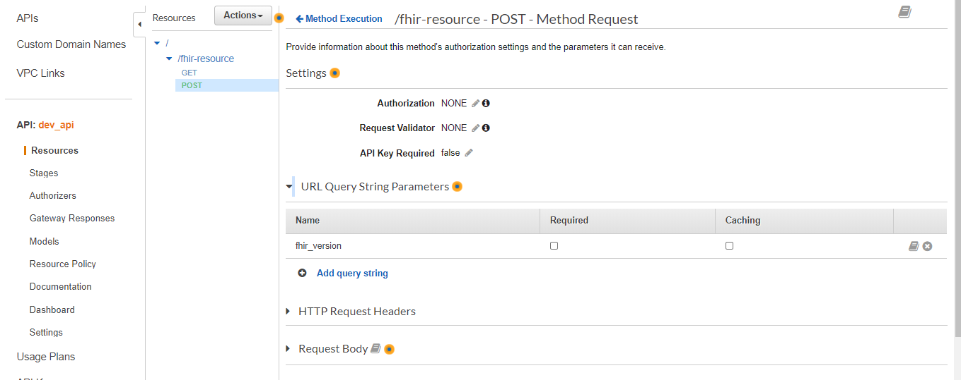

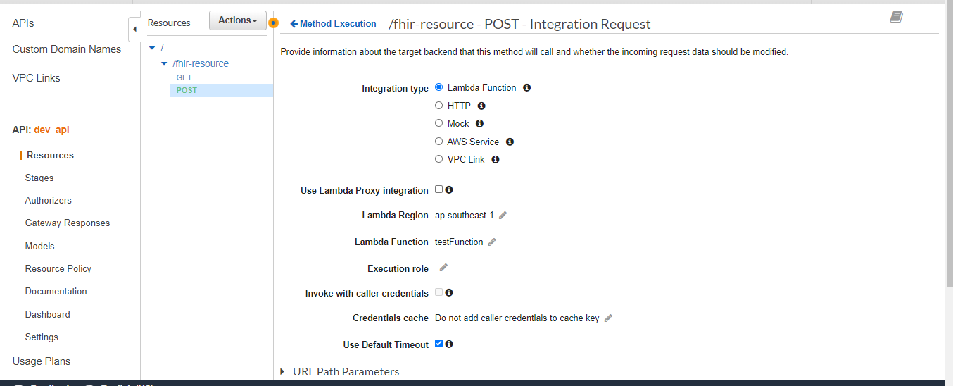

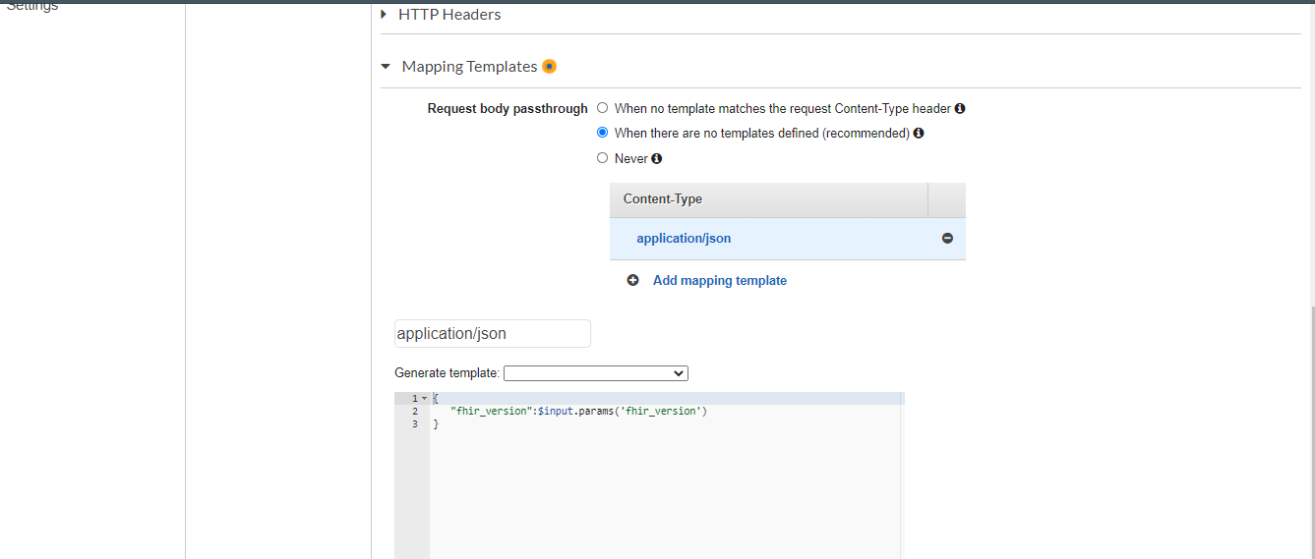

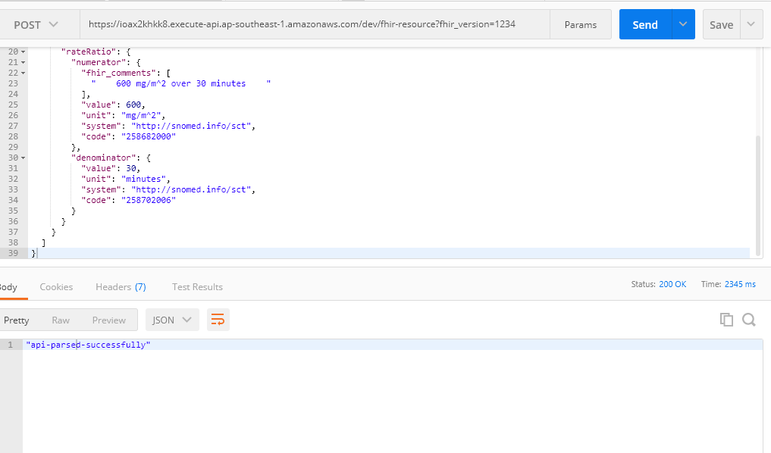

Lambda:

<https://xxxxxxx.execute-api.ap-southeast-1.amazonaws.com/dev/fhir-resource?fhir_version=1234>

import os

import logging

logger = logging.getLogger()

logger.setLevel(logging.INFO)

def lambda_handler(event, context):

logger.info('## EVENT')

logger.info('## QUERY STRING PARAMS')

logger.info(event['fhir_version'])

return 'api-parsed-successfully'

**Cloud watch logs:**

2020-09-05T13:08:19.770+05:30 START RequestId: 84f06d25-8665-4dad-8a94-4cdc46232572 Version: $LATEST

2020-09-05T13:08:19.770+05:30 [INFO] 2020-09-05T07:38:19.770Z 84f06d25-8665-4dad-8a94-4cdc46232572 ## QUERY STRING PARAMS

2020-09-05T13:08:19.770+05:30 [INFO] 2020-09-05T07:38:19.770Z 84f06d25-8665-4dad-8a94-4cdc46232572 ##EVENT

2020-09-05T13:08:19.771+05:30 [INFO] 2020-09-05T07:38:19.770Z 84f06d25-8665-4dad-8a94-4cdc46232572 {u'fhir_version': 1234}

2020-09-05T13:08:19.771+05:30 [INFO] 2020-09-05T07:38:19.771Z 84f06d25-8665-4dad-8a94-4cdc46232572 ##fhir_version

2020-09-05T13:08:19.771+05:30 [INFO] 2020-09-05T07:38:19.771Z 84f06d25-8665-4dad-8a94-4cdc46232572 1234

2020-09-05T13:08:19.771+05:30 END RequestId: 84f06d25-8665-4dad-8a94-4cdc46232572

2020-09-05T13:08:19.771+05:30 REPORT RequestId: 84f06d25-8665-4dad-8a94-4cdc46232572 Duration: 0.63 ms Billed Duration: 100 ms Memory Size: 128 MB Max Memory Used: 53 MB Init Duration: 163.69 ms

2020-09-05T13:09:18.135+05:30 START RequestId: ca5b5d86-75f9-4365-9c78-489e8cc4d9ed Version: $LATEST

2020-09-05T13:09:18.138+05:30 [INFO] 2020-09-05T07:39:18.137Z ca5b5d86-75f9-4365-9c78-489e8cc4d9ed ## QUERY STRING PARAMS

2020-09-05T13:09:18.138+05:30 [INFO] 2020-09-05T07:39:18.138Z ca5b5d86-75f9-4365-9c78-489e8cc4d9ed ##EVENT

2020-09-05T13:09:18.138+05:30 [INFO] 2020-09-05T07:39:18.138Z ca5b5d86-75f9-4365-9c78-489e8cc4d9ed {u'fhir_version': 1234}

2020-09-05T13:09:18.138+05:30 [INFO] 2020-09-05T07:39:18.138Z ca5b5d86-75f9-4365-9c78-489e8cc4d9ed ##fhir_version

2020-09-05T13:09:18.138+05:30 [INFO] 2020-09-05T07:39:18.138Z ca5b5d86-75f9-4365-9c78-489e8cc4d9ed 1234

2020-09-05T13:09:18.138+05:30 END RequestId: ca5b5d86-75f9-4365-9c78-489e8cc4d9ed

2020-09-05T13:09:18.138+05:30 REPORT RequestId: ca5b5d86-75f9-4365-9c78-489e8cc4d9ed Duration: 0.55 ms Billed Duration: 100 ms Memory Size: 128 MB Max Memory Used: 53 MB

2020-09-05T13:09:33.344+05:30 START RequestId: 317a532d-b81f-4a27-b330-ef65134ad6b0 Version: $LATEST

2020-09-05T13:09:33.348+05:30 [INFO] 2020-09-05T07:39:33.348Z 317a532d-b81f-4a27-b330-ef65134ad6b0 ## QUERY STRING PARAMS

2020-09-05T13:09:33.348+05:30 [INFO] 2020-09-05T07:39:33.348Z 317a532d-b81f-4a27-b330-ef65134ad6b0 ##EVENT

2020-09-05T13:09:33.348+05:30 [INFO] 2020-09-05T07:39:33.348Z 317a532d-b81f-4a27-b330-ef65134ad6b0 {u'fhir_version': 1234}

2020-09-05T13:09:33.348+05:30 [INFO] 2020-09-05T07:39:33.348Z 317a532d-b81f-4a27-b330-ef65134ad6b0 ##fhir_version

2020-09-05T13:09:33.348+05:30 [INFO] 2020-09-05T07:39:33.348Z 317a532d-b81f-4a27-b330-ef65134ad6b0 1234

2020-09-05T13:09:33.348+05:30 END RequestId: 317a532d-b81f-4a27-b330-ef65134ad6b0

2020-09-05T13:09:33.348+05:30REPORT RequestId: 317a532d-b81f-4a27-b330-ef65134ad6b0 Duration: 0.56 ms Billed Duration: 100 ms Memory Size: 128 MB Max Memory Used: 53 MB