**Support Vector Regression**

**Support Vector Machin**e - Support Vector Machines (SVM) are a class of methods, developed originally for classification, that find support points that best separate classes. SVM for regression is called Support Vector Regression (SVM).

Regression (SVR) Support Vector Machine can also be used as a regression method, maintaining all the main features that characterize the algorithm (maximal margin). The Support Vector Regression (SVR) uses the same principles as the SVM for classification, with only a few minor differences.

A Support Vector Machine (SVM) performs **classification** by finding the hyperplane that

maximizes the margin between the two classes. The vectors (cases) that define the

hyperplane are the support vectors.

**RBF:** Radial Basis Function

An RBF net is similar to a 2-layer network. We have an input that is fully connected to a hidden layer. Then, we take the output of the hidden layer perform a weighted sum to get our output.

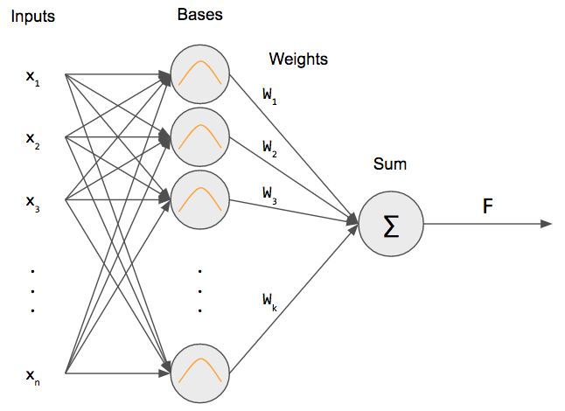

**Algorithm**

1. Define an optimal hyperplane: maximize margin

2. Extend the above definition for non-linearly separable problems: have a penalty term

for misclassifications.

3. Map data to high dimensional space where it is easier to classify with linear decision

surfaces: reformulate problem so that data is mapped implicitly to this space.

**To define an optimal hyperplane we need to maximize the width of the margin (w).**

**-Chandrashekhar**

**Hadoop Trainer**